*Florida International University*

*School of Computing and Information Sciences*

Software Engineering Focus

Feature Document

User Story ID 731

**Name:** Kevin Delamo

**Team Member(s):** Lukas Borges, Cristian Cabrera, Hamilton Chevez, Filip Klepsa, Francisco Lozada

**Project:** AR-VR-VE for Computer Science

**Product Owner(s)**: Francisco Ortega

**Mentor(s)**: Francisco Ortega

**Instructor**: Masoud Sadjadi

**User Story Name: Have Robot Communicate**

* Description: As a User, I’d like to have the Robot character communicate with me to facilitate my understanding of basic rules for the game so that I may clearly understand how to play.

Acceptance Criteria

* Text Box appears above head of robot
* Scrolls through various messages providing delays to allow for reading.
* Text Box constantly faces player
* Provide details to the player essential for their understanding of how they could possibly complete the game. (Balance between giving hints and telling the player outright what to do.)

**Use Case**

* Name: Have robot Communicate
* Actor: Player
* Preconditions: Game is started
* Description <Flow of events>:
  + Player spawns.
  + Text Box appears over robots head and begins to type out messages.
  + Checks if player has moved
  + Text box rotates to face player if movement occurs
  + Types out 2 characters of predetermined message.
  + Delays for .10 seconds.
  + Use Case repeats

**Use Case Diagram**

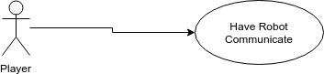

**Sequence Diagram**

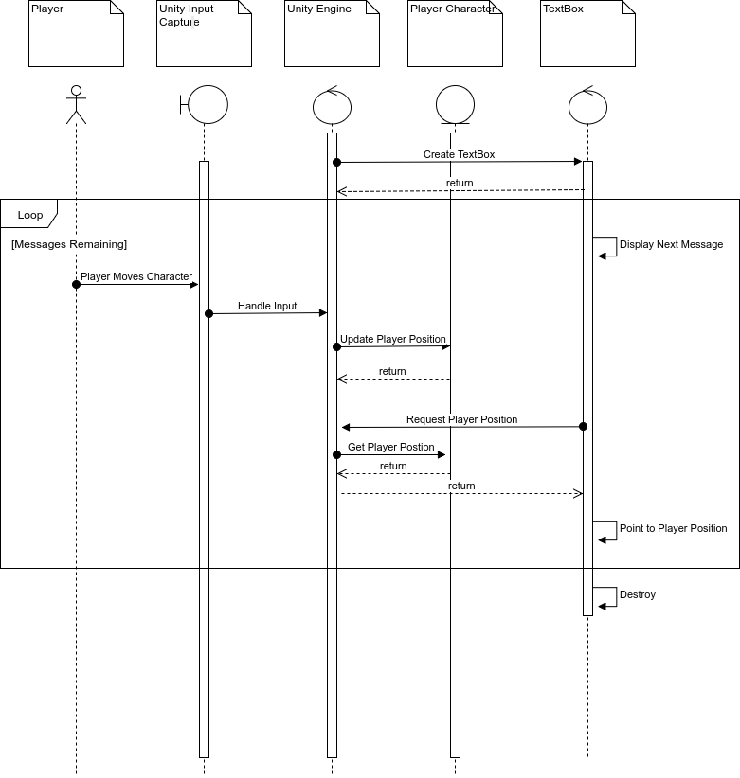

**Class Diagram**

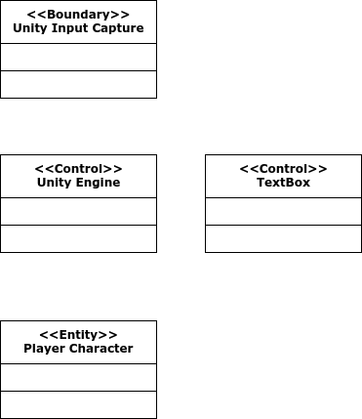

**Unit Test**

* Test case ID: 001
* Description/Summary of Test:
* Pre-condition:
* Expected Results:
* Actual Result:
* Status (Fail/Pass):

**Integration Test**

Test case ID: 003

* Description/Summary of Test: Player moves around the room while facing the text box.
* Pre-condition: Player started game.
* Expected Results: The textbox will display messages one by one, delaying between each one, while turning to face the player before disappearing after the last message plays.
* Actual Result: The textbox displayed messages one by one, delaying between each one, while turning to face the player disappearing after the last message plays.
* Status (Fail/Pass): Pass

**Visual User Guide**