*Florida International University*

*School of Computing and Information Sciences*

Software Engineering Focus

Feature Document

User Story ID #733 Prevent Robot from Going Through Walls

**Name:** Nicolette Celli

**Team Member(s):** Lukas Borges, Cristian Cabrera, Hamilton Chevez, Kevin Delamo, Filip Klepsa, Francisco Lozada

**Project:** AR-VR-VE for Computer Science

**Product Owner(s)**: Francisco Ortega

**Mentor(s)**: Francisco Ortega

**Instructor**: Masoud Sadjadi

**User Story Name:**

* Description: As a user, I would like the robot to stop moving when it bumps into a wall, so the game and its objective makes sense.

Acceptance Criteria

* The robot stops moving when it comes into contact with a rigid body.

**Use Case**

* Name: Run Robot Sequence
* Actor: Player
* Preconditions: The player has modelled already a sequence for the robot to follow.
* Description:
  + The player presses the “Run” button.
    - The robot will automatically move where the player’s sequence guides it.
    - If it comes into contact with a rigid body, it will stop; otherwise, it will continue until the sequence ends.

**Use Case Diagram**

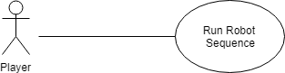

**Sequence Diagram**

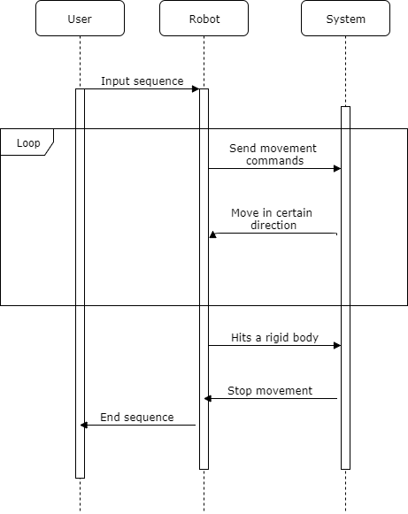

**Class Diagram**

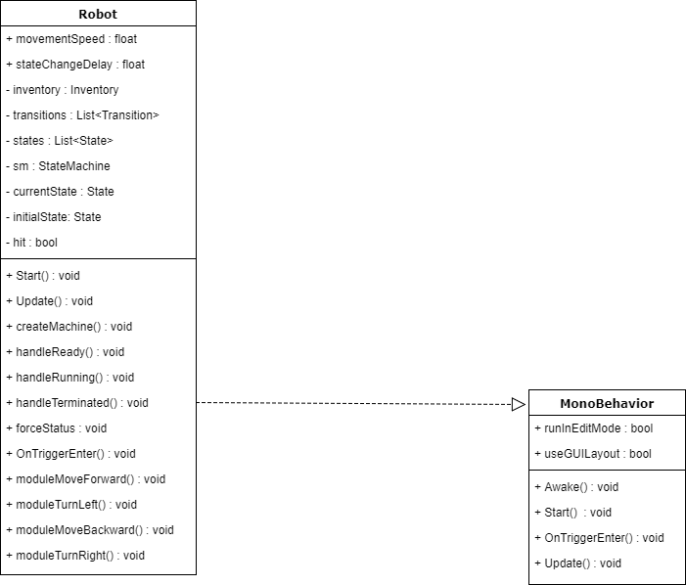

**Unit Test**

* Test case ID: 005
* Description/Summary of Test: Check to see if robot goes through rigid bodies.
* Pre-condition: The player has entered and run a sequence in front of the metal bars.
* Expected Results: The robot will stop at the bars.
* Actual Result: The robot stopped when it hit the bars.
* Status (Fail/Pass): Pass

**Visual User Guide**

