*Florida International University*

*School of Computing and Information Sciences*

Software Engineering Focus

Feature Document

User Story ID 732

**Name:** Kevin Delamo

**Team Member(s):** Lukas Borges, Cristian Cabrera, Hamilton Chevez, Filip Klepsa, Francisco Lozada

**Project:** AR-VR-VE for Computer Science

**Product Owner(s)**: Francisco Ortega

**Mentor(s)**: Francisco Ortega

**Instructor**: Masoud Sadjadi

**User Story Name: Create Button For Level**

* Description: As a user, I would like to have a button in the game as a goal so that my goal in the game is clearly visible. With this I can focus on how to reach the goal instead of trying to understand what the goal is.

Acceptance Criteria

* Button prompts victory when pressed by robot.
* Button is clearly visible to user so that they can plot how they can get to it.
* Button also causes come visible changes in the game world as to fit within the context of how it is a goal.

**Use Case**

* Name: Create Button for Completing Level
* Actor: Player
* Preconditions: Game is started
* Description <Flow of events>:
  + Player spawns.
  + Button Spawns
  + Player programs bot to move to button
  + Bot collides with button.
  + Button prompts victory screen.

**Use Case Diagram**

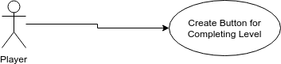

**Sequence Diagram**

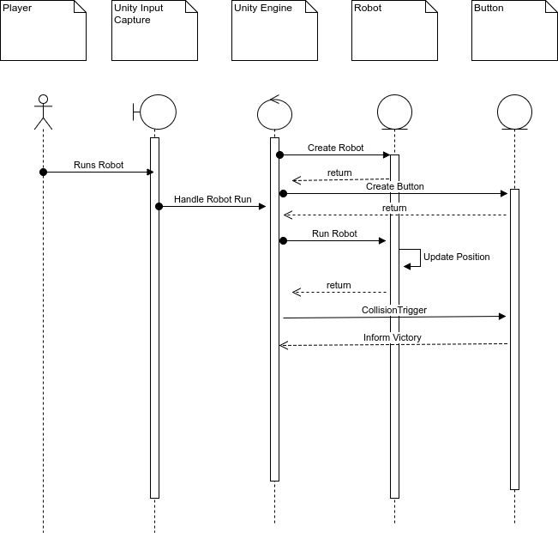

**Class Diagram**

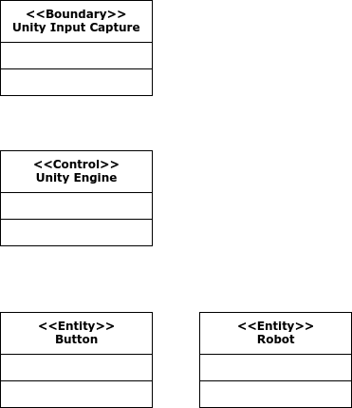

**Unit Test**

* Test case ID: 001
* Description/Summary of Test:
* Pre-condition:
* Expected Results:
* Actual Result:
* Status (Fail/Pass):

**Integration Test**

Test case ID: 002

* Description/Summary of Test: Robot touches button
* Pre-condition: Player ran robot to touch button.
* Expected Results: The button will prompt a victory screen when touched by the robot.
* Actual Result:The victory screen appeared when the robot touched the button.
* Status (Fail/Pass): Pass

**Visual User Guide**

