*Florida International University*

*School of Computing and Information Sciences*

Software Engineering Focus

Feature Document

User Story ID #734 Create Lightning Door

**Name:** Nicolette Celli

**Team Member(s):** Lukas Borges, Cristian Cabrera, Hamilton Chevez, Kevin Delamo, Filip Klepsa, Francisco Lozada

**Project:** AR-VR-VE for Computer Science

**Product Owner(s)**: Francisco Ortega

**Mentor(s)**: Francisco Ortega

**Instructor**: Masoud Sadjadi

**User Story Name:**

* Description: As a user, I would like to see a door with lightning instead of metal bars, so it makes more sense when the robot passes through it.

Acceptance Criteria

* The door’s bars are made of a non-rigid lightning material.
* The lightning is animated.

**Use Case**

* Name: Walk Through Door
* Actor: Player
* Preconditions: The player is moving towards the lightning door.
* Description:
  + The user presses the W key as he approaches the lightning door.

**Use Case Diagram**

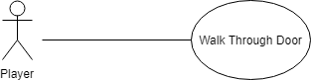

**Sequence Diagram**

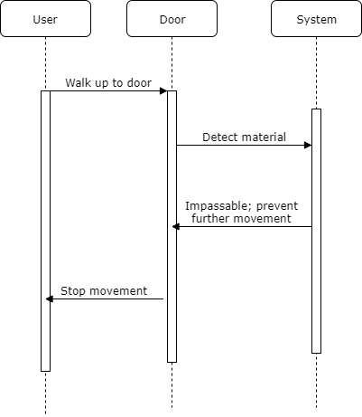

**Class Diagram**

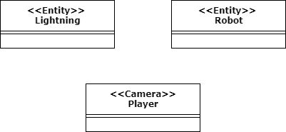

**Unit Test**

* Test case ID: 006
* Description/Summary of Test: Check to see if the robot can pass through the lightning.
* Pre-condition: The robot is running on a player-made sequence.
* Expected Results: The robot will pass through the lighting.
* Actual Result: The robot passed through the lightning.
* Status (Fail/Pass): Pass
* Test case ID: 007
* Description/Summary of Test: Check to see if the player cannot pass through the lightning.
* Pre-condition: The user is moving towards the lightning door.
* Expected Results: The user will not be able to go through the lightning.
* Actual Result: The user passes through the lightning.
* Status (Fail/Pass): Fail

**Visual User Guide**

