*Florida International University*

*School of Computing and Information Sciences*

Software Engineering Focus

Feature Document

User Story ID #674 Binary Conversion Activity

**Name:** Hamilton Chevez

**Team Member(s):** Lukas Borges, Filip Klepsa, Nicolette Celli, Francisco Lozada, Cristian Cabrera, Kevin Delamo

**Project:** AR-VR-VE for Computer Science 1.0

**Product Owner(s)**: Francisco Ortega

**Mentor(s)**: Francisco Ortega

**Instructor**: Masoud Sadjadi

**User Story Name:**

* Description: As a user I would like to practice converting binary values to decimal by playing a quiz game in augmented reality.

Acceptance Criteria

* The user can view multiple answers.
* The user is notified if the answer is correct or wrong.

**Use Case**

* Name: Binary Conversion Quiz
* Actor: Student
* Preconditions: The student is aiming the device’s camera towards the image target.
* Description <Flow of events>:
  + System displays the virtual choice buttons and binary quiz question.
* Student touches the virtual button choice they want.
  + System notifies users if choice was correct or wrong.
  + System proceeds with the next question in the quiz.

**Use Case Diagram**

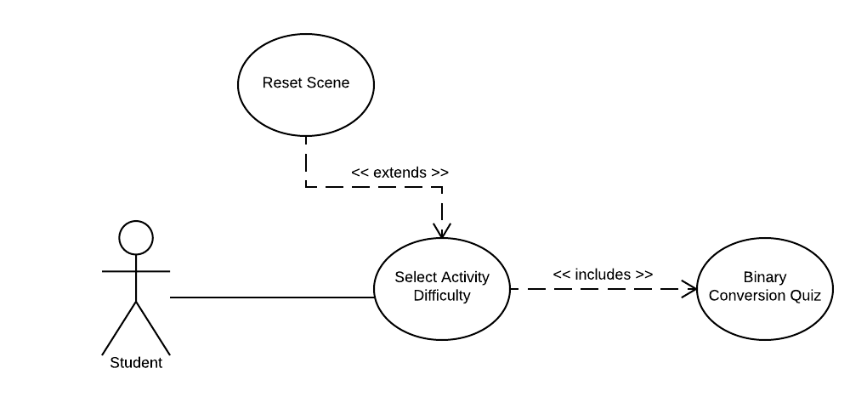

**Sequence Diagram**

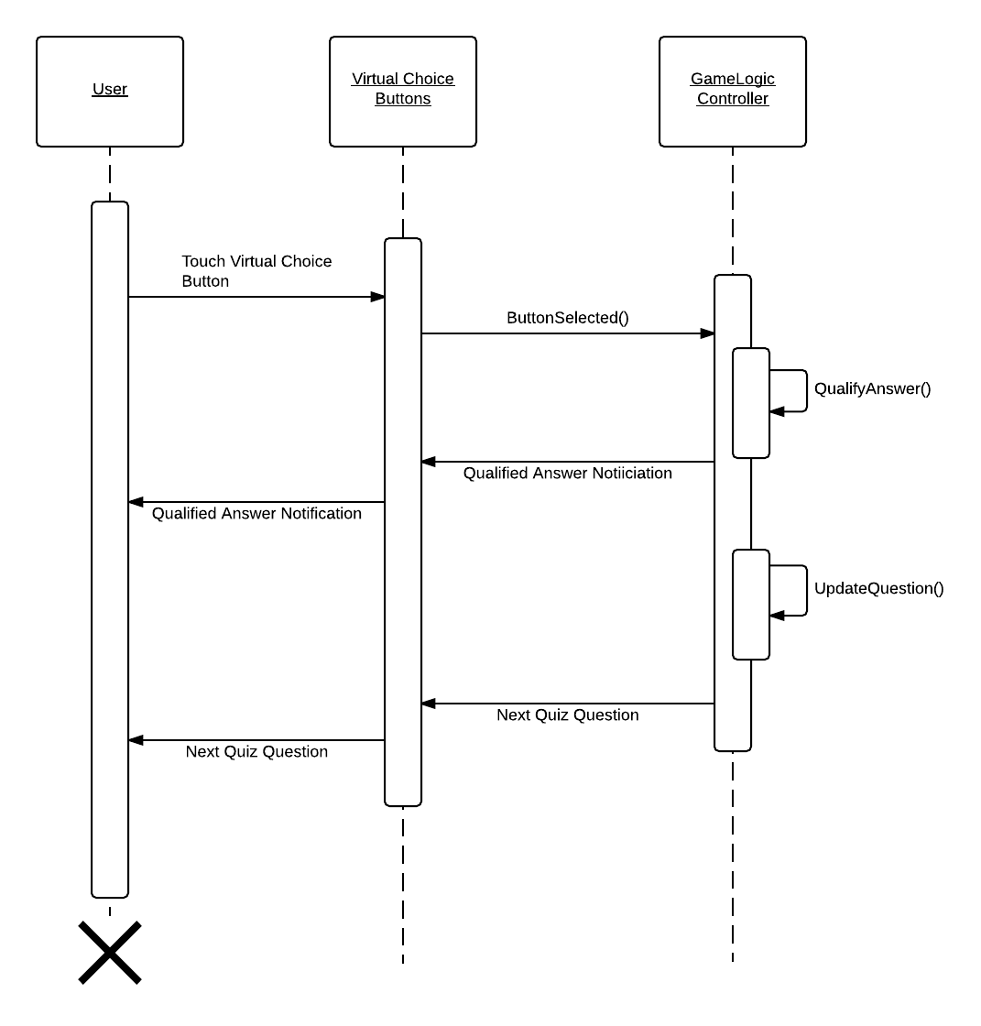

**Class Diagram**

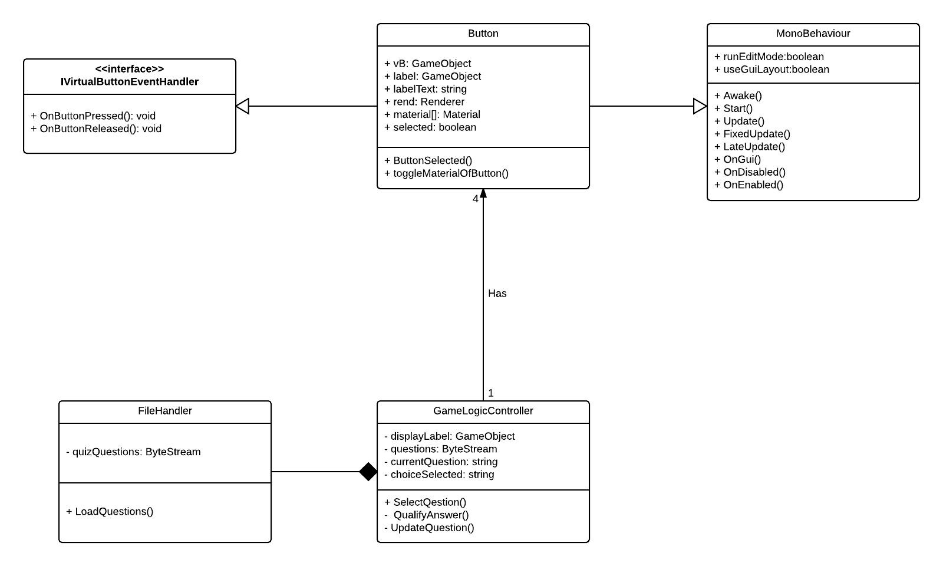

**Unit Test**

|  |  |
| --- | --- |
| Test Case ID: | BAS-14 |
| Description/Summary of Test | QualifyAnswer() returns false when the User picks the incorrect answer. |
| Pre-Condition | The correct answer for the current question is 49. |
| Expected Results | The user picks the answer 48. |
| Actual Results | QualifyAnswer() returns false. |
| Status(Pass/Fail) | Pass |

**Visual User Guide**

