*Florida International University*

*School of Computing and Information Sciences*

Software Engineering Focus

Feature Document

User Story ID #722 Add a Main Menu

**Name:** Nicolette Celli

**Team Member(s):** Lukas Borges, Cristian Cabrera, Hamilton Chevez, Kevin Delamo, Filip Klepsa, Francisco Lozada

**Project:** AR-VR-VE for Computer Science

**Product Owner(s)**: Francisco Ortega

**Mentor(s)**: Francisco Ortega

**Instructor**: Masoud Sadjadi

**User Story Name: Add a Main Menu**

* Description: As a user, I would like to see a main menu when starting the game, so I can know my options when beginning to play.

Acceptance Criteria

* A scene with three buttons (Play, Controls, Exit) appears when the game is run.

**Use Case**

* Name: Use Main Menu
* Actor: Player
* Preconditions: The main menu is currently loaded.
* Description:
  + The user clicks the PLAY button.
    - The first level is loaded.
  + The user clicks the EXIT button.
    - The application exits.
  + The user clicks the CONTROLS button.
    - An image replaces the menu to display the control scheme.

**Use Case Diagram**

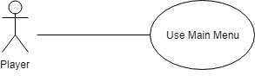

**Sequence Diagram**

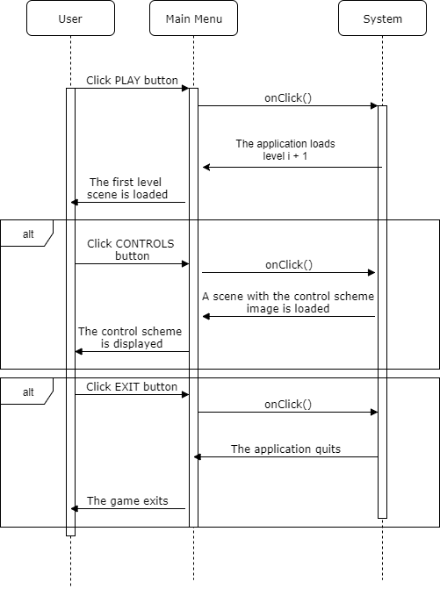

**Class Diagram**

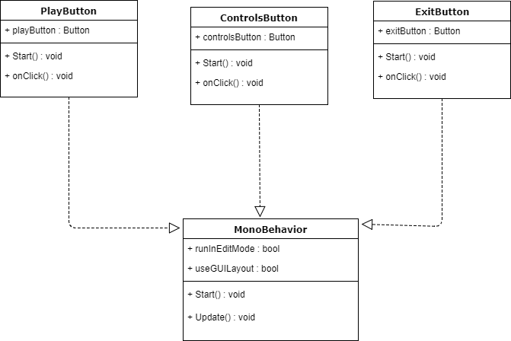

**Unit Test**

* Test case ID: 008
* Description/Summary of Test: Verify that the PLAY button is functioning.
* Pre-condition: The main menu scene is loaded and the user presses the PLAY button.
* Expected Results: The first scene will be loaded.
* Actual Result: The first scene loaded.
* Status (Fail/Pass): Pass
* Test case ID: 009
* Description/Summary of Test: Verify that the EXIT button is functioning.
* Pre-condition: The main menu scene is loaded and the user presses the EXIT button.
* Expected Results: The application will close.
* Actual Result: The application closed.
* Status (Fail/Pass): Pass
* Test case ID: 010
* Description/Summary of Test: Verify that the CONTROLS button is functioning.
* Pre-condition: The main menu scene is loaded and the user presses the CONTROLS

button.

* Expected Results: An image on the control scheme will replace the current menu scene.
* Actual Result: The image of the control scheme is displayed.
* Status (Fail/Pass): Pass

**Visual User Guide**

