*Florida International University*

*School of Computing and Information Sciences*

Software Engineering Focus

Feature Document

User Story ID #681 Difficulty Selection for Binary Activity

**Name:** Hamilton Chevez

**Team Member(s):** Lukas Borges, Filip Klepsa, Nicolette Celli, Francisco Lozada, Cristian Cabrera, Kevin Delamo

**Project:** AR-VR-VE for Computer Science 1.0

**Product Owner(s)**: Francisco Ortega

**Mentor(s)**: Francisco Ortega

**Instructor**: Masoud Sadjadi

**User Story Name:**

* Description: As a user I would like to select different difficulty levels for the Binary Activity so I can challenge myself with more difficult questions.

Acceptance Criteria

* The user can pick between Easy, Medium, and Hard.
* The user can only make one choice.

**Use Case**

* Name: Select Activity Difficulty
* Actor: Student
* Preconditions: The student is aiming the device’s camera towards the target.
* Description <Flow of events>:
  + System displays the virtual buttons and instructions.
* User selects a difficulty by touching a virtual button target.
  + System enables the Okay virtual button.
* User confirms difficulty level by interacting with Virtual Okay Button.
  + System loads Binary Activity scene.

**Use Case Diagram**

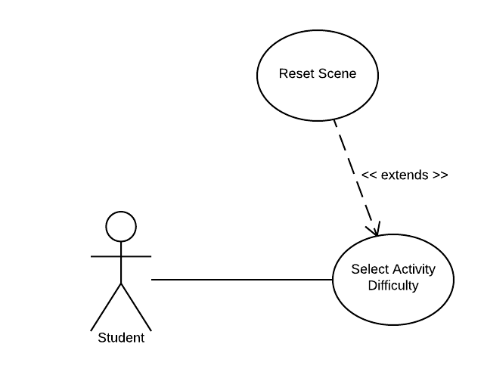

**Sequence Diagram**

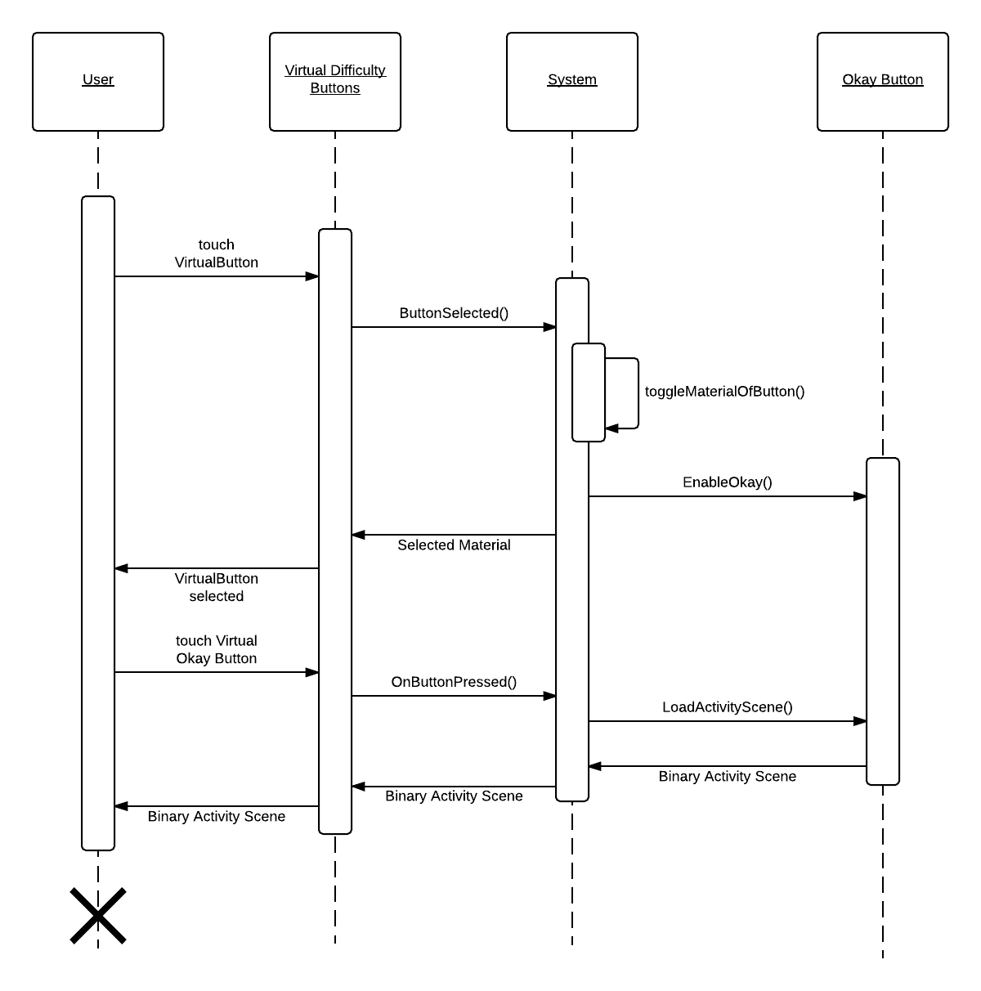

**Class Diagram**

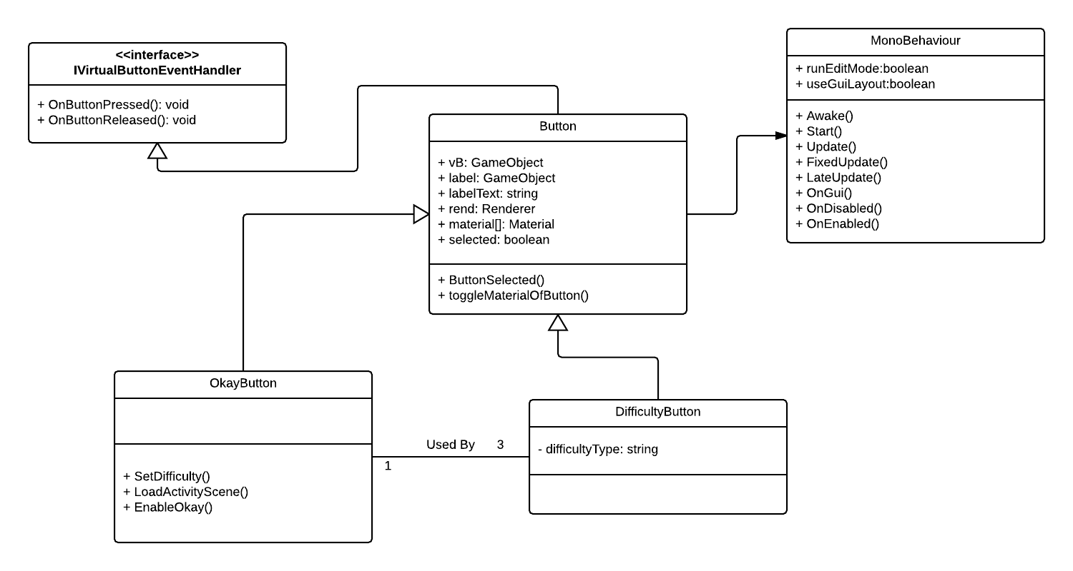

**Unit Test**

|  |  |
| --- | --- |
| Test Case ID | BAS-12 |
| Description/Summary of Test | SetDifficulty() saves the selected difficulty into the PlayerPrefs object. |
| Pre-Condition | PlayerPrefs.SetString(“Difficulty”, “Easy”) is called. |
| Expected Results | When PlayerPrefs.GetString(“Difficulty”) is called it will return “Easy”. |
| Actual Results | “Easy” is returned. |
| Status(Pass/Fail) | Pass |

**Visual User Guide**

