*Florida International University*

*School of Computing and Information Sciences*

Software Engineering Focus

Feature Document

User Story ID #757 Proceed to Next Level

**Name:** Nicolette Celli

**Team Member(s):** Lukas Borges, Cristian Cabrera, Hamilton Chevez, Kevin Delamo, Filip Klepsa, Francisco Lozada

**Project:** AR-VR-VE for Computer Science

**Product Owner(s)**: Francisco Ortega

**Mentor(s)**: Francisco Ortega

**Instructor**: Masoud Sadjadi

**User Story Name: Proceed to Next Level**

* Description: As a user, I would like to pass through a door after I complete the objective, so I can move on to the next level.

Acceptance Criteria

* Touching the exit door with the Vive controller will load the next level.

**Use Case**

* Name: Proceed to Next Level
* Actor: Player
* Preconditions: The player has completed the objective and the lightning door has shut off (allowing the player to walk through it), and the player is standing in front of the exit door.
* Description:
  + The player touches the door with the HTC Vive controller.
    - The next level is loaded.

**Use Case Diagram**

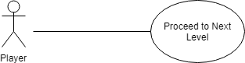

**Sequence Diagram**

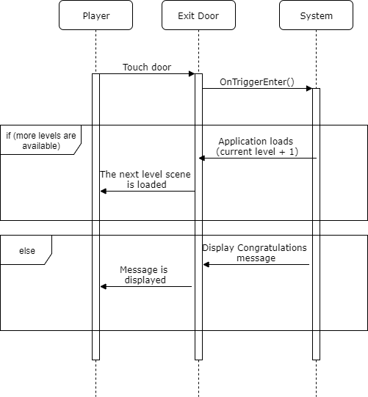

**Class Diagram**

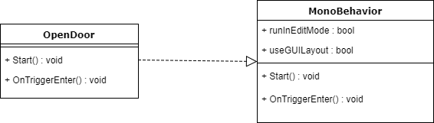

**Unit Test**

* Test case ID: 014
* Description/Summary of Test: Verify that loading the next level functions.
* Pre-condition: The player is standing in front of the exit door and has touched it with the

Vive controller.

* Expected Results: The next level will be loaded.
* Actual Result: The next level was loaded.
* Status (Fail/Pass): Pass

**Visual User Guide**

