*Florida International University*

*School of Computing and Information Sciences*

Software Engineering Focus

Feature Document

User Story ID #750 Conversion Activity Modes: Binary to Hex.

**Name:** Hamilton Chevez

**Team Member(s):** Lukas Borges, Filip Klepsa, Nicolette Celli, Francisco Lozada, Cristian Cabrera, Kevin Delamo

**Project:** AR-VR-VE for Computer Science 1.0

**Product Owner(s)**: Francisco Ortega

**Mentor(s)**: Francisco Ortega

**Instructor**: Masoud Sadjadi

**User Story Name:**

* Description: As a user I would like to be tested on converting binary values to hexadecimal values so I can become better with the hexadecimal number system.

Acceptance Criteria

* The user has the choice to pick from four hexadecimal value responses.

**Use Case**

* Name: Select Answer Mode
* Actor: Student
* Preconditions:
* Extends Difficulty Selection for Binary Activity use case.
* Description <Flow of events>:
  + System displays the virtual buttons and instructions.
* User selects difficulty by touching conversion button.
  + System alternates between Binary to Hexadecimal on touch.

**Use Case Diagram**

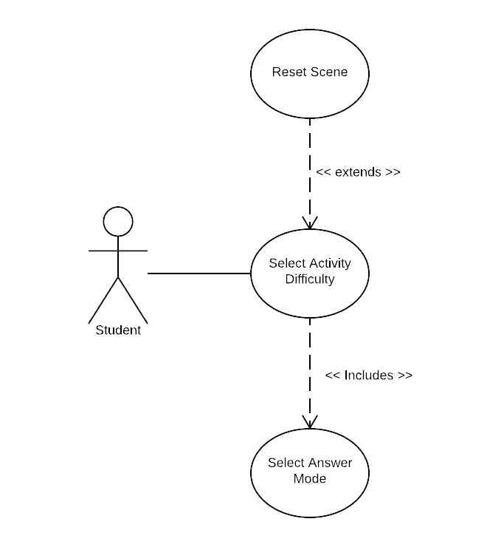

**Sequence Diagram**

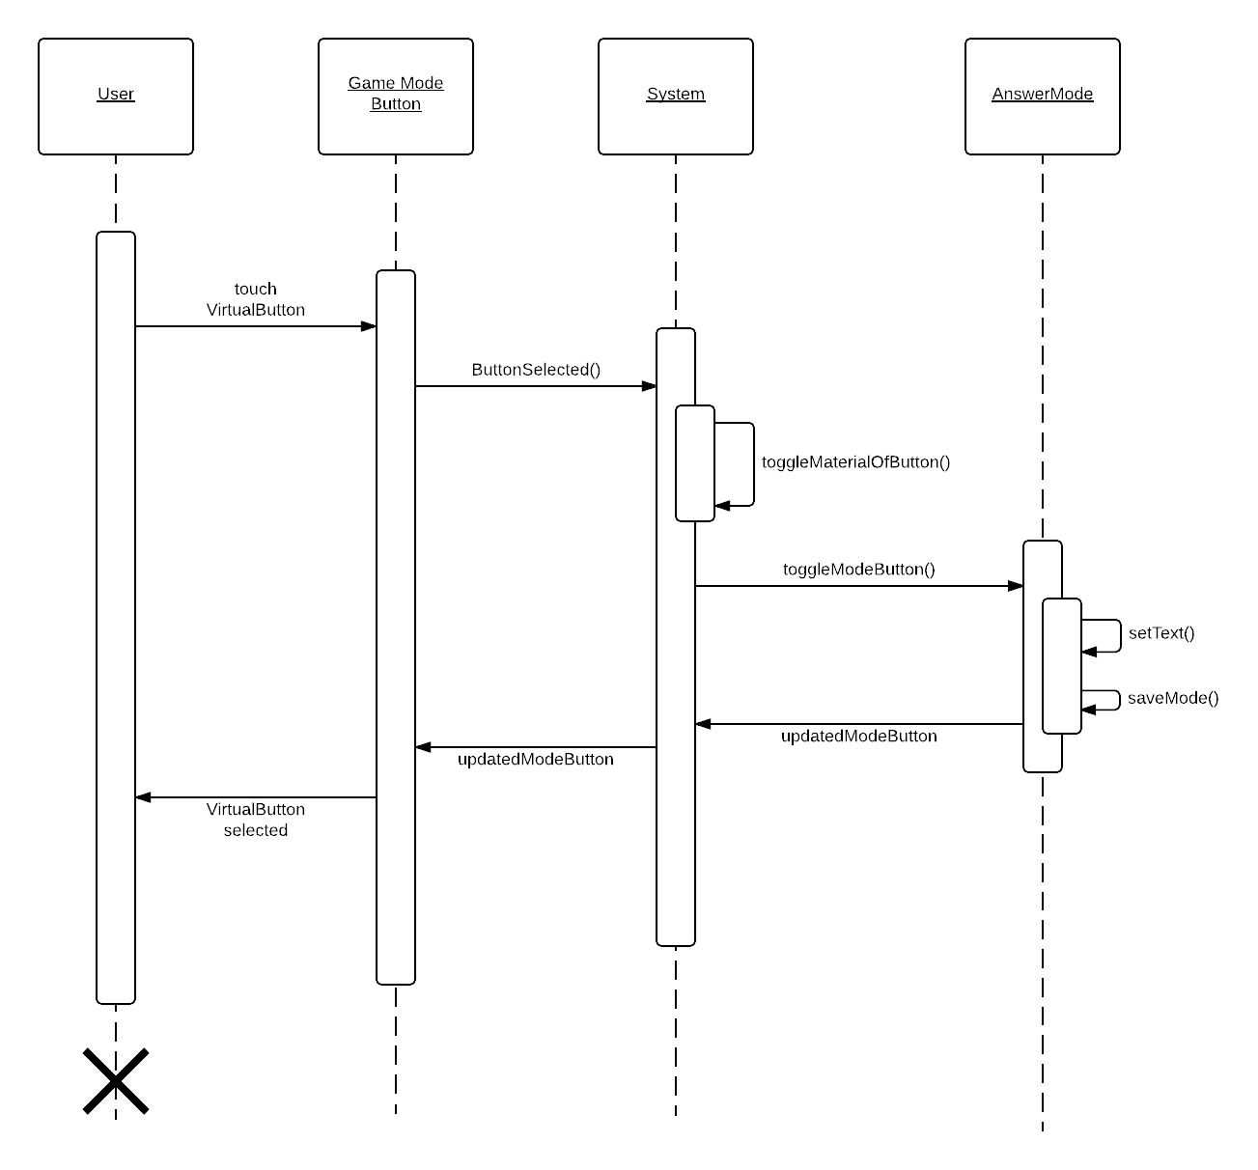

**Class Diagram**

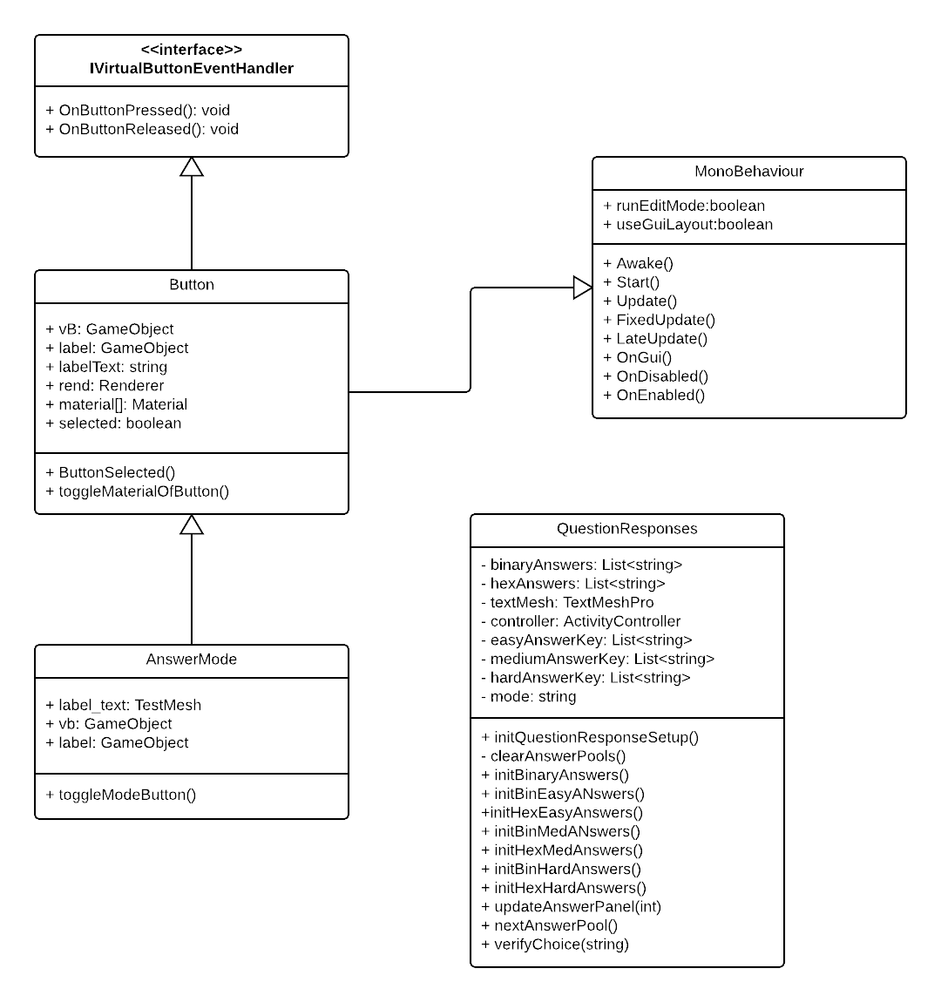

**Unit Test**

|  |  |
| --- | --- |
| Test Case ID | BAS-501 |
| Description/Summary of Test | toggleModeButton() when called, sets the PlayerPrefs “Mode” to Hex. |
| Pre-Condition | Current value for the PlayerPrefs “Mode” key is “Binary” |
| Expected Results | PlayerPrefs.GetString(“Mode”) returns “Hex” |
| Actual Results | The string “Hex” is returned when PlayerPrefs.GetString(“Mode”) is called. |
| Status(Pass/Fail) |  |

**Visual User Guide** <like one or two screenshots of the feature. For the hardware project, a photo of device is required>