*Florida International University*

*School of Computing and Information Sciences*

Software Engineering Focus

Feature Document

User Story ID #754 Add Right Turn Module

**Name:** Nicolette Celli

**Team Member(s):** Lukas Borges, Cristian Cabrera, Hamilton Chevez, Kevin Delamo, Filip Klepsa, Francisco Lozada

**Project:** AR-VR-VE for Computer Science

**Product Owner(s)**: Francisco Ortega

**Mentor(s)**: Francisco Ortega

**Instructor**: Masoud Sadjadi

**User Story Name: Add Right Turn Module**

* Description: As a user, I would like the game to have a right-turn module, so I can direct the robot to turn right.

Acceptance Criteria

* The robot moves to its right when the module is called until it collides with another object.
* The module can be linked to other existing modules

**Use Case**

* Name: Command Robot to Move Right
* Actor: Player
* Preconditions: The player has a right turn module and the robot’s board is open.
* Description:
  + The player places the right turn module on the board.
  + The player presses the “Run” option on their controller menu.
    - The board closes and the robot moves to its right until it collides with another object.

**Use Case Diagram**

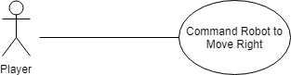

**Sequence Diagram**

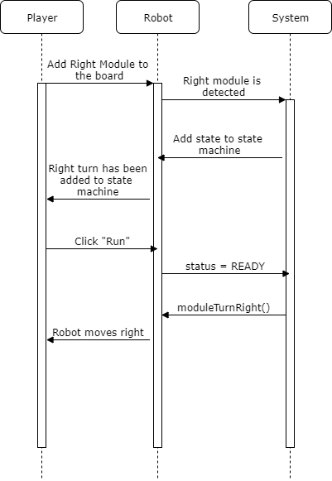

**Class Diagram**

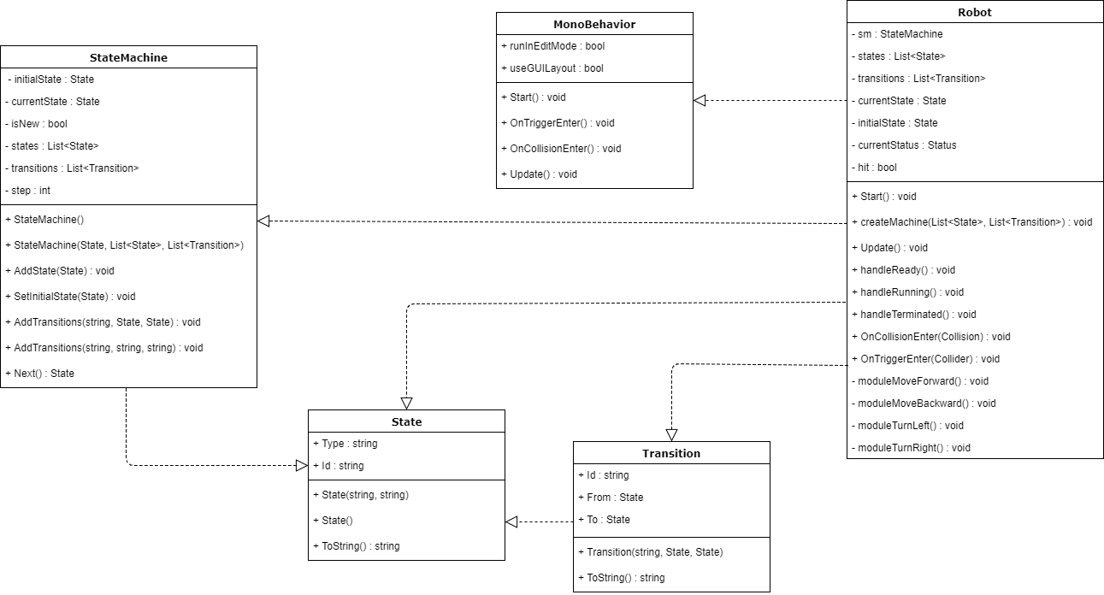

**Unit Test**

* Test case ID: 015
* Description/Summary of Test: Verify that right turn module is functioning.
* Pre-condition: The user has placed the right turn module on the board and pressed the

“Run” button.

* Expected Results: The robot will move to its right until it collides with another object.
* Actual Result: The robot moved to the right until it hit the wall.
* Status (Fail/Pass): Pass

**Visual User Guide**