Florida International University
School of Computing and Information Sciences

CIS 4911 - Senior Capstone Project
Software Engineering Focus

Final Deliverable

Antibiotic Drug Prescription

Team Members:
Sean Iamartino
Alan Nieto

Product Owner(s):
Giri Narasimhan

Mentor(s):
Trevor Cickovski

Instructor:
Masoud Sadjadi

The MIT License (MIT)
Copyright (c) 2016 Florida International University
Permission is hereby granted, free of charge, to any person obtaining a copy of this software and associated documentation files (the "Software"), to deal in the Software without restriction, including without limitation the rights to use, copy, modify, merge, publish, distribute, sublicense, and/or sell copies of the Software, and to permit persons to whom the Software is furnished to do so, subject to the following conditions:
The above copyright notice and this permission notice shall be included in all copies or substantial portions of the Software.
THE SOFTWARE IS PROVIDED "AS IS", WITHOUT WARRANTY OF ANY KIND, EXPRESS OR IMPLIED, INCLUDING BUT NOT LIMITED TO THE WARRANTIES OF MERCHANTABILITY, FITNESS FOR A PARTICULAR PURPOSE AND NONINFRINGEMENT. IN NO EVENT SHALL THE AUTHORS OR COPYRIGHT HOLDERS BE LIABLE FOR ANY CLAIM, DAMAGES OR OTHER LIABILITY, WHETHER IN AN ACTION OF CONTRACT, TORT OR OTHERWISE, ARISING FROM, OUT OF OR IN CONNECTION WITH THE SOFTWARE OR THE USE OR OTHER DEALINGS IN THE SOFTWARE.

Abstract

This document presents the information necessary to gain a good understanding of the Antibiotic Drug Prescription 1 project. The Antibiotic Drug Prescription project is a cross-platform mobile app that helps physicians prescribe antibiotic drugs. In the following pages, user stories, diagrams and information will be presented that will describe the project in detail.

Table of Contents

Introduction ……………………………………………………………………………………………………………………………….. 5
Current System ………………………………………………………………………………………………………………………... 5
Purpose of New System ……………………………………………………………………………………………………………... 5
User Stories
Implemented User Stories ………………………………………………………………………………………………………….. 7
Pending User Stories …………………………………………………………………………………………………………..….. 10
Project Plan
Hardware and Software Resources ………………………………………………………………………………………….… 12
Sprints Plan …………………………………………………………………………………………………………………………. 13
Sprint 1 …………………………………………………………………………………………………………………………... 13
Sprint 2 …………………………………………………………………………………………………………………………... 13
Sprint 3 …………………………………………………………………………………………………………………………... 14
Sprint 4 …………………………………………………………………………………………………………………………... 15
Sprint 5 …………………………………………………………………………………………………………………………... 16
System Design
Architectural Patterns ………………………………………………………………………………………………………….. 20
System and Subsystem Decomposition ……………………………………………………………………………………….… 21
Deployment Diagram ………………………………………………………………………………………………………….…... 22
Design Patterns ……………………………………………………………………………………………………………….….... 22
System Validation ……………………………………………………………………………………………………………………. 23
Glossary …………………………………………………………………………………………………………………………………. 37
Appendix …………………………………………………………………………………………………………………………………. 38
Appendix A - UML Diagrams ……………………………………………………………………………………………………. 38
Static UML Diagrams ………………………………………………………………………………………………………. 38
Dynamic UML Diagrams ………………………………………………………………………………………………….. 40
Appendix B - User Interface Design ……………………………………………………………………………………….…... 52
Appendix C - Sprint Review Reports ……………………………………………………………………………………...…… 69
Appendix D - Sprint Retrospective Reports …………………………………………………………………….…………… 74
References ……………………………………………………………………………………………………………………...………... 80

Introduction
Antibiotic resistance is a major issue confronting healthcare providers and their patients. Changing antibiotic resistance patterns, rising antibiotic costs and the introduction to new antibiotics have made selecting optimal antibiotic regimens more difficult now than ever before.

Current System
The current system allows a doctor to login, view patients, and search for an antibiotic. After the doctor have selected a patient, he can start using the rule engine to prescribe a specific antibiotic. The result of the rule engine depends on the rules and the patient information already stored in a repository.

Purpose of New System
Create a new App to help physicians to prescribe the correct antibiotic to a specific patient. The new system will have a rule engine that will take in as an input a set of rules and facts about the patient to output the proper antibiotic depending on the patient selected. The system should be cross platform (iOS and Android).

User Stories

The following section provides the detailed user stories that were implemented in this iteration of the Antibiotic Drug Prescription project. These user stories served as the basis for the implementation of the project’s features. This section also shows the user stories that are to be considered for future development.

Implemented User Stories

User Story #663 Implement Initial User Interface
- As a Doctor, I would like to see an initial user interface so that I can begin to search for the proper antibiotic
Acceptance Criteria
- Doctor must be logged in
- Initial UI should contain clickable images
- Doctor must be able to select an image
Modeling: Refer to UML diagrams in Appendix A: Figure A.1 (sequence diagram) and A.2 (class diagram)

User Story #666 Implement log in/out
- As a Doctor, I would like to have a login page so that I can log in

Acceptance Criteria
- If user is not logged in, the login screen will be shown
- Login screen has a field for username and password
- Username and password must be authenticated
- User must already be registered in the database
- If the user is logged in there will a button for the user to log out
Modeling: Refer to UML diagrams in Appendix A: Figure A.3 (sequence diagram) and A.4 (class diagram)
User Story #667 Implement Patient Information
- As a Doctor, I would like to see a list of my patients so that I can select a patient and display its information (visits, prescriptions, etc..)
Acceptance Criteria
- Doctor is logged in
- Doctor has a patient
- Patient has information stored in the database
- Patient Information is displayed after selected
Modeling: Refer to UML diagrams in Appendix A: Figure A.5 (sequence diagram) and A.6 (class diagram)

User Story #671 Implement Antibiotic Information
- As a User, I would like to search for an antibiotic so that I can see the antibiotic information.

Acceptance Criteria
- User is logged in
- An antibiotic has been searched for, found, or selected
- Antibiotic information exists
Modeling: Refer to UML diagrams in Appendix A: Figure A.7 (sequence diagram) and A.8 (class diagram)
User Story #672 Implement Search Antibiotic for Pulmonary Infection.
- As a Doctor, I would like to search for an antibiotic for pulmonary infections so that I can find which antibiotic/s is/are available for a specific pulmonary infection.

Acceptance Criteria
- A Doctor can select pulmonary infection
- A Doctor can select a type of pulmonary infection
- A Doctor can search an antibiotic for a specific infection
- The correct antibiotic/s information is/are displayed to the Doctor
- The Doctor can return to home page

Modeling: Refer to UML diagrams in Appendix A: Figure A.9 (sequence diagram) and A.10 (class diagram)

User Story #673 Implement Search Antibiotic for Abdominal Infection.
- As a Doctor, I would like to search for an antibiotic for pulmonary infections so that I can find which antibiotic/s is/are available for a specific abdominal infection.

Acceptance Criteria
- A Doctor can select abdominal infection
- A Doctor can select a type of abdominal infection
- A Doctor can search an antibiotic for a specific infection
- The correct antibiotic/s information is/are displayed to the Doctor
- The Doctor can return to home page

Modeling: Refer to UML diagrams in Appendix A: Figure A.11 (sequence diagram) and A.12 (class diagram)
User Story #701 Improve Android UI/UX
- As a developer, I would like to improve Android user interface and user experience so that I can use the app more easily and quickly.
Acceptance Criteria
- The Android version of the application must look good
- Doctor should be able to easily switch pages
- Doctor can easily understand all the pages on the App
- Doctors should feel attracted to the App (Logic and aesthetic)
- Every page should display information to let the user know current status (Minimum information as possible)
User Story #703 Implement rule engine graceful failures

- As a user, I would like the rule engine to provide relevant information as to what was missing when it fails to find an antibiotic so that I can know what information is required for it to work.

Acceptance Criteria
- A patient has been selected
- A doctor has searched for an antibiotic
- An antibiotic was not found by the rule engine

Modeling: Refer to UML diagrams in Appendix A: Figure A.13 (sequence diagram) and A.14 (class diagram)
User Story #712 Implement iOS version

- As a user, I would like an improved iOS so that I can use the App with the same functionalities as the Android.

Acceptance Criteria
- Doctor can use the same features in the iOS as in the android version

User Story #711 Implement knowledge base

- As a user, I would like to prescribe an antibiotic according to the patient’s information so that I can recommend the right antibiotic depending on the chosen patient

Acceptance Criteria
- The inference engine return a different antibiotic for patients with different symptoms
- Inference engine returns at least one antibiotic if found

Modeling: Refer to UML diagrams in Appendix A: Figure A.14 (sequence diagram) and A.15(class diagram)

Pending User Stories

#669 Antibiotic History
- As a Doctor, I would like to see which antibiotics I have recently accessed
#718 Expand Guidebook
- Expand the entire guideline book (all diseases and infections)
#719 Improve iOS UI/UX
- Current UI/UX in the iOS App is poor
#720 Input Missing Information
- Allow Doctor to input missing information of patient
#721 Intelligent Inference Engine
- Return all possible antibiotics, not only the first one found
#722 Electronical Medical Records
- Get data from real patients

Project Plan

This section describes the planning that went into the realization of this project. This project incorporated the agile development techniques and as such required the sprints to be planned. These sprint plannings are detailed in the section. This section also describes the components, both software and hardware, chosen for this project.

Hardware and Software Resources

The following is a list of all hardware and software resources that were used in this project:

Mingle
Mingle was used as a planning and management tool for the various agile development processes

Visual Studio
Integrated development environment (IDE) from Microsoft. It is used to develop computer programs for Microsoft Windows.

Xamarin
Used to create a cross platform mobile App

SQLite
Local and portable database for mobile devices

Android
OS available in Android phones

iOS
OS available in iOS phones

Git
Repository hosting service,provides access control and several collaboration features

Sprints Plan

The following is a list of sprint planning of the project:

Sprint 1

Attendees: Alan Nieto, Sean Lamartino, Trevor, Giri
Start time: 11:30 am
End time: 12:35 pm

After discussion, the velocity of the team were estimated to be 48

The product owner chose the following user stories to be done during the next sprint. They are ordered based on their priority.
- As a Doctor, I would like an initial user interface to begin searching for the proper antibiotic
- As a Doctor, I would like to log in/out

The team members indicated their willingness to work on the following user stories.
- Alan Nieto
  - As a Doctor, I would like an initial user interface to begin searching for the proper antibiotic
- Sean Lamartino
  - As a Doctor, I would like to log in/out

Sprint 2

Attendees: Alan Nieto, Sean Iamartino, Trevor
Start time: 11:30 am
End time: 12:30 pm

After discussion, the velocity of the team were estimated to be 48

The product owner chose the following user stories to be done during the next sprint. They are ordered based on their priority.
- As a user, I would like to see antibiotic information.
- As a Doctor, I would like to see my patient information(visits, prescriptions, etc..)

The team members indicated their willingness to work on the following user stories.
- Alan Nieto
  - As a Doctor, I would like to see my patient information(visits, prescriptions, etc..)
- Sean Lamartino
  - As a user, I would like to see antibiotic information.

Sprint 3

Attendees: Alan Nieto, Sean Iamartino
Start time: 11:30 am
End time: 12:35 pm

After discussion, the velocity of the team were estimated to be 48

The product owner chose the following user stories to be done during the next sprint. They are ordered based on their priority.
- User Story #672 Antibiotics for Pulmonary Infections
- User Story #673 Antibiotics for Abdominal Infections

The team members indicated their willingness to work on the following user stories.
- Alan Nieto
  - User Story #673 Antibiotics for Abdominal Infections
- Sean Iamartino
  - User Story #672 Antibiotics for Pulmonary Infections

Sprint 4

Attendees: Alan Nieto, Sean Iamartino
Start time: 11:30 am
End time: 12:30 pm

After discussion, the velocity of the team were estimated to be 48

The product owner chose the following user stories to be done during the next sprint. They are ordered based on their priority.
- User Story #701 Improve Android UI/UX
- User Story #703 Implement rule engine graceful failures

The team members indicated their willingness to work on the following user stories.
- Alan Nieto
  - User Story #701 Improve UI/UX
- Sean Iamartino
  - User Story #703 Implement rule engine graceful failures

Sprint 5

Attendees: Alan Nieto, Sean Iamartino, Giri, Trevor
Start time: 11:30 am
End time: 12:30 pm

After discussion, the velocity of the team were estimated to be 48

The product owner chose the following user stories to be done during the next sprint. They are ordered based on their priority.
- User Story #711 Knowledge Base
- User Story #712 Improve iOS UI/UX
- User Story #717 Improve UI/UX Android further

The team members indicated their willingness to work on the following user stories.
- Alan Nieto
  - User Story #711 Knowledge Base
  - User Story #712 Improve iOS UI/UX
- Sean Iamartino
  - User Story #717 Improve UI/UX Android further

System Design

This section contains information on the design decisions that went into this project. The architecture patterns are outlined and explained. The entire system is shown in a package diagram and the subsystems are explained. Finally, the design patterns used in the project are discussed.

Architectural Patterns

This project uses a cross-platform 3-tier architecture. The presentation layer was split between the three devices while the business, and data layer was together as part of a shared codebase. The following diagram illustrates this cross-platform architecture.
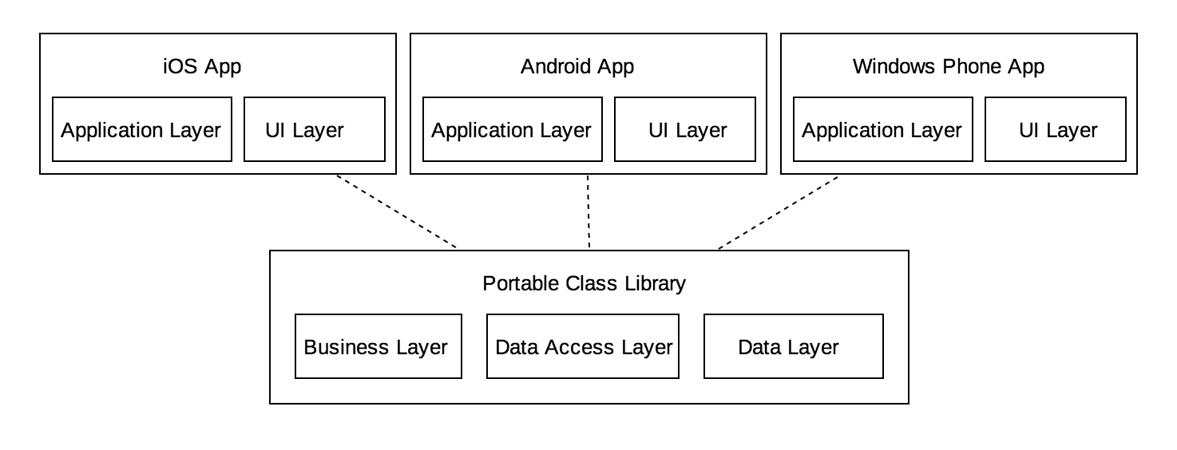

Deployment Diagram

All the component are in the same device because the database is local. The project contain a SQLite file which allow to create a local repository in any OS.

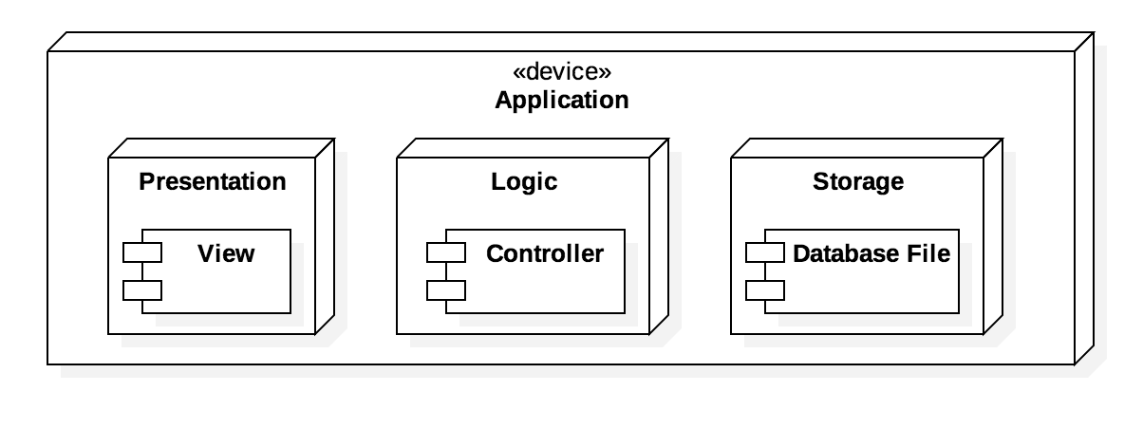

System Validation

In this section, all of the test cases that were down to validate our system are outlined. All of the testing was done manually, following the input requirements of test cases.

Unit Testing
Test ID: U666-TC001
Purpose: A valid create user request to the database will return true
Preconditions:
- A Doctor object is created with:
  - Username is not already in use
  - Password and name are not null
Input:
- Username: “Sean”
- Password: “12345”
Expected Result:
- True

Test ID: U666-TC001
Purpose: A valid create user request to the database will return true
Preconditions:
- A Doctor object with the Username “Sean” does not exist on the database
- Password and name are not null
Input:
- Username: “Sean”
- Password: “12345”
Expected Result:
- True

Test ID: U666-TC002
Purpose: An invalid create user request will return false
Preconditions:
- A Doctor exists in the database
  - Username: “Sean”
  - Password: “12345”
Input:
- Username: “Sean”
- Password: “12345”
Expected Result:
- False

Test ID: U666-TC003
Purpose: An attempt to create a user with null username or password will return false
Preconditions:
- A doctor is created with a null username or password
Input:
- Username: null
- Password: null
Expected Result:
- False

Test ID: U666-TC004
Purpose: A authentication request with valid credentials should return true
Preconditions:
- A user exists in the database
  - Username: “testuser123”
  - Password: “987”
Input:
- Username: “testuser123”
- Password: “987”
Expected Result:
- True

Test ID: U666-TC005
Purpose: An authentication request with valid credentials will return true
Preconditions:
- A user exists in the database.
  - Username: “testuser123”
  - Password: “987”
Input:
- username: “testuser123”
- password: “985”
Expected Result:
- True

Test ID: U666-TC006
Purpose: An authentication request with invalid credentials will return false
Preconditions:
- A user does not exists in the database.
Input:
- username: “testuser123”
- password: “985”
Expected Result:
- False

Test ID: U667-TC001
Purpose: Patient can be added to the database
Preconditions:
- A patient object is created with name "Sergio" and DoB "Jul"
- createPatient() is called
Input:
- Name: “Sergio”
- DoB: “Jul”
Expected Result: True

Test ID: U667-TC002
Purpose: Null Patients can not be added to the database
Preconditions:
- A Patient object is created with a null name
- createPatient() is called
Input:
- Name: null
Expected Result: False

Test ID: U667-TC003
Purpose: A list of Patients that exists in the database can be retrieved
Preconditions:
- A Patient exists in the database
- displayPatient() is called
Input:
- Name: “Sergio”
Expected Result: A list of Patients name is returned

Test ID: U667-TC004
Purpose: A list of Patients that does not exists in the database can not be retrieved
Preconditions:
- A list of petients does not exists in the database
- displayPatients() is called
Input:
- Name: “Romulo”
Expected Result: Empty list is returned

Test ID: U667-TC005
Purpose: A list of Patients that does not exists in the database can not be retrieved
Preconditions:
- A patient with name "Sergio" does not exist
Input:
- Name: “Sergio”
Expected Result: Null

Test ID: U667-TC006
Purpose: A list of Patients that exists in the database can be retrieved
Preconditions:
- A patient with id = 1, name = "Sergio" and DoB = "Jul" does exist
- A Doctor with username = “Alan” and Password = “12345” does exist
- A DoctorPatient with Doctor = “Alan” and patient_id = 1 does exist
Input:
- Name: “Sergio”
Expected Result: A list of patient with an Object with the name = “Sergio” and DoB = “Jul”

Test ID: U671.TC001
Purpose: Antibiotics can be added to the database.
Preconditions:
- An antibiotic with name "TestAB" does not exist in the database
- An antibiotic object is created
- addAntibiotic() is called
Input:
- Antibiotic name: “TestAB”
Expected Result: True

Test ID: U671.TC002
Purpose: Duplicate antibiotics can not be added to the database
Preconditions:
- An antibiotic with name "TestAB" does exist in the database
- An antibiotic object is created with the name "TestAB"
- addAntibiotic() is called
Input:
- Antibiotic name: “TestAB”
Expected Result: False

Test ID: U671.TC003
Purpose: An antibiotic that exists in the database can be retrieved
Preconditions:
- A Antibiotic exists in the database
- getAntibiotic() is called
Input:
- Antibiotic name: “TestAB”
Expected Result: Antibiotic is returned

Test ID: U671.TC004
Purpose: An antibiotic that does not exists in the database can not be retrieved
Preconditions:
- A Antibiotic does not exists in the database
- getAntibiotic() is called
Input:
- Antibiotic name: “TestAB”
Expected Result: null is returned

Test ID: U672-TC001
Purpose: Evaluate condition returns true with a true conditional string
Preconditions:
- Knowledge: weight = 500, alan = true
- Condition: weight > 100 & alan == true
Input:
- evaluateCondition(condition, knowledge)
Expected Result:
- true

Test ID: U672-TC002
Purpose: Evaluate condition returns true with a true conditional string(real application)
Preconditions:
- Knowledge: community acquired = true, severely ill = false, PCN allergy = no
- Condition: community acquired == true & severely ill == false & PCN allergy == no
Input:
- evaluateCondition(condition, knowledge)
Expected Result:
- true

Test ID: U672-TC003
Purpose: Evaluate condition returns false with a false conditional string
Preconditions:
- Knowledge: community acquired = true, severely ill = false, PCN allergy = no
- Condition: community acquired == false & severely ill == false & PCN allergy = no
Input:
- evaluateCondition(condition, knowledge)
Expected Result:
- false

Test ID: U672-TC004
Purpose: Determine antibiotic for a given illness will return an antibiotic
Preconditions:
- Knowledge: community acquired = true, severely ill = false, PCN allergy = no
- Rule: (Biliary tract infection, “community acquired == true & severely ill == false & PCN allergy = no”, “BTIAB”)
- Antibiotic: BTIAB
- Condition: weight > 100 & alan == true
Input:
- detemineAntibiotic(“Biliary tract infection”)
Expected Result:
- “BTIAB”

Test ID: U673-TC001
Purpose: Evaluate condition returns true with a true conditional string
Preconditions:
- Knowledge: weight = 500, alan = true
- Condition: weight > 100 & alan == true
Input:
- evaluateCondition(condition, knowledge)
Expected Result:
- true

Test ID: U673-TC002
Purpose: Evaluate condition returns true with a true conditional string(real application)
Preconditions:
- Knowledge: community acquired = true, severely ill = false, PCN allergy = no
- Condition: community acquired == true & severely ill == false & PCN allergy == no
Input:
- evaluateCondition(condition, knowledge)
Expected Result:
- true

Test ID: U673-TC003
Purpose: Evaluate condition returns false with a false conditional string
Preconditions:
- Knowledge: community acquired = true, severely ill = false, PCN allergy = no
- Condition: community acquired == false & severely ill == false & PCN allergy = no
Input:
- evaluateCondition(condition, knowledge)
Expected Result:
- false

Test ID: U673-TC004
Purpose: Determine antibiotic for a given illness will return an antibiotic
Preconditions:
- Knowledge: community acquired = true, severely ill = false, PCN allergy = no
- Rule: (Biliary tract infection, “community acquired == true & severely ill == false & PCN allergy = no”, “BTIAB”)
- Antibiotic: BTIAB
- Condition: weight > 100 & alan == true
Input:
- detemineAntibiotic(“Biliary tract infection”)
Expected Result:
- “BTIAB”

Test ID: U672-TC001
Purpose: Determine if get missing returns the missing value
Preconditions:
- Condition: weight > 100 & alan == true
- knowledge : none
Input:
- evaluateCondition(condition,knowledge)
- getMissing()
Expected Result:
- “weight”

Test ID: U672-TC002
Purpose: Make sure getMissing return the missing value if only one condition is missing
Preconditions:
- Knowledge: community acquired = true, severely ill = false
- Condition: community acquired == true & severely ill == false & PCN allergy == no
Input:
- evaluateCondition(condition, knowledge)
- getMissing()
Expected Result:
- “PCN allergy”

Test ID: U672-TC003
Purpose: Evaluate condition returns false with a false conditional string
Preconditions:
- Knowledge: community acquired = true, severely ill = false, PCN allergy = no
- Condition: community acquired == false & severely ill == false & PCN allergy = no
Input:
- evaluateCondition(condition, knowledge)
Expected Result:
- false

Integration Testing

Test ID: IT663.TC001
Purpose: Doctor can select area of infection
Preconditions:
- User is logged in and in the initial page
Input:
- Abs button is pressed
Expected Result:
- Abs button is clicked

Test ID: IT663.TC002
Purpose: Doctor can select area of infection
Preconditions:
- User is logged in and in the initial page
Input:
- Abs button is pressed
Expected Result:
- Lung button is clicked

Test ID: IT666.TC001
Purpose: A user logging in with valid credentials will be logged in
Preconditions:
- User with username “testuser123” exists and password is “987”
Input:
- Username field: :“testuser123”
- Password field: “987”
- Login button pressed
Expected Result:
- User is logged in

Test ID: IT666.TC002
Purpose: A user logging in with invalid credentials will not be logged in
Preconditions:
- User with username “testuser234” does not exist
Input:
- Username field: “testuser234”
- Password field: “987”
- Login button pressed
Expected Result:
- User is not logged in

Test ID: IT666.TC003
Purpose: A user logging in
Preconditions:
- User with username “testuser123” exists but password is “987”
Input:
- Username field “testuser123”
- Password field: “123”
- Login button pressed
Expected Result:
- User is not logged in

Test ID: IT667.TC001
Purpose: Once logged in a user can click on the “Patient List” button and the Patient List view will be shown
Preconditions: User is logged in
Input:
- Click Patient List
Expected Result: Patient List view is displayed

Test ID: IT667.TC002
Purpose: Once logged in and on the Patient List view. A patient can be selected and if a patient with that name exists it will be displayed.
Preconditions:
- User is logged in
- User is viewing the Patient list view
- A patient name is selected in the list
- Selected Patient exists in the database
Input:
- Click Patient List
Expected Result: Patient information is displayed

Test ID: IT671.TC001
Purpose: Once logged in a user can click on the “Search Antibiotic” button and the Antibiotic search view will be shown
Preconditions:
- User is logged in
Input:
- Click search antibiotic
Expected Result: Antibiotic search view is displayed

Test ID: IT671.TC002
Purpose: Once logged in and on the Antibiotic search view. An antibiotic name can be entered and if an antibiotic with that name exists it will be displayed.
Preconditions:
- User is logged in
- User is viewing the Antibiotic search view
- An antibiotic name is entered in the text field
- Search button is clicked
- Searched Antibiotic exists in the database
Input:
- Antibiotic name: “TestAB”
- Click search antibiotic button
Expected Result: Antibiotic information is displayed

Test ID: IT671.TC003
Purpose: Once logged in and on the Antibiotic search view. An antibiotic name can be entered and if an antibiotic with that name does not exist nothing will be displayed.
Preconditions:
- User is logged in
- User is viewing the Antibiotic search view
- An antibiotic name is entered in the text field
- Search button is clicked
- Searched Antibiotic does not exist the the database
Input:
- Antibiotic name: “TestCD”
- Click search antibiotic button
Expected Result: Nothing is displayed

Test ID: IT673-TC001
Purpose: When Doctor selects an infection for an antibiotic, the information of the antibiotics for that infection should be displayed
Preconditions:
- Doctor is currently on Infection page
- Doctor selects “Biliary Track Infection”
- Doctor selects “Community acquired infection AND no severely ill”
- Doctor selects “No PCN allergy”
Input:
- Infection = “Biliary Track Infection”
Expected Result:
- Antibiotic information for Ceftriaxone and Ertapenem

Test ID: IT673-TC002
Purpose: When Doctor selects an infection for an antibiotic, the information of the antibiotics for that infection should be displayed
Preconditions:
- Doctor is currently on Infection page
- Doctor selects “Biliary Track Infection”
- Doctor selects “Community acquired infection AND no severely ill”
- Doctor selects “Severe PCN allergy”
Input:
- Infection = “Biliary Track Infection”
Expected Result:
- Antibiotic information for Severe PCN allergy

Test ID: IT673-TC001
Purpose: When Doctor selects an infection for an antibiotic, the information of the antibiotics for that infection should be displayed
Preconditions:
- Doctor is currently on Infection page
- Doctor selects “Biliary Track Infection”
- Doctor selects “Community acquired infection AND no severely ill”
- Doctor selects “No PCN allergy”
Input:
- Infection = “Biliary Track Infection”
Expected Result:
- Antibiotic information for Ceftriaxone and Ertapenem

Test ID: IT673-TC001
Purpose: When Doctor selects an infection for an antibiotic, the information of the antibiotics for that infection should be displayed
Preconditions:
- Doctor is currently on Infection page
- Doctor selects “Biliary Track Infection”
- Doctor selects “Community acquired infection AND no severely ill”
- Doctor selects “Severe PCN allergy”
Input:
- Infection = “Biliary Track Infection”
Expected Result:
- Antibiotic information for Severe PCN allergy

Glossary

Inference Engine: Artificial intelligence (A.I.). It contains a set of rules and facts from patients

Appendix

Appendix A - UML Diagrams

Static
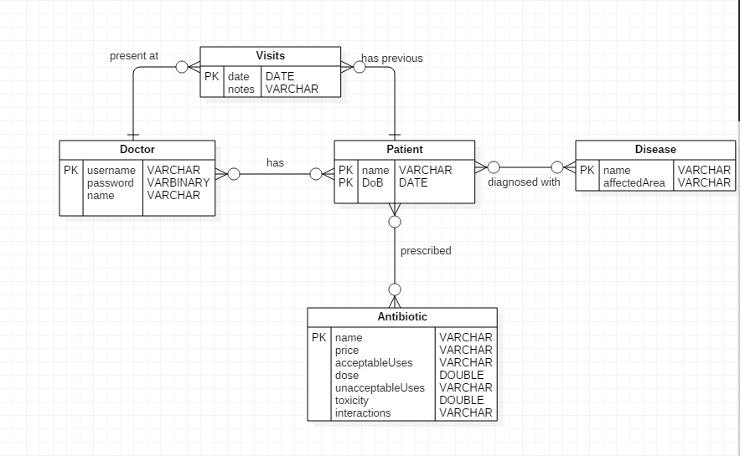
Figure 1.0 ERD

Dynamic

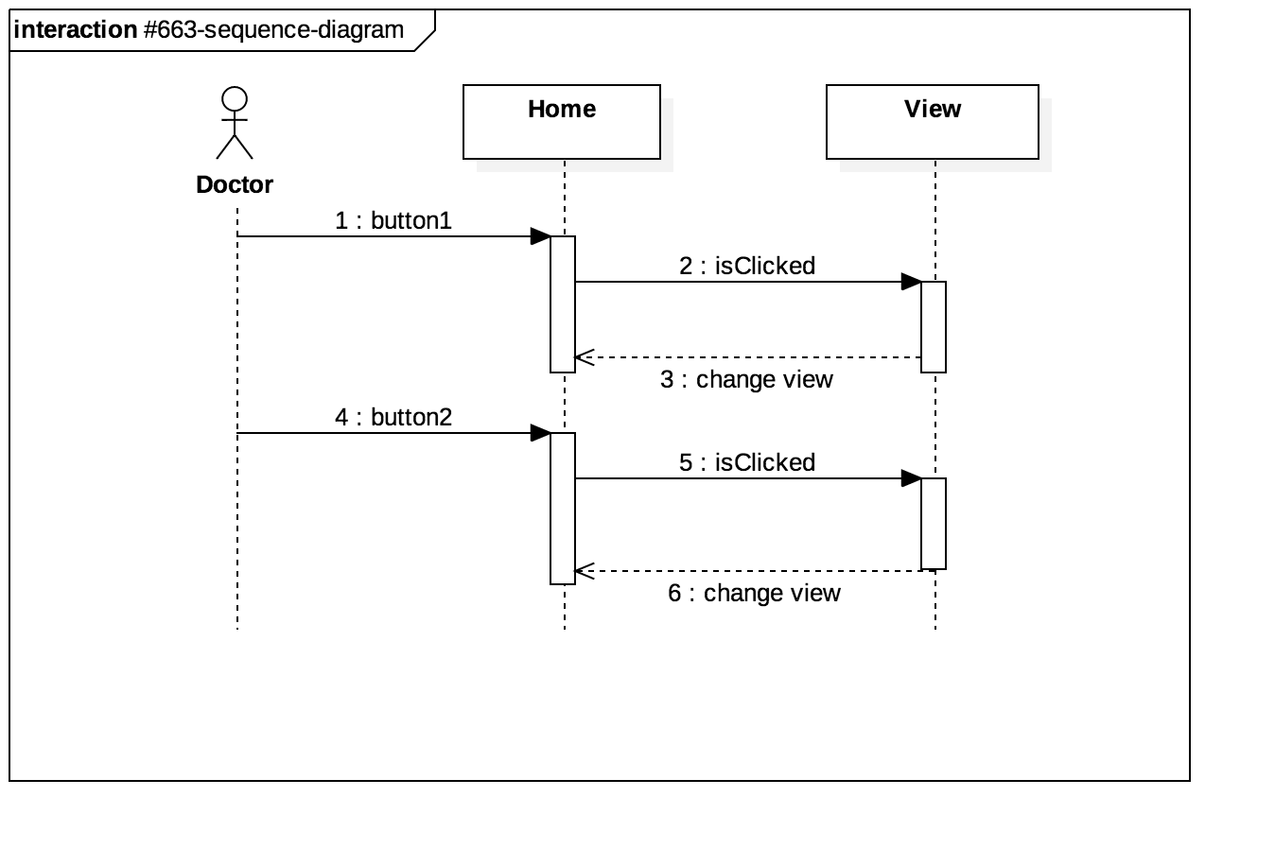
Figure A.1 Sequence Diagram #663
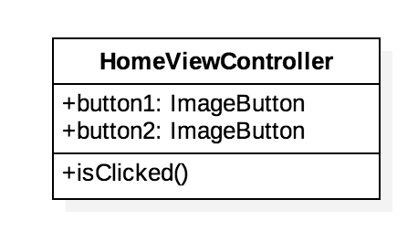
Figure A.2 Class Diagram #663
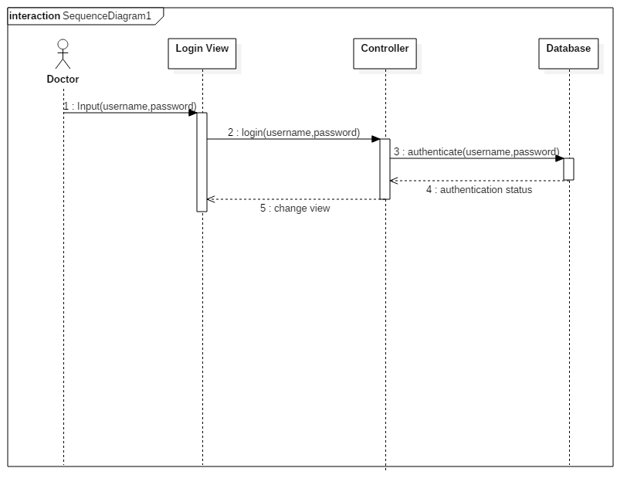
Figure A.3 Sequence Diagram #666
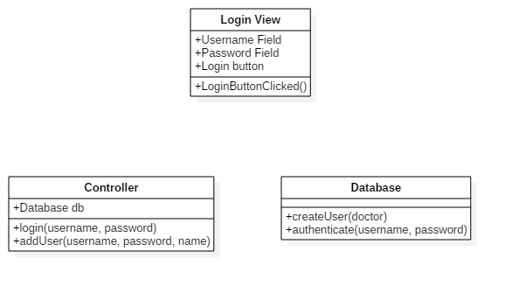
Figure A.4 Class Diagram #666
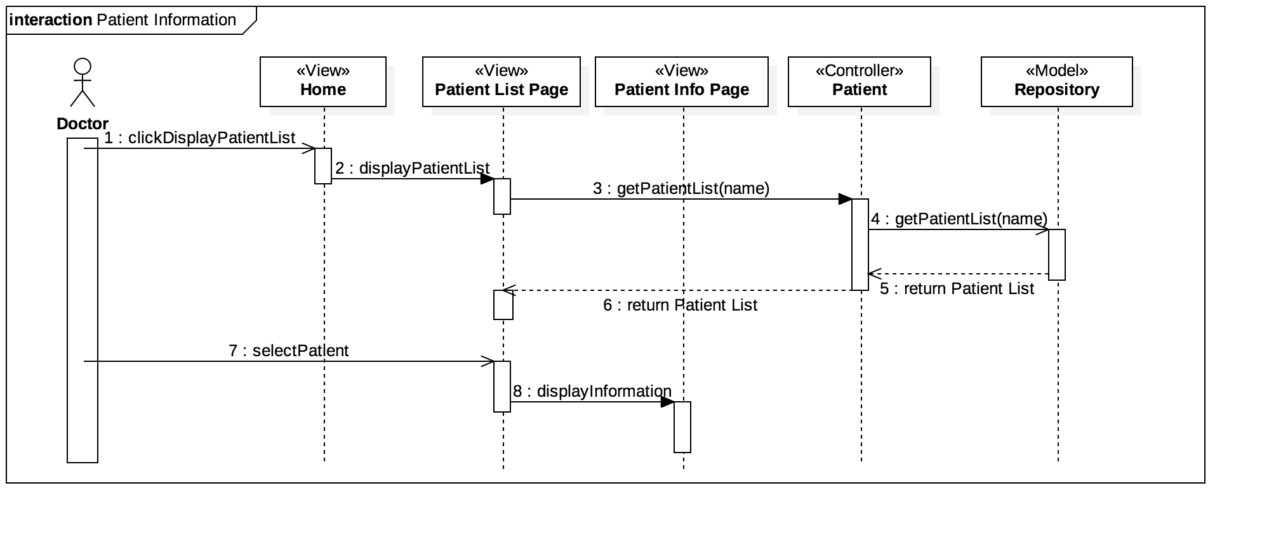
Figure 1.5 Sequence Diagram #667
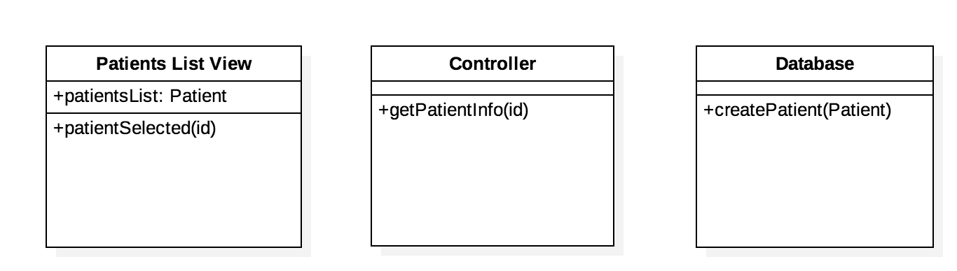
Figure A.6 Class Diagram #667
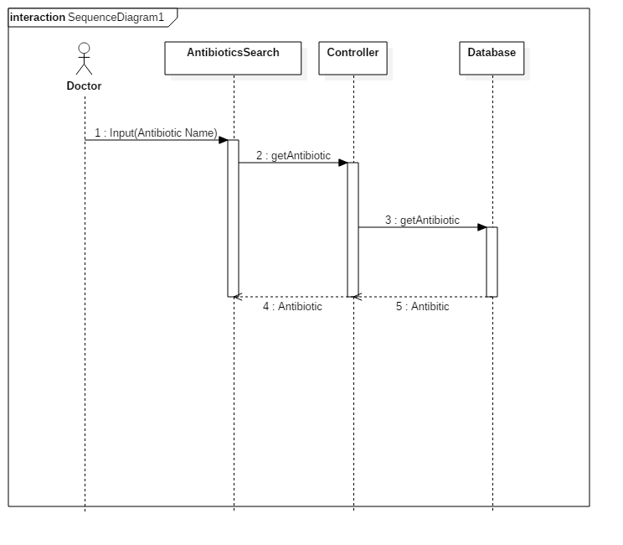
Figure A.7 Sequence Diagram #671
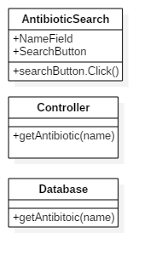
Figure A.8 Sequence Diagram #671
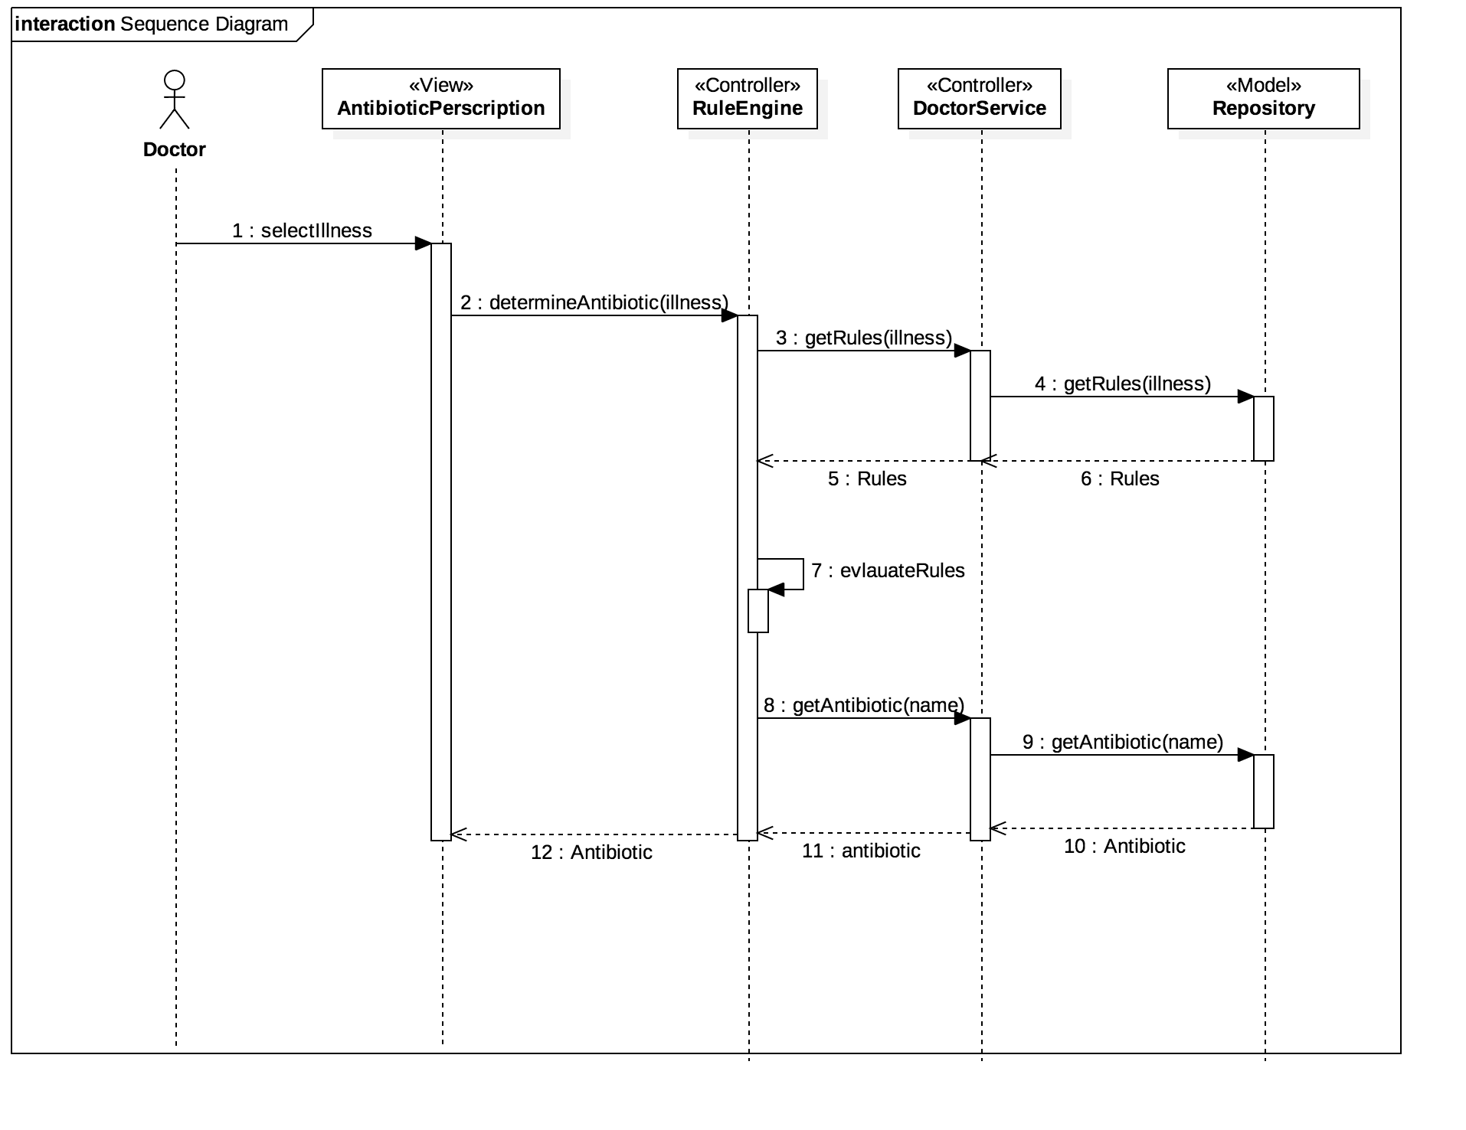
Figure A.9 Sequence Diagram #672
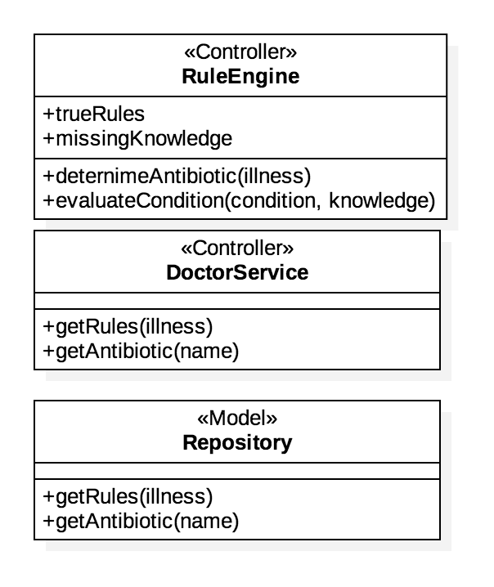

Figure A.10 Class Diagram #672
Figure A.11 Sequence Diagram #673
Figure A.12 Class Diagram #673
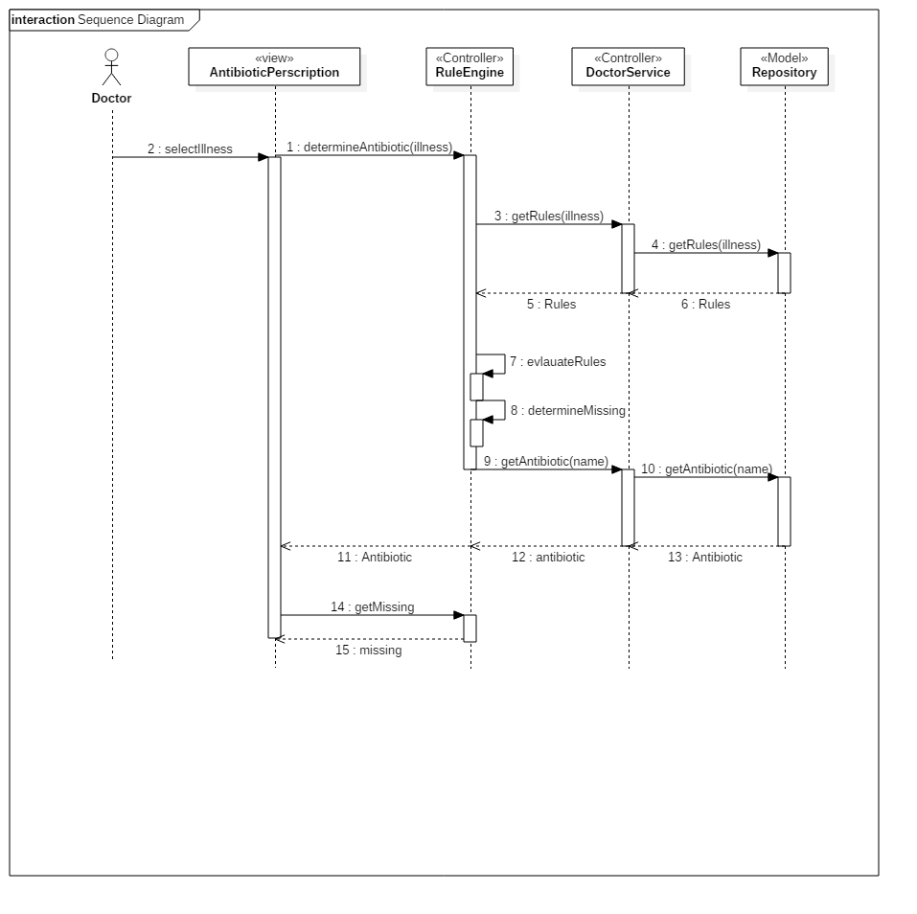
Figure A.13 Sequence Diagram #703
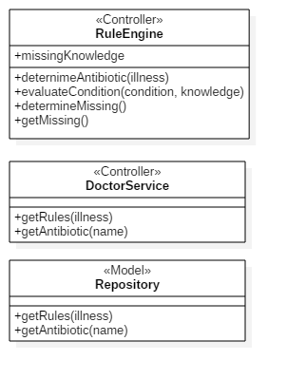
Figure A.14 Class Diagram #703
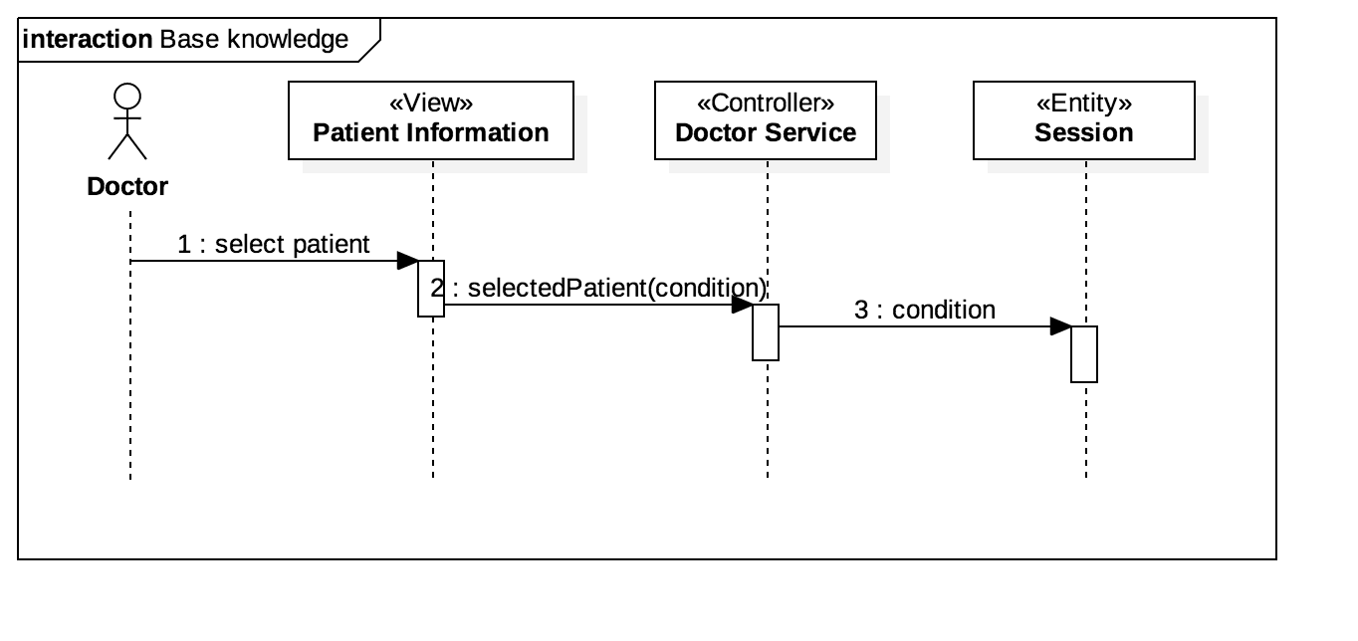
Figure A.15 Sequence Diagram #711
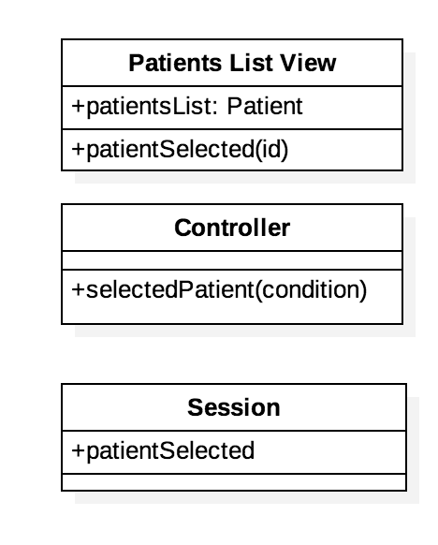
Figure A.16 Sequence Diagram #711

Appendix B - User Interface Design

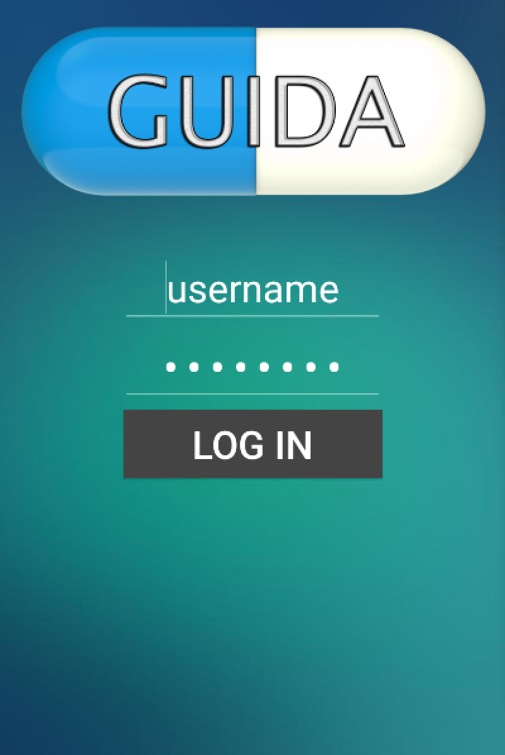
Figure B.1 Android Login Page
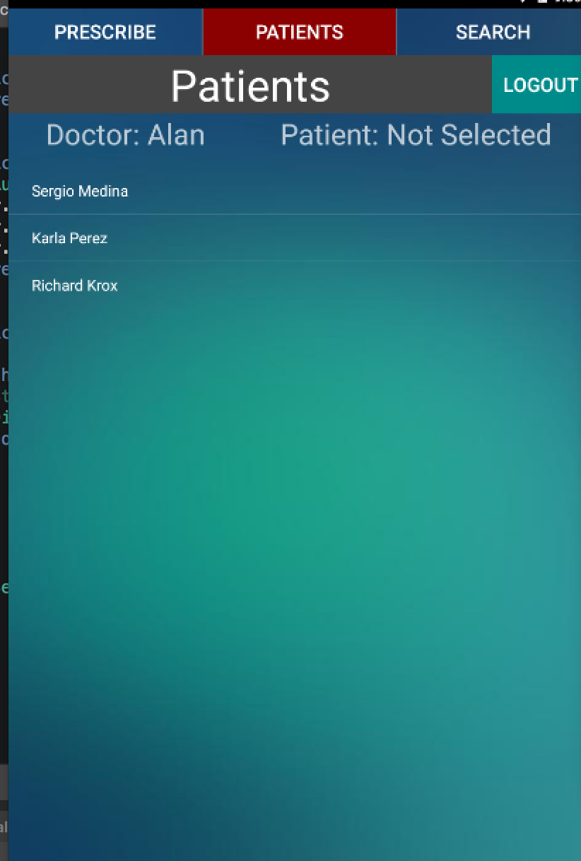
Figure B.2 Android Patient List Page
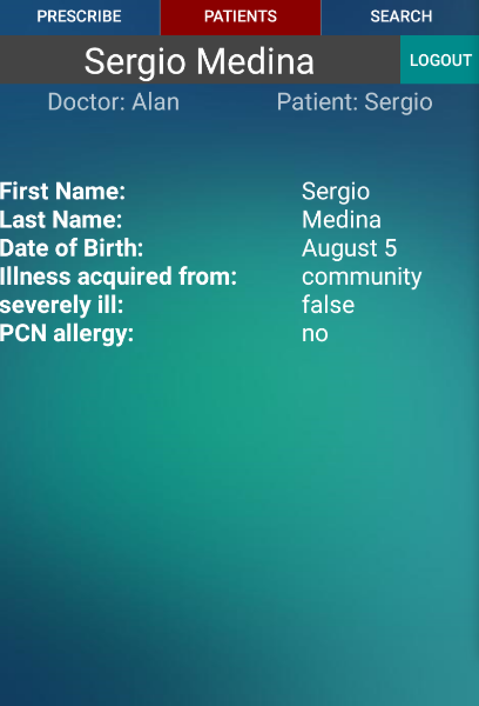
Figure B.3 Android Patient Information Page
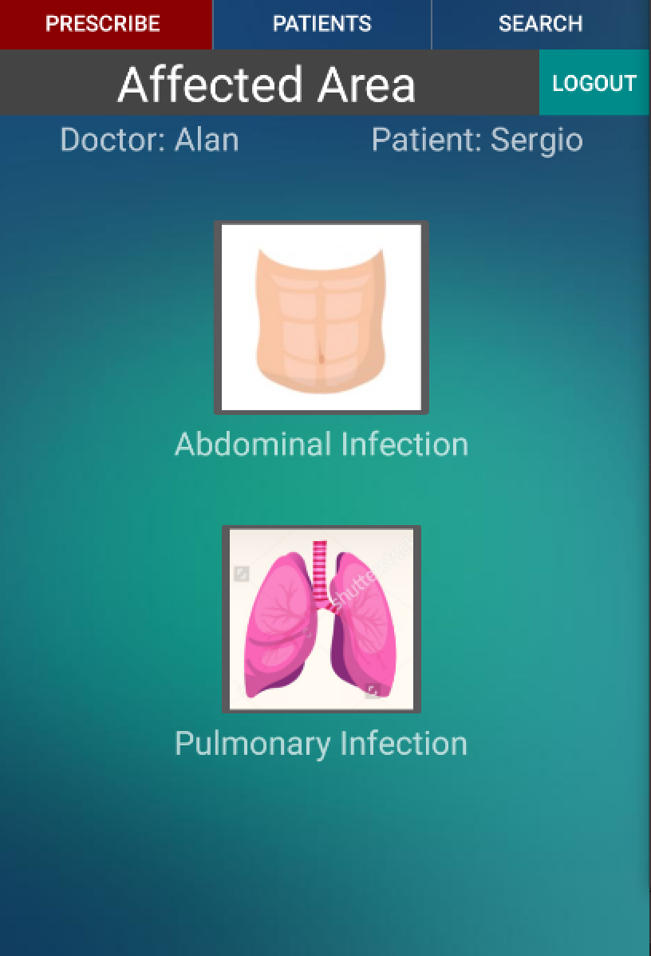
Figure B.4 Android Prescribe Antibiotic Page
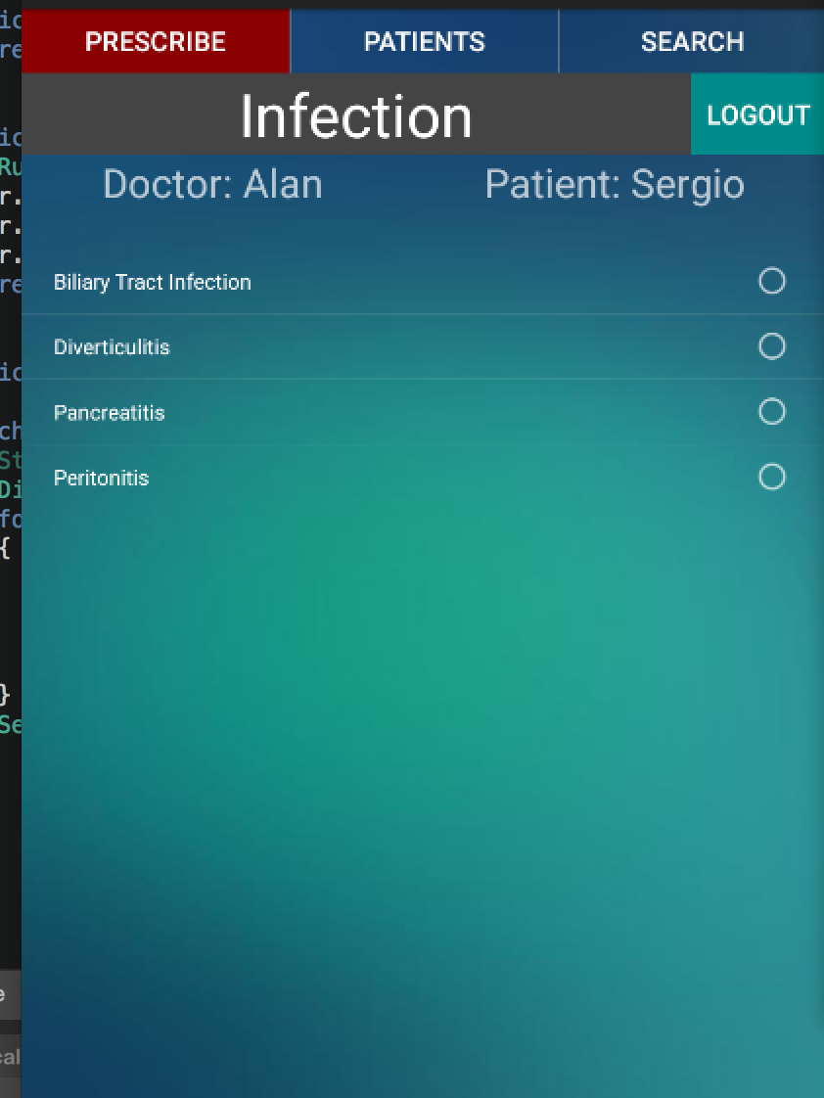
Figure B.5 Android Infection Page
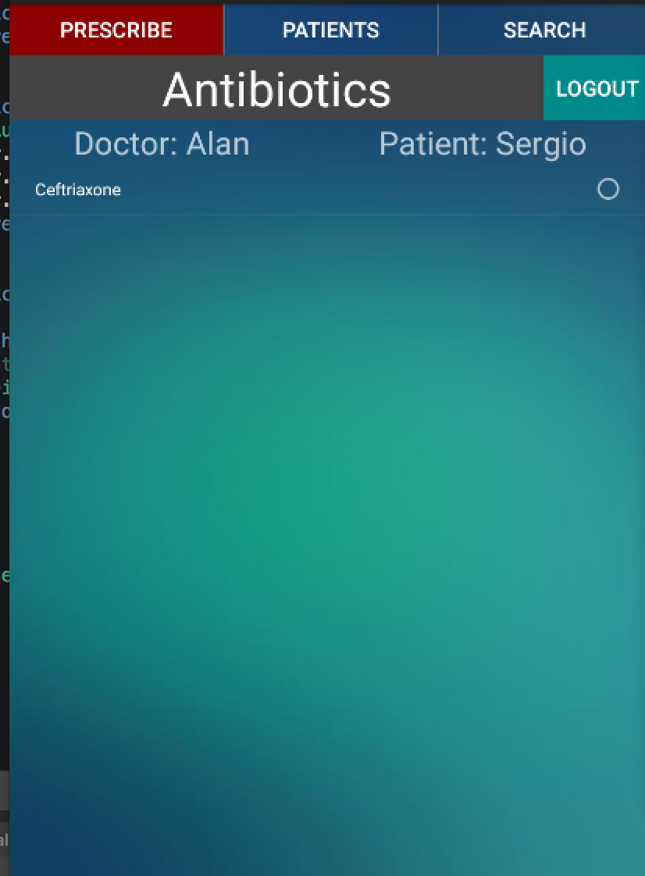
Figure B.6 Android Antibiotic List Page
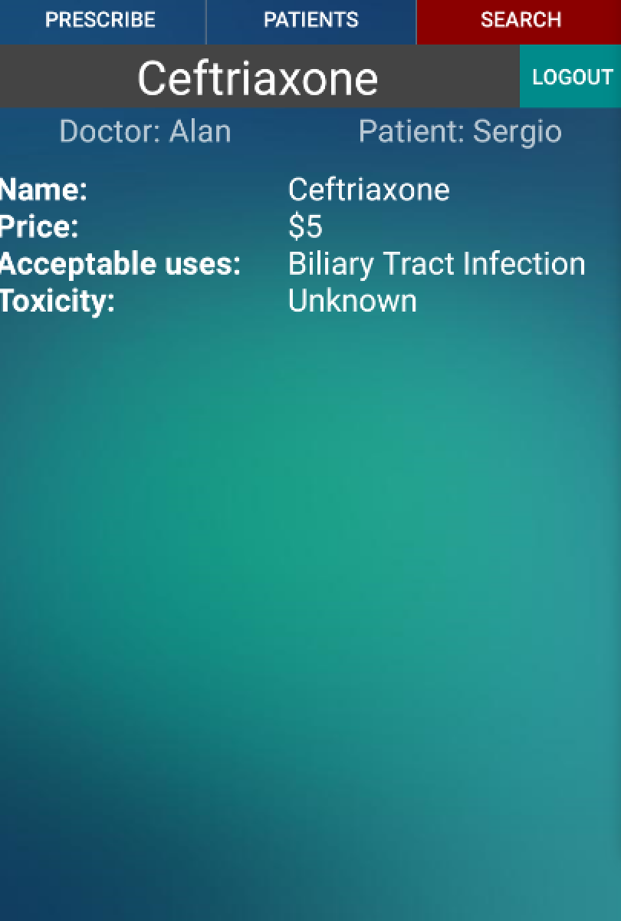
Figure B.7 Android Antibiotic Information Page
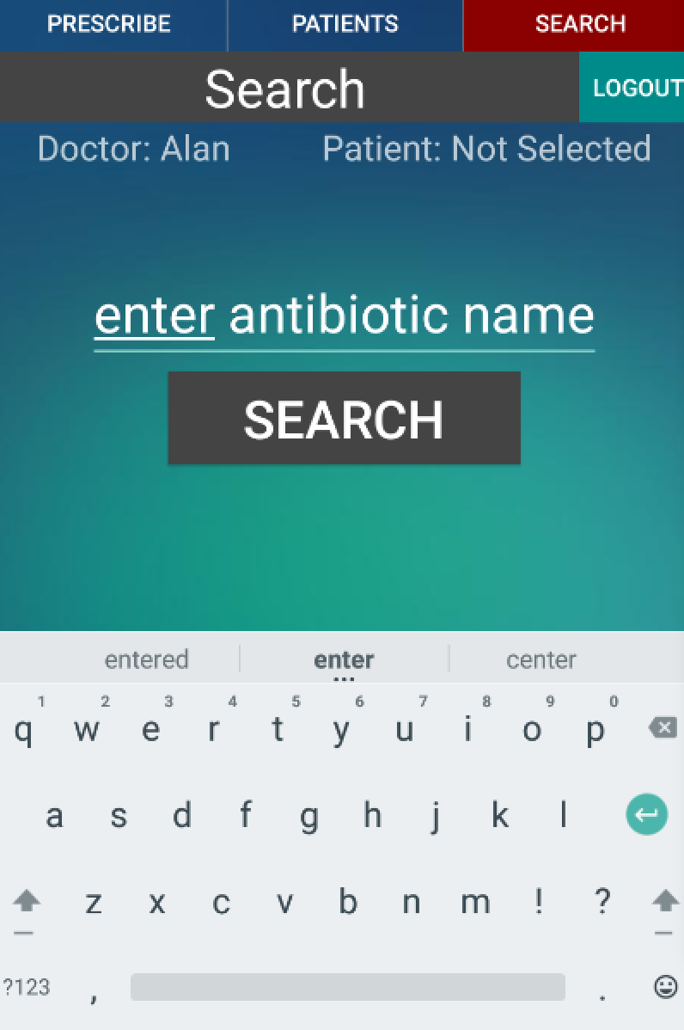
Figure B.8 Android Search Antibiotic Page
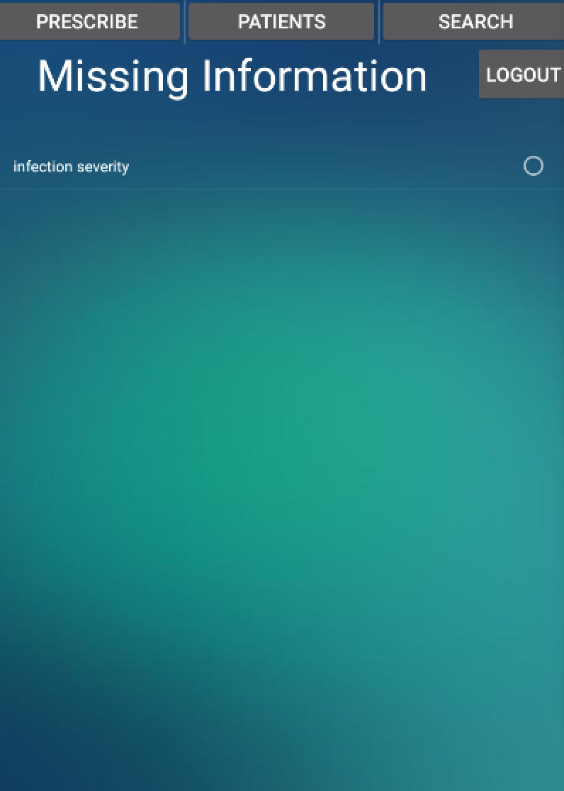
Figure B.9 Android Missing Information Page
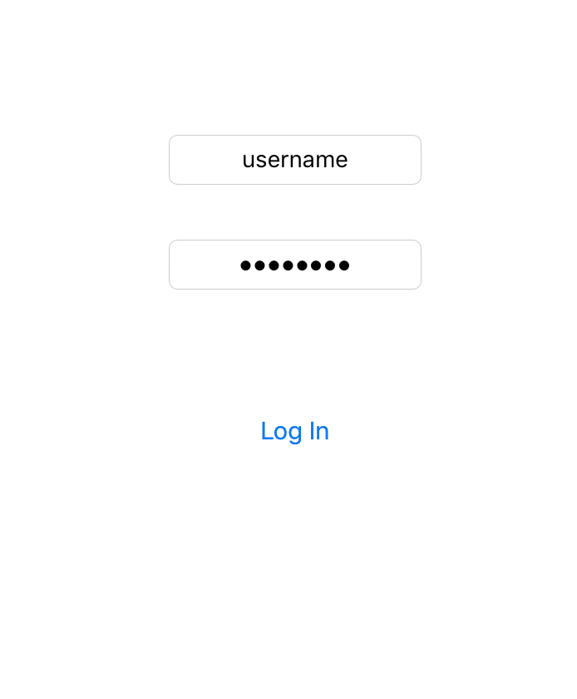
Figure B.10 iOS Login Page

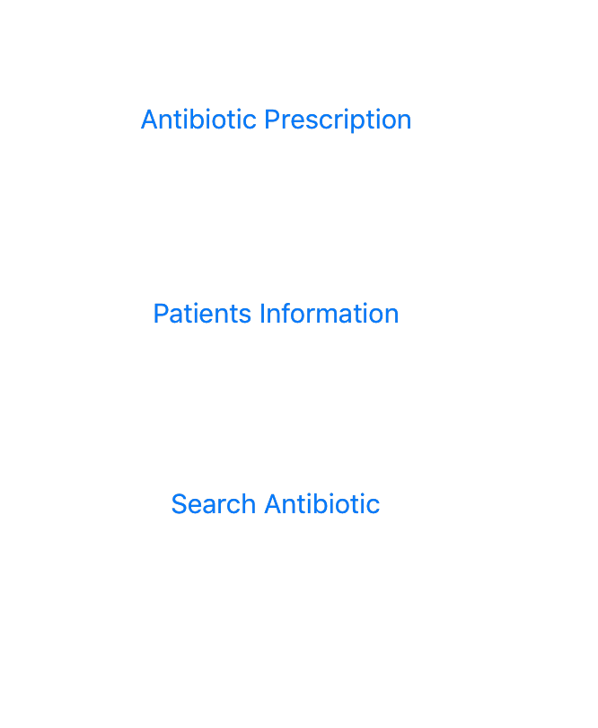
Figure B.11 iOS Menu Page
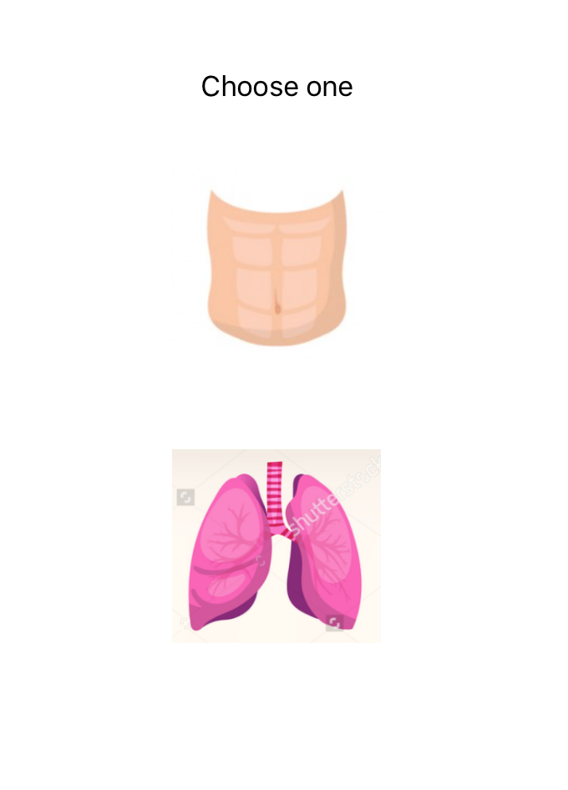
Figure B.12 iOS Antibiotic Prescription Page
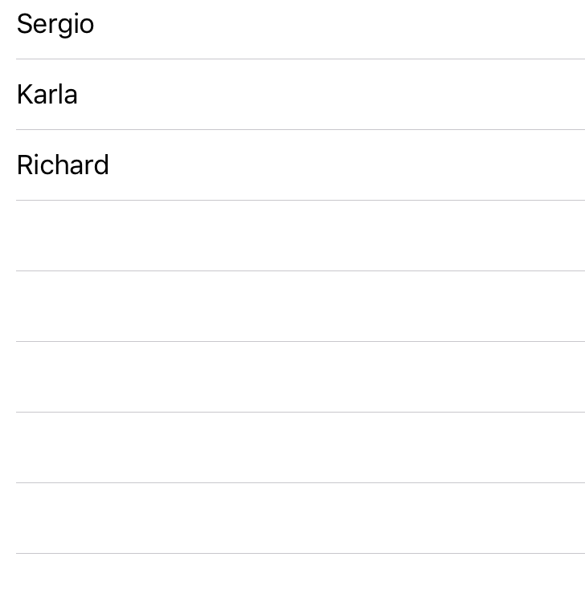
Figure B.13 iOS Patient Lost Page

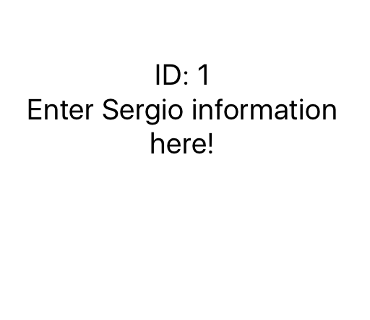
Figure B.14 iOS Patient Information Page
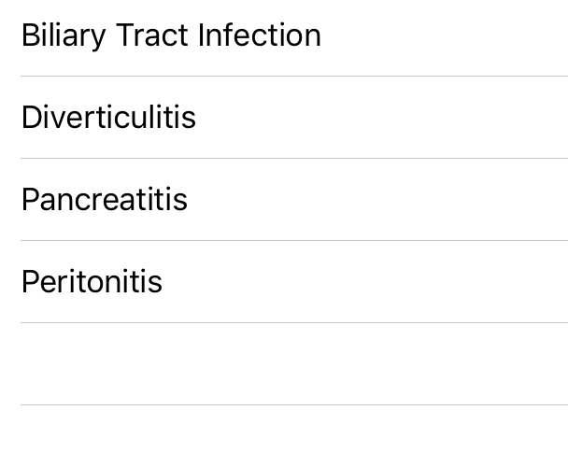
Figure B.15 iOS Antibiotic Infection Page
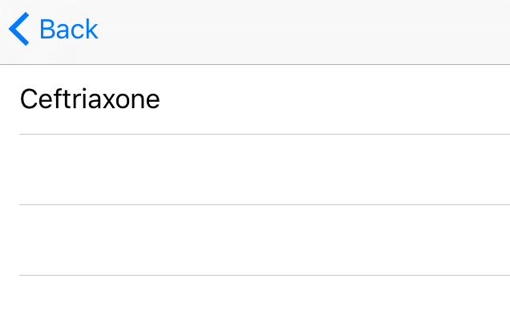
Figure B.16 iOS Antibiotic List Page
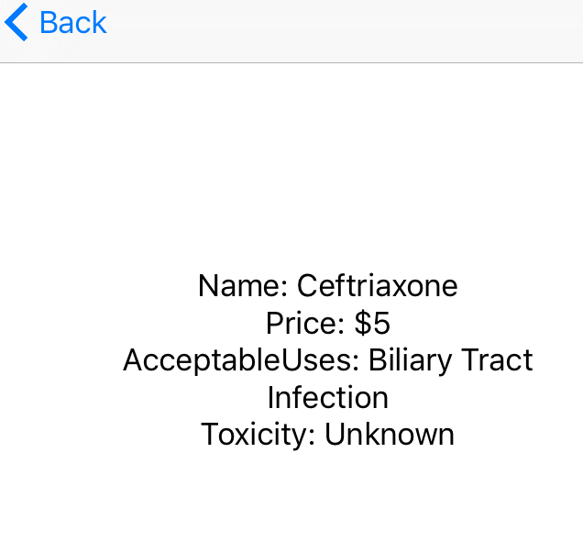
Figure B.17 iOS Antibiotic Information Page
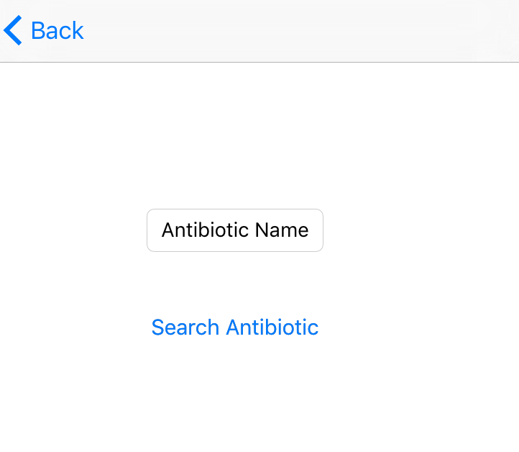
Figure B.18 iOS Search antibiotic page
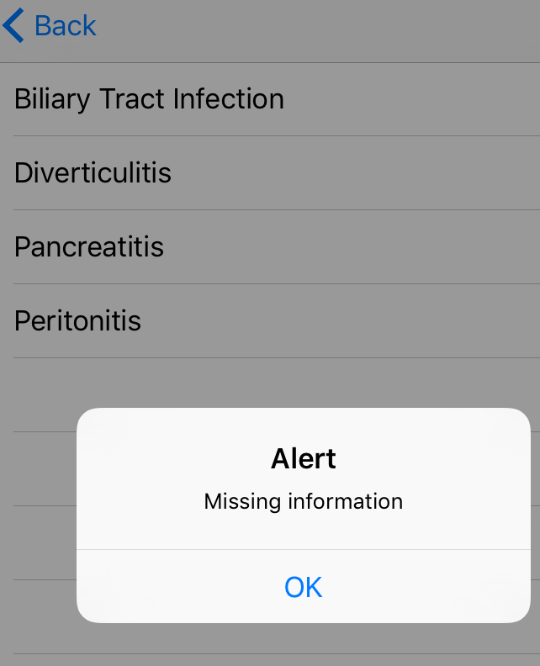
Figure B.19 iOS Missing information on infection page

Appendix C - Sprint Review Reports

Sprint 1

Attendees: Alan Nieto, Sean Iamartino, Trevor
Start time: 11:30 am
End time: 12:30 am

After a show and tell presentation, the implementation of the following user stories were accepted by the product owners: All.
- User Story #663 Initial User Interface
- User Story #666 Log in/out

Sprint 2

Attendees: Alan Nieto, Sean Lamartino
Start time: 11:30 am
End time: 12:30 am

After a show and tell presentation, the implementation of the following user stories were accepted by the product owners: All.
- As a user, I would like to see antibiotic information.
- As a Doctor, I would like to see my patient information(visits, prescriptions, etc..)

Sprint 3

Attendees: Alan Nieto, Sean Lamartino
Start time: 11:30 am
End time: 12:00 pm

After a show and tell presentation, the implementation of the following user stories were accepted by the product owners: All.
- User Story #672 Antibiotics for Pulmonary Infections
- User Story #673 Antibiotics for Abdominal Infections

The following ones were rejected and moved back to the product backlog to be assigned to a future sprint at a future Spring Planning meeting.
- None

Sprint 4

Attendees: Alan Nieto, Sean Iamartino
Start time: 12:00 pm
End time: 12:30 pm

After a show and tell presentation, the implementation of the following user stories were accepted by the product owners: All.
- User Story #701 Improve Android UI/UX
- User Story #703 Implement rule engine graceful failures

Sprint 5

Attendees: Alan Nieto, Sean Lamartino
Start time: 11:30 am
End time: 12:30 am

After a show and tell presentation, the implementation of the following user stories were accepted by the product owners: All.
- User Story #711 Knowledge Base
- User Story #712 Improve iOS UI/UX
- User Story #

Appendix D - Sprint Retrospective Reports

Sprint 1

Attendees: Alan Nieto, Sean Iamartino
Start time: 6:00 pm
End time: 7:00 pm

What went wrong?
- Did we do a good job estimating our team's velocity?
  - Yes
- Did we do a good job estimating the points (time required) for each user story?
  - Yes
- Did each team member work as scheduled?
  - Yes

What went right?
- Finished our user stories

How to address the issues in the next sprint?
- How to improve the process?
  - Keep doing what we are doing
- How to improve the product?
  - Implement more user stories

Sprint 2

Attendees: Alan Nieto
Start time: 11:30 am
End time: 12:30 pm

What went wrong?
- Did we do a good job estimating our team's velocity?
  - Yes
- Did we do a good job estimating the points (time required) for each user story?
  - Yes
- Did each team member work as scheduled?
  - Yes

What went right?
- User stories implemented

How to address the issues in the next sprint?
- How to improve the process?
  - Testing the product earlier to have more time to fix bugs
- How to improve the product?
  - Put all the logic in the backend whenever is possible

Sprint 3

Attendees: Sean Iamartino, Alan Nieto
Start time: 12:00
End time: 12:30

What went wrong?
- Did we do a good job estimating our team's velocity?
  - Yes
- Did we do a good job estimating the points (time required) for each user story?
  - Yes
- Did each team member work as scheduled?
  - Yes

What went right?
- Objectives were met by the required time. Rule engine was implemented.

How to address the issues in the next sprint?
- How to improve the process?
  - Have a better understanding of how to accomplish tasks before the sprint.
- How to improve the product?
  - Visual upgrades, graceful failures.

Sprint 4

Attendees: Alan Nieto, Sean Iamartino
Start time: 11:30 am
End time: 12:00 pm

What went wrong?
- Did we do a good job estimating our team's velocity?
  - Yes
- Did we do a good job estimating the points (time required) for each user story?
  - Yes
- Did each team member work as scheduled?
  - Yes

What went right?
- We made progress

How to address the issues in the next sprint?
- How to improve the process?
  - Add more people
- How to improve the product?
  - Add real data

Sprint 5

Attendees: Alan Nieto, Sean Iamartino
Start time: 11:30 am
End time: 12:30 pm

What went wrong?
- Did we do a good job estimating our team's velocity?
  - Yes
- Did we do a good job estimating the points (time required) for each user story?
  - Yes
- Did each team member work as scheduled?
  - Yes

What went right?
- The first release is finished for iOS and Android

How to address the issues in the next sprint?
- How to improve the product?
  - Have real data of the patients and antibiotic

References

Antibiotic Guidelines: Treatment Recommendations for Adult Inpatients, John Hopkins Medicine

