Florida International University
School of Computing and Information Sciences

CIS 4911 - Senior Capstone Project
Software Engineering Focus

Installation Guide

Team Members:
Sean Iamartino, Alan Nieto
Product Owner(s):
Giri Narasimhan

Mentor(s):
Trevor Cickovski

Instructor:
Masoud Sadjadi

Step 1: Download Visual Studio Community Edition https://go.microsoft.com/fwlink/?LinkId=691978&clcid=0x409

Step 2: Run the installer
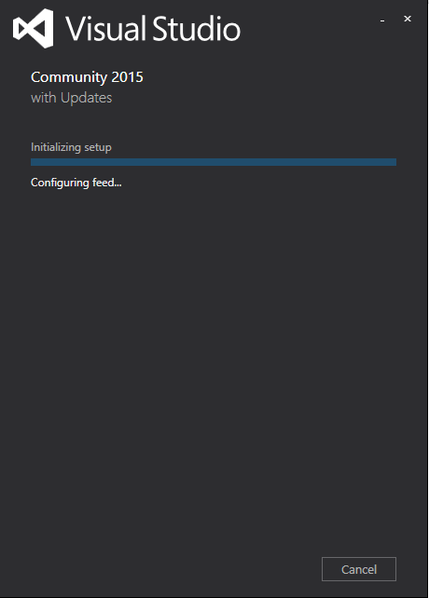

Step 3: Select custom installation, or if an installation already exists click modify.

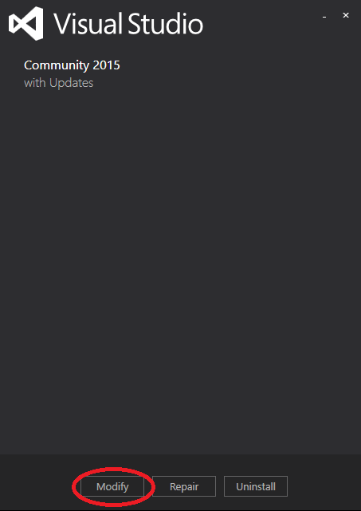

Step 4: Under Cross Platform Mobile Development, select, C#/.NET (Xamarin v4.1.1), Microsoft Visual Studio Emulator for Android, and Android Native Development Kit.

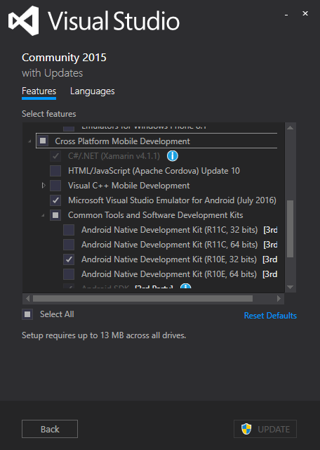

Step 5: Scroll down and select Android SDK, Android SDK Setup, and Java SE Development Kit, then UPDATE or INSTALL
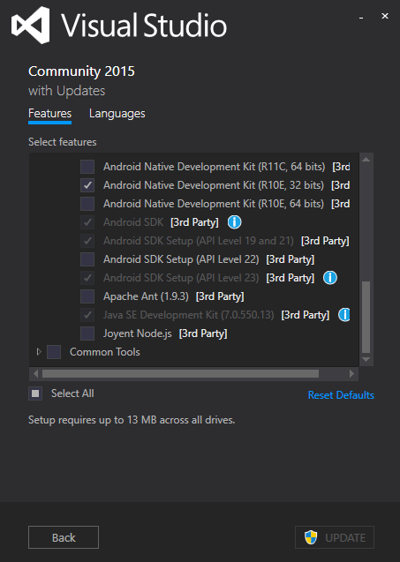

Step 6: Now open the project in Visual Studio.

Step 7: On the top toolbar select Open Android SDK Manager
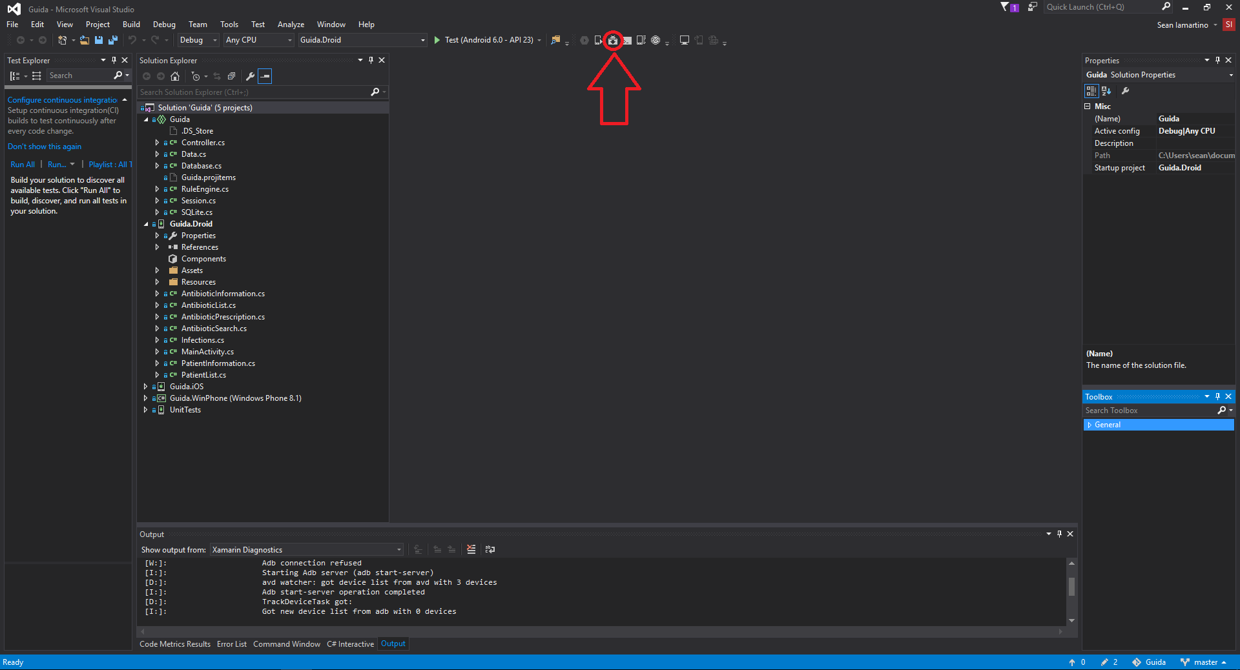

Step 8: Select Android SDK Tools, Android SDK Platform-tools, and Android SDK Build-tools
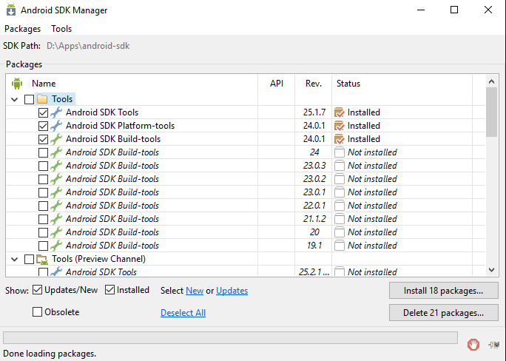

Step 9: Scroll down, select Android 7.0, Android 6.0, and android 5.1, you can install any previous versions as you wish.
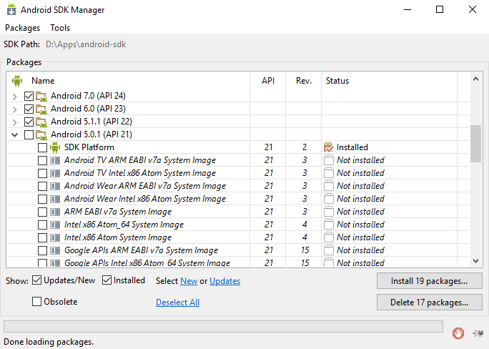

Step 10: Scroll all the way to the bottom and select Intel x86 Emulator Accelerator(HAXM Installer)
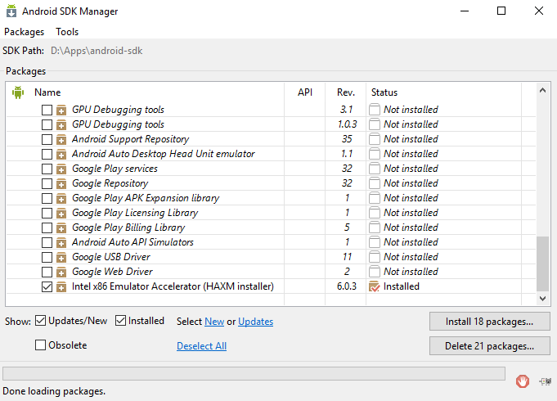

Step 11: Click install. Accept the license, and click install once more.

Step 12: In Visual Studio again, on the top bar, click Open Android Emulator Manager(AVD)
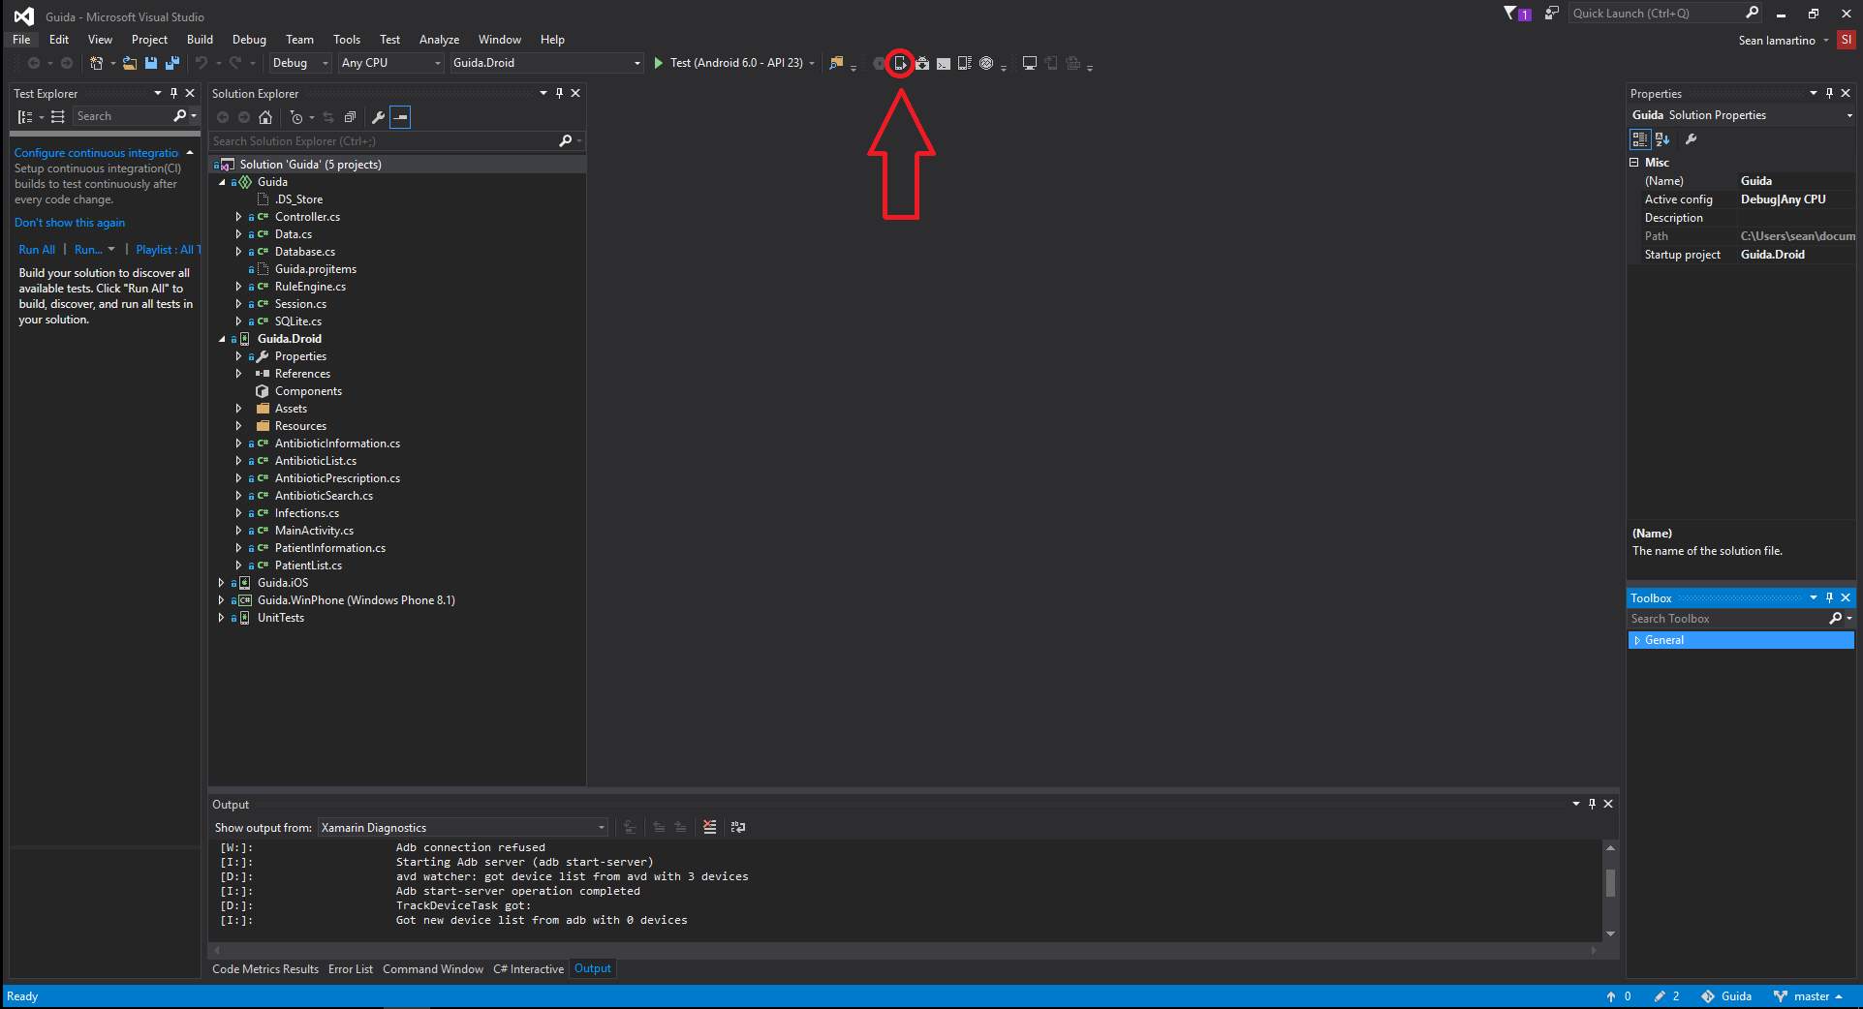

Step 13: You may have some default emulators. We are going to create a new one. On the right click Create.

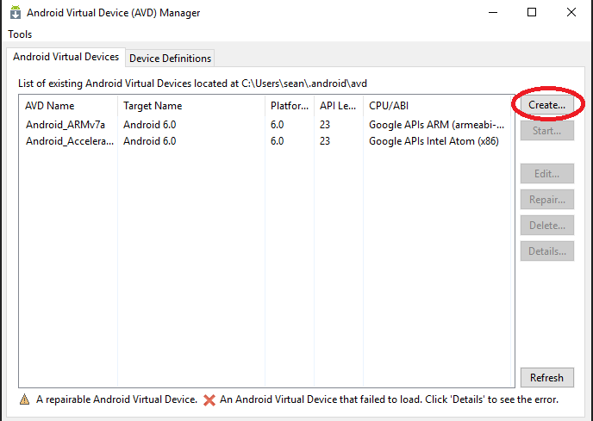

Step 14: Use the following settings. Although you may create different devices to test on.
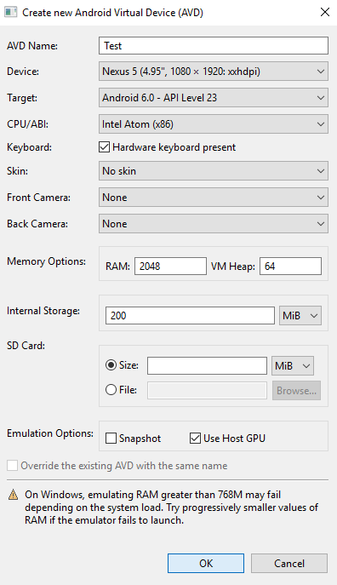

Step 15: Now that the emulator is created. Start it. 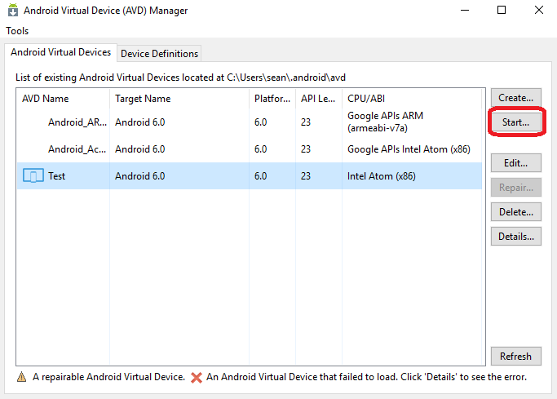

Step 16: After a few minutes the emulator should be up and running. Go back to Visual Studio, right click on the Guida.Droid project and select Deploy. This will build and deploy the project to our emulator.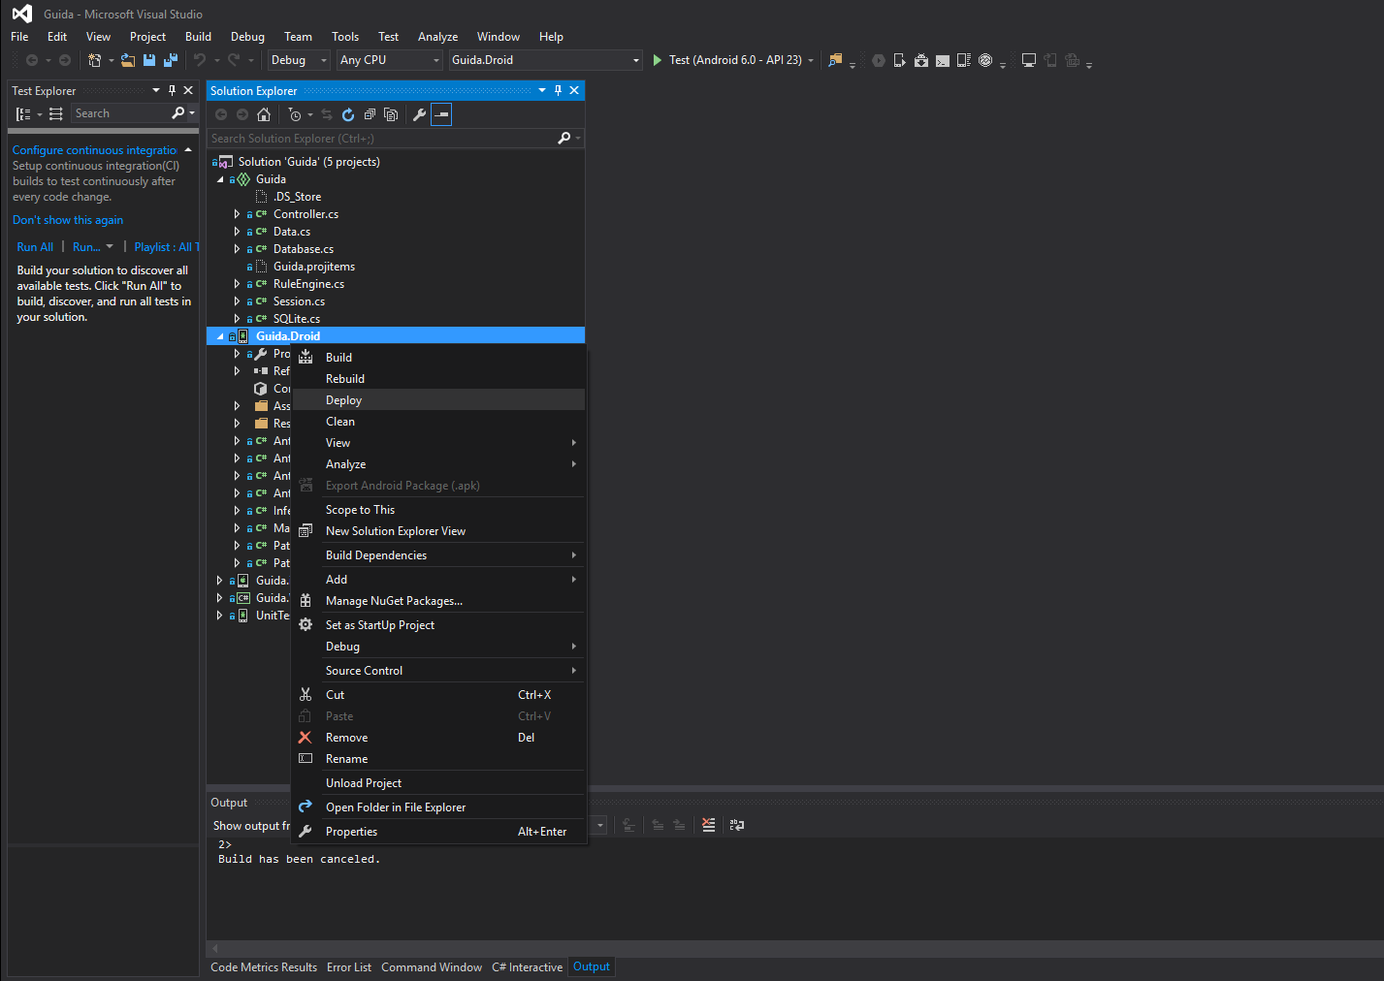

Step 17: Once that process is done, the project has been deployed to the emulator. In the emulator, open all apps, and look for Guida.Droid.


The project is now set up, and ready to be modified, and tested.

