*Florida International University*

*School of Computing and Information Sciences*

Software Engineering Focus

Final Deliverable

Project Title: Flagway App for the Algebra Project and Young People’s Project Ver 1.0

**Team Members:** Deya Banisakher and Md Musfiqur Rahman Sazal

**Product Owner(s)**: Mario Eraso

**Mentor(s)**: Mohsen Taheri

**Instructor**: Masoud Sadjadi

Copyright (c) *2016 Florida International University*

Permission is hereby granted, free of charge, to any person obtaining a copy of this software and associated documentation files (the "Software"), to deal in the Software without restriction, including without limitation the rights to use, copy, modify, merge, publish, distribute, sublicense, and/or sell copies of the Software, and to permit persons to whom the Software is furnished to do so, subject to the following conditions:

The above copyright notice and this permission notice shall be included in all copies or substantial portions of the Software.

THE SOFTWARE IS PROVIDED "AS IS", WITHOUT WARRANTY OF ANY KIND, EXPRESS OR IMPLIED, INCLUDING BUT NOT LIMITED TO THE WARRANTIES OF MERCHANTABILITY, FITNESS FOR A PARTICULAR PURPOSE AND NONINFRINGEMENT. IN NO EVENT SHALL THE AUTHORS OR COPYRIGHT HOLDERS BE LIABLE FOR ANY CLAIM, DAMAGES OR OTHER LIABILITY, WHETHER IN AN ACTION OF CONTRACT, TORT OR OTHERWISE, ARISING FROM, OUT OF OR IN CONNECTION WITH THE SOFTWARE OR THE USE OR OTHER DEALINGS IN THE SOFTWARE.

***Abstract***

*This document presents the information necessary to gain a good understanding of the first version of the Flagway App for the Algebra Project and Young People’s Project. In detail, this document contains the product features’ documentation, the overall system design, and some relevant current and future discussion.*

**Table of Contents**

**Introduction** ……………………………………………………………………………………………………………………………….. 5

Current System …………………………………………………………………….……………………………………………... 5

Purpose of New System ………………………………………………………………………..……………………………... 5

**User Stories**

Implemented User Stories …………………………………………………………………….……………………………..6

**Project Plan**

Hardware and Software Resources ………………………………………………………..…………………….… 30

Sprints Plan …………………………………………………………………………..…………………………………………. 30

*Sprint 1*  …………………………………………………………………………………………………………………………... 31

*Sprint 2*  …………………………………………………………………………………………………………………………... 31

*Sprint 3*  …………………………………………………………………………………………………………………………... 32

*Sprint 4*  …………………………………………………………………………………………………………………………... 33

*Sprint 5*  …………………………………………………………………………………………………………………………... 33

**System Design**

Architectural Patterns ………………………………………………………………………………………………….. 34

System and Subsystem Decomposition ……………………………………………………………………………… 35

Controllers ………….... ………………………………………………………………………………………………………….36

Design Patterns ……………………………………………………………………………………………………………....... 37

**System Validation**  …………………………………………………………………………………………………………………….37

**Appendix**  ………………………………………………………………………………………………………………………………….39

Appendix A- Sprint Review Reports ………………………………………………………….………………...…… 39

**References** ……………………………………………………………………………………………………………………...………...41

# 

# 

# Introduction

The goal of the Flagway Game is to create environments where very young students can practice and celebrate learning math. There are many different ways to create a cultural context in which mathematics emerges naturally from students’ experience. One method used by the YPP and the Algebra Project is to create mathematically rich games and experiences. The Flagway Game was developed by Bob Moses in 1995 and patented in 1996.

* Players navigate a Flagway or course of radial “paths”.
* Can be played without knowing underlying mathematical principles.
* We are assigned to develop a Flagway Android Game

## 

## Current System

Currently Flagway is played in physical track. In this game, Speed counts, so as students develop into skilled players several may be running through the course simultaneously, creating dynamics similar to that of a sporting event. But there is no computer or mobile application for this game. So this is version 1.0.

## Purpose of New System

The new system is an integration of the physical Flagway game into the digital hemisphere - a phone game-app. Given that smartphones have become an essential part of our daily lives and given the abundance of smarphones in general, it was sought to bring the Flagway game to the Android platform in order to widen the access and reach for the successful original game. The game-app is intended to replace or augment the current implementation of the math game discussed.

# User Stories

The following section provides the detailed user stories that were implemented in this iteration of the project. These user stories served as the basis for the implementation of the project’s features. This section also shows the user stories that are to be considered for future development.

## Implemented User Stories

**User Story #1** Project description and requirements’ understanding

* The main goal of this project is to teach mathematics and algebra implicitly to elementary, middle, and high school students.
* User will play the game and that will initiate the learning process.
* User may not know that they are in the learning process

Acceptance Criteria

* Game should be developed sequentially (level-1, level-2 etc.)
* Should have different levels of difficulties per requirements
* The game must be interactive and progressive.

**User Story #2** (Development of a Prototype App) -- 2 points (medium)

* Develop an initial/demo version of the game
* The prototype will have only basic features
* May not have all functions workable

Acceptance Criteria

* Product owner should have a big picture from the prototype
* Well organized and easily understandable as our target customer is school going children

**User Story #3** Design of Game-Level 1 UI --1 point

* This will be an initial/primitive design to accelerate development of the prototype app.
* The design will consist of 4 circles containing initial numbers.

Acceptance Criteria

* The shape must reflect user requirement demonstrated in the sprint planning meeting.
* The UI must be simple and not cluttered.

**Use Case** #**.... – Title**

**Use Case Diagram**

level.png

## 

**User Story #4** (Level 1 UI Integration) -- 4 points (large)

* Develop an initial/demo version of the game (Up-to level 1)
* The prototype app will have the UI for level 1 show up when the app is opened.

Acceptance Criteria

* Only the circles and initial numbers appear on the screen.
* No text or explanation of the image must be present.

**Use Case** 4**.... – Title**

**Use Case Diagram**

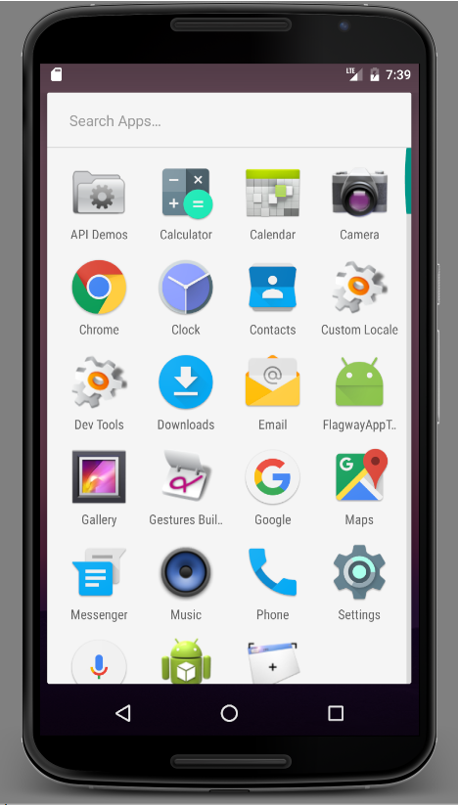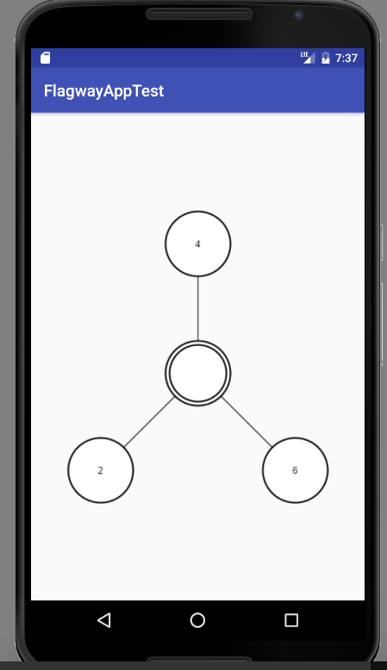

## 

**User Story** (Input the algebraic rules of the game) -- 2 points (medium)

* The user will get some place to input their rules
* The user can give any kind of input to the game whatever they want

Acceptance Criteria

* The app should take any kind of input ( Text, numbers, special character and even blank space)
* The app should take three rules both individually and all three at a time

**Use Case** # **5 –** Interact with with Level 1 interface and Input algebraic Rules

**Use Case Diagram**

Use Case#2.png

**Sequence Diagram**

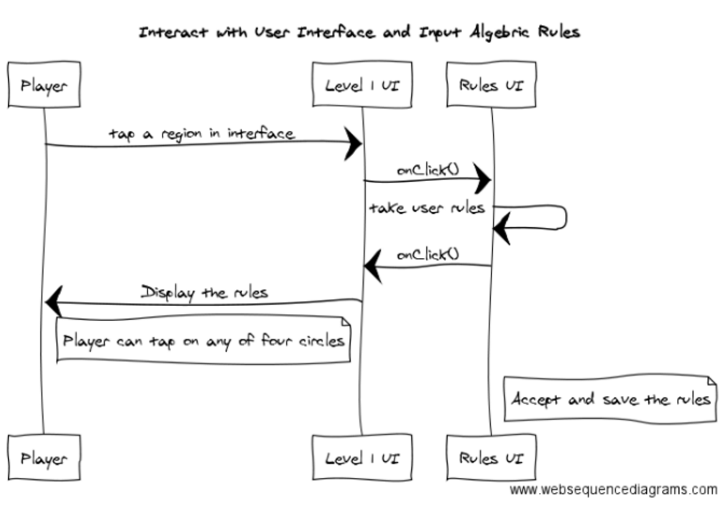

**User Story #6** Interact with with Level 1 interface --2 points (medium)

* The user clicks on different regions in level 1 interface.
* The user will be able to move to different interface where they can input their respective rules based on the region clicked.

Acceptance Criteria

* There must be 4 regions where the user can interact with level 1 (the four main circles)
* The user must be directed to another interface where they will interact to input their rules (user story# 5).

**Use Case** #**6 –** Interact with with Level 1 interface and Input algebraic Rules

**Use Case Diagram**

Use Case#1.png

**Sequence Diagram**



**User Story #7** User Story #7 (Select Game Mode and Settings) -- 2 points (medium)

* The users open the game application on their smartphone. Then the app will prompt to select the game mode, level of difficulties and range of numbers to be played with. The user then select the mode, range and level and the app will store the user’s response. Finally the user can proceed to the desired game window.

Acceptance Criteria

* All the options must be clearly visible and understandable
* Users can select the options by clicking or selecting from menu (no typing required)
* Aesthetics are not an issue as this will be a prototype

**Use Case** #**7 –** Select Game Mode and Settings

**Use Case Diagram**

UseCaseDiagram 7.png

**Sequence Diagram**

Sequence7.png

**Class Diagram**

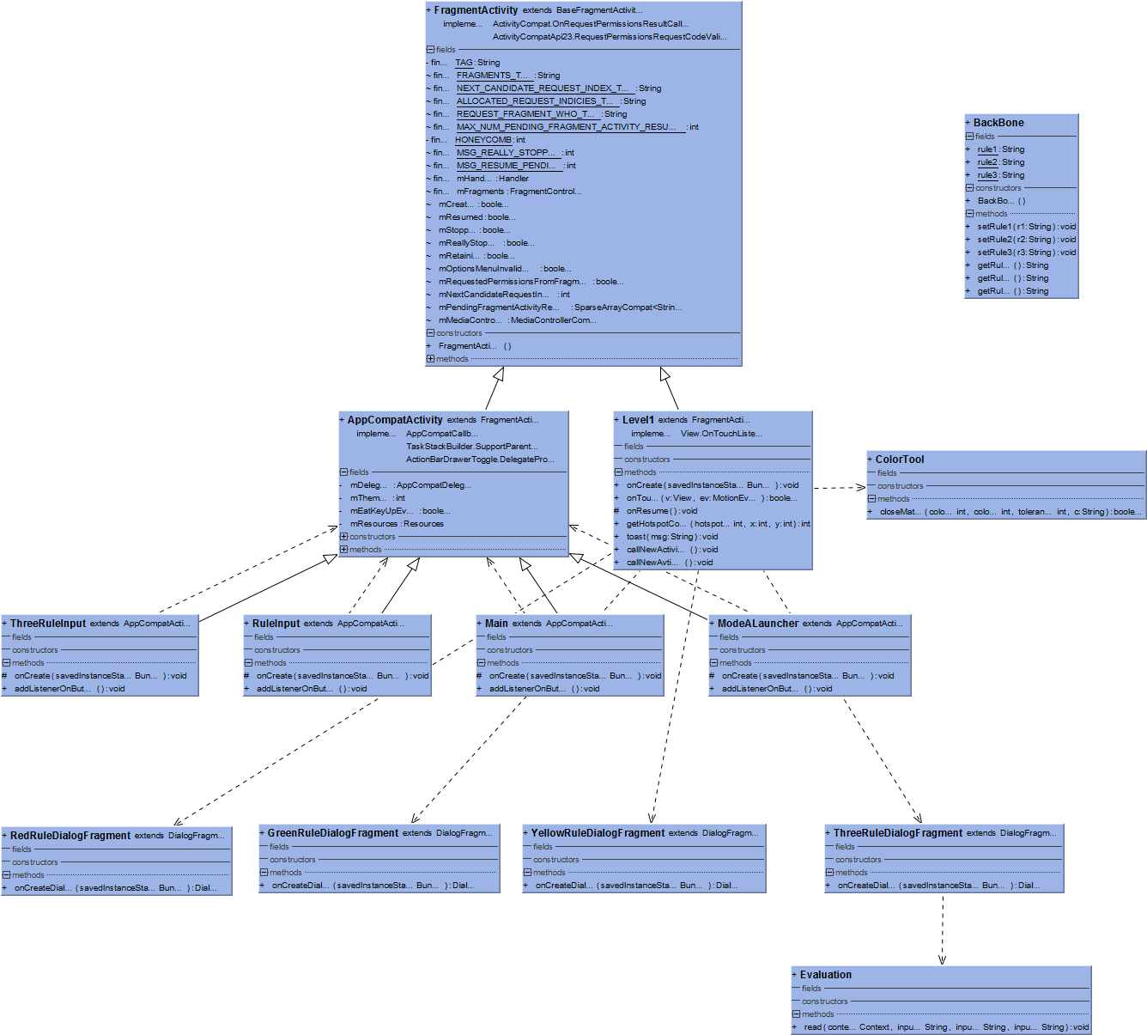

**User Story #8** (Input the algebraic rules for level-2 and mode B) -- 2 points (medium)

* After the user has selected the mode and settings desired, the game flashes the user with level-1 and mode B interface. In that interface the user will see four circle - one hollow circle in the center and three other circle placed in a triangular shape each of which have a distinct number 2,4 and 6. A message will also pop telling the user to tap screen to find clickable region(the four circle). If the user taps a white space in the screen, four red circle will light where the user can interact to input rules. After the user realizes the clickable regions, they may click on any of the four circle. If they click in one of the three circle containing number they will be prompted with input dialog box. Each will take the user respective rule and record it in the game. If they click on central circle they will be prompted with a screen displaying all the three rules

Acceptance Criteria

* The app should take any kind of input ( Text, numbers, special character and even blank space)
* The app should show the right place to click
* The pop up that will display rules must be in the center of the screen

**Use Case** #**8 –** Input the algebraic rules for level-2 and mode B

**Use Case Diagram**

UseCase8.png

**Sequence Diagram**

sequence8.png

**Class Diagram**



**User Story #8** (Input the algebraic rules for level-2 and mode B and verify the rules) -- 3 points (large) [ User story is continuing from the last sprint with some modification and some new features]

After the user has selected the mode and settings desired, the game flashes the user with level-1 and mode B interface. In that interface the user will see four circle - one hollow circle in the center and three other circle placed in a triangular shape each of which have a distinct number 2,4 and 6. A message will also pop telling the user to tap screen to find clickable region(the four circle). If the user taps a white space in the screen, four red circle will light where the user can interact to input rules. After the user realizes the clickable regions, they may click on any of the four circle. If they click in one of the three circle containing number they will be prompted with input dialog box. Each will take the user respective rule and record it in the game. If they click on central circle they will be prompted with a screen displaying all the three rules.

After getting all rules in the screen the user can see whether their rules are correct or not. This step is called verification. A list of words (related to high school mathematics) are stored in the backend. If the input of the users are matched with the bank of words somehow ( for example, any word from the list is a substring of user’s input), then it will be considered as correct. It do not match, the user’s input will be considered as incorrect.

Acceptance Criteria

* The app should take any kind of input ( Text, numbers, special character and even blank space)
* The app should show the right place to click
* The pop up that will display rules must be in the center of the screen
* Verification will be done against the given list of the words
* Verification should not be too strict

**Use Case** # **8 –** Input the algebraic rules for level-2 and mode B and verify the rules

**Use Case Diagram**

Use Case Diagram 8_sprint5.png

**Sequence Diagram**

UserStory8_sprint5.png

**Class Diagram**



**User Story #9** (Select the rules the number follows) -- 3 points (large)

* The user is in Level-1 (or any level). A random number from the range selected previously will appear on the screen. The user will have to select the color that the number falls in according to the algebraic rules. The game will then prompt the user with feedback regarding their input (correct vs. incorrect). If it is correct, the number will be saved in the correct bag/color and will be displayed to the user. Also, a new number will appear (until all numbers in the range selected have appeared) and the process will start again. If it is incorrect however, the user will have to re-select the appropriate rule.

Acceptance Criteria

* Random number must be within range selected
* User should be able to select numbers by color
* The user should have feedback (correct vs. incorrect)

**Use Case** # **9 –** Select the rules the number follows

**Use Case Diagram**

UseCase Diagram 9_sprint5.png

**Sequence Diagram**

UserStory9_sprint5.png

**Class Diagram**



**Unit Test**

**Integration Test**

**Visual User Guide**

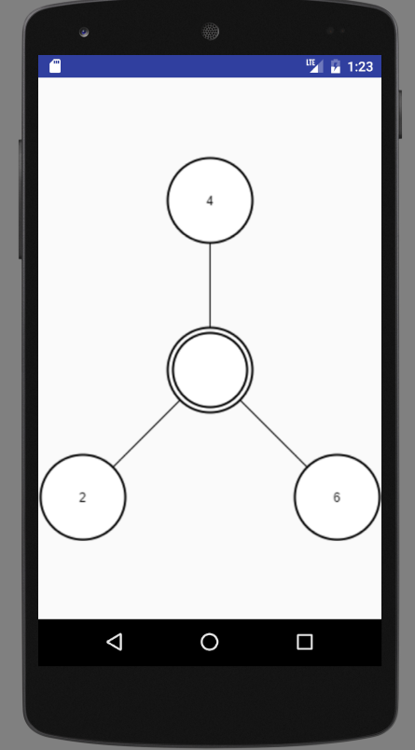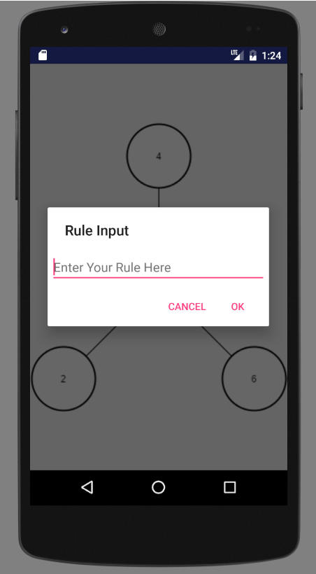

# Project Plan

This section describes the planning that went into the realization of this project. This project incorporated the agile development techniques and as such required the sprints to be planned. These sprint plannings are detailed in the section. This section also describes the components, both software and hardware, chosen for this project.

## Hardware and Software Resources

The following is a list of all hardware and software resources that were used in this project:

* Hardware:
  + Android-powered smartphones and tablets
* Software:
  + Java JDK 8
  + Android SDK
  + Android Studio
  + Visio
  + Adobe Illustrator
  + GeoGebra

## 

## 

## Sprints Plan

### Sprint 1

Attendees: Deya Banisakher, Musfiqur Rahman, Mario Eraso

Start time: 10:00 AM

End time: 11:30 AM

After discussion, the velocity of the team were estimated to be 40 hours.

The product owner chose the following user stories to be done during the next sprint. They are ordered based on their priority.

* User Story #1 (Project Description and Requirements’ Understanding)

The team members indicated their willingness to work on the following user stories.

* Deya Banisakher
* Md Musfiqur Rahman Sazal
* User Story #1 Project Description and Requirements’ Understanding

### Sprint 2

Attendees: Deya Banisakher, Musfiqur Rahman

Date: September 12, 2016

Start time: 11:00 AM

End time: 12:00 AM

After discussion, the velocity of the team were estimated to be 20 hours.

The product owner chose the following user stories to be done during the next sprint. They are ordered based on their priority.

* User Story #2 (Development of a Prototype App) -- 2 points (medium)
* User Story #3 (Design of Game-Level 1 UI) -- 1 point (small)
* User Story #4 (Level 1 UI Integration) -- 4 points (large)

The team members indicated their willingness to work on the following user stories.

* Deya Banisakher
* User Story #2 (Development of a Prototype App)
* User Story #4 (Level 1 UI Integration) [Couple coding]
* Md Musfiqur Rahman Sazal
* User Story #3 (Design of Game-Level 1 UI)
* User Story #4 (Level 1 UI Integration) [Couple Coding]

### Sprint 3

Attendees: Deya Banisakher, Musfiqur Rahman

Date: Sep 26 , 2016

Start time: 5:00 PM

End time: 6:00 PM

After discussion, the velocity of the team were estimated to be 20 hours.

The product owner chose the following user stories to be done during the next sprint. They are ordered based on their priority.

* User Story #5 (Input the algebraic rules for level 1) -- 2 points (medium)
* User Story #6 (Interact with with Level 1 interface) -- 2 points (medium)

The team members indicated their willingness to work on the following user stories.

* Deya Banisakher
* User Story #6 (Interact with Level 1 interface)
* Md Musfiqur Rahman Sazal
* User Story #5 (Input the algebraic rules for level 1)

### Sprint 4

Attendees: Deya Banisakher, Musfiqur Rahman

Date: Oct 10, 2016

Start time: 5:00 PM

End time: 6:00 PM

After discussion, the velocity of the team were estimated to be 20 hours.

The product owner chose the following user stories to be done during the next sprint. They are ordered based on their priority.

* User Story #7 (Select Game Mode and Settings) -- 2 points (medium)
* User Story #8 (Input the Algebraic Rules for Level - 1 and Mode B) -- 2 points (medium)

The team members indicated their willingness to work on the following user stories.

* Deya Banisakher
* User Story #7 (Select Game Mode and Settings)
* Md Musfiqur Rahman Sazal
* User Story #8 (Input the Algebraic Rules for Level - 1 and Mode B)

### Sprint 5

Attendees: Deya Banisakher, Musfiqur Rahman

Date: Oct 24, 2016

Start time: 5:00 PM

End time: 6:00 PM

After discussion, the velocity of the team were estimated to be 20 hours.

The product owner chose the following user stories to be done during the next sprint. They are ordered based on their priority.

* User Story #8 (Input the Algebraic Rules for Level - 1 and Mode B) -- 2 points (medium)
* User Story #9 (Assign numbers to algebraic rules/patterns) -- 3 points (large)

The team members indicated their willingness to work on the following user stories.

* Deya Banisakher
* User Story #9 (Assign numbers to algebraic rules/patterns)
* Md Musfiqur Rahman Sazal
* User Story #8 (Input the Algebraic Rules for Level - 1 and Mode B)

# System Design

This section contains information on the design decisions that went into this project. The architecture patterns are outlined and explained. The entire system is shown in a package diagram and the subsystems are explained. Finally, the design patterns used in the project are discussed.

## Architectural Patterns

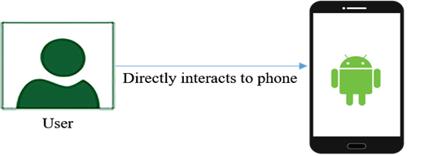

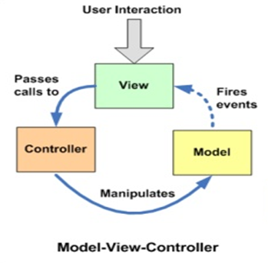

## System and Subsystem Decomposition

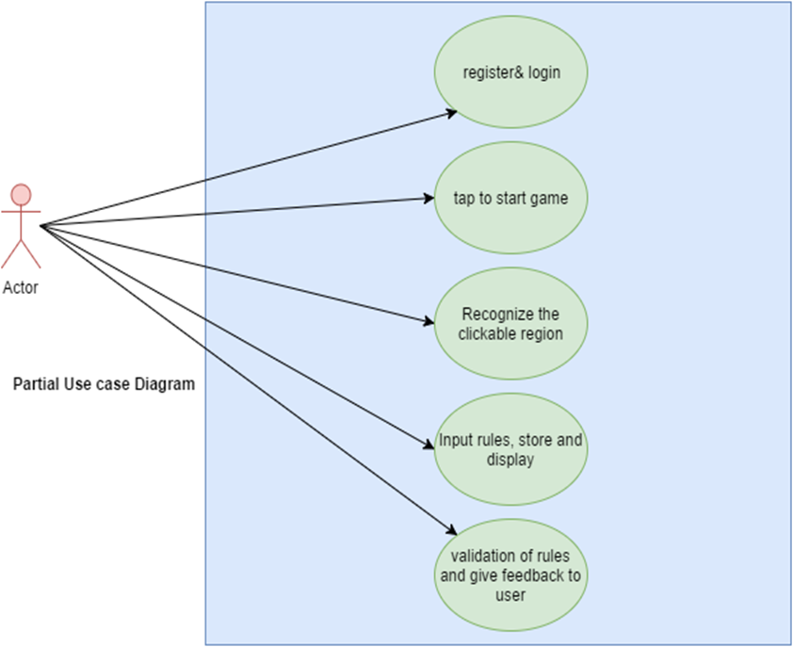

## Controllers

* Player’s input handler
* Controller to process input
* Controller to perform actions

## Design Patterns

* View and view group: Composite
* View holder: Singleton
* Intent: Factory

# System Validation

The following are some highlighted test cases that were considered:

1. **Game Mode Selection**

**Purpose:** Ensure that the user is able to select the game mode, level, and range initially. **Precondition:** The user must be logged in and had just started the app.

**Input:** The user selects the level and range desired followed by tapping the mode button.

**Expected Result:** The game should proceed to the selected game mode and level. If mode A is selected, a screen containing the mathematical rules will be shown to the user. If mode B is selected, the game directly proceeds to the level selected. Finally, only numbers within the selected range can be given to the user.

**Actual Result:** The game proceeded as expected. Mode A leads to a screen showing the rules, followed by the game level selected, while mode B leads directly to the game level selected. The numbers shown to the user.

1. **Number Assignment Verification**

**Purpose:** To ensure that the game verifies the user selection (rule selection) and provides appropriate feedback to the user.

**Precondition:** The user is in either mode A or B (any level and range). The user is prompted with a number and is asked to assign it to a color (red, blue, or yellow).

**Input:** The user selects the desired color and taps the submit button.

**Expected Result:** If the user made the correct selection, a feedback message will inform the user of a correct answer. Consequently, the number assigned must appear in the color circle box. If the selection is incorrect, the user will receive an appropriate feedback message asking for a retry.

**Actual Result:** When the user made the correct selection, a feedback message was shown indicating a correct answer. Consequently, the number assigned appeared in the respective color-circle’s box. When the selection was incorrect, the user received an appropriate feedback message asking for a retry.

1. **Login**

**Purpose:** Ensure that the user is able to sign in with their correct credentials

**Precondition:** The app is running at its initial page

**Input:** The user credentials and user presses login button

**Expected Result:** If the credentials are a match, the user will have access to game. If the credentials are incorrect, the user will be prompted to re-input their credentials

**Actual Result:** When the credentials were a match, the user gained access to game. When the credentials were incorrect, the use prompted to re-input their credentials.

1. **Rule Verification**

**Purpose:** To ensure that the rules entered by the user are correct and reflect the different patterns of numbers.

**Precondition:** The user is in Mode B of the game. The user clicks the rule-input circle

**Input:** The user inputs the rules, and submits them.

**Expected Result:** If the individual rules contain the certain keywords, the game will accept the rules and inform the user that they are correct. If they don’t contain the correct keywords, the game discard the rules and prompts the user to re-try.

**Actual result:** When the individual rules contain the certain keywords, the game accepted the rules and inform the user that they are correct. When they don’t contain the correct keywords, the game discarded the rules and prompts the user to re-try.

# 

# 

# 

# Appendix

## Appendix A - Sprint Review Reports

***Sprint 1***

Attendees: Deya Banisakher, Musfiqur Rahman

Start time: 9/9/2016 10:00 AM

End time: 9/9/2016 11:30 AM

After a show and tell presentation, the implementation of the following user stories were accepted by the product owners: All.

* User Story #1 (Project Description and Requirements’ Understanding)

The following ones were rejected and moved back to the product backlog to be assigned to a future sprint at a future Spring Planning meeting.

* NA

***Sprint 2***

Attendees: Deya Banisakher, Musfiqur Rahman

Start time: 9/9/2016 10:00 AM

End time: 9/9/2016 11:30 AM

After a show and tell presentation, the implementation of the following user stories were accepted by the product owners: All.

* User Story #2 (Development of a Prototype App) -- 2 points (medium)
* User Story #3 (Design of Game-Level 1 UI) -- 1 point (small)
* User Story #4 (Level 1 UI Integration) -- 4 points (large)

The following ones were rejected and moved back to the product backlog to be assigned to a future sprint at a future Spring Planning meeting.

* NA

***Sprint 3***

Attendees: Deya Banisakher, Musfiqur Rahman

Date:10/7/2016

Start time: 10:00 AM

End time: 11:30 AM

After a show and tell presentation between the team members, the implementation of the following user stories were found to be as required and outlined by the product owner:

* User Story #5 (Input the algebraic rules for level 1) -- 2 points (medium)

The following ones were rejected and moved back to the product backlog to be assigned to a future sprint at a future Spring Planning meeting.

* User Story #6 (Interact with with Level 1 interface) -- 2 points (medium) (due to incomplete link between level 1 interface and rules-input interface)

***Sprint 4***

Attendees: Deya Banisakher, Musfiqur Rahman

Date:10/21/2016

Start time: 10:00 AM

End time: 11:30 AM

After a show and tell presentation between the team members, the implementation of the following user stories were found to be as required and outlined by the product owner:

* User Story #7 (Select Game Mode and Settings) -- 2 points (medium)

The following user stories are carried to the following Sprint:

* User Story #8 (Input the Algebraic Rules for Level - 1 and Mode B) -- 2 points (medium)

***Sprint 5***

Attendees: Deya Banisakher, Musfiqur Rahman

Date:10/21/2016

Start time: 10:00 AM

End time: 11:30 AM

After a show and tell presentation between the team members, the implementation of the following user stories were found to be as required and outlined by the product owner:

* User Story #8 (Select Game Mode and Settings) -- 2 points (medium)

The following user stories will be carries for the next sprint:

* User Story #9 (Input the Algebraic Rules for Level - 1 and Mode B) -- 3 points (large)

# References

<https://developer.android.com/studio/install.html>

<http://web.cse.ohio-state.edu/~champion/5236/AndroidStudio.pdf>

http://cic.gatech.edu/sites/default/files/documents/spring-2015/Workshop-04\_Android-Development.pdf