*Florida International University*

*School of Computing and Information Sciences*

CIS 4911 - Senior Capstone Project

Software Engineering Focus

ShortComings and WishList

Go Local App Staff

Team # 7

**Team Members**

Luis Castillo

Wilfredo Gomez

**Product Owner**: Eddie Garcia

**Instructor**: Masoud Sadjadi

# ShortComings

Autolayout constraints in Xcode allows the UI of the application to be configured for all devices (Iphone & Ipad)

Example:

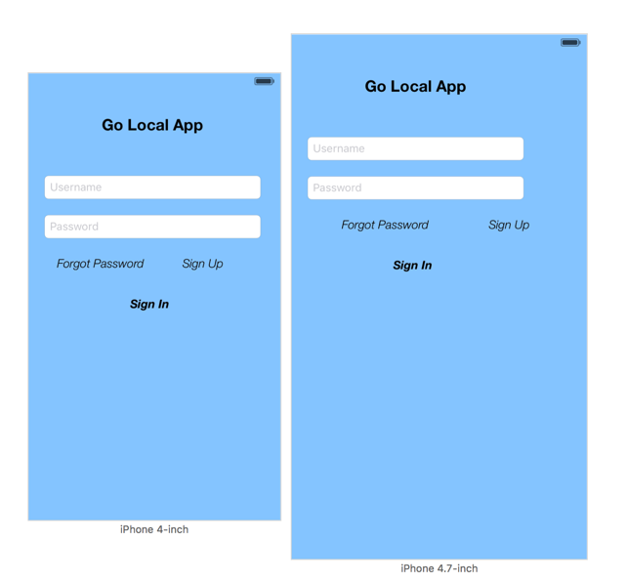

WishList

* Expand Management Website
* Implement View Accept Jobs, Search Accept Jobs for Registered Staff
* Implement View Booked Talent, Booked Talent for Registered Employer
* Implement Add Job, View Posted Jobs, Delete Job, Edit Job for Registered Employer
* Configure Core Data with NSFetchResults Classes
  + This will allow controller objects to be notified whenever the data stored in Core Data changes, allowing the controllers to keep the views updated in ways that keep your code trim and extensible.