Go Local Staff App

TEAM#7

*User Guide*

Team Members: Luis Castillo Wilfredo Gomez

Product Owner: Eduardo Garcia

Project Mentor: Masoud Sadjadi

Table of Contents

Employer User Registration 3

Staff User Registration 6

Staff Search 6

# Employer User Registration

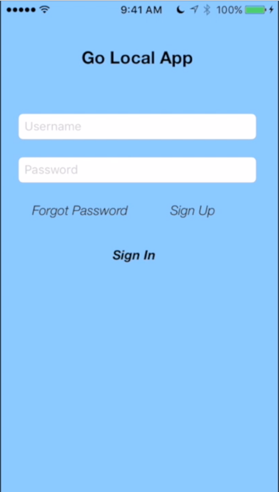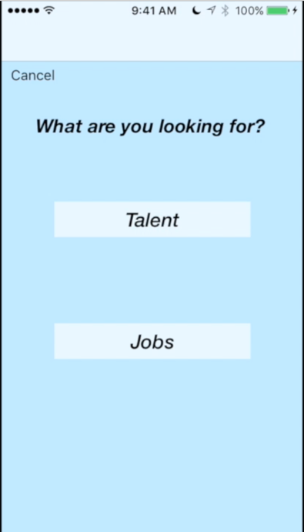

* Click “Talent”
* Open the GoLocalStaff App
* Cick on “Signup” Button

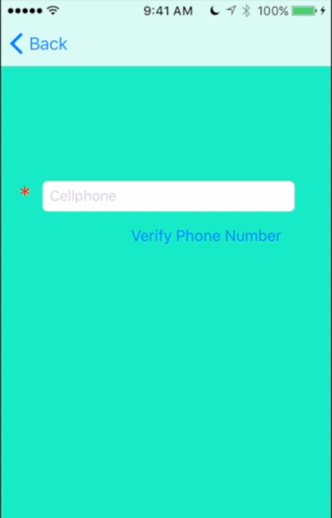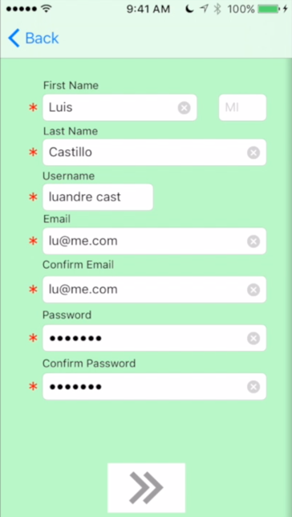

* Enter Cellphone
* Press “Verify Phone Number” Button
* Enter First Name
* Enter Middle
* Enter Last Name
* Enter username
* Enter email
* Enter confirm Email
* Enter password
* Enter confirm password
* Press Submit button

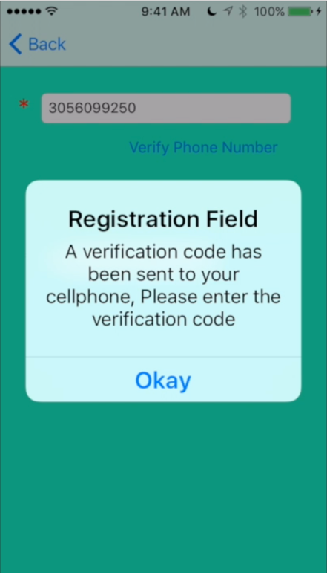

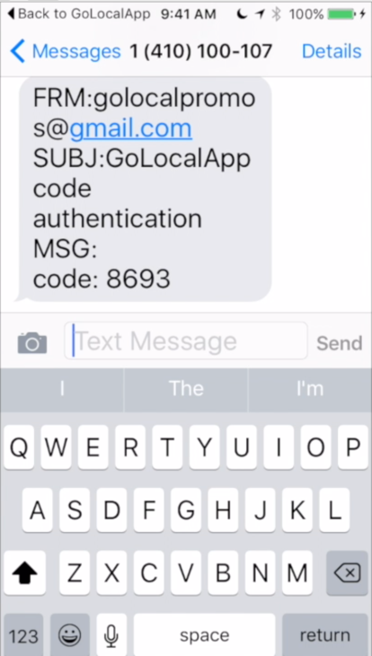

* Check your text messages for the verification Code that was sent to you
* The above message will appear, press the Okay button

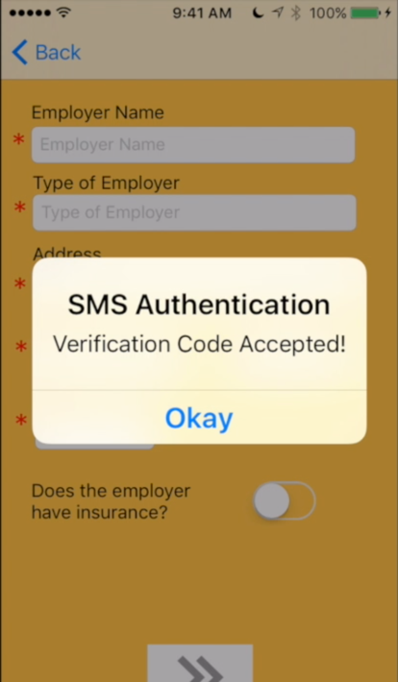



* The Above message will display, Press the “Okay” Button
* Enter the Verification Code
* Press “Verify Code” Button

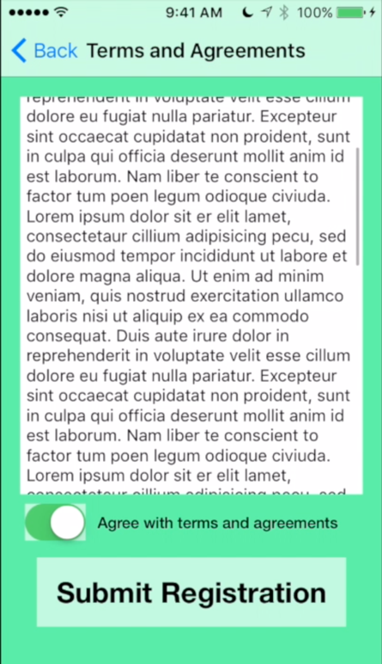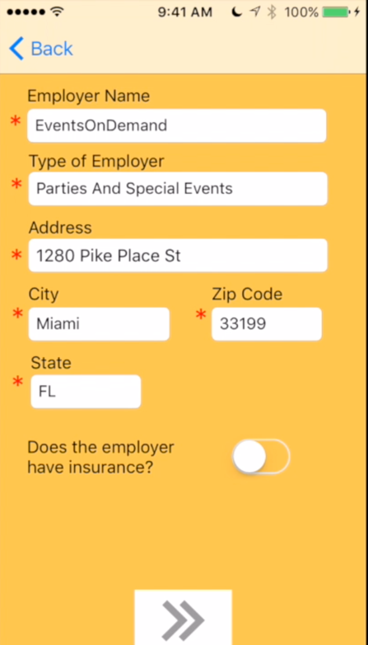

* Read Term and agreements
* Agree to terms
* Press the “Submit Registration” button
* Enter Employer Name (Company Name)
* Enter Type of Employer
* Enter Address
* Enter City
* Enter Zipcode
* Enter State
* Does the employer have insurance? Select the switch according to your answer
* Press the submit button

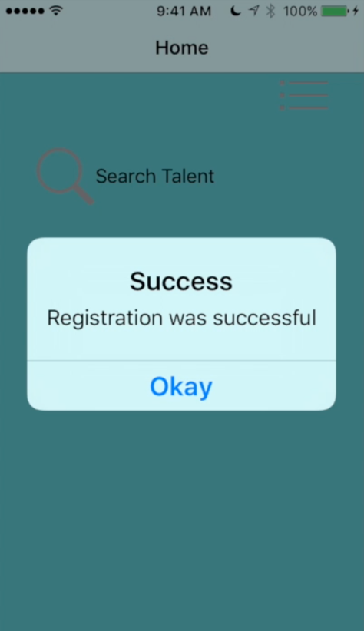

**Live Demo:**

<https://www.youtube.com/watch?v=kHxFaDq-BWE>

* The message above message will display, meaning you have successfully register and are now login as employer

# Staff User Registration

Step by Step:

1. Tap sign up.
2. Tap Jobs.
3. Enter the information being asked.
4. Go to the next view.
5. Enter your phone number to get verified.
6. Tap verify phone number.
7. Enter the verification code received as a text message.
8. Tap verify code.
9. Move to the next view.
10. Enter the information being asked.
11. Go to the next view.
12. Select your work experience.
13. Go to the next view.
14. Enter information being asked.
15. Go to the next view.
16. Enter information being asked.
17. Go to the next view.
18. Upload a headshot (optional)
19. Go to the next view.
20. Select whether you want direct deposit or not.
21. Go to the next view.
22. Accept Terms and Agreements.
23. **You have successfully been registered.**

**Live Demo:**

<https://www.youtube.com/watch?v=7gWDBkqCDjk>

# Staff Search

Step by Step:

1. Tap 'Search Talent'
2. Select the required criteria for the search
3. Tap Search
4. Tap on a specific person (optional)
5. Tap 'Edit' (optional)
6. Tap 'Map Mode'
7. Tap 'Hybrid' or 'Standard'
8. Tap 'List Mode'

**Live Demo:**

<https://www.youtube.com/watch?v=ezrjWd_3WDI>