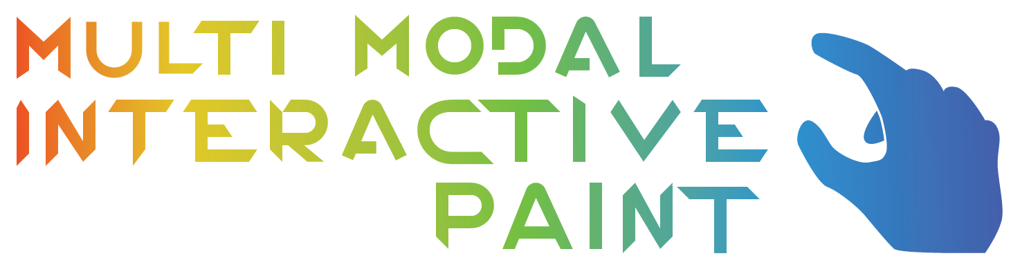

Multi Modal Interactive Paint is an application designed to showcase various input devices. Currently implemented devices include Multitouch Monitor Tobii EyeX Leap Motion Controller Intel Real Sense Camera

The application was designed for the OpenHID lab at Florida International University. It will be an application that sets the baseline for testing new devices on their in development Smart Desk, a desk designed for students that will make use of various input devices.

The application is a painting application, allowing users to draw on a canvas using different shapes, colors, as well as more intricate functionality such as layer and alpha color support.

This user manual goes over the new features added to this project. These are the resizing capabilities of the application window, and painting with the Xbox Kinect. The Hololens features are gone over in another document.

User Read Me - Refer to our feature documents for more in depth explanations on a User Story by User Story basis.

The first new feature is resizing the windows. A user has to click on the window, and manually drag it across to resize it.



Also, a user can minimize and maximize with the standard buttons on the top right corner.



After resizing, a user can draw by touching or using the various devices of the program.

The other new feature is drawing with the Kinect. To draw with the Kinect a user stands in front of the Kinect with their hands open. If the user is registered, a circle will appear to show the hand position.

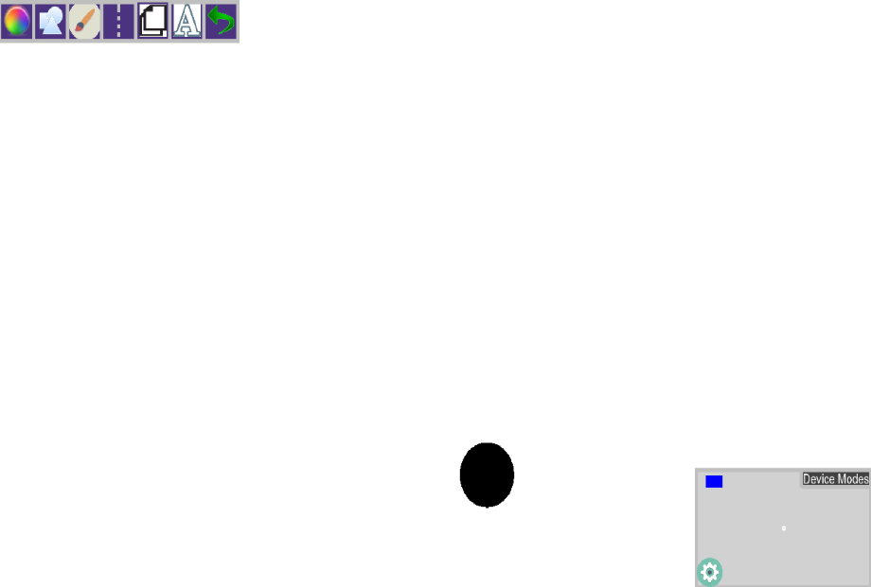

With the appropriate shape and color, a user can then close their hands and make a fist to begin drawing a shape that they can edit as long as their hand is a fist. Once their hand opens, the shape is finally drawn and the program resumes.

