*Florida International University*

*School of Computing and Information Sciences*

Software Engineering Focus

Final Deliverable

Project Title: Internet Coast v1.0

**Team Members: Ariel E Novo**

**Product Owner(s)**: Dale Gregory

**Mentor(s)**: Mohsen Taheri

**Instructor**: Masoud Sadjadi

The MIT License (MIT)

Copyright (c) *2016 Florida International University*

Permission is hereby granted, free of charge, to any person obtaining a copy of this software and associated documentation files (the "Software"), to deal in the Software without restriction, including without limitation the rights to use, copy, modify, merge, publish, distribute, sublicense, and/or sell copies of the Software, and to permit persons to whom the Software is furnished to do so, subject to the following conditions:

The above copyright notice and this permission notice shall be included in all copies or substantial portions of the Software.

THE SOFTWARE IS PROVIDED "AS IS", WITHOUT WARRANTY OF ANY KIND, EXPRESS OR IMPLIED, INCLUDING BUT NOT LIMITED TO THE WARRANTIES OF MERCHANTABILITY, FITNESS FOR A PARTICULAR PURPOSE AND NONINFRINGEMENT. IN NO EVENT SHALL THE AUTHORS OR COPYRIGHT HOLDERS BE LIABLE FOR ANY CLAIM, DAMAGES OR OTHER LIABILITY, WHETHER IN AN ACTION OF CONTRACT, TORT OR OTHERWISE, ARISING FROM, OUT OF OR IN CONNECTION WITH THE SOFTWARE OR THE USE OR OTHER DEALINGS IN THE SOFTWARE.

***Abstract***

This document presents the information necessary to gain a good understanding of Internet Coast v1.0 System.

The mission of this project is to create a software product, usable, scalable and secure to provide a straightforward view of funding opportunities from sources other than angel investors and venture capitalists to entrepreneurs and small businesses, including funding sources from Federal agencies, State of Florida, private sector, private equity, foreign investments, and more.

**Table of Contents**

**Introduction** ……………………………………………………………………………………………………………………….. 6

Current System ……………………………………………………………………………………………………………………... 6

Purpose of New System …………………………………………………………………………… …………………………... 6

**User Stories**

Implemented User Stories …………………………………………………………………………………………………….7

**Sprint Plan …….**…………………………………………………………………………………………………………………………9

**System Design**

Architectural Design …………………………………………………………………………………………………….. 12

**Appendix**  ……………………………………………………………………………………………………………………………….13

Appendix A - UML Diagrams …………………………………………………………………………………………………. 13

Appendix B - User Interface Design ………………………………………………………………………………….…... 17

Appendix C - Sprint Review Reports ………………………………………………………………………………...…… 20

**References** ………………………………………………………………………………………………………………...………...22

# 

# Introduction

## Raising capital for startup is challenging and time consuming. Early stage funding sources include founders cash and debt, friends and family.... with angel and venture capital being extremely difficult to obtain.

The mission of this project is to create a software product, usable, scalable and secure to provide a straightforward view of funding opportunities from sources other than angel investors and venture capitalists to entrepreneurs and small businesses, including funding sources from Federal agencies, State of Florida, private sector, private equity, foreign investments, and more.

## Current System

Currently Internet Coast has a web site where all the posting is done manually, in pdf format, thus the necessity of navigate to several web sites to get the information from, wish is costly to maintain and keep op to date.

## Purpose of New System

The purpose of the new system is to create a software product, usable, scalable and secure to provide a straightforward view of funding opportunities from sources other than angel investors and venture capitalists to entrepreneurs and small businesses, including funding sources from Federal agencies, State of Florida, private sector, private equity, foreign investments, and more.

Automate the current process and enhance the maintenance of the information.

# User Stories

This section will show the user stories implemented during the version 3 of this product. There will not be any carry over user stories since all the functionality requested by the product owners was successfully turned in on time.

* #120 Create Internet Coast Data Base

As a system administrator store the information from all the grant sources in a standardized way that will facilitate the process of adding new funds opportunities to the system and also will allow the users to perform quick searches by topics of interest.

Acceptance Criteria:

1. A first version of the database is created.
2. Data can be inserted, modified and requested from and to the db.

* #121: Create DOD reader component

As a system administrator I need to automate the process of reading from the Department of Defense SBIR grants and insert that information into the system.

Acceptance Criteria:

1. Been able to automatically read the information from the source.
2. Been able to automatically save the information into the system.

* #124: List of Funds

As a user of the system i want a list of funds so i can see all the current opportunities.

Acceptance Criteria:

1. Different types of funds are displayed in the list.
2. A link to the original posting is available for every item in the list.

* #123: Add competitive Programs

As a system administrator I need to add Competitive Programs into the system. These Programs are another source of funding opportunities. Once the information is recorded then it will be available to the users in the founds list.

Acceptance Criteria:

1. The information is captured accordingly.

* #133: Add State & Federal Grants

As an administrator of the system i would like to add State & Federal Grants to the system. These are another source of funding opportunities. Once the information is recorded then it will be available to the users in the founds list.

Acceptance Criteria:

1. No duplicates should be entered.
2. After information is entered, should be available in the list of funds immediately

* #138: Admin Login

As an admin of the system i want to login so that i can manage the content of the site.

Acceptance Criteria:

1. Admin menu should be available after login.

# Sprints Plan

This section describes the planning that went into the realization of this project. This project incorporated the agile development techniques and as such required the sprints to be planned. These sprints planning are detailed in the section. This section also describes the components, both software and hardware, chosen for this project.

Sprint #3 Planning

Attendees: Dale Gregory, Ariel Novo

Start time: 09/27/2016 12:00 pm

End time: 09/27/2016 12:35 pm

After discussion, the velocity of the team was estimated to be 16 story points.

The product owner chose the following user stories to be done during the next sprint. They are ordered based on their priority.

* User Story #124 List of Funds

The team members indicated their willingness to work on the following user stories.

* Ariel Novo
* User Story #124 List of Funds

Sprint #4 Planning

Attendees: Dale Gregory, Ariel Novo

Start time: 10/10/2016 12:00 pm

End time: 10/10/2016 12:35 pm

After discussion, the velocity of the team was estimated to be 16 story points.

The product owner chose the following user stories to be done during the next sprint. They are ordered based on their priority.

* User Story #123 Add Competitive Program

The team members indicated their willingness to work on the following user stories.

* Ariel Novo
* User Story #123 Add Competitive Program

Sprint #5 Planning

Attendees: Dale Gregory, Ariel Novo

Start time: 10/20/2016 12:00 pm

End time: 10/20/2016 12:35 pm

After discussion, the velocity of the team was estimated to be 16 story points.

The product owner chose the following user stories to be done during the next sprint. They are ordered based on their priority.

* User Story #133 Add State and Federal Grants

The team members indicated their willingness to work on the following user stories.

* Ariel Novo
* User Story #133 Add State and Federal Grants

Sprint #6 Planning

Attendees: Dale Gregory, Ariel Novo

Start time: 11/03/2016 12:00 pm

End time: 10/03/2016 12:35 pm

After discussion, the velocity of the team was estimated to be 16 story points.

The product owner chose the following user stories to be done during the next sprint. They are ordered based on their priority.

* User Story #138 Admin Login

The team members indicated their willingness to work on the following user stories.

* Ariel Novo
* User Story #138 Admin Login

## 

## 

# System Design

This section contains information on the design decisions that went into this project. The architecture patterns are outlined and explained. The entire system is shown in a package diagram and the subsystems are explained. Finally, the design patterns used in the project are discussed.



# Appendix

## Appendix A - UML Diagrams



Use case diagram.



Class Diagram



Use case Add Competitive Programs Sequence Diagram



Use case Add Federal And State Grants sequence diagram.



Use case Admin Login sequence diagram.

## Appendix B - User Interface Design

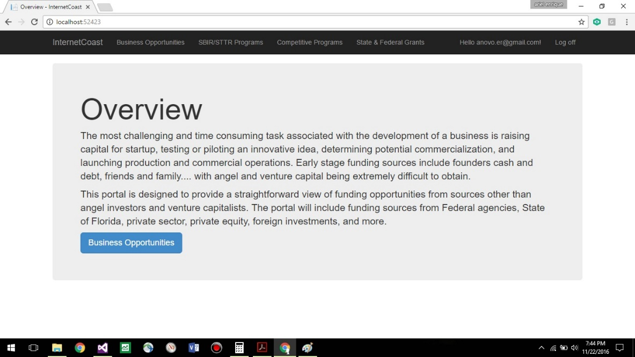

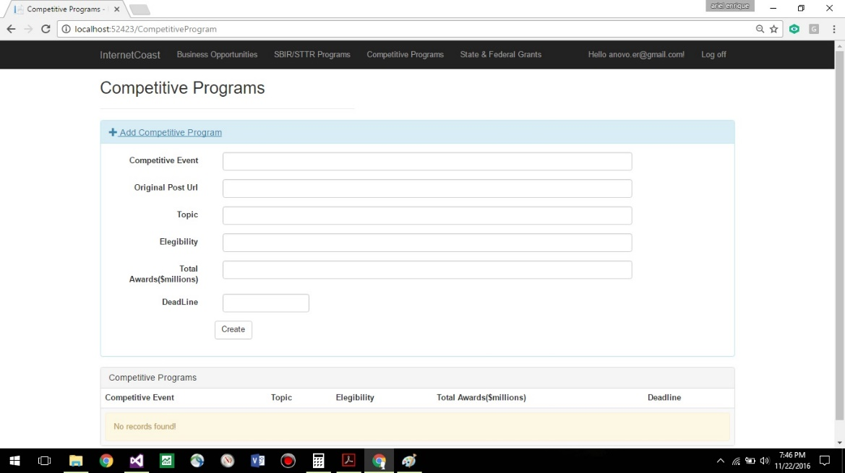

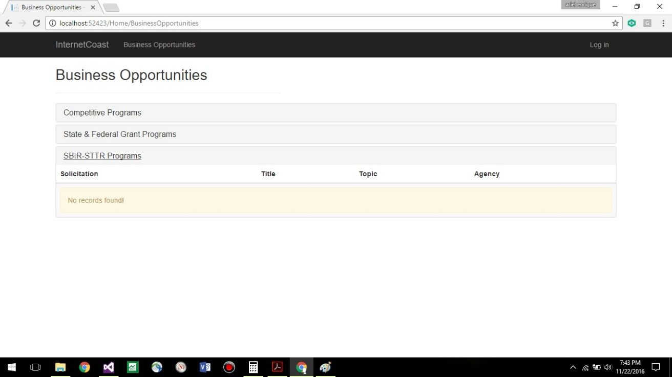

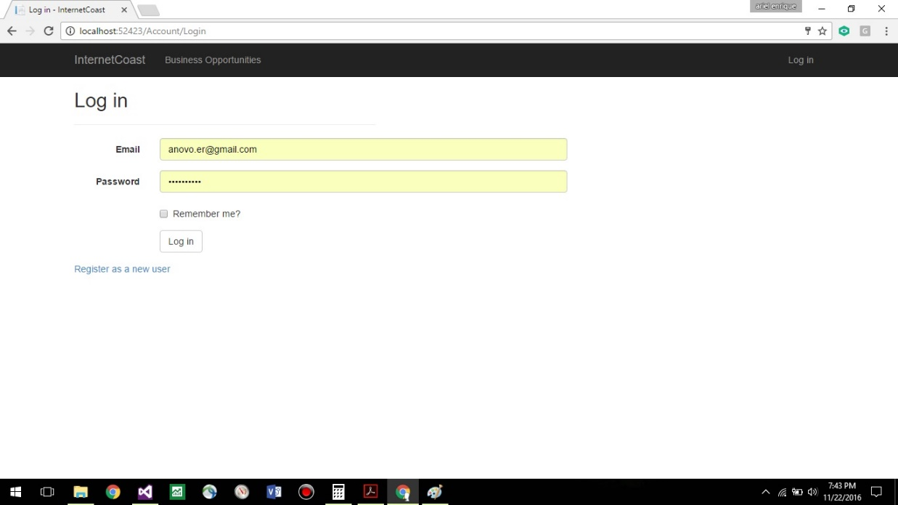

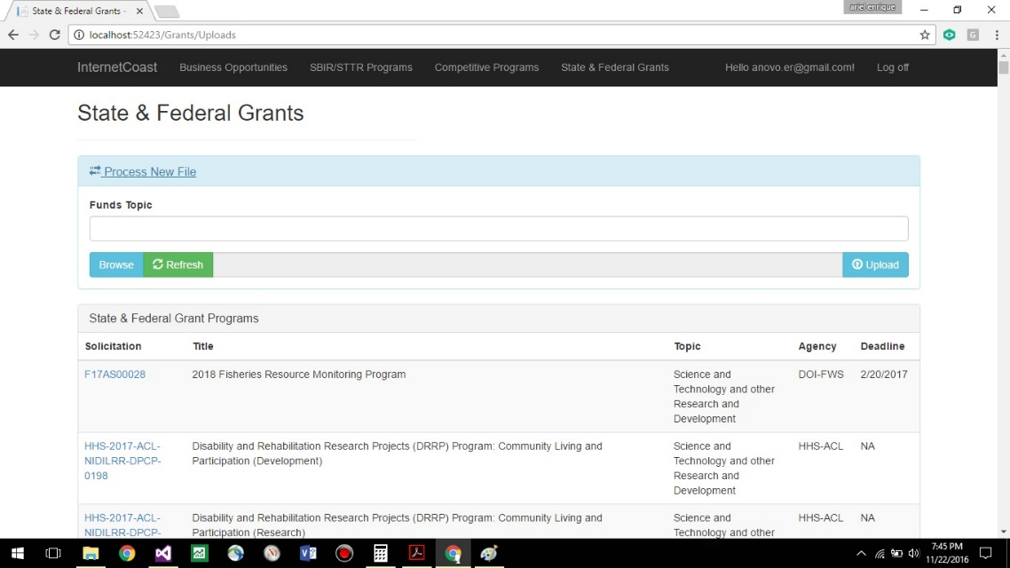

## 

## Appendix C - Sprint Review Reports

Sprint #3 Retrospective

Attendees: Dale Gregory, Ariel Novo

Start time: 10/10/2016 12:00 pm

End time: 10/10/2016 12:35 pm

What went wrong?

* We need to improve the estimation of the points.

What went right?

* Good communication during the sprint.
* Work was done as scheduled

How to address the issues in the next sprint?

* How to improve the process?
  + 8 points means one week of work and 16 points two weeks.

Sprint #4 Retrospective

Attendees: Dale Gregory, Ariel Novo

Start time: 10/20/2016 12:00 pm

End time: 10/20/2016 12:35 pm

What went wrong?

* n/a.

What went right?

* Good communication during the sprint.
* Work was done as scheduled

How to address the issues in the next sprint?

* How to improve the process?
  + 8 points means one week of work and 16 points two weeks.

Sprint #5 Restrospective

Attendees: Dale Gregory, Ariel Novo

Start time: 11/03/2016 12:00 pm

End time: 11/03/2016 12:35 pm

What went wrong?

* n/a.

What went right?

* Good communication during the sprint.
* Work was done as scheduled

How to address the issues in the next sprint?

* + n/a

# References

Internet Coast. www.icoast.com