*Florida International University*

*School of Computing and Information Sciences*

CIS 4911 - Senior Capstone Project

Software Engineering Focus

Final Deliverable

LegalWise

**Team Members Product Owner**: Jaime Borras

Amanda Chiu **Instructor**: Masoud Sadjadi

Valeria Lopez



*Copyright and trademark notices, restrictions on copying or distributing the documentation, information for contacting the issuing organization (reader’s comments), warranties, contractual obligations or disclaimers, and general warnings and cautions.*

***Abstract***

*The concept of LegalWise is a web application that can facilitate legal firms to answer legal questions using artificial intelligence technologies. This application can help tremendously on saving time by filtering legal documents electronically instead of doing manual work by hands. In this project, we are using modern technologies and cutting edge methodologies to achieve the expected outcome.*

# Table of Contents

Table of Contents 2

**Introduction** 4

Current System 4

Purpose of the New System 5

**Requirements of the System** 6

Requirement Elicitation – User Stories 6

Requirement Elicitation – Not Implemented 13

Requirement Analysis 16

**Software Architecture** 17

Overview – Package Diagram 17

Subsystem Decompositon 21

Hardware and Software Mapping 23

Persistent Data Management 23

Security and Privacy 25

**Detail Class Design** 26

Overview – Minimal Class Diagrams 26

Object Interaction 27

Detail Class Design 31

**Testing Process** 33

System Test 33

Subsystem Test 37

Evaluation of Test 37

Testing Tools 38

**Glossary** 39

**Appendix** 40

Appendix A - Project schedule (Gantt chart or PERT chart). 40

Appendix B – All use cases with nonfunctional requirements. 41

Appendix C – User Interface designs. 51

Appendix D – Analysis models (static and dynamic) 53

Appendix E – Object Interaction 55

Appendix F – Documented code for test drivers and stubs. 59

Appendix G – Scrums meetings. 60

# Introduction

The following document describes the architecture and design of LegalWise. The document is divided in five chapters and each chapter is divided in subsections. The first chapter is the Introduction which contains the Current System and the Purpose of the new System. The second chapter is Requirements of the System. This chapter includes the Requirement Elicitation and the Requirement Analysis. On the Requirement Elicitation, all the use cases implemented on the project are listed including all the functional and non-functional requirements. On the Requirement Analysis section, the object interaction is outlined. On the Hardware and Software Requirement we will find an Architectural design of the system. The third chapter is the Software Architecture chapter and is divide on Overview-Package Diagram, Subsystem Decomposition, Hardware and Software Mapping, Persistent Data Management and Security and Privacy. On the overview of the system the primary and secondary architectural patterns are define. The package diagrams showing the major subsystems are also part of this section. The Subsystem Decomposition describes each of the major subsystems and identifies the user stories associated with each subsystem. The Hardware and Software Mapping maps the subsystems to software and hardware. The Persistent Data Management identifies the data that needs to be stored and any security requirements. The Security/ Privacy section describes the user authentication process, encryption of data, and use of firewalls.

The Detail Class Design chapter is divide on Minimal Class Diagrams, Object Interaction and Detail Class Design. The Minimal Class Diagrams for the subsystem does not include any attributes for the classes. The Object Interaction includes all the Sequence Diagrams and Detail Class Design contains all the classes with methods and attributes.

## Current System

The legal system uses a great amount of human labor to accomplish tedious tasks on formatted documents. When a lawyer is looking for a case referral in order to use it on his/her current case, the staff needs to go over all the related cases and find the appropriate one that suits the circumstances. This process is time consuming and also prone to errors. This system is currently being use for years making law services very expensive and time consuming.

## Purpose of the New System

LegalWise is the solution for this problem. The web application is trained to answer simple legal questions and go back with related cases or answers that will help the lawyer to win a case. The user registers for an account on the application and once approve it, he/she can use the application freely. The user must provide a legal question within the application domain and he/she will receive an answer with a percentage of accuracy. If the user needs a reference for related/similar cases, the answer provided by with a link to access the related case. The application makes the tedious and time consuming work within a few seconds giving the legal industry a tool that can help to lower cost and increase productivity.

|  |  |
| --- | --- |
| **LegalWise** |  |
| **User Story ID** | LegalWise_001 |
| **User Story Level** |  |
| **Scenario** | User asks a question to the application. The response should have a hyperlink with the source case that redirects the user to the case. |
| **Actor** | User |
| **Pre-Conditions** | 1. The user must be sign in to the system 2. The user input a question for the application |
| **Description** | 1. Use case begins when the user inputs a question into the question window and clicks on the button to receive a response. 2. The application generates a response based on the databases. 3. The response includes a hyperlink with the source case. 4. The hyperlink will redirect the user to the source case in a new window |
| **Relevant Requirements** | The user must have access to the application |
| **Post – Conditions** | Each response provide by the application will include a hyperlink with source case. |
| **Alternative Courses of Action** | If the application doesn’t have an answer for the question, a predetermine answer will be provided |
| **Exceptions** | 1. Unable to reach the server to get a response. 2. Unable to redirect the user when clicking on the hyperlink. |
| **Related User Stories** | LegalWise_002 |
| **Decision Support** |  |
| **Frequency** | One by response provided by the application |
| **Critically** | High. The user must be able to refer to the source case |
| **Risk** | Medium. Implementing this story requires the application to communicate with the database to retrieve the source case |
| **Constrains** | 1. The request for the source case should be loaded immediately |
| **Modification History** |  |
| **Owner** | Valeria Lopez |
| **Initiation Date** | 09/10/2015 |
| **Date Last Modified** | 09/10/2015 |

# Requirements of the System

## Requirement Elicitation – User Stories

|  |  |
| --- | --- |
| **LegalWise** |  |
| **User Story ID** | LegalWise_002 |
| **User Story Level** | High-Level |
| **Scenario** | User inputs content and Q&A tool responds with suggestion. |
| **Actor** | User |
| **Pre-Conditions** | 1. User must be logged in 2. User must be on the homepage |
| **Description** | 1. Use case begins when the user has inputted some context and clicks enter. 2. The system shall display a suggestion message. |
| **Relevant Requirements** | The user is not inputting the wrong content format. i.e audio |
| **Post – Conditions** | 1. Query was successfully called 2. The suggestion message is displayed. |
| **Alternative Courses of Action** | 1. In D1, if |
| **Exceptions** | If the system cannot find or analyze the content entered by the user, the screen shall display a message to inform user no data could be found for reference. |
| **Related User Stories** |  |
| **Decision Support** |  |
| **Frequency** | High |
| **Critically** | High. As this is core functionality. |
| **Risk** | Medium. Implementing this use case requires the system to connect to the server and database. |
| **Constrains** | Content must be validated by grammar check. |
| **Modification History** |  |
| **Owner** | Amanda Chiu |
| **Initiation Date** | 09/11/15 |
| **Date Last Modified** | 09/11/15 |

|  |  |
| --- | --- |
| **LegalWise** |  |
| **User Story ID** | LegalWise_003 |
| **User Story Level** |  |
| **Scenario** | User needs to create an account in order to access the application |
| **Actor** | User |
| **Pre-Conditions** | 1. The registration page must be active |
| **Description** | 1. Use Case begins when the user lands on the registration page and is ready to register. 2. The user fills all the appropriate information on the site and clicks the Register button. 3. The user completes the registration when confirms his/her email address. |
| **Relevant Requirements** |  |
| **Post – Conditions** | 1. A new user is created on the system 2. An email to confirm the user’s email address is send. In order to confirm the account the user must confirm his/her email address. |
| **Alternative Courses of Action** | 1. At any point on the registration the user can cancel the request |
| **Exceptions** | 1. Unable to reach the server to create the user 2. The user did not fill up all the required information 3. User is already on the system |
| **Related User Stories** | None |
| **Decision Support** |  |
| **Frequency** | On average 20% of the visitors will sign up on a daily basis |
| **Critically** | High. The user needs to register in order to have access to the application features |
| **Risk** | Medium. The information of the user will be save on the server. |
| **Constrains** | 1. User should be able to use this story easily. 2. The application should be able to handle as many request as the number of visitors |
| **Modification History** |  |
| **Owner** | Valeria Lopez |
| **Initiation Date** | 09/10/2015 |
| **Date Last Modified** | 09/10/2015 |

|  |  |
| --- | --- |
| **LegalWise** |  |
| **User Story ID** | LegalWise_004 |
| **User Story Level** | Low-Level |
| **Scenario** | When user edits personal information for his/her profile. |
| **Actor** | User |
| **Pre-Conditions** | 1. User must be logged in 2. User must be on the profile page |
| **Description** | 1. Use case begins when the user has inputted personal information and clicks Save button. 2. The system shall display a successful message. |
| **Relevant Requirements** |  |
| **Post – Conditions** | 1. Profile was successfully updated. 2. The successful message is displayed. |
| **Alternative Courses of Action** |  |
| **Exceptions** | In D1, if user left out required field(s) blank, the system should not allow user to proceed and wait until user inputs correct data. |
| **Related User Stories** | LegalWise_003 |
| **Decision Support** |  |
| **Frequency** | Intermediate |
| **Critically** | Low. As Watson result suggestion is not dependent on user profile. |
| **Risk** | Medium. Implementing this use case requires the system to connect to the database. |
| **Constrains** | 1. User must be logged in. |
| **Modification History** |  |
| **Owner** | Amanda Chiu |
| **Initiation Date** | 09/11/15 |
| **Date Last Modified** | 09/11/15 |

|  |  |
| --- | --- |
| **LegalWise** |  |
| **User Story ID** | LegalWise_005 |
| **User Story Level** |  |
| **Scenario** | User forgets his/her password to access the application |
| **Actor** | User |
| **Pre-Conditions** | 1. User must have an active account on the system |
| **Description** | 1. Use case begins when the user attempts to sign in to the application, but doesn’t have the proper credentials 2. To obtain a new password to access the application, the user will click on “Forget Password” on the sign in page. 3. The user is redirected to a page to provide his/her email address. The user clicks on the submit button 4. An email with the steps to follow is send to the user’s email address 5. The user must follow the steps on the email to obtain a new password |
| **Relevant Requirements** |  |
| **Post – Conditions** | 1. The user creates a new password 2. The user is able to access the application |
| **Alternative Courses of Action** | 1. At any point on the request the user can cancel the action. |
| **Exceptions** | 1. The user doesn’t have an active account on the system. 2. The user never confirmed his/her email address. |
| **Related User Stories** | LegalWise_001 |
| **Decision Support** |  |
| **Frequency** | On average 10% of the register user will require this feature |
| **Critically** | Medium. The user cannot access the application without the proper credentials. |
| **Risk** | Medium. The request to change the password may be started by someone else that is not the user. |
| **Constrains** | 1. The application should be able to receive as many request as the number of registered users on the system. |
| **Modification History** |  |
| **Owner** | Valeria Lopez |
| **Initiation Date** | 09/10/2015 |
| **Date Last Modified** | 09/10/2015 |

|  |  |
| --- | --- |
| **LegalWise** |  |
| **User Story ID** | LegalWise_006 |
| **User Story Level** | Low-Level |
| **Scenario** | User logs in to his/her account. |
| **Actor** | User |
| **Pre-Conditions** | User must be logged out.  User must be on the login page. |
| **Description** | Use case begins when the user has inputted login credentials and clicks Sign in button.  The system shall directs user to the homepage. |
| **Relevant Requirements** |  |
| **Post – Conditions** | User was successfully logged in. |
| **Alternative Courses of Action** |  |
| **Exceptions** | In D1, if user inputs wrong login credentials, the system should display an error message to inform user he/she has inputted wrong credentials. |
| **Related User Stories** |  |
| **Decision Support** |  |
| **Frequency** | High |
| **Critically** | High. As user must have an account in order to use the application. |
| **Risk** | High. Implementing this use case requires the system to connect to the server and database. |
| **Constrains** | User must be logged out. |
| **Modification History** |  |
| **Owner** | Amanda Chiu |
| **Initiation Date** | 09/11/15 |
| **Date Last Modified** | 09/11/15 |

|  |  |
| --- | --- |
| **LegalWise** |  |
| **User Story ID** | LegalWise_007 |
| **User Story Level** |  |
| **Scenario** | User uploads a PDF document. |
| **Actor** | User |
| **Pre-Conditions** | 1. The user must be sign in to the system |
| **Description** | 1. Use case begins when the user uploads a PDF document and presses upload button. 2. The application generates a response based on the databases. 3. The response includes a hyperlink with the source case. 4. The hyperlink will redirect the user to the source case in a new window |
| **Relevant Requirements** | The user must have access to the application |
| **Post – Conditions** | User has successfully uploaded a PDF document. |
| **Alternative Courses of Action** | If the PDF document is invalid, the system should reject the request. |
| **Exceptions** | 1. Unable to reach the server to get a response. 2. Unable to upload due to an invalid document. |
| **Related User Stories** | LegalWise_002 |
| **Decision Support** |  |
| **Frequency** | One by response provided by the application |
| **Critically** | High. The  user must be able to refer to the source case |
| **Risk** | Medium. Implementing this story requires the application to communicate with the database and the web server. |
| **Constrains** | 1. The PDF document must be a valid document. |
| **Modification History** |  |
| **Owner** | Amanda Chiu |
| **Initiation Date** | 09/15/2015 |
| **Date Last Modified** | 09/15/2015 |

## Requirement Elicitation – Not Implemented

|  |  |
| --- | --- |
| **LegalWise** |  |
| **User Story ID** | LegalWise_008 |
| **User Story Level** |  |
| **Scenario** | Upgrade the Solr Server |
| **Actor** | Developer |
| **Pre-Conditions** | 1. None |
| **Description** | 1. The Solr Server use by the QA system is upgraded to a new version. 2. The Solr Sever is compatible with the logic and Java version 3. The Solr Server is index properly and is able to answer questions |
| **Relevant Requirements** | The developer must have access to the application. |
| **Post – Conditions** | The developer can test the system from the UI. |
| **Alternative Courses of Action** | The new version of the Solr Server is not compatible with the logic or Java version currently being use on the system. |
| **Exceptions** | 1. Unable to reach the server to get a response. 2. Unable to answer questions. |
| **Related User Stories** | None |
| **Decision Support** |  |
| **Frequency** | High. The Server will be use on each request to the UI. |
| **Critically** | High. The  Solr Server must be working in order for application to work. |
| **Risk** | Medium. Implementing this story requires the Solr Server to be compatible with the logic and Java version. |
| **Constrains** | None |
| **Modification History** |  |
| **Owner** | Valeria Lopez |
| **Initiation Date** | 11/25/2015 |
| **Date Last Modified** | 11/25/2015 |

|  |  |
| --- | --- |
| **LegalWise** |  |
| **User Story ID** | LegalWise_009 |
| **User Story Level** |  |
| **Scenario** | Index cases to the Solr Server. |
| **Actor** | Developer |
| **Pre-Conditions** | The Solr Server must be working properly and the Developer must have access to the server. |
| **Description** | 1. Use case begins when the Developer index the Solr Server. 2. The cases must have the proper format and only include relevant information. 3. The Developer should be able to see the case uploaded into the Solr Server and index properly. 4. The Developer should be able to answer questions with the indexed legal files. |
| **Relevant Requirements** | The developer must have access to the source code and server. |
| **Post – Conditions** | The developer is able to test the application from the UI. |
| **Alternative Courses of Action** | The legal files were not index properly and the QA system is not able to find them to provide answers to questions on the UI. |
| **Exceptions** | 1. Unable to reach the server to get a response. 2. Unable to upload the legal files due to incorrect format. |
| **Related User Stories** | LegalWise_008 |
| **Decision Support** |  |
| **Frequency** | High. The application depends on the legal files to answer questions. |
| **Critically** | High. The application depends on the legal files to answer questions. |
| **Risk** | Medium. The Solr Sever depends on the indexed files to answer questions. |
| **Constrains** | 1. The legal files must have the proper format and include only relevant information. |
| **Modification History** |  |
| **Owner** | Valeria Lopez |
| **Initiation Date** | 11/25/2015 |
| **Date Last Modified** | 11/25/2015 |

|  |  |
| --- | --- |
| **LegalWise** |  |
| **User Story ID** | LegalWise_010 |
| **User Story Level** |  |
| **Scenario** | Add PROs and CONs to answer in the application. |
| **Actor** | User |
| **Pre-Conditions** | 1. The user must be sign in to the system |
| **Description** | 1. Use case begins when the user types a question on the UI. 2. The application generates response including all the pros and cons for the question. 3. The use case ends when the user can see the Pros and Cons in the UI |
| **Relevant Requirements** | The user must have access to the application |
| **Post – Conditions** | The user can see the Pros and Cons for a question. |
| **Alternative Courses of Action** | The user inputs an invalid question or the system doesn’t have supporting documents to answer with Pros and Cons to answer the question. |
| **Exceptions** | 1. Unable to reach the server to get a response. 2. Invalid question. 3. No supporting documents |
| **Related User Stories** | LegalWise_008, LegalWise_009 |
| **Decision Support** |  |
| **Frequency** | High. A user may ask 3 questions per day. |
| **Critically** | High. Each user should have access to receive an answer with Pros and Cons |
| **Risk** | Medium. Implementing this story requires the Solr Sever to be index properly with relevant documentation and changes in the source code to resolve the Pros and Cons. |
| **Constrains** | 1. The question must be valid and have supporting documentation indexed on the Solr Server. |
| **Modification History** |  |
| **Owner** | Valeria Lopez |
| **Initiation Date** | 11/25/2015 |
| **Date Last Modified** | 11/25/2015 |

## Requirement Analysis

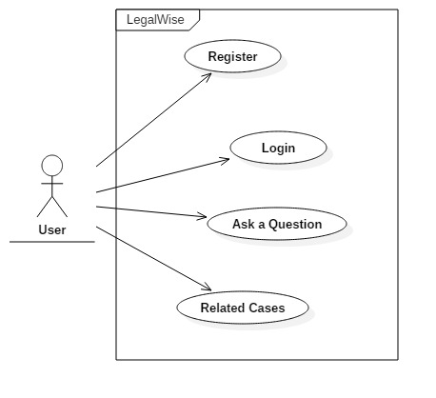

# Software Architecture

## Overview – Package Diagram

The architectural patterns choose for LegalWise are Three Tier Pattern as the primary pattern and the Model View Controller (MVC) as a secondary pattern.

The Three Tier pattern was selected as a primary pattern because the project will be implemented as a web application with the need of a presentation layer or user interface, a business layer where all the application code will reside and the store of persistent data where the legal documents will be save and also user information. In the presentation layer all the windows, forms and webpages will reside. The logic layer will include the control and entity objects for the application. The storage layer will handle the storage, retrieval and query of persistent objects.

The MVC pattern was selected as a secondary pattern because the system needs a view to be displayed to the user since is a web application, it also needs a model that can maintain the domain knowledge to handle the request from the users and a controller that manages the sequences of interactions between the user and the system. The controller gathers information from the user and sends the message to the model. This includes the questions and answer process and user registration.

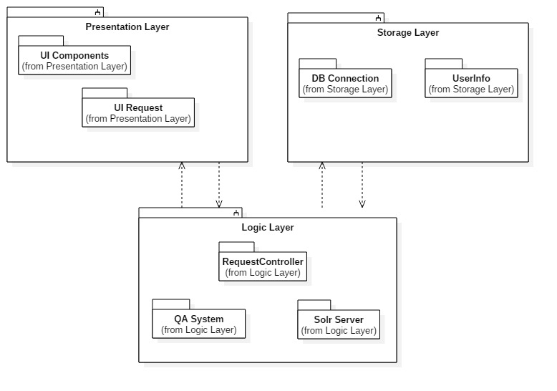

**Figure 1**

**Presentation Layer – Package Diagram**

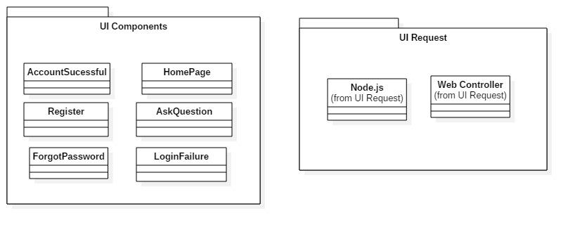

**Figure 2**

**Logic Layer – Package Diagram**

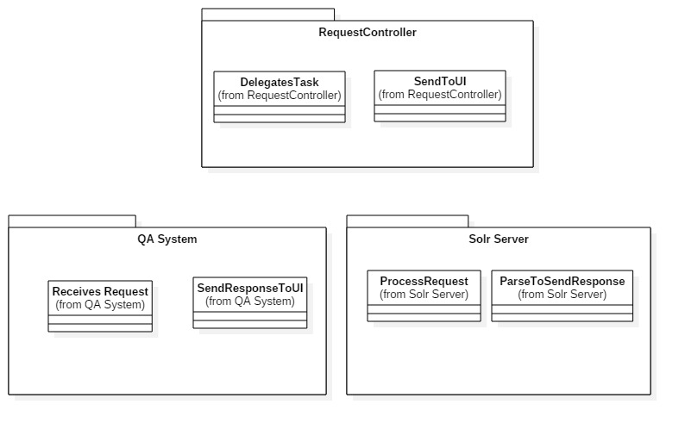

**Figure 3**

**Storage Layer – Package Diagram**

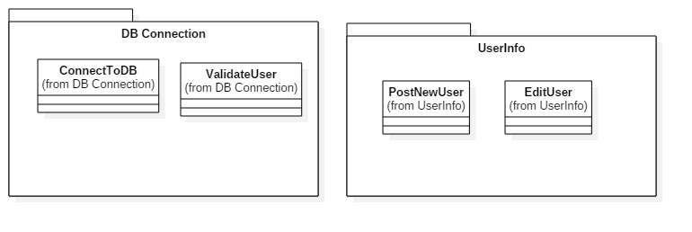

**Figure 4**

## Subsystem Decompositon

**Presentation Layer:** The presentation layer is in charge of the UI and contains all the code that interacts directly with the user. Inside of this layer we will have two packages:

* UI Interactions
* UI Request

UI Interactions handles all the pages, forms, and pictures that the user sees; while UI Request send the information the user inputs on the application to the Logic Layer. The use cases associated with this subsystem are:

* LegalWise_001
* LegalWise_002
* LegalWise_003
* LegalWise_004
* LegalWise_005
* LegalWise_006

**Logic Layer:** The logic layer handles all the interaction between the components of the application. It receives information from the Presentation Layer to be process, send and retrieves information from the database and interacts with the QA system. The logic layer contains the following packages:

* Request Controller
* QA System
* Solr Server

Request Controller receives request from all the components of the application and redirects this request to the appropriate subsystem. The QA system handles all the questions and answer processing. The Solr server has the logic to answer the questions, tools and indexed files:

* LegalWise_001
* LegalWise_002
* LegalWise_003
* LegalWise_004
* LegalWise_005
* LegalWise_006

**Storage Layer:** The storage layer handles all the request to the Cloundant Database for users. It builds the JSON objects to store the new users and retrieves any information needed by the Presentation Layer. The Storage Layer has the following packages:

* DB Connection
* User Info

The User Info stores a new user in the database. The DB connections handles the connection to the NoSql database through modules. The following use cases are related to this subsystem.

* LegalWise_001
* LegalWise_003
* LegalWise_004
* LegalWise_005
* LegalWise_006

## Hardware and Software Mapping

To develop the LegalWise web application we decided to use the Node.js web application starter from Bluemix. The application will use JavaScript for the server side and the client side. To be able to store all the legal documents we choose the IBM Cloundant NoSql database that is based on Apache CouchDB and is delivered as a multitenant dedicated, and installed service. On the backend we have an application built in Java using the Solar sever as a question and answer tool. The Q&A system was built in UNIX using the code from the Taming Text book. In order to communicate the Q&A tool and UI needs a REST service that will respond to queries. The rest service will provide a URL, username and password to communicate and send request.

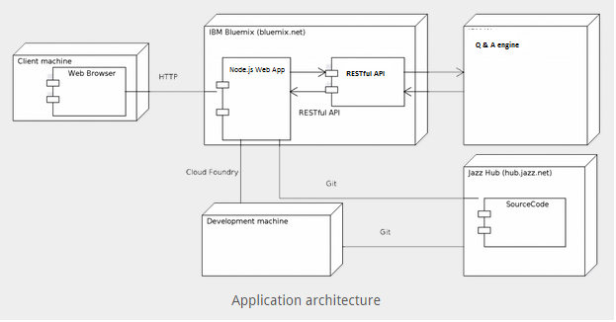

**Figure 5**

## Persistent Data Management

For the LegalWise application only the user information will be save and change continually. The cases will not be store in the NoSql database.

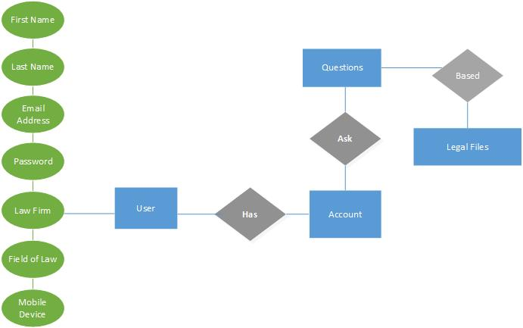



## Security and Privacy

On the LegalWise web application the user authentication process follows the following format. A user needs to register in the application in order to have access to the Q&A system. The user must provide all the information to be store according to the persistent data management chapter. Once the user has register and has access to the application, the user must login before using the Q&A system. The user will use an email address and a password to login to the application. All the information is stored at the Cloudant NoSql database. The web services query the database with the email address and confirms if the password to allow the user to proceed. Currently the user doesn’t need to provide any type of payment to use the application thus there is no need for encryption at this level. The Cloudant NoSql database is hosted on Bluemix therefore counts with the security of the IBM Public Cloud. All the communication between the web services and the database happens inside the Bluemix Cloud.

# Detail Class Design

## Overview – Minimal Class Diagrams



**Minimal Class Diagram for Logic Layer**

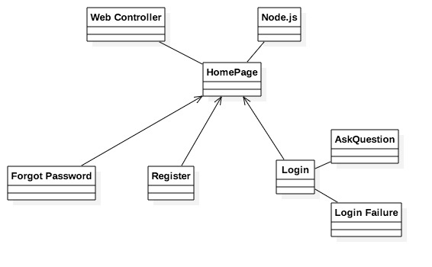

**Minimal Class Diagram for Presentation Layer**

## Object Interaction

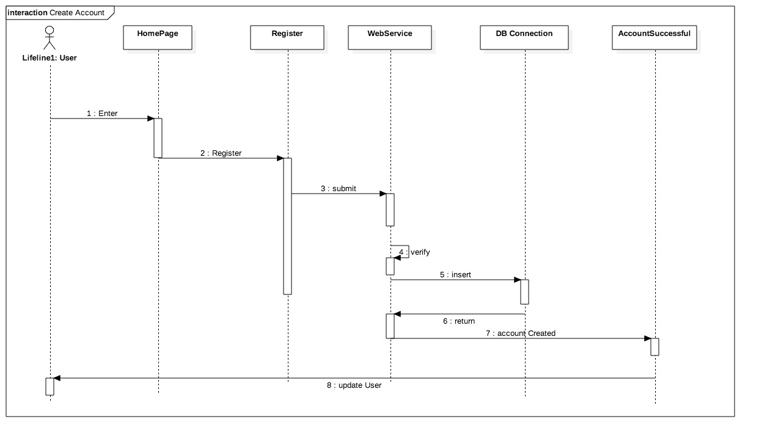

**Figure 6 – Create Account**

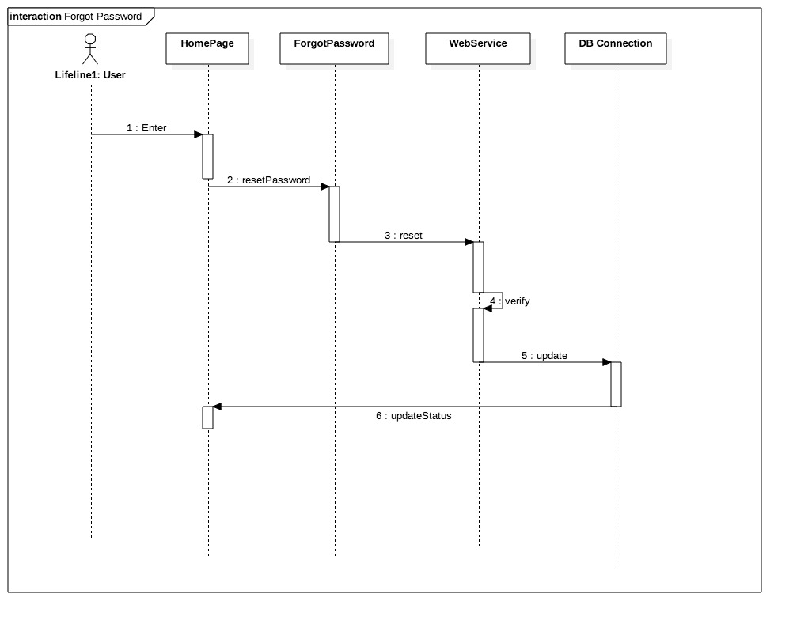

**Figure 7 – Forget Password**

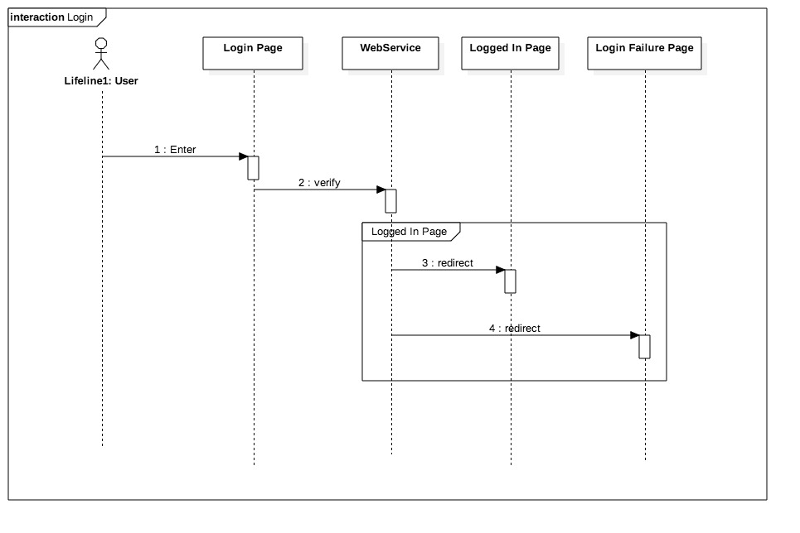

**Figure 8 – Login**

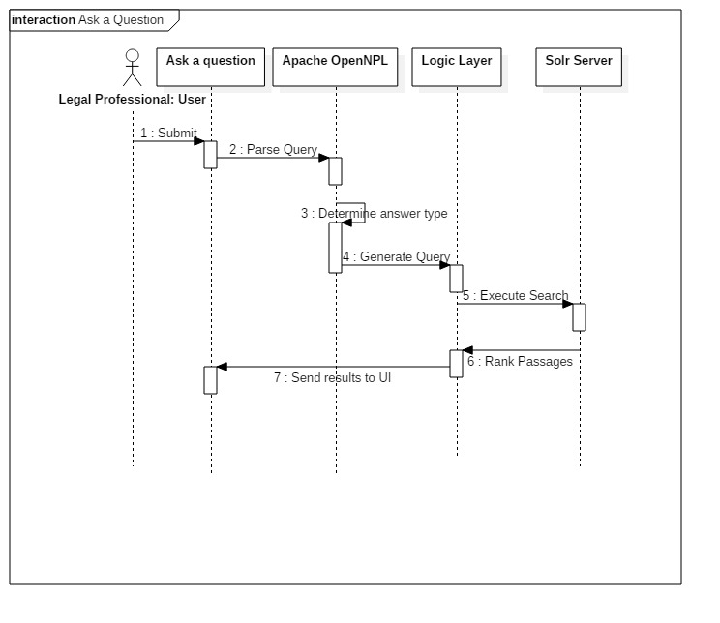

**Figure 9 – Ask Question**

## Detail Class Design

The system is decomposed in 3 subsystems. The Presentation Layer the logic layer and the storage layer.

**Presentation Layer:** The presentation layer is responsible for the interaction between the user and the system. Inside the presentation layer we have two packages:

UI Components: This package has all the pages from the web application. Each page will send the request to the UI Request package to be process. The pages currently in the system are:

* AccountSuccessful
* HomePage
* Register
* AskQuestion
* ForgotPassword
* LoginFailure

Each of the pages has a self-descripting name for development purposes.

UI Request: Handles the interaction between the UI Components and the Logic Layer. It sends the request to the web services on the Logic Layer for further processing. The components inside the UI request are:

* Node.js – server where the system is running on. Includes all the modules and outside libraries.
* Web Controller – Receives request from the UI and sends it to the Logic Layer. It also receives request from the Logic Layer and sends it to the UI Component.

**Logic Layer:** The logic layer handles the interaction between the UI, Webs services, database and the QA system. The packages inside the Logic Layer goes as follows:

Request Controller: It handles the interaction between the web services, QA system and Solr sever. The request controller has the following components:

* DelegateTask: As described by its name, it delegates the task to its respective component.
* SendToUI: Send the response to the UI. The response may come from any of the components of the UI.

QA System: The QA system has two components to parse the question and find the proper answer from the system.

* Receives Request: Parses the question, and match the sentence with some documents in the databse.
* SendResponsetoUI: Selects the more accurate response according to the ranks and sends the response to the UI.

Solr Server: The Solr sever has all the documents indexed and makes it easy for searching. Each documents has a unique ID, title and different fields to help to find the results faster. The Solr has two components that are important to the understanding of the system.

* ProcessRequest
* ParseToSendResponse

**Storage Layer:** This layer handles the storage of users in the system. It has two main components:

DB Connection: Handles the connection between the web services and the NoSql database. This component is divided as follows:

* ConnectToDB
* ValidateUser

UserInfo : Uses a JSON object to save, edit or delete the user from the database. The UserInfo component is divided as follows:

* PostNewUser – creates a new user in the system
* EditUser – modifies an existing user from the system

# Testing Process

## System Test

**TEST SUITE LegalWise_001**

**Purpose:** To test the functionality of use case:LegalWise_003: User needs to create an account.

**Test case 1:**

Purpose:

* To test the functionality when a user register on the website. The user should receive an email to confirm his/her account.

Precondition:

* The application must be running properly on the IBM Cloud
* The database needs to be properly bind to the application and accessible to the web services
* The IBM Cloud and DevOps services must be working properly

Input:

A new user has access to the homepage and would like to create an account to use the application. The user clicks on Sign Up button on the top left corner of the website. The new user provides the following information.

* First Name
* Last Name
* Email address
* Password
* Mobile Number
* Position
* Field of Law
* Law Firm

Once the user clicks the Submit button a new user is created on the database.

Expected Output:

A new user is created on the database and the user receives an email to confirm the account. Once the user confirms the account he/she is able to login and use the application.

**Test case 2:**

Purpose:

* To test the functionality when a user register on the website. The user should be able to login to through the homepage.

Precondition:

* The user should have access to the application
* The application must be running properly on the IBM Cloud
* The user must have register on the website and have a valid account.

Input:

In order for the user to login through the homepage he/she must provide with the following credentials which must match the ones in the database. If the user is not register or does not have a valid account he/she will not be able to login.

* Email
* Password

Expected Output:

After the user provides the credentials on the homepage and clicks the Login button, he/she should have access to the application.

**Test case 3:**

Purpose:

* To test a user is not able to create an account when the required fields are blank.

Precondition:

* The application must be running properly on the IBM Cloud
* The database needs to be properly bind to the application and accessible to the web services
* The IBM Cloud and DevOps services must be working properly

Input:

A new user has access to the homepage and would like to create an account to use the application. The user clicks on Sign Up button on the top left corner of the website. The new user provides some of the following information and leaves some fields in blank.

* First Name
* Last Name
* Email address
* Password
* Mobile Number
* Position
* Field of Law
* Law Firm

Expected Output:

* An error message is display on the UI “Please fill out this field”. The user must fill out all the fields before proceeding.

**TEST SUITE LegalWise_002**

**Purpose:** To test the functionality of use case:LegalWise_005: User forgot password.

**Test case 1:**

Purpose:

* To test the functionality when a user register on the website and forgets his/her password. The user should be able to reset his/her password on the website.

Precondition:

* The user should have access to the application
* The application must be running properly on the IBM Cloud
* The user must have register on the website and have a valid account.

Input:

On the homepage the user will click the Forget Password button and follow the instructions to reset his/her password. On the next page the user will be ask to provide a valid email address and an email will be send with instructions on how to reset the password.

Expected Output:

After the user fills up his/her information an email will be send to his/her account to reset the password.

**Test case 2:**

Purpose:

* To test the functionality when a user register on the website and forgets his/her password. The user should be able to reset his/her password on the website.

Precondition:

* The user should have access to the application
* The application must be running properly on the IBM Cloud
* The user must have register on the website and have a valid account.

Input:

On the homepage the user will click the Forget Password button and follow the instructions to reset his/her password. On the next page the user will be ask to provide a valid email address. The user will provide an email address not on the database.

* Email address: none@gmail.com

Expected Output:

An error message will display on the page letting the user know that there are no user register with that email address.

**Test case 3:**

Purpose:

* To test a user is not able to proceed to reset the password when the email address field is blank.

Precondition:

* The application must be running properly on the IBM Cloud
* The database needs to be properly bind to the application and accessible to the web services
* The IBM Cloud and DevOps services must be working properly

Input:

On the homepage the user will click the Forget Password button and follow the instructions to reset his/her password. On the next page the user will be ask to provide a valid email address. The email address field will be blank.

Expected Output:

* An error message is display on the UI “Please fill out this field”. The user must fill out all the requested field with a valid email address before proceeding.

**TEST SUITE LegalWise_003**

**Purpose:** To test the functionality of use case:LegalWise_003: User ask a question to the application.

**Test case 1:**

Purpose:

* To test the functionality when a user ask a question to the Q&A engine.

Precondition:

* The application must be running properly on the IBM Cloud
* The user must have a valid account to use the system.
* The Solr Server must be running properly.
* The user must be login to the system.

Input:

A user has a valid account and is ready to use the application. The user navigates to the “Ask a Question” page and types a question on the box.

* Question: What is dry ice?

Expected Output:

The Q&A engine comes back with an answer based on the files indexed on the server. Also comes back with a list of documents that contain any reference with dry ice.

**Test case 2:**

Purpose:

* To test the functionality when a user ask a question to the Q&A engine.

Precondition:

* The application must be running properly on the IBM Cloud
* The user must have a valid account to use the system.
* The Solr Server must be running properly.
* The user must be login to the system.

Input:

A user has a valid account and is ready to use the application. The user navigates to the “Ask a Question” page and phrase in the box

Phrase: panthers FIU

Expected Output:

The application comes back with all the documents that have any reference for panthers FIU.

**Test case 3:**

Purpose:

* To test the functionality when a user ask a question to the Q&A engine when there is no input.

Precondition:

* The application must be running properly on the IBM Cloud
* The user must have a valid account to use the system.
* The Solr Server must be running properly.
* The user must be login to the system.

Input:

A user has a valid account and is ready to use the application. The user navigates to the “Ask a Question” page and leaves the box on blank and clicks search.

Expected Output:

The Q&A engine doesn’t process any request and doesn’t return anything.

|  |  |
| --- | --- |
| **TEST SUITE** | **LegalWise_003** |
| **Purpose:** | To test the functionality of use case: LegalWise_003: User ask a question to the application. |
| **Precondition:** | * The application must be running properly on the IBM Cloud * The user must have a valid account to use the system. * The Solr Server must be running properly. * The user must be log in to the system. |
| **Input :** | A user has a valid account and is ready to use the application. The user navigates to the “Ask a Question” page and types a question on the box.   * Question: What is dry ice? |
| **Expected Output:** | The Q&A engine comes back with an answer based on the files indexed on the server. Also comes back with a list of documents that contain any reference with dry ice. |

## Subsystem Test

There are 2 implemented use cases that will be tested: Log in, Create Account, and verify new user. We used a JavaScript unit testing framework called QUnit to perform our subsystem testing. TC1 is to test if user logs into the system with the correct credentials, it should return username and password. TC2 is to test if the database receives the correct information that the user inputs on the create account form. Test method should return user telephone number.

TC1

* User should get login credentials.
  + Returns login credentials.

TC2

* User should get account information: telephone number
  + Returns account information: telephone number

## Evaluation of Test

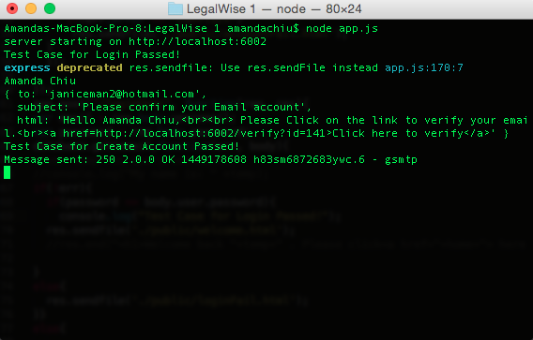

## Testing Tools

The testing tool that we used for the project is QUnit. QUnit is easy-to-use JavaScript unit testing framework. It's used by the jQuery, jQuery UI and jQuery Mobile projects and is capable of testing any generic JavaScript code. We implemented total of three test cases for three methods: Login, create account, and verify account. We tested the expected by printing the results on the console log. Please see the screenshots in Evaluation of Test for reference.

# Glossary

**Solr**: The Solr sever has all the documents indexed and makes it easy for searching.

**JSON**: (Javascript Object Notation) is a text-based, human-readable data interchange format used for representing simple data structures and objects in Web browser-based code.

**MVC**: (Model View Controller) : an architectural pattern

**UML**: Unified Modeling Language

**Use Case**: Sequence of events that describe all possible actions between the actor and the system

**Deliverable**: work product for client

# Appendix

## Appendix A - Project schedule (Gantt chart or PERT chart).

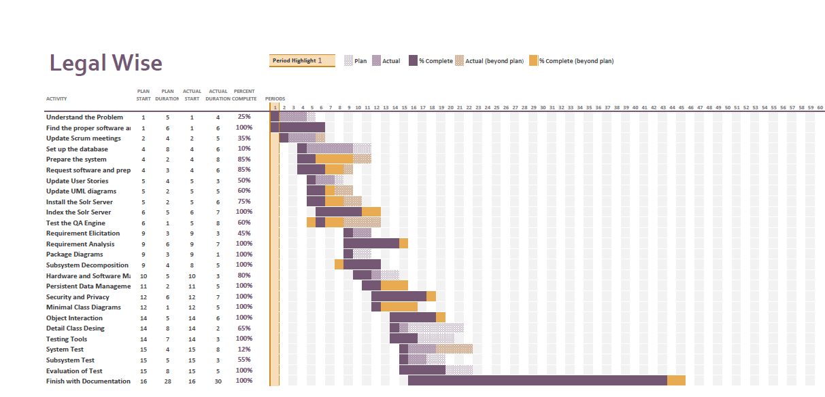

## Appendix B – All use cases with nonfunctional requirements.

|  |  |
| --- | --- |
| **LegalWise** |  |
| **User Story ID** | LegalWise_001 |
| **User Story Level** |  |
| **Scenario** | User asks a question to the application. The response should have a hyperlink with the source case that redirects the user to the case. |
| **Actor** | User |
| **Pre-Conditions** | 1. The user must be sign in to the system 2. The user input a question for the application |
| **Description** | 1. Use case begins when the user inputs a question into the question window and clicks on the button to receive a response. 2. The application generates a response based on the databases. 3. The response includes a hyperlink with the source case. 4. The hyperlink will redirect the user to the source case in a new window |
| **Relevant Requirements** | The user must have access to the application |
| **Post – Conditions** | Each response provide by the application will include a hyperlink with source case. |
| **Alternative Courses of Action** | If the application doesn’t have an answer for the question, a predetermine answer will be provided |
| **Exceptions** | 1. Unable to reach the server to get a response. 2. Unable to redirect the user when clicking on the hyperlink. |
| **Related User Stories** | LegalWise_002 |
| **Decision Support** |  |
| **Frequency** | One by response provided by the application |
| **Critically** | High. The user must be able to refer to the source case |
| **Risk** | Medium. Implementing this story requires the application to communicate with the database to retrieve the source case |
| **Constrains** | 1. The request for the source case should be loaded immediately |
| **Modification History** |  |
| **Owner** | Valeria Lopez |
| **Initiation Date** | 09/10/2015 |
| **Date Last Modified** | 09/10/2015 |

|  |  |
| --- | --- |
| **LegalWise** |  |
| **User Story ID** | LegalWise_002 |
| **User Story Level** | High-Level |
| **Scenario** | User inputs content and Q&A tool responds with suggestion. |
| **Actor** | User |
| **Pre-Conditions** | 1. User must be logged in 2. User must be on the homepage |
| **Description** | 1. Use case begins when the user has inputted some context and clicks enter. 2. The system shall display a suggestion message. |
| **Relevant Requirements** | The user is not inputting the wrong content format. i.e audio |
| **Post – Conditions** | 1. Query was successfully called 2. The suggestion message is displayed. |
| **Alternative Courses of Action** | 1. In D1, if |
| **Exceptions** | If the system cannot find or analyze the content entered by the user, the screen shall display a message to inform user no data could be found for reference. |
| **Related User Stories** |  |
| **Decision Support** |  |
| **Frequency** | High |
| **Critically** | High. As this is core functionality. |
| **Risk** | Medium. Implementing this use case requires the system to connect to the server and database. |
| **Constrains** | Content must be validated by grammar check. |
| **Modification History** |  |
| **Owner** | Amanda Chiu |
| **Initiation Date** | 09/11/15 |
| **Date Last Modified** | 09/11/15 |

|  |  |
| --- | --- |
| **LegalWise** |  |
| **User Story ID** | LegalWise_003 |
| **User Story Level** |  |
| **Scenario** | User needs to create an account in order to access the application |
| **Actor** | User |
| **Pre-Conditions** | 1. The registration page must be active |
| **Description** | 1. Use Case begins when the user lands on the registration page and is ready to register. 2. The user fills all the appropriate information on the site and clicks the Register button. 3. The user completes the registration when confirms his/her email address. |
| **Relevant Requirements** |  |
| **Post – Conditions** | 1. A new user is created on the system 2. An email to confirm the user’s email address is send. In order to confirm the account the user must confirm his/her email address. |
| **Alternative Courses of Action** | 1. At any point on the registration the user can cancel the request |
| **Exceptions** | 1. Unable to reach the server to create the user 2. The user did not fill up all the required information 3. User is already on the system |
| **Related User Stories** | None |
| **Decision Support** |  |
| **Frequency** | On average 20% of the visitors will sign up on a daily basis |
| **Critically** | High. The user needs to register in order to have access to the application features |
| **Risk** | Medium. The information of the user will be save on the server. |
| **Constrains** | 1. User should be able to use this story easily. 2. The application should be able to handle as many request as the number of visitors |
| **Modification History** |  |
| **Owner** | Valeria Lopez |
| **Initiation Date** | 09/10/2015 |
| **Date Last Modified** | 09/10/2015 |

|  |  |
| --- | --- |
| **LegalWise** |  |
| **User Story ID** | LegalWise_004 |
| **User Story Level** | Low-Level |
| **Scenario** | When user edits personal information for his/her profile. |
| **Actor** | User |
| **Pre-Conditions** | 1. User must be logged in 2. User must be on the profile page |
| **Description** | 1. Use case begins when the user has inputted personal information and clicks Save button. 2. The system shall display a successful message. |
| **Relevant Requirements** |  |
| **Post – Conditions** | 1. Profile was successfully updated. 2. The successful message is displayed. |
| **Alternative Courses of Action** |  |
| **Exceptions** | In D1, if user left out required field(s) blank, the system should not allow user to proceed and wait until user inputs correct data. |
| **Related User Stories** | LegalWise_003 |
| **Decision Support** |  |
| **Frequency** | Intermediate |
| **Critically** | Low. As Watson result suggestion is not dependent on user profile. |
| **Risk** | Medium. Implementing this use case requires the system to connect to the database. |
| **Constrains** | 1. User must be logged in. |
| **Modification History** |  |
| **Owner** | Amanda Chiu |
| **Initiation Date** | 09/11/15 |
| **Date Last Modified** | 09/11/15 |

|  |  |
| --- | --- |
| **LegalWise** |  |
| **User Story ID** | LegalWise_005 |
| **User Story Level** |  |
| **Scenario** | User forgets his/her password to access the application |
| **Actor** | User |
| **Pre-Conditions** | 1. User must have an active account on the system |
| **Description** | 1. Use case begins when the user attempts to sign in to the application, but doesn’t have the proper credentials 2. To obtain a new password to access the application, the user will click on “Forget Password” on the sign in page. 3. The user is redirected to a page to provide his/her email address. The user clicks on the submit button 4. An email with the steps to follow is send to the user’s email address 5. The user must follow the steps on the email to obtain a new password |
| **Relevant Requirements** |  |
| **Post – Conditions** | 1. The user creates a new password 2. The user is able to access the application |
| **Alternative Courses of Action** | 1. At any point on the request the user can cancel the action. |
| **Exceptions** | 1. The user doesn’t have an active account on the system. 2. The user never confirmed his/her email address. |
| **Related User Stories** | LegalWise_001 |
| **Decision Support** |  |
| **Frequency** | On average 10% of the register user will require this feature |
| **Critically** | Medium. The user cannot access the application without the proper credentials. |
| **Risk** | Medium. The request to change the password may be started by someone else that is not the user. |
| **Constrains** | 1. The application should be able to receive as many request as the number of registered users on the system. |
| **Modification History** |  |
| **Owner** | Valeria Lopez |
| **Initiation Date** | 09/10/2015 |
| **Date Last Modified** | 09/10/2015 |

|  |  |
| --- | --- |
| **LegalWise** |  |
| **User Story ID** | LegalWise_006 |
| **User Story Level** | Low-Level |
| **Scenario** | User logs in to his/her account. |
| **Actor** | User |
| **Pre-Conditions** | User must be logged out.  User must be on the login page. |
| **Description** | Use case begins when the user has inputted login credentials and clicks Sign in button.  The system shall directs user to the homepage. |
| **Relevant Requirements** |  |
| **Post – Conditions** | User was successfully logged in. |
| **Alternative Courses of Action** |  |
| **Exceptions** | In D1, if user inputs wrong login credentials, the system should display an error message to inform user he/she has inputted wrong credentials. |
| **Related User Stories** |  |
| **Decision Support** |  |
| **Frequency** | High |
| **Critically** | High. As user must have an account in order to use the application. |
| **Risk** | High. Implementing this use case requires the system to connect to the server and database. |
| **Constrains** | User must be logged out. |
| **Modification History** |  |
| **Owner** | Amanda Chiu |
| **Initiation Date** | 09/11/15 |
| **Date Last Modified** | 09/11/15 |

|  |  |
| --- | --- |
| **LegalWise** |  |
| **User Story ID** | LegalWise_007 |
| **User Story Level** |  |
| **Scenario** | User uploads a PDF document. |
| **Actor** | User |
| **Pre-Conditions** | 1. The user must be sign in to the system |
| **Description** | 1. Use case begins when the user uploads a PDF document and presses upload button. 2. The application generates a response based on the databases. 3. The response includes a hyperlink with the source case. 4. The hyperlink will redirect the user to the source case in a new window |
| **Relevant Requirements** | The user must have access to the application |
| **Post – Conditions** | User has successfully uploaded a PDF document. |
| **Alternative Courses of Action** | If the PDF document is invalid, the system should reject the request. |
| **Exceptions** | 1. Unable to reach the server to get a response. 2. Unable to upload due to an invalid document. |
| **Related User Stories** | LegalWise_002 |
| **Decision Support** |  |
| **Frequency** | One by response provided by the application |
| **Critically** | High. The  user must be able to refer to the source case |
| **Risk** | Medium. Implementing this story requires the application to communicate with the database and the web server. |
| **Constrains** | 1. The PDF document must be a valid document. |
| **Modification History** |  |
| **Owner** | Amanda Chiu |
| **Initiation Date** | 09/15/2015 |
| **Date Last Modified** | 09/15/2015 |

|  |  |
| --- | --- |
| **LegalWise** |  |
| **User Story ID** | LegalWise_008 |
| **User Story Level** |  |
| **Scenario** | Upgrade the Solr Server |
| **Actor** | Developer |
| **Pre-Conditions** | 1. None |
| **Description** | 1. The Solr Server use by the QA system is upgraded to a new version. 2. The Solr Sever is compatible with the logic and Java version 3. The Solr Server is index properly and is able to answer questions |
| **Relevant Requirements** | The developer must have access to the application. |
| **Post – Conditions** | The developer can test the system from the UI. |
| **Alternative Courses of Action** | The new version of the Solr Server is not compatible with the logic or Java version currently being use on the system. |
| **Exceptions** | 1. Unable to reach the server to get a response. 2. Unable to answer questions. |
| **Related User Stories** | None |
| **Decision Support** |  |
| **Frequency** | High. The Server will be use on each request to the UI. |
| **Critically** | High. The  Solr Server must be working in order for application to work. |
| **Risk** | Medium. Implementing this story requires the Solr Server to be compatible with the logic and Java version. |
| **Constrains** | None |
| **Modification History** |  |
| **Owner** | Valeria Lopez |
| **Initiation Date** | 11/25/2015 |
| **Date Last Modified** | 11/25/2015 |

|  |  |
| --- | --- |
| **LegalWise** |  |
| **User Story ID** | LegalWise_009 |
| **User Story Level** |  |
| **Scenario** | Index cases to the Solr Server. |
| **Actor** | Developer |
| **Pre-Conditions** | The Solr Server must be working properly and the Developer must have access to the server. |
| **Description** | 1. Use case begins when the Developer index the Solr Server. 2. The cases must have the proper format and only include relevant information. 3. The Developer should be able to see the case uploaded into the Solr Server and index properly. 4. The Developer should be able to answer questions with the indexed legal files. |
| **Relevant Requirements** | The developer must have access to the source code and server. |
| **Post – Conditions** | The developer is able to test the application from the UI. |
| **Alternative Courses of Action** | The legal files were not index properly and the QA system is not able to find them to provide answers to questions on the UI. |
| **Exceptions** | 1. Unable to reach the server to get a response. 2. Unable to upload the legal files due to incorrect format. |
| **Related User Stories** | LegalWise_008 |
| **Decision Support** |  |
| **Frequency** | High. The application depends on the legal files to answer questions. |
| **Critically** | High. The application depends on the legal files to answer questions. |
| **Risk** | Medium. The Solr Sever depends on the indexed files to answer questions. |
| **Constrains** | 1. The legal files must have the proper format and include only relevant information. |
| **Modification History** |  |
| **Owner** | Valeria Lopez |
| **Initiation Date** | 11/25/2015 |
| **Date Last Modified** | 11/25/2015 |

|  |  |
| --- | --- |
| **LegalWise** |  |
| **User Story ID** | LegalWise_010 |
| **User Story Level** |  |
| **Scenario** | Add PROs and CONs to answer in the application. |
| **Actor** | User |
| **Pre-Conditions** | 1. The user must be sign in to the system |
| **Description** | 1. Use case begins when the user types a question on the UI. 2. The application generates response including all the pros and cons for the question. 3. The use case ends when the user can see the Pros and Cons in the UI |
| **Relevant Requirements** | The user must have access to the application |
| **Post – Conditions** | The user can see the Pros and Cons for a question. |
| **Alternative Courses of Action** | The user inputs an invalid question or the system doesn’t have supporting documents to answer with Pros and Cons to answer the question. |
| **Exceptions** | 1. Unable to reach the server to get a response. 2. Invalid question. 3. No supporting documents |
| **Related User Stories** | LegalWise_008, LegalWise_009 |
| **Decision Support** |  |
| **Frequency** | High. A user may ask 3 questions per day. |
| **Critically** | High. Each user should have access to receive an answer with Pros and Cons |
| **Risk** | Medium. Implementing this story requires the Solr Sever to be index properly with relevant documentation and changes in the source code to resolve the Pros and Cons. |
| **Constrains** | 1. The question must be valid and have supporting documentation indexed on the Solr Server. |
| **Modification History** |  |
| **Owner** | Valeria Lopez |
| **Initiation Date** | 11/25/2015 |
| **Date Last Modified** | 11/25/2015 |

## Appendix C – User Interface designs.

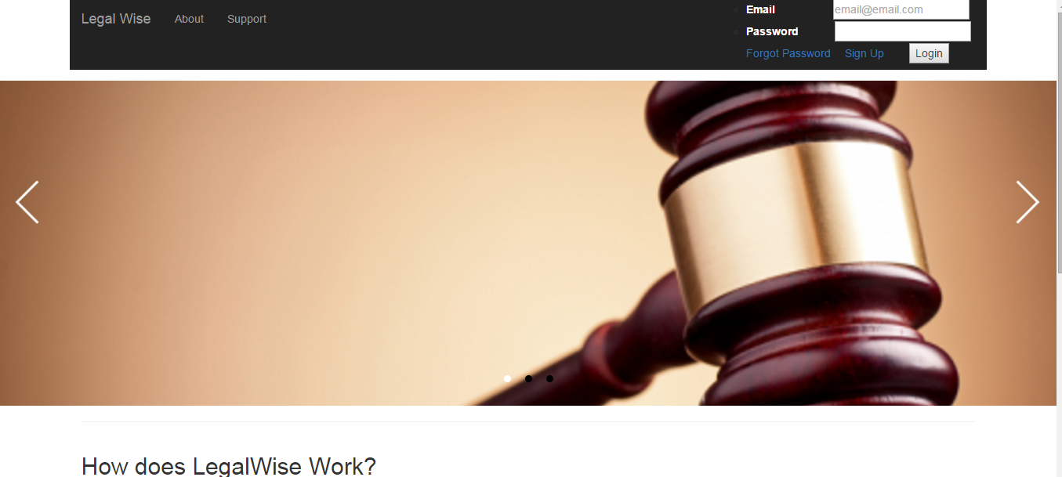

**HomePage**

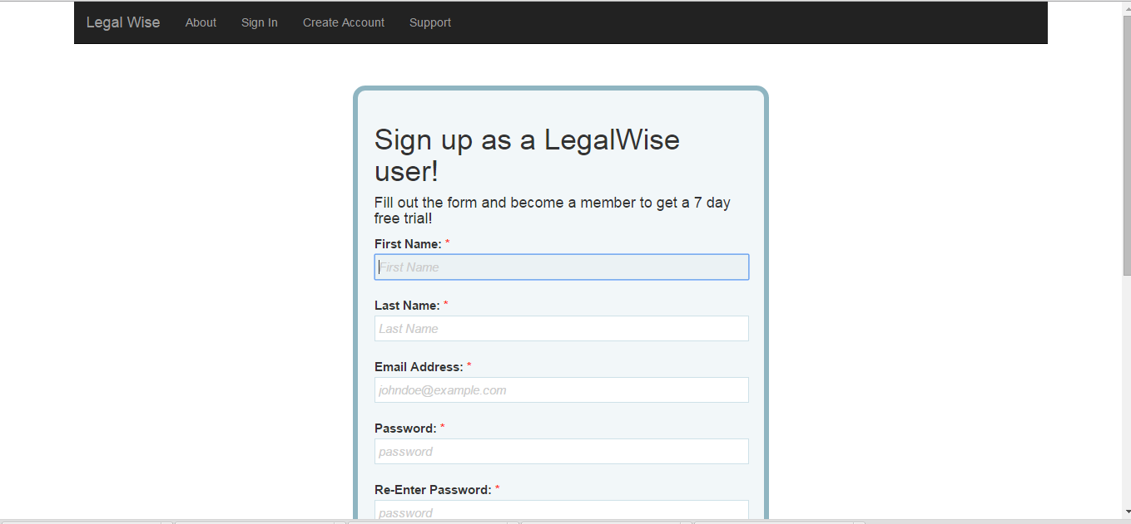

**Sign Up**

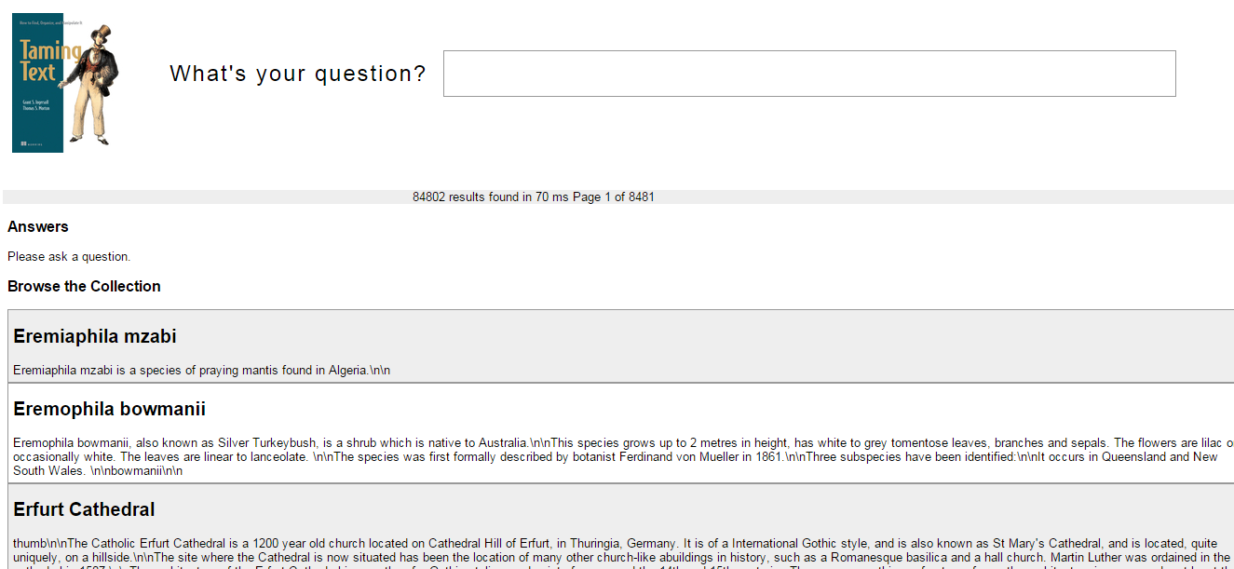

**QA Engine**

## Appendix D – Analysis models (static and dynamic)



**Presentation Layer – Package Diagram**



**Logic Layer – Package Diagram**



**Storage Layer – Package Diagram**



## Appendix E – Object Interaction



**Create Account**



**Forget Password**



**Login**

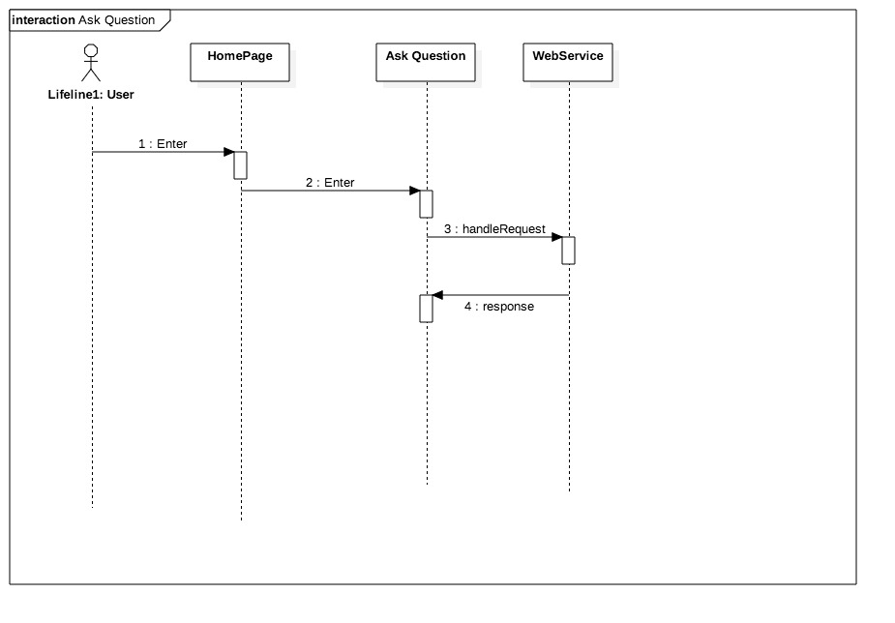

**Ask Question**

## Appendix F – Documented code for test drivers and stubs.../Desktop/Screen%20Shot%202015-12-04%20at%202.41.02%20AM.png

## Appendix G – Scrums meetings.

Date: 08/31

Attendees: Amanda Chiu, Valeria Lopez

Start time: 10:00AM

End time: 11:00 AM

Minute Taker: Valeria Lopez

First student: Amanda Chiu

* What was done since the last scrum meeting?
  + 1  N/A
  + 2  N/A
  + 3  N/A
* What is planned to be done until the next scrum meeting?
  + 1  Watch the videos to learn about Watson
  + 2  Contact Jaime to schedule the meeting
  + 3
* What are the hurdles?
  + 1 -  None
  + 2 - None
  + 3 - None

Second student: Valeria Lopez

* What was done since the last scrum meeting?
  + 1  N/A
  + 2  N/A
  + 3  N/A
* What is planned to be done until the next scrum meeting?
  + 1 Watch the videos to learn about Watson
  + 2 Contact Jaime to schedule the meeting
  + 3
* What are the hurdles?
  + 1 None
  + 2 None
  + 3 None

Date: 09/01

Attendees: Amanda Chiu, Valeria Lopez, Jamie Borras

Start time: 10:00AM

End time: 10:30 AM

Minute Taker: Valeria Lopez

First student: Amanda Chiu

* What was done since the last scrum meeting?
  + 1  Finished watching the videos for Watson
  + 2  Schedule the meeting with Jaime for Wednesday morning
  + 3
* What is planned to be done until the next scrum meeting?
  + 1- Review the IBM bluemix website to have questions for Jaime
  + 2 -
  + 3
* What are the hurdles?
  + 1 N/A
  + 2 N/A
  + 3 N/A

Second student: Valeria Lopez

* What was done since the last scrum meeting?
  + 1 Finished watching the videos for Watson
  + 2 Schedule the meeting with Jaime for Wednesday morning
  + 3 -
* What is planned to be done until the next scrum meeting?
  + 1 Review the IBM bluemix website to have questions for Jaime
  + 2
  + 3
* What are the hurdles?
  + 1 N/A

Date: 09/02

Attendees: Amanda Chiu, Valeria Lopez, Jamie Borras

Start time: 10:00AM

End time: 11:00 AM

Minute Taker: Amanda Chiu

First student: Amanda Chiu

* What was done since the last scrum meeting?
  + 1 - This was our first time meeting in person, so we came up with some questions regarding the project before the meeting.
  + 2
  + 3
* What is planned to be done until the next scrum meeting?
  + 1 - Research on the legal information databases(Jaime is also looking into this).
  + 2 - Start creating the User Interface demo
  + 3 - Setup blueMix accounts
* What are the hurdles?
  + 1 - finding legal information databases(Jamie is also looking into this)
  + 2 - Since it was our first time meeting, due to traffic, we started the meeting a little late.
  + 3

Second student: Valeria Lopez

* What was done since the last scrum meeting?
  + 1 - This was our first time meeting in person, so we came up with some questions regarding the project before the meeting.
  + 2
  + 3
* What is planned to be done until the next scrum meeting?
  + 1- Research on the legal information databases.
  + 2 - Research on how the Waston Experience Manager works
  + 3 - Setup blueMix accounts
* What are the hurdles?
  + 1 - finding legal information databases(Jamie is also looking into this)
  + 2 - Since it was our first time meeting, due to traffic, we started the meeting a little late.
  + 3

Date: 09/03/15

Attendees: Amanda Chiu Valeria Lopez

Start time: 3:00 PM

End time: 3:30 PM

Minute Taker: Amanda Chiu

First student:

* What was done since the last scrum meeting?
  + 1 Learning more about BlueMix
  + 2
  + 3
* What is planned to be done until the next scrum meeting?
  + 1 - Find out the technologies the APIs support our application
  + 2 - Design of the User Interface demo
  + 3 - Gather information on the legal databases
* What are the hurdles?
  + 1 None
  + 2 None
  + 3 None

Second student:

* What was done since the last scrum meeting?
  + 1 Select the APIs that are suitable for our project
  + 2
  + 3
* What is planned to be done until the next scrum meeting?
  + 1 - Find out the technologies the APIs support our application
  + 2 - Design of the User Interface demo
  + 3 - Gather information on the legal databases
* What are the hurdles?
  + 1 None
  + 2 None
  + 3 None

Date: 09/04/15

Attendees: Amanda Chiu, Valeria Lopez

Start time: 11:00 am

End time: 11:30 am

Minute Taker: Valeria Lopez

First student: Amanda Chiu

* What was done since the last scrum meeting?
  + 1 Find out the technologies the APIs support our application
  + 2 Gather information on the legal databases
  + 3
* What is planned to be done until the next scrum meeting?
  + 1 Come up with a list of use cases to be implemented
  + 2 Set up environment
  + 3 Read on Bluemix applications
* What are the hurdles?
  + 1 None
  + 2 None
  + 3 None

Second student: Valeria Lopez

* What was done since the last scrum meeting?
  + 1 Find out the technologies the APIs support our application
  + 2 Gather information on the legal databases
  + 3
* What is planned to be done until the next scrum meeting?
  + 1 Create the LegalWise application on Bluemix
  + 2 Set up environment
  + 3 Read on Bluemix applications
* What are the hurdles?
  + 1 None
  + 2 None
  + 3 None

Date: 09/08/2015

Attendees: Amanda Chiu, Valeria Lopez

Start time: 11:00am

End time: 11:30am

Minute Taker: Valeria Lopez

First student: Amanda Chiu

* What was done since the last scrum meeting?
  + 1 Come up with a list of use cases to be implemented
  + 2 Set up environment
  + 3 Read on Bluemix applications
* What is planned to be done until the next scrum meeting?
  + 1 Start working on the Use Cases
  + 2 Review links from Robert and watch videos
  + 3
* What are the hurdles?
  + 1 We need to become part of the FIU-Senior Project on bluemix
  + 2
  + 3

Second student: Valeria Lopez

* What was done since the last scrum meeting?
  + 1 Create the LegalWise application on Bluemix
  + 2 Set up environment
  + 3 Read on Bluemix applications
* What is planned to be done until the next scrum meeting?
  + 1 Start working on Use Cases
  + 2 Come up with questions for Robert meeting
  + 3
* What are the hurdles?
  + 1 We need to become part of the FIU-Senior Project on bluemix
  + 2
  + 3

Date:  09/09/2015

Attendees:Valeria Lopez, Amanda Chiu

Start time: 4:00pm

End time: 4:30 pm

Minute Taker: Valeria Lopez

First student: Amanda Chiu

* What was done since the last scrum meeting?
  + 1 Set up environment
  + 2 Review links from Robert and watch videos
  + 3
* What is planned to be done until the next scrum meeting?
  + 1 Work on Use Cases
  + 2 Work on Documentation
  + 3
* What are the hurdles?
  + 1 None
  + 2 None
  + 3 None

Second student: Valeria Lopez

* What was done since the last scrum meeting?
  + 1 Set up environment
  + 2 Come up with questions for Robert meeting
  + 3
* What is planned to be done until the next scrum meeting?
  + 1 Work on Use Cases
  + 2 Work on Documentation
  + 3
* What are the hurdles?
  + 1 None
  + 2 None
  + 3 None

Date:  09/10/2015

Attendees: Valeria Lopez, Amanda Chiu

Start time: 4:00pm

End time: 4:30 pm

Minute Taker: Amanda Chiu

First student: Amanda Chiu

* What was done since the last scrum meeting?
  + 1. Coming up with questions for Robert about BlueMix
  + 2. Coming up with Use Cases for Sprint 1
  + 3.
* What is planned to be done until the next scrum meeting?
  + 1. Elaborate on the use cases
  + 2. Get started with the documentation
  + 3. Research on which programming language should be used for this project
* What are the hurdles?
  + 1. Getting BlueMix account working(waiting on Professor Sadjadi)
  + 2.
  + 3

Second student: Valeria Lopez

* What was done since the last scrum meeting?
  + 1 Coming up with questions for Robert about BlueMix
  + 2. Setup the database
  + 3
* What is planned to be done until the next scrum meeting?
  + 1. Research on which programming language should be used for this project
  + 2. Elaborate on the use cases
  + 3. Get started with the documentation
* What are the hurdles?
  + 1. Getting BlueMix account working(waiting on Professor Sadjadi)
  + 2.
  + 3

Date:  09/11/2015

Attendees: Amanda Chiu, Valeria Lopez

Start time: 3:30pm

End time: 4:00pm

Minute Taker: Valeria Lopez

First student: Amanda Chiu

* What was done since the last scrum meeting?
  + 1 Finished with the assigned use cases
  + 2 Created a deployment diagram for the documentation
  + 3. Research on the software to built the application
* What is planned to be done until the next scrum meeting?
  + 1 Update the deployment diagram
  + 2 Research and intall Node.js
  + 3
* What are the hurdles?
  + 1 We need access to the FIU organization in order to create our application
  + 2.
  + 3

Second student: Valeria Lopez

* What was done since the last scrum meeting?
  + 1 Finished with the assigned use cases
  + 2 Hardware and Software requirements for documentation
  + 3 Hardware and Software mapping including architectural patterns
* What is planned to be done until the next scrum meeting?
  + 1 Create Package diagrams
  + 2 Research Cloudant DB
  + 3 Set up Cloudant DB
* What are the hurdles?
  + 1 We need access to the FIU organization in order to create our application
  + 2.
  + 3

Date:  09/14/15

Attendees: Valeria Lopez, Amanda Chiu

Start time: 2:00 PM

End time: 2:30 PM

Minute Taker: Amanda Chiu

First student: Amanda Chiu

* What was done since the last scrum meeting?
  + 1- Deployment Diagram
  + 2 - Research and setup node.js
  + 3.
* What is planned to be done until the next scrum meeting?
  + 1 - Update Deployment Diagram
  + 2 - Add new user story
  + 3
* What are the hurdles?
  + 1 None
  + 2.
  + 3

Second student: Valeria Lopez

* What was done since the last scrum meeting?
  + 1 Package diagram
  + 2 research and setup Cloudant database
  + 3
* What is planned to be done until the next scrum meeting?
  + 1 Select a sample case and email it to Jaime
  + 2 System and subsystem decomposition
  + 3
* What are the hurdles?
  + 1 None
  + 2.
  + 3

Date:  09/15/15

Attendees: Valeria Lopez, Amanda Chiu

Start time: 2:00 PM

End time: 2:30 PM

Minute Taker: Valeria Lopez

First student: Amanda Chiu

* What was done since the last scrum meeting?
  + 1 Update Deployment Diagram
  + 2 Add new user story
  + 3.
* What is planned to be done until the next scrum meeting?
  + 1 Sequence Diagrams
  + 2 Class Diagrams for Presentation Layer
  + 3
* What are the hurdles?
  + 1 None
  + 2.
  + 3

Second student: Valeria Lopez

* What was done since the last scrum meeting?
  + 1 Select a sample case and email it to Jaime
  + 2 System and subsystem decomposition
  + 3
* What is planned to be done until the next scrum meeting?
  + 1 Class Diagrams for Logic Layer
  + 2 Inject cases and users into the DB
  + 3
* What are the hurdles?
  + 1 None
  + 2.
  + 3

Date:  09/16/15

Attendees: Valeria Lopez, Amanda Chiu

Start time: 2:00 PM

End time: 2:30 PM

Minute Taker: Amanda Chiu

First student: Amanda Chiu

* What was done since the last scrum meeting?
  + 1 Design Sequence diagrams for all user stories
  + 2 Class Diagrams for Presentation Layer
  + 3.
* What is planned to be done until the next scrum meeting?
  + 1 More Sequence Diagrams
  + 2 Select case files to be inserted into the database
  + 3
* What are the hurdles?
  + 1 None
  + 2.
  + 3

Second student: Valeria Lopez

* What was done since the last scrum meeting?
  + 1 Class Diagrams for Logic Layer
  + 2 Research on NoSql Databases
  + 3
* What is planned to be done until the next scrum meeting?
  + 1 Class Diagram for the Storage Layer
  + 2 More reserach on NoSql databases
  + 3
* What are the hurdles?
  + 1 None
  + 2.
  + 3

Date:  09/17/15

Attendees: Valeria Lopez, Amanda Chiu

Start time: 2:00 PM

End time: 2:30 PM

Minute Taker: Valeria Lopez

First student: Amanda Chiu

* What was done since the last scrum meeting?
  + 1 More Sequence Diagrams
  + 2 Select case files to be inserted into the database
  + 3.
* What is planned to be done until the next scrum meeting?
  + 1
  + 2
  + 3
* What are the hurdles?
  + 1 None
  + 2.
  + 3

Second student: Valeria Lopez

* What was done since the last scrum meeting?
  + 1 Class Diagram for the Storage Layer
  + 2 More reserach on NoSql databases
  + 3
* What is planned to be done until the next scrum meeting?
  + 1
  + 2
  + 3
* What are the hurdles?
  + 1 None
  + 2.
  + 3

Date:  09/18/15

Attendees: Valeria Lopez, Amanda Chiu

Start time: 2:00 PM

End time: 2:30 PM

Minute Taker: Amanda Chiu

First student: Amanda Chiu

* What was done since the last scrum meeting?
  + 1 More Sequence Diagrams
  + 2 Select case files to be inserted into the database
  + 3.
* What is planned to be done until the next scrum meeting?
  + 1 Create UI template/ design
  + 2 More Sequence Diagrams and update class diagrams
  + 3
* What are the hurdles?
  + 1 None
  + 2.
  + 3

Second student: Valeria Lopez

* What was done since the last scrum meeting?
  + 1 Class diagram for the Storage Layer
  + 2 Select case files to be inserted into the database
  + 3
* What is planned to be done until the next scrum meeting?
  + 1 Implement “Ask a question to Watson”
  + 2 Research on how to teach Watson
  + 3
* What are the hurdles?
  + 1 None
  + 2.
  + 3

Date:  09/21/15

Attendees: Valeria Lopez, Amanda Chiu

Start time: 2:00 PM

End time: 2:30 PM

Minute Taker: Valeria Lopez

First student: Amanda Chiu

* What was done since the last scrum meeting?
  + 1 Create UI template/ design  for the Home Page
  + 2 More Sequence Diagrams and update class diagrams
  + 3.
* What is planned to be done until the next scrum meeting?
  + 1 Deploy UI on bluemix
  + 2  Research on how to teach Watson
  + 3
* What are the hurdles?
  + 1 None
  + 2.
  + 3

Second student: Valeria Lopez

* What was done since the last scrum meeting?
  + 1 Implement “Ask a question to Watson” - started code
  + 2 Research on How to teach Watson
  + 3
* What is planned to be done until the next scrum meeting?
  + 1 Bind the services API’s with LegalWise application
  + 2 Implement “ Ask a question to Watson”
  + 3
* What are the hurdles?
  + 1 None
  + 2.
  + 3

Date:  09/22/15

Attendees: Valeria Lopez, Amanda Chiu

Start time: 2:00 PM

End time: 2:30 PM

Minute Taker: Valeria Lopez

First student: Amanda Chiu

* What was done since the last scrum meeting?
  + 1 Deploy UI on bluemix
  + 2 Research on how to teach Watson
  + 3.
* What is planned to be done until the next scrum meeting?
  + 1 Test the UI in bluemix
  + 2  Include information about LegalWise in the UI
  + 3
* What are the hurdles?
  + 1 None
  + 2.
  + 3

Second student: Valeria Lopez

* What was done since the last scrum meeting?
  + 1 Implement “Ask a question to Watson” - Watson connection
  + 2 Research on How to teach Watson
  + 3
* What is planned to be done until the next scrum meeting?
  + 1 Implement “ Ask a question to Watson” - finilize
  + 2 Deploy the code on bluemix
  + 3
* What are the hurdles?
  + 1 None
  + 2.
  + 3

Date:  09/23/15

Attendees: Valeria Lopez, Amanda Chiu

Start time: 2:00 PM

End time: 2:30 PM

Minute Taker: Valeria Lopez

First student: Amanda Chiu

* What was done since the last scrum meeting?
  + 1 Test UI on bluemix
  + 2 Include information about LegalWise in the UI
  + 3.
* What is planned to be done until the next scrum meeting?
  + 1 Review the code for “Ask Watson” to integrate with the logic side
  + 2  Integrate the IU with the logic
  + 3
* What are the hurdles?
  + 1 None
  + 2.
  + 3

Second student: Valeria Lopez

* What was done since the last scrum meeting?
  + 1 Implement “ Ask a question to Watson” - finilize
  + 2 Deploy the code on bluemix
  + 3
* What is planned to be done until the next scrum meeting?
  + 1 Test the code in bluemix
  + 2 Put the final documentation together
  + 3
* What are the hurdles?
  + 1 None
  + 2.
  + 3

Date:  09/23/15

Attendees: Valeria Lopez, Amanda Chiu

Start time: 2:00 PM

End time: 2:30 PM

Minute Taker: Valeria Lopez

First student: Amanda Chiu

* What was done since the last scrum meeting?
  + 1 Review the code for “Ask Watson” to integrate with the logic side
  + 2 Integrate the IU with the logic - start
  + 3.
* What is planned to be done until the next scrum meeting?
  + 1 Integrate the IU with the logic
  + 2  Research on how to teach Watson
  + 3
* What are the hurdles?
  + 1 None
  + 2.
  + 3

Second student: Valeria Lopez

* What was done since the last scrum meeting?
  + 1 Test the code in bluemix
  + 2
  + 3
* What is planned to be done until the next scrum meeting?
  + 1 Test the code in bluemix
  + 2 Research on how to teach Watson
  + 3
* What are the hurdles?
  + 1 None
  + 2.
  + 3

Date:  09/24/15

Attendees: Valeria Lopez, Amanda Chiu

Start time: 2:00 PM

End time: 2:30 PM

Minute Taker: Valeria Lopez

First student: Amanda Chiu

* What was done since the last scrum meeting?
  + 1 Integrate the IU with the logic - solving issues
  + 2
  + 3.
* What is planned to be done until the next scrum meeting?
  + 1 Integrate the IU with the logic - testing
  + 2
  + 3
* What are the hurdles?
  + 1 None
  + 2.
  + 3

Second student: Valeria Lopez

* What was done since the last scrum meeting?
  + 1 Test the code on bluemix
  + 2 Research on Watson Explorer
  + 3
* What is planned to be done until the next scrum meeting?
  + 1 Research on Watson Experience Manager
  + 2 Email Jaime, Robert and Professor Sadjadi for advice and software.
  + 3
* What are the hurdles?
  + 1 None
  + 2.
  + 3

Date:  09/28/15

Attendees: Valeria Lopez, Amanda Chiu

Start time: 2:00 PM

End time: 2:30 PM

Minute Taker: Valeria Lopez

First student: Amanda Chiu

* What was done since the last scrum meeting?
  + 1 Integrate the IU with the logic - testing
  + 2
  + 3.
* What is planned to be done until the next scrum meeting?
  + 1 Integrate the IU with the logic - continue testing
  + 2
  + 3
* What are the hurdles?
  + 1 None
  + 2.
  + 3

Second student: Valeria Lopez

* What was done since the last scrum meeting?
  + 1 Research on Watson Experience Manager
  + 2 Email Jaime, Robert and Professor Sadjadi for advice and software
  + 3
* What is planned to be done until the next scrum meeting?
  + 1 Current System, Introduction and Purpose of new System
  + 2. Research on Watson Experience Manager
  + 3
* What are the hurdles?
  + 1 None
  + 2.
  + 3

Date:  09/29/15

Attendees: Valeria Lopez, Amanda Chiu

Start time: 2:00 PM

End time: 2:30 PM

Minute Taker: Amanda Chiu

First student: Amanda Chiu

* What was done since the last scrum meeting?
  + 1 Integrate the IU with the logic - testing
  + 2
  + 3.
* What is planned to be done until the next scrum meeting?
  + 1 Continue with the Integrate the IU with the logic - continue testing
  + 2  Add buttons for login and register
  + 3
* What are the hurdles?
  + 1 None
  + 2.
  + 3

Second student: Valeria Lopez

* What was done since the last scrum meeting?
  + 1 Current System, Introduction and Purpose of new System
  + 2 Research on Watson Experience Manager
  + 3
* What is planned to be done until the next scrum meeting?
  + 1 Research on how to connect the DB to the UI
  + 2 Research on latency between NoSql and SQL databases
  + 3 Bind the DB to the application
* What are the hurdles?
  + 1 None
  + 2.
  + 3

Date:  09/30/15

Attendees: Valeria Lopez, Amanda Chiu

Start time: 2:00 PM

End time: 2:30 PM

Minute Taker: Valeria Lopez

First student: Amanda Chiu

* What was done since the last scrum meeting?
  + 1 Continue with the Integrate the IU with the logic - continue testing
  + 2 Add buttons for login and register
  + 3.
* What is planned to be done until the next scrum meeting?
  + 1 Create User fields for database
  + 2
  + 3
* What are the hurdles?
  + 1 Waiting on Jaime for access to WEM
  + 2.
  + 3

Second student: Valeria Lopez

* What was done since the last scrum meeting?
  + 1 Research on how to connect the DB to the UI
  + 2 Research on latency between NoSql and SQL databases
  + 3 Bind the DB to the application
* What is planned to be done until the next scrum meeting?
  + 1 Get the credentials from the DB and test them to make sure they work
  + 2 Requirement Analysis
  + 3
* What are the hurdles?
  + 1 Waiting on Jaime for access to WEM
  + 2.
  + 3

Date:  10/01/15

Attendees: Valeria Lopez, Amanda Chiu

Start time: 2:00 PM

End time: 2:30 PM

Minute Taker: Valeria Lopez

First student: Amanda Chiu

* What was done since the last scrum meeting?
  + 1 Create User fields for database
  + 2
  + 3.
* What is planned to be done until the next scrum meeting?
  + 1
  + 2
  + 3
* What are the hurdles?
  + 1 Waiting on Jaime for access to WEM
  + 2.
  + 3

Second student: Valeria Lopez

* What was done since the last scrum meeting?
  + 1 Requirement Analysis
  + 2 Get the credentials from the DB and test them to make sure they work
  + 3
* What is planned to be done until the next scrum meeting?
  + 1 Write the code that access the database
  + 2 Test the code that access the database
  + 3
* What are the hurdles?
  + 1 Waiting on Jaime for access to WEM
  + 2.
  + 3

Date:  10/02/15

Attendees: Valeria Lopez, Amanda Chiu

Start time: 2:00 PM

End time: 2:30 PM

Minute Taker: Amanda Chiu

First student: Amanda Chiu

* What was done since the last scrum meeting?
  + 1 Syncing UI with the Logic layer
  + 2
  + 3.
* What is planned to be done until the next scrum meeting?
  + 1 Discuss methodologies with Professor Finalyson
  + 2  Redo user stories
  + 3
* What are the hurdles?
  + 1 None
  + 2.
  + 3

Second student: Valeria Lopez

* What was done since the last scrum meeting?
  + 1 Write the code that access the database
  + 2 Test the code that access the database
  + 3
* What is planned to be done until the next scrum meeting?
  + 1 Research on Q&A tools
  + 2
  + 3
* What are the hurdles?
  + 1 Waiting on Jaime for access to WEM
  + 2.
  + 3

Date:  10/05/15

Attendees: Valeria Lopez, Amanda Chiu

Start time: 2:00 PM

End time: 2:30 PM

Minute Taker: Amanda Chiu

First student: Amanda Chiu

* What was done since the last scrum meeting?
  + 1 Discuss methodologies with Professor Finalyson
  + 2  Redo user stories
  + 3.
* What is planned to be done until the next scrum meeting?
  + 1 Redo Create a user logic
  + 2 Implement a function to get a JSON object
  + 3
* What are the hurdles?
  + 1 None
  + 2.
  + 3

Second student: Valeria Lopez

* What was done since the last scrum meeting?
  + 1 Write the code that access the database
  + 2 Test the code that access the database
  + 3
* What is planned to be done until the next scrum meeting?
  + 1 Research on Q&A tools
  + 2
  + 3
* What are the hurdles?
  + 1 Waiting on Jaime for access to WEM
  + 2.
  + 3

Date:  10/06/15

Attendees: Valeria Lopez, Amanda Chiu

Start time: 2:00 PM

End time: 2:30 PM

Minute Taker: Amanda Chiu

First student: Amanda Chiu

* What was done since the last scrum meeting?
  + 1 Redo Create a user logic
  + 2 Implement a function to get a JSON object
  + 3.
* What is planned to be done until the next scrum meeting?
  + 1 Continue with the implementation of the JSON function
  + 2
  + 3
* What are the hurdles?
  + 1 None
  + 2.
  + 3

Second student: Valeria Lopez

* What was done since the last scrum meeting?
  + 1 Research on Q&A tools
  + 2
  + 3
* What is planned to be done until the next scrum meeting?
  + 1 Connect the Logic with Cloudant
  + 2
  + 3
* What are the hurdles?
  + 1
  + 2.
  + 3

Date:  10/07/15

Attendees: Valeria Lopez, Amanda Chiu

Start time: 2:00 PM

End time: 2:30 PM

Minute Taker: Amanda Chiu

First student: Amanda Chiu

* What was done since the last scrum meeting?
  + 1 Continue with the implementation of the JSON function
  + 2
  + 3.
* What is planned to be done until the next scrum meeting?
  + 1 Bind the logic and push to BlueMix
  + 2
  + 3
* What are the hurdles?
  + 1 None
  + 2.
  + 3

Second student: Valeria Lopez

* What was done since the last scrum meeting?
  + 1 Research on Q&A tools
  + 2 Connect the Logic with Cloudant
  + 3
* What is planned to be done until the next scrum meeting?
  + 1 Bind the logic and push to BlueMix
  + 2 Run the Q&A app
  + 3
* What are the hurdles?
  + 1
  + 2.
  + 3

Date:  10/08/15

Attendees: Valeria Lopez, Amanda Chiu

Start time: 2:00 PM

End time: 2:30 PM

Minute Taker: Amanda Chiu

First student: Amanda Chiu

* What was done since the last scrum meeting?
  + 1 Bind the logic and push to BlueMix
  + 2
  + 3.
* What is planned to be done until the next scrum meeting?
  + 1 Continue with binding the logic and push to BlueMix
  + 2 Update the documentation
  + 3
* What are the hurdles?
  + 1 None
  + 2.
  + 3

Second student: Valeria Lopez

* What was done since the last scrum meeting?
  + 1  Bind the logic and push to BlueMix
  + 2 Run the Q&A app
  + 3
* What is planned to be done until the next scrum meeting?
  + 1 Continue with binding the logic and push to BlueMix
  + 2 Continue Run the Q&A app
  + 3
* What are the hurdles?
  + 1 The Q&A app is depreciated, so we need to find a way to bind the app with the tools needed.
  + 2.
  + 3

Date:  10/09/15

Attendees: Valeria Lopez, Amanda Chiu

Start time: 2:00 PM

End time: 2:30 PM

Minute Taker: Amanda Chiu

First student: Amanda Chiu

* What was done since the last scrum meeting?
  + 1 Continue with binding the logic and push to BlueMix
  + 2 Update the documentation
  + 3.
* What is planned to be done until the next scrum meeting?
  + 1 Wrapping up with binding the logic to the DB and push to BlueMix
  + 2
  + 3
* What are the hurdles?
  + 1 None
  + 2.
  + 3

Second student: Valeria Lopez

* What was done since the last scrum meeting?
  + 1 Continue with binding the logic and push to BlueMix
  + 2 Continue Run the Q&A app
  + 3
* What is planned to be done until the next scrum meeting?
  + 1 Continue with binding the logic and push to BlueMix
  + 2 Continue Run the Q&A app
  + 3
* What are the hurdles?
  + 1 None
  + 2.
  + 3

Date:  10/12/15

Attendees: Valeria Lopez, Amanda Chiu

Start time: 2:00 PM

End time: 2:30 PM

Minute Taker: Valeria Lopez

First student: Amanda Chiu

* What was done since the last scrum meeting?
  + 1 Wrapping up with binding the logic to the DB and push to BlueMix
  + 2
  + 3.
* What is planned to be done until the next scrum meeting?
  + 1 Modify the createAccount.html to a nicer format
  + 2
  + 3
* What are the hurdles?
  + 1 None
  + 2.
  + 3

Second student: Valeria Lopez

* What was done since the last scrum meeting?
  + 1 Continue with binding the logic and push to BlueMix
  + 2 Meeting with Professor Mark Finlayson to review the Q&A engine
  + 3
* What is planned to be done until the next scrum meeting?
  + 1 Fix the errors on the Q&A application
  + 2 Build the application
  + 3
* What are the hurdles?
  + 1 None
  + 2.
  + 3

Date:  10/13/15

Attendees: Valeria Lopez, Amanda Chiu

Start time: 2:00 PM

End time: 2:30 PM

Minute Taker: Valeria Lopez

First student: Amanda Chiu

* What was done since the last scrum meeting?
  + 1 Modify the createAccount.html to a nicer format
  + 2
  + 3.
* What is planned to be done until the next scrum meeting?
  + 1 Add a new HTML page for questions to users
  + 2
  + 3
* What are the hurdles?
  + 1 None
  + 2.
  + 3

Second student: Valeria Lopez

* What was done since the last scrum meeting?
  + 1 Fix the errors on the Q&A application
  + 2 Build the application
  + 3
* What is planned to be done until the next scrum meeting?
  + 1 Push the application to Git
  + 2 Run the samples on the book
  + 3
* What are the hurdles?
  + 1 None
  + 2.
  + 3

Date:  10/14/15

Attendees: Valeria Lopez, Amanda Chiu

Start time: 2:00 PM

End time: 2:30 PM

Minute Taker: Valeria Lopez

First student: Amanda Chiu

* What was done since the last scrum meeting?
  + 1 Add a new HTML page for questions to users
  + 2
  + 3.
* What is planned to be done until the next scrum meeting?
  + 1 Change the background pictures from the homepage
  + 2 Push the changes to Bluemix
  + 3
* What are the hurdles?
  + 1 None
  + 2.
  + 3

Second student: Valeria Lopez

* What was done since the last scrum meeting?
  + 1 Push the application to Git
  + 2 Run the samples on the book
  + 3
* What is planned to be done until the next scrum meeting?
  + 1 Create a VM to build the application
  + 2 Install all the software and build the application
  + 3
* What are the hurdles?
  + 1 None
  + 2.
  + 3

Date:  10/14/15

Attendees: Valeria Lopez, Amanda Chiu

Start time: 2:00 PM

End time: 2:30 PM

Minute Taker: Valeria Lopez

First student: Amanda Chiu

* What was done since the last scrum meeting?
  + 1 Change the background pictures from the homepage
  + 2 Push the changes to Bluemix
  + 3.
* What is planned to be done until the next scrum meeting?
  + 1 Fit Jaime needs on the UI
  + 2 Add the login option on the homepage
  + 3
* What are the hurdles?
  + 1 None
  + 2.
  + 3

Second student: Valeria Lopez

* What was done since the last scrum meeting?
  + 1 Create a VM to build the application
  + 2 Install all the software and build the application
  + 3
* What is planned to be done until the next scrum meeting?
  + 1 Input the Wiki content on the Q&A tool
  + 2 Run the Wiki with the samples from the book
  + 3
* What are the hurdles?
  + 1 None
  + 2.
  + 3

Date:  10/15/15

Attendees: Valeria Lopez, Amanda Chiu

Start time: 2:00 PM

End time: 2:30 PM

Minute Taker: Valeria Lopez

First student: Amanda Chiu

* What was done since the last scrum meeting?
  + 1 Fit Jaime needs on the UI
  + 2 Add the login option on the homepage
  + 3.
* What is planned to be done until the next scrum meeting?
  + 1 Checks if Database receives the information
  + 2 Continue working on add the login option on the homepage
  + 3
* What are the hurdles?
  + 1 None
  + 2.
  + 3

Second student: Valeria Lopez

* What was done since the last scrum meeting?
  + 1 Input the Wiki content on the Q&A tool
  + 2 Read the book to understand the process
  + 3
* What is planned to be done until the next scrum meeting?
  + 1 Read and understand how queries are form
  + 2 Run the Wiki with the samples from the book
  + 3
* What are the hurdles?
  + 1 None
  + 2.
  + 3

Date:  10/16/15

Attendees: Valeria Lopez, Amanda Chiu

Start time: 2:00 PM

End time: 2:30 PM

Minute Taker: Valeria Lopez

First student: Amanda Chiu

* What was done since the last scrum meeting?
  + 1 Checks if Database receives the information
  + 2 Continue working on add the login option on the homepage
  + 3.
* What is planned to be done until the next scrum meeting?
  + 1 Checks if Database receives the information
  + 2 Continue working on add the login option on the homepage
  + 3
* What are the hurdles?
  + 1 None
  + 2.
  + 3

Second student: Valeria Lopez

* What was done since the last scrum meeting?
  + 1 Run the Wiki with the samples from the book
  + 2 Read and understand how queries are form
  + 3
* What is planned to be done until the next scrum meeting?
  + 1 Read and understand how queries are form
  + 2 Run the Wiki with the samples from the book
  + 3
* What are the hurdles?
  + 1 None
  + 2.
  + 3

Date:  10/19/15

Attendees: Valeria Lopez, Amanda Chiu

Start time: 2:00 PM

End time: 2:30 PM

Minute Taker: Amanda Chiu

First student: Amanda Chiu

* What was done since the last scrum meeting?
  + 1 Checks if Database receives the information
  + 2 Continue working on add the login option on the homepage
  + 3.
* What is planned to be done until the next scrum meeting?
  + 1 Continue with checking if Database receives the information
  + 2 Continue working on add the login option on the homepage
  + 3
* What are the hurdles?
  + 1 None
  + 2.
  + 3

Second student: Valeria Lopez

* What was done since the last scrum meeting?
  + 1 Read and understand how queries are form
  + 2 Run the Wiki with the samples from the book
  + 3
* What is planned to be done until the next scrum meeting?
  + 1 Modify use cases, hardware and software mapping
  + 2
  + 3
* What are the hurdles?
  + 1 None
  + 2.
  + 3

Date:  10/20/15

Attendees: Valeria Lopez, Amanda Chiu

Start time: 2:00 PM

End time: 2:30 PM

Minute Taker: Amanda Chiu

First student: Amanda Chiu

* What was done since the last scrum meeting?
  + 1 Checks if Database receives the information
  + 2 Continue working on add the login option on the homepage
  + 3.
* What is planned to be done until the next scrum meeting?
  + 1 Adjusting the UI based on Jaime’s needs: on forgot password
  + 2 Continue with databases connectivity
  + 3
* What are the hurdles?
  + 1 None
  + 2.
  + 3

Second student: Valeria Lopez

* What was done since the last scrum meeting?
  + 1 Modify use cases, hardware and software mapping
  + 2
  + 3
* What is planned to be done until the next scrum meeting?
  + 1 familiarize with the code and come up with strategy
  + 2 understand how queries are form
  + 3
* What are the hurdles?
  + 1 None
  + 2.
  + 3

Date:  10/21/15

Attendees: Valeria Lopez, Amanda Chiu

Start time: 2:00 PM

End time: 2:30 PM

Minute Taker: Amanda Chiu

First student: Amanda Chiu

* What was done since the last scrum meeting?
  + 1 Adjusting the UI based on Jaime’s needs: on forgot password
  + 2 Continue with databases connectivity
  + 3.
* What is planned to be done until the next scrum meeting?
  + 1 Continue with adjusting the UI based on Jaime’s needs: on forgot password
  + 2 Continue with databases connectivity
  + 3
* What are the hurdles?
  + 1 None
  + 2.
  + 3

Second student: Valeria Lopez

* What was done since the last scrum meeting?
  + 1 Familiarize with the code and come up with strategy
  + 2 Understand how queries are form
  + 3
* What is planned to be done until the next scrum meeting?
  + 1 Continue with familiarizing with the code and come up with strategy
  + 2 Continue with understanding how queries are form
  + 3
* What are the hurdles?
  + 1 None
  + 2.
  + 3

Date:  10/22/15

Attendees: Valeria Lopez, Amanda Chiu

Start time: 2:00 PM

End time: 2:30 PM

Minute Taker: Amanda Chiu

First student: Amanda Chiu

* What was done since the last scrum meeting?
  + 1 Continue with adjusting the UI based on Jaime’s needs: on forgot password
  + 2 Continue with databases connectivity
  + 3.
* What is planned to be done until the next scrum meeting?
  + 1 Modify the response page
  + 2 Send confirm email to new user
  + 3
* What are the hurdles?
  + 1 None
  + 2.
  + 3

Second student: Valeria Lopez

* What was done since the last scrum meeting?
  + 1 Continue with familiarizing with the code and come up with strategy
  + 2 Continue with understanding how queries are form
  + 3
* What is planned to be done until the next scrum meeting?
  + 1 Continue with modifying use cases
  + 2
  + 3
* What are the hurdles?
  + 1 None
  + 2.
  + 3

Date:  10/23/15

Attendees: Valeria Lopez, Amanda Chiu

Start time: 2:00 PM

End time: 2:30 PM

Minute Taker: Amanda Chiu

First student: Amanda Chiu

* What was done since the last scrum meeting?
  + 1 Continue with modifying the response page
  + 2 Continue with sending confirm email to new user
  + 3.
* What is planned to be done until the next scrum meeting?
  + 1 Prepare for the sprint review: polish on the UI
  + 2
  + 3
* What are the hurdles?
  + 1 None
  + 2.
  + 3

Second student: Valeria Lopez

* What was done since the last scrum meeting?
  + 1 Continue with modifying use cases
  + 2
  + 3
* What is planned to be done until the next scrum meeting?
  + 1 Continue with modifying use cases
  + 2 Start with test understand keywords
  + 3
* What are the hurdles?
  + 1 None
  + 2.
  + 3

Date:  10/26/15

Attendees: Valeria Lopez, Amanda Chiu

Start time: 2:00 PM

End time: 2:30 PM

Minute Taker: Amanda Chiu

First student: Amanda Chiu

* What was done since the last scrum meeting?
  + 1. Prepare for the sprint review: polish on the UI
  + 2.
  + 3.
* What is planned to be done until the next scrum meeting?
  + 1 Implement a function to validate the user to avoid collision.
  + 2
  + 3
* What are the hurdles?
  + 1 None
  + 2.
  + 3

Second student: Valeria Lopez

* What was done since the last scrum meeting?
  + 1 Continue with modifying use cases
  + 2 Start with test understand keywords
  + 3
* What is planned to be done until the next scrum meeting?
  + 1. Modify all UML diagrams
  + 2.
  + 3
* What are the hurdles?
  + 1 None
  + 2.
  + 3

Date:  10/27/15

Attendees: Valeria Lopez, Amanda Chiu

Start time: 2:00 PM

End time: 2:30 PM

Minute Taker: Amanda Chiu

First student: Amanda Chiu

* What was done since the last scrum meeting?
  + 1. Implement a function to validate the user to avoid collision.
  + 2.
  + 3.
* What is planned to be done until the next scrum meeting?
  + 1   Create a create account failure page
  + 2
  + 3
* What are the hurdles?
  + 1 None
  + 2.
  + 3

Second student: Valeria Lopez

* What was done since the last scrum meeting?
  + 1. Modify all UML diagrams
  + 2.
  + 3
* What is planned to be done until the next scrum meeting?
  + 1. Preprocess the file for the QA system
  + 2.
  + 3
* What are the hurdles?
  + 1 None
  + 2.
  + 3

Date:  10/28/15

Attendees: Valeria Lopez, Amanda Chiu

Start time: 2:00 PM

End time: 2:30 PM

Minute Taker: Amanda Chiu

First student: Amanda Chiu

* What was done since the last scrum meeting?
  + 1. I Create a create account failure page
  + 2.
  + 3.
* What is planned to be done until the next scrum meeting?
  + 1  Sync new user to the Cloudant Database
  + 2
  + 3
* What are the hurdles?
  + 1 None
  + 2.
  + 3

Second student: Valeria Lopez

* What was done since the last scrum meeting?
  + 1. Retrieve the questions.
  + 2.Review the pdf files and test the xml output
  + 3
* What is planned to be done until the next scrum meeting?
  + 1. Preprocess the files for the QA engine
  + 2.
  + 3
* What are the hurdles?
  + 1 None
  + 2.
  + 3

Date:  10/29/15

Attendees: Valeria Lopez, Amanda Chiu

Start time: 2:00 PM

End time: 2:30 PM

Minute Taker: Amanda Chiu

First student: Amanda Chiu

* What was done since the last scrum meeting?
  + 1. Sync new user to the Cloudant Database
  + 2.
  + 3.
* What is planned to be done until the next scrum meeting?
  + 1  Modify the askquestion.html, add a input bar for question
  + 2
  + 3
* What are the hurdles?
  + 1 None
  + 2.
  + 3

Second student: Valeria Lopez

* What was done since the last scrum meeting?
  + 1. Create new word files for input
  + 2. Test the files with curl on the xml format
  + 3
* What is planned to be done until the next scrum meeting?
  + 1. Push a test file into the example server
  + 2.  Verify the files is on server by queries
  + 3
* What are the hurdles?
  + 1 None
  + 2.
  + 3

Date:  10/30/15

Attendees: Valeria Lopez, Amanda Chiu

Start time: 2:00 PM

End time: 2:30 PM

Minute Taker: Amanda Chiu

First student: Amanda Chiu

* What was done since the last scrum meeting?
  + 1. Modifying the askquestion.html, add a input bar for question
  + 2.
  + 3.
* What is planned to be done until the next scrum meeting?
  + 1  Continue with modify the askquestion.html, add a input bar for question
  + 2
  + 3
* What are the hurdles?
  + 1 None
  + 2.
  + 3

Second student: Valeria Lopez

* What was done since the last scrum meeting?
  + 1. Push a test file into the example server
  + 2. Verify the files is on server by queries
  + 3
* What is planned to be done until the next scrum meeting?
  + 1. Modifying the solrconfig.xml to understand legal files
  + 2.
  + 3
* What are the hurdles?
  + 1 None
  + 2.
  + 3

Date:  10/31/15

Attendees: Valeria Lopez, Amanda Chiu

Start time: 2:00 PM

End time: 2:30 PM

Minute Taker: Amanda Chiu

First student: Amanda Chiu

* What was done since the last scrum meeting?
  + 1. Continue with modify the askquestion.html, add a input bar for question
  + 2.
  + 3.
* What is planned to be done until the next scrum meeting?
  + 1  Implement the reset password use case
  + 2
  + 3
* What are the hurdles?
  + 1 None
  + 2.
  + 3

Second student: Valeria Lopez

* What was done since the last scrum meeting?
  + 1. Continue with modifying the solrconfig.xml to understand legal files
  + 2.
  + 3
* What is planned to be done until the next scrum meeting?
  + 1. Continue with modifying the solrconfig.xml to understand legal files
  + 2.
  + 3
* What are the hurdles?
  + 1 None
  + 2.
  + 3

Date:  11/02/15

Attendees: Valeria Lopez, Amanda Chiu

Start time: 2:00 PM

End time: 2:30 PM

Minute Taker: Amanda Chiu

First student: Amanda Chiu

* What was done since the last scrum meeting?
  + 1. Implement the reset password use case
  + 2.
  + 3.
* What is planned to be done until the next scrum meeting?
  + 1  Continue implementing the reset password use case
  + 2
  + 3
* What are the hurdles?
  + 1 None
  + 2.
  + 3

Second student: Valeria Lopez

* What was done since the last scrum meeting?
  + 1. Continue with modifying the solrconfig.xml to understand legal files
  + 2.
  + 3
* What is planned to be done until the next scrum meeting?
  + 1. Modify the schema.xml to understand metatags
  + 2.
  + 3
* What are the hurdles?
  + 1 None
  + 2.
  + 3

Date:  11/03/15

Attendees: Valeria Lopez, Amanda Chiu

Start time: 2:00 PM

End time: 2:30 PM

Minute Taker: Amanda Chiu

First student: Amanda Chiu

* What was done since the last scrum meeting?
  + 1. Implement the reset password use case
  + 2.
  + 3.
* What is planned to be done until the next scrum meeting?
  + 1  Modify the response page
  + 2
  + 3
* What are the hurdles?
  + 1 None
  + 2.
  + 3

Second student: Valeria Lopez

* What was done since the last scrum meeting?
  + 1. Modify the schema.xml to understand metatags
  + 2.
  + 3
* What is planned to be done until the next scrum meeting?
  + 1. Test the schema.xml to make sure changes were successful
  + 2.
  + 3
* What are the hurdles?
  + 1 None
  + 2.
  + 3

Date:  11/04/15

Attendees: Valeria Lopez, Amanda Chiu

Start time: 2:00 PM

End time: 2:30 PM

Minute Taker: Amanda Chiu

First student: Amanda Chiu

* What was done since the last scrum meeting?
  + 1. Modify the response page
  + 2.
  + 3.
* What is planned to be done until the next scrum meeting?
  + 1  Continue modifying the response page
  + 2
  + 3
* What are the hurdles?
  + 1 None
  + 2.
  + 3

Second student: Valeria Lopez

* What was done since the last scrum meeting?
  + 1. Test the schema.xml to make sure changes were successful
  + 2.
  + 3
* What is planned to be done until the next scrum meeting?
  + 1. Research on how to send the files to Solr
  + 2. Send the files to Solr
  + 3
* What are the hurdles?
  + 1 None
  + 2.
  + 3

Date:  11/04/15

Attendees: Valeria Lopez, Amanda Chiu

Start time: 2:00 PM

End time: 2:30 PM

Minute Taker: Amanda Chiu

First student: Amanda Chiu

* What was done since the last scrum meeting?
  + 1. Modify the response page
  + 2.
  + 3.
* What is planned to be done until the next scrum meeting?
  + 1  Continue modifying the response page
  + 2
  + 3
* What are the hurdles?
  + 1 None
  + 2.
  + 3

Second student: Valeria Lopez

* What was done since the last scrum meeting?
  + 1. Research on how to send the files to Solr
  + 2.
  + 3
* What is planned to be done until the next scrum meeting?
  + 1. Research on how to phrase questions
  + 2. Send the files to Solr
  + 3
* What are the hurdles?
  + 1 None
  + 2.
  + 3

Date:  11/04/15

Attendees: Valeria Lopez, Amanda Chiu

Start time: 2:00 PM

End time: 2:30 PM

Minute Taker: Valeria Lopez

First student: Amanda Chiu

* What was done since the last scrum meeting?
  + 1. Modify the response page
  + 2.
  + 3.
* What is planned to be done until the next scrum meeting?
  + 1  Continue modifying the response page
  + 2
  + 3
* What are the hurdles?
  + 1 None
  + 2.
  + 3

Second student: Valeria Lopez

* What was done since the last scrum meeting?
  + 1. Research on how to send the files to Solr
  + 2.
  + 3
* What is planned to be done until the next scrum meeting?
  + 1. Research on how to phrase questions
  + 2. Send the files to Solr
  + 3
* What are the hurdles?
  + 1 None
  + 2.
  + 3

Date:  11/05/15

Attendees: Valeria Lopez, Amanda Chiu

Start time: 2:00 PM

End time: 2:30 PM

Minute Taker: Valeria Lopez

First student: Amanda Chiu

* What was done since the last scrum meeting?
  + 1. Modify the response page
  + 2.
  + 3.
* What is planned to be done until the next scrum meeting?
  + 1  Continue modifying the response page
  + 2
  + 3
* What are the hurdles?
  + 1 None
  + 2.
  + 3

Second student: Valeria Lopez

* What was done since the last scrum meeting?
  + 1.Research on how to phrase questions
  + 2. Send the files to Solr
  + 3
* What is planned to be done until the next scrum meeting?
  + 1. Test the files in Solr
  + 2.
  + 3
* What are the hurdles?
  + 1 None
  + 2.
  + 3

Date:  11/09/15

Attendees: Valeria Lopez, Amanda Chiu

Start time: 2:00 PM

End time: 2:30 PM

Minute Taker: Valeria Lopez

First student: Amanda Chiu

* What was done since the last scrum meeting?
  + 1. Improve the appearance of the Sign In box
  + 2.
  + 3.
* What is planned to be done until the next scrum meeting?
  + 1   Continue Improving the appearance of the Sign In Box
  + 2
  + 3
* What are the hurdles?
  + 1 None
  + 2.
  + 3

Second student: Valeria Lopez

* What was done since the last scrum meeting?
  + 1. Schedule meeting with Professor Finlayson
  + 2. Send questions format to Jaime
  + 3 Modify the subsystem decomposition on the Documentation
* What is planned to be done until the next scrum meeting?
  + 1.
  + 2.
  + 3
* What are the hurdles?
  + 1 None
  + 2.
  + 3

Date:  11/10/15

Attendees: Valeria Lopez, Amanda Chiu

Start time: 2:00 PM

End time: 2:30 PM

Minute Taker: Valeria Lopez

First student: Amanda Chiu

* What was done since the last scrum meeting?
  + 1.  Validate User
  + 2.
  + 3.
* What is planned to be done until the next scrum meeting?
  + 1
  + 2
  + 3
* What are the hurdles?
  + 1 None
  + 2.
  + 3

Second student: Valeria Lopez

* What was done since the last scrum meeting?
  + 1. Schedule meeting with Professor Finlayson
  + 2. Send questions format to Jaime
  + 3  Modify the subsystem decomposition on the Documentation
* What is planned to be done until the next scrum meeting?
  + 1. Read the book to understand question processing
  + 2.  Persistent Data Management
  + 3
* What are the hurdles?
  + 1 None
  + 2.
  + 3

Date:  11/11/15

Attendees: Valeria Lopez, Amanda Chiu

Start time: 2:00 PM

End time: 2:30 PM

Minute Taker: Valeria Lopez

First student: Amanda Chiu

* What was done since the last scrum meeting?
  + 1.  Improve the appearance of the Sign In box
  + 2.
  + 3.
* What is planned to be done until the next scrum meeting?
  + 1  Validate User
  + 2
  + 3
* What are the hurdles?
  + 1 None
  + 2.
  + 3

Second student: Valeria Lopez

* What was done since the last scrum meeting?
  + 1. Schedule meeting with Professor Finlayson
  + 2. Send questions format to Jaime
  + 3  Modify the subsystem decomposition on the Documentation
* What is planned to be done until the next scrum meeting?
  + 1. Read the book to understand question processing
  + 2.  Persistent Data Management
  + 3
* What are the hurdles?
  + 1 None
  + 2.
  + 3

Date:  11/12/15

Attendees: Valeria Lopez, Amanda Chiu

Start time: 2:00 PM

End time: 2:30 PM

Minute Taker: Valeria Lopez

First student: Amanda Chiu

* What was done since the last scrum meeting?
  + 1.  Working on Validate the user
  + 2.
  + 3.
* What is planned to be done until the next scrum meeting?
  + 1  Validate User
  + 2
  + 3
* What are the hurdles?
  + 1 None
  + 2.
  + 3

Second student: Valeria Lopez

* What was done since the last scrum meeting?
  + 1. Read the book to understand question processing
  + 2. Persistent Data Management
  + 3
* What is planned to be done until the next scrum meeting?
  + 1. Create the QA in the VM
  + 2.  Troubleshoot and test the QA on the VM
  + 3
* What are the hurdles?
  + 1 None
  + 2.
  + 3

Date:  11/13/15

Attendees: Valeria Lopez, Amanda Chiu

Start time: 2:00 PM

End time: 2:30 PM

Minute Taker: Valeria Lopez

First student: Amanda Chiu

* What was done since the last scrum meeting?
  + 1.  Working on Validate the user
  + 2.
  + 3.
* What is planned to be done until the next scrum meeting?
  + 1  Connect Q&A App to the UI
  + 2
  + 3
* What are the hurdles?
  + 1 None
  + 2.
  + 3

Second student: Valeria Lopez

* What was done since the last scrum meeting?
  + 1. Create the QA in the VM
  + 2. Troubleshoot and test the QA on the VM
  + 3
* What is planned to be done until the next scrum meeting?
  + 1. Index the QA system running on the VM
  + 2.  Research on how to make the system answer legal questions
  + 3
* What are the hurdles?
  + 1 None
  + 2.
  + 3

Date:  11/16/15

Attendees: Valeria Lopez, Amanda Chiu

Start time: 2:00 PM

End time: 2:30 PM

Minute Taker: Amanda Chiu

First student: Amanda Chiu

* What was done since the last scrum meeting?
  + 1.  Connect Q&A App to the UI
  + 2.
  + 3.
* What is planned to be done until the next scrum meeting?
  + 1  Research on how node.js automate confirmation email
  + 2
  + 3
* What are the hurdles?
  + 1 None
  + 2.
  + 3

Second student: Valeria Lopez

* What was done since the last scrum meeting?
  + 1. Index the QA system running on the VM
  + 2.  Research on how to make the system answer legal questions
  + 3
* What is planned to be done until the next scrum meeting?
  + 1 Work on the detail class diagram
  + 2
  + 3
* What are the hurdles?
  + 1 None
  + 2.
  + 3

Date:  11/17/15

Attendees: Valeria Lopez, Amanda Chiu

Start time: 2:00 PM

End time: 2:30 PM

Minute Taker: Amanda Chiu

First student: Amanda Chiu

* What was done since the last scrum meeting?
  + 1.  Research on how node.js automate confirmation email
  + 2.
  + 3.
* What is planned to be done until the next scrum meeting?
  + 1  Research on how to send server variables to client with Node.JS
  + 2
  + 3
* What are the hurdles?
  + 1 None
  + 2.
  + 3

Second student: Valeria Lopez

* What was done since the last scrum meeting?
  + 1. Work on the detail class diagram
  + 2.
  + 3
* What is planned to be done until the next scrum meeting?
  + 1 Continue with the detail class diagram
  + 2
  + 3
* What are the hurdles?
  + 1 None
  + 2.
  + 3

Date:  11/18/15

Attendees: Valeria Lopez, Amanda Chiu

Start time: 2:00 PM

End time: 2:30 PM

Minute Taker: Amanda Chiu

First student: Amanda Chiu

* What was done since the last scrum meeting?
  + 1.  Research on how to send server variables to client with Node.JS
  + 2.
  + 3.
* What is planned to be done until the next scrum meeting?
  + 1  Work on if email is invalid, throw error exception
  + 2
  + 3
* What are the hurdles?
  + 1 None
  + 2.
  + 3

Second student: Valeria Lopez

* What was done since the last scrum meeting?
  + 1. Continue with the detail class diagram
  + 2.
  + 3
* What is planned to be done until the next scrum meeting?
  + 1 Start indexing cases to solr to answer legal questions
  + 2
  + 3
* What are the hurdles?
  + 1 None
  + 2.
  + 3

Date:  11/19/15

Attendees: Valeria Lopez, Amanda Chiu

Start time: 2:00 PM

End time: 2:30 PM

Minute Taker: Amanda Chiu

First student: Amanda Chiu

* What was done since the last scrum meeting?
  + 1.  Work on if email is invalid, throw error exception
  + 2.
  + 3.
* What is planned to be done until the next scrum meeting?
  + 1  Organize the UI on HTML templates
  + 2
  + 3
* What are the hurdles?
  + 1 None
  + 2.
  + 3

Second student: Valeria Lopez

* What was done since the last scrum meeting?
  + 1. Start indexing cases to solr to answer legal questions
  + 2.
  + 3
* What is planned to be done until the next scrum meeting?
  + 1 Continue with indexing cases to solr to answer legal questions
  + 2
  + 3
* What are the hurdles?
  + 1 None
  + 2.
  + 3

Date:  11/20/15

Attendees: Valeria Lopez, Amanda Chiu

Start time: 2:00 PM

End time: 2:30 PM

Minute Taker: Amanda Chiu

First student: Amanda Chiu

* What was done since the last scrum meeting?
  + 1.  Organize the UI on HTML templates
  + 2.
  + 3.
* What is planned to be done until the next scrum meeting?
  + 1  Continue with organizing the UI on HTML templates
  + 2
  + 3
* What are the hurdles?
  + 1 None
  + 2.
  + 3

Second student: Valeria Lopez

* What was done since the last scrum meeting?
  + 1. Continue with indexing cases to solr to answer legal questions
  + 2.
  + 3
* What is planned to be done until the next scrum meeting?
  + 1 Continue with indexing cases to solr to answer legal questions
  + 2
  + 3
* What are the hurdles?
  + 1 None
  + 2.
  + 3

Date:  11/23/15

Attendees: Valeria Lopez, Amanda Chiu

Start time: 2:00 PM

End time: 2:30 PM

Minute Taker: Amanda Chiu

First student: Amanda Chiu

* What was done since the last scrum meeting?
  + 1.  Continue with organizing the UI on HTML templates
  + 2.
  + 3.
* What is planned to be done until the next scrum meeting?
  + 1  Documentation: Evaluation of Test
  + 2
  + 3
* What are the hurdles?
  + 1 None
  + 2.
  + 3

Second student: Valeria Lopez

* What was done since the last scrum meeting?
  + 1. Continue with indexing cases to solr to answer legal questions
  + 2.
  + 3
* What is planned to be done until the next scrum meeting?
  + 1 Documentation: Minimal Class Diagram
  + 2
  + 3
* What are the hurdles?
  + 1 None
  + 2.
  + 3

Date:  11/24/15

Attendees: Valeria Lopez, Amanda Chiu

Start time: 2:00 PM

End time: 2:30 PM

Minute Taker: Amanda Chiu

First student: Amanda Chiu

* What was done since the last scrum meeting?
  + 1.  Documentation: Evaluation of Test
  + 2.
  + 3.
* What is planned to be done until the next scrum meeting?
  + 1  Documentation: Abstract
  + 2
  + 3
* What are the hurdles?
  + 1 None
  + 2.
  + 3

Second student: Valeria Lopez

* What was done since the last scrum meeting?
  + 1. Documentation: Minimal Class Diagram
  + 2.
  + 3
* What is planned to be done until the next scrum meeting?
  + 1 Documentation: User Guide
  + 2
  + 3
* What are the hurdles?
  + 1 None
  + 2.
  + 3

Date:  11/25/15

Attendees: Valeria Lopez, Amanda Chiu

Start time: 2:00 PM

End time: 2:30 PM

Minute Taker: Amanda Chiu

First student: Amanda Chiu

* What was done since the last scrum meeting?
  + 1.  Documentation: Abstract
  + 2.
  + 3.
* What is planned to be done until the next scrum meeting?
  + 1  Documentation: Testing Tools
  + 2
  + 3
* What are the hurdles?
  + 1 None
  + 2.
  + 3

Second student: Valeria Lopez

* What was done since the last scrum meeting?
  + 1. Documentation: User Guide
  + 2.
  + 3
* What is planned to be done until the next scrum meeting?
  + 1 Add new User Stories to the documentation
  + 2
  + 3
* What are the hurdles?
  + 1 None
  + 2.
  + 3

Date:  11/26/15

Attendees: Valeria Lopez, Amanda Chiu

Start time: 2:00 PM

End time: 2:30 PM

Minute Taker: Amanda Chiu

First student: Amanda Chiu

* What was done since the last scrum meeting?
  + 1.  Documentation: Testing Tools
  + 2.
  + 3.
* What is planned to be done until the next scrum meeting?
  + 1  Continue with the Testing Tools
  + 2
  + 3
* What are the hurdles?
  + 1 None
  + 2.
  + 3

Second student: Valeria Lopez

* What was done since the last scrum meeting?
  + 1. Add new User Stories to the documentation
  + 2.
  + 3
* What is planned to be done until the next scrum meeting?
  + 1 System Testing
  + 2
  + 3
* What are the hurdles?
  + 1 None
  + 2.
  + 3

Date:  11/27/15

Attendees: Valeria Lopez, Amanda Chiu

Start time: 2:00 PM

End time: 2:30 PM

Minute Taker: Amanda Chiu

First student: Amanda Chiu

* What was done since the last scrum meeting?
  + 1.  Continue with the Testing Tools
  + 2.
  + 3.
* What is planned to be done until the next scrum meeting?
  + 1  Documentation: Glossary
  + 2
  + 3
* What are the hurdles?
  + 1 None
  + 2.
  + 3

Second student: Valeria Lopez

* What was done since the last scrum meeting?
  + 1. System Testing
  + 2.
  + 3
* What is planned to be done until the next scrum meeting?
  + 1 Continue with System Testing
  + 2
  + 3
* What are the hurdles?
  + 1 None
  + 2.
  + 3

Date:  11/30/15

Attendees: Valeria Lopez, Amanda Chiu

Start time: 2:00 PM

End time: 2:30 PM

Minute Taker: Amanda Chiu

First student: Amanda Chiu

* What was done since the last scrum meeting?
  + 1.  Documentation: Glossary
  + 2.
  + 3.
* What is planned to be done until the next scrum meeting?
  + 1  Upload all the legal cases to the drive for future usage
  + 2
  + 3
* What are the hurdles?
  + 1 None
  + 2.
  + 3

Second student: Valeria Lopez

* What was done since the last scrum meeting?
  + 1. Continue with System Testing
  + 2.
  + 3
* What is planned to be done until the next scrum meeting?
  + 1 Documentation: Privacy and Security
  + 2
  + 3
* What are the hurdles?
  + 1 None
  + 2.
  + 3

Date:  12/01/15

Attendees: Valeria Lopez, Amanda Chiu

Start time: 2:00 PM

End time: 2:30 PM

Minute Taker: Amanda Chiu

First student: Amanda Chiu

* What was done since the last scrum meeting?
  + 1.  Upload all the legal cases to the drive for future usage
  + 2.
  + 3.
* What is planned to be done until the next scrum meeting?
  + 1  Subsystem Testing
  + 2
  + 3
* What are the hurdles?
  + 1 None
  + 2.
  + 3

Second student: Valeria Lopez

* What was done since the last scrum meeting?
  + 1. Documentation: Privacy and Security
  + 2.
  + 3
* What is planned to be done until the next scrum meeting?
  + 1 Document with all the questions and answers
  + 2
  + 3
* What are the hurdles?
  + 1 None
  + 2.
  + 3

Date:  12/02/15

Attendees: Valeria Lopez, Amanda Chiu

Start time: 2:00 PM

End time: 2:30 PM

Minute Taker: Amanda Chiu

First student: Amanda Chiu

* What was done since the last scrum meeting?
  + 1.  Subsystem Testing
  + 2.
  + 3.
* What is planned to be done until the next scrum meeting?
  + 1  Continue with Subsystem Testing
  + 2
  + 3
* What are the hurdles?
  + 1 None
  + 2.
  + 3

Second student: Valeria Lopez

* What was done since the last scrum meeting?
  + 1. Document with all the questions and answers
  + 2.
  + 3
* What is planned to be done until the next scrum meeting?
  + 1 Create a new QA system and index it with the cases only.
  + 2
  + 3
* What are the hurdles?
  + 1 None
  + 2.
  + 3

Date:  12/03/15

Attendees: Valeria Lopez, Amanda Chiu

Start time: 2:00 PM

End time: 2:30 PM

Minute Taker: Amanda Chiu

First student: Amanda Chiu

* What was done since the last scrum meeting?
  + 1.  Continue with Subsystem Testing
  + 2.
  + 3.
* What is planned to be done until the next scrum meeting?
  + 1  Wrap up with Subsystem Testing
  + 2
  + 3
* What are the hurdles?
  + 1 None
  + 2.
  + 3

Second student: Valeria Lopez

* What was done since the last scrum meeting?
  + 1. Create a new QA system and index it with the cases only.
  + 2.
  + 3
* What is planned to be done until the next scrum meeting?
  + 1 Continue with creating a new QA system and index it with the cases only.
  + 2
  + 3
* What are the hurdles?
  + 1 None
  + 2.
  + 3

Date:  12/03/15

Attendees: Valeria Lopez, Amanda Chiu

Start time: 2:00 PM

End time: 2:30 PM

Minute Taker: Amanda Chiu

First student: Amanda Chiu

* What was done since the last scrum meeting?
  + 1.  Wrap up with Subsystem Testing
  + 2.
  + 3.
* What is planned to be done until the next scrum meeting?
  + 1  Wrap up with final documentation, add scrum meetings
  + 2
  + 3
* What are the hurdles?
  + 1 None
  + 2.
  + 3

Second student: Valeria Lopez

* What was done since the last scrum meeting?
  + 1. Continue with creating a new QA system and index it with the cases only.
  + 2.
  + 3
* What is planned to be done until the next scrum meeting?
  + 1 Documentation: Appendix
  + 2
  + 3
* What are the hurdles?
  + 1 None
  + 2.
  + 3

Date:  12/04/15

Attendees: Valeria Lopez, Amanda Chiu

Start time: 2:00 PM

End time: 2:30 PM

Minute Taker: Amanda Chiu

First student: Amanda Chiu

* What was done since the last scrum meeting?
  + 1.  Wrap up with final documentation, add scrum meetings
  + 2.
  + 3.
* What is planned to be done until the next scrum meeting?
  + 1  Continue with wrapping up with final documentation, add scrum meetings
  + 2
  + 3
* What are the hurdles?
  + 1 None
  + 2.
  + 3

Second student: Valeria Lopez

* What was done since the last scrum meeting?
  + 1. Documentation: Appendix
  + 2.
  + 3
* What is planned to be done until the next scrum meeting?
  + 1 Continue with the Documentation: Appendix
  + 2
  + 3
* What are the hurdles?
  + 1 None
  + 2.
  + 3