*Florida International University*

*School of Computing and Information Sciences*

CIS 4911 - Senior Capstone Project

Software Engineering Focus

Feature Document

User Story #548

**Team Member:**

Victoriano Vega

**Product Owner(s)**:

Masoud Sadjadi

**Mentor(s)**:

Frank Hernandez

...

**Instructor**: Masoud Sadjadi

# User Story

Export Grades

-As an administrator, I would like to be able to export final grades in a csv file, so I can import them into the Moodle course.

***Use Case:***

**Use Case ID: MJ548 - Export Grades**

*Details:*

*Actor:* Administrator

*Preconditions:*

1. Administrator has successfully logged onto the system.

*Description*

1. Use case begins when the administrator clicks on People button in the left side panel.
2. Administrator clicks on students button on the left right panel of that page.
3. The grades are shown in the page.
4. The administrator clicks on the 'Export' button.
5. A small window comes up confirming the file to save, then click on the OK button. The file is saved in a specific location in csv format.
6. Use case ends when the administrator logins to Moodle and import the grades to the system.

*Post-Conditions*

1. The administrator is able to see the grades of the students in the Moodle system.

*Alternative Course of Action*

1. In step D.5 the administrator has the option to cancel the request.

**Constraints**

1. Usability

a. The administrator should be able to use this use case easily.

2. Performance

*a. Request for loading the sign up page should be loaded immediately after being requested.*

*b.* *The system should be able to handle as many requests as the administrator needs*

3. Supportability

a. The MobileJudge site will be correctly displayed in Firefox and Chrome.

**Modification History:**

*Owner:* Victoriano Vega

*Initiation Date:* 01/26/2016

**Sequence Diagram**

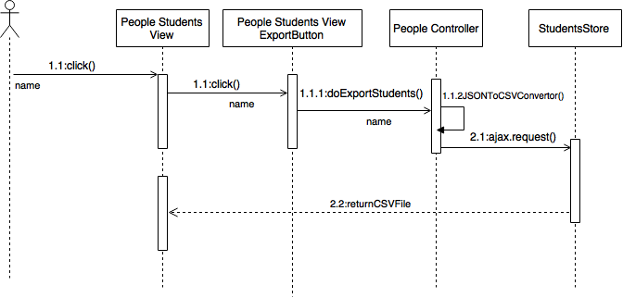

## Class Diagram

## 

## Unit and Integration Test

**Test Case 1 (Sunny Day)**

**ID: MJ-SD-548-01**

**Purpose**

* To test if administrator can click on the Export button and save as an csv file.

**Precondition**

* Administrator has successfully logged onto MobileJudge site.

**Input**

* Administrator clicks on the Export button and a small windows comes up.
* Administrator saves the file with the default name.
* Administrator clicks on the OK button.

**Expected Result**

* The file is saved successfully.

**Actual Result**

* The file is saved successfully.

**Test Case 2 (Rainy Day)**

**ID: MJ-RD-548-02**

**Purpose**

* To test if administrator can click on the Export button and save as an csv file.

**Precondition**

* Administrator has successfully logged onto MobileJudge site.

**Input**

* Administrator clicks on the Export button and a small window comes up.
* Administrator clicks on the 'Open with' button and the program select does not open csv files.
* Administrator clicks on the OK button.

**Expected Result**

* The file is saved successfully.

**Actual Result**

* File is not saved successfully because the program selected will not open the file.

## User Guide

* administrator clicks on People tab

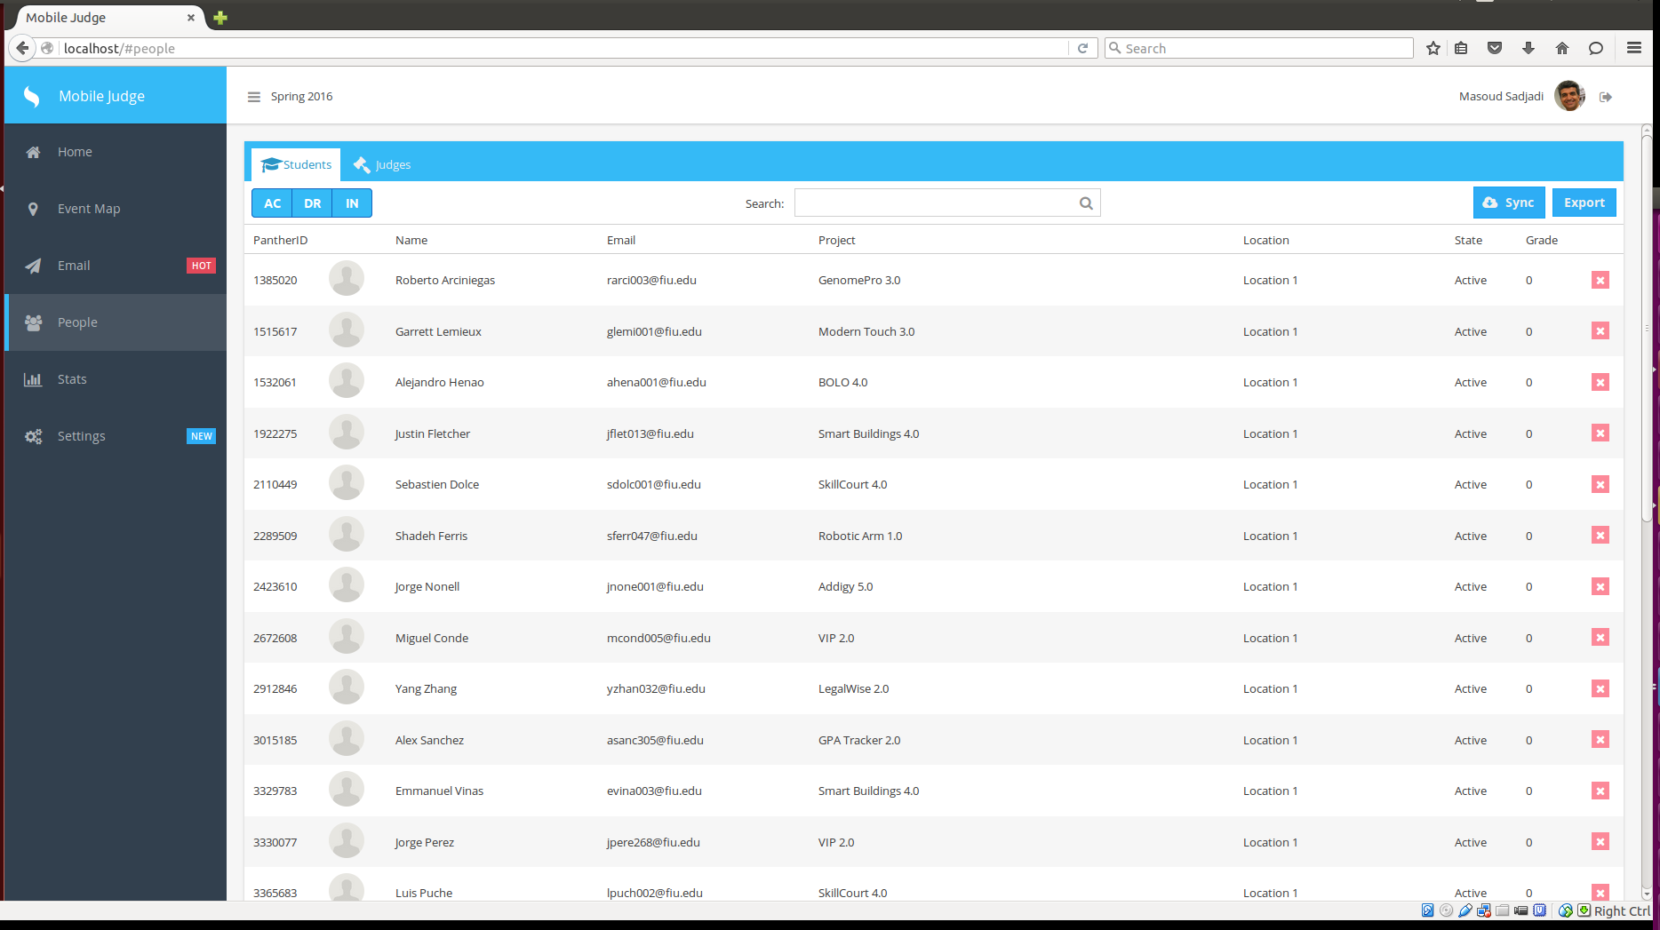

* administrator clicks on students tab



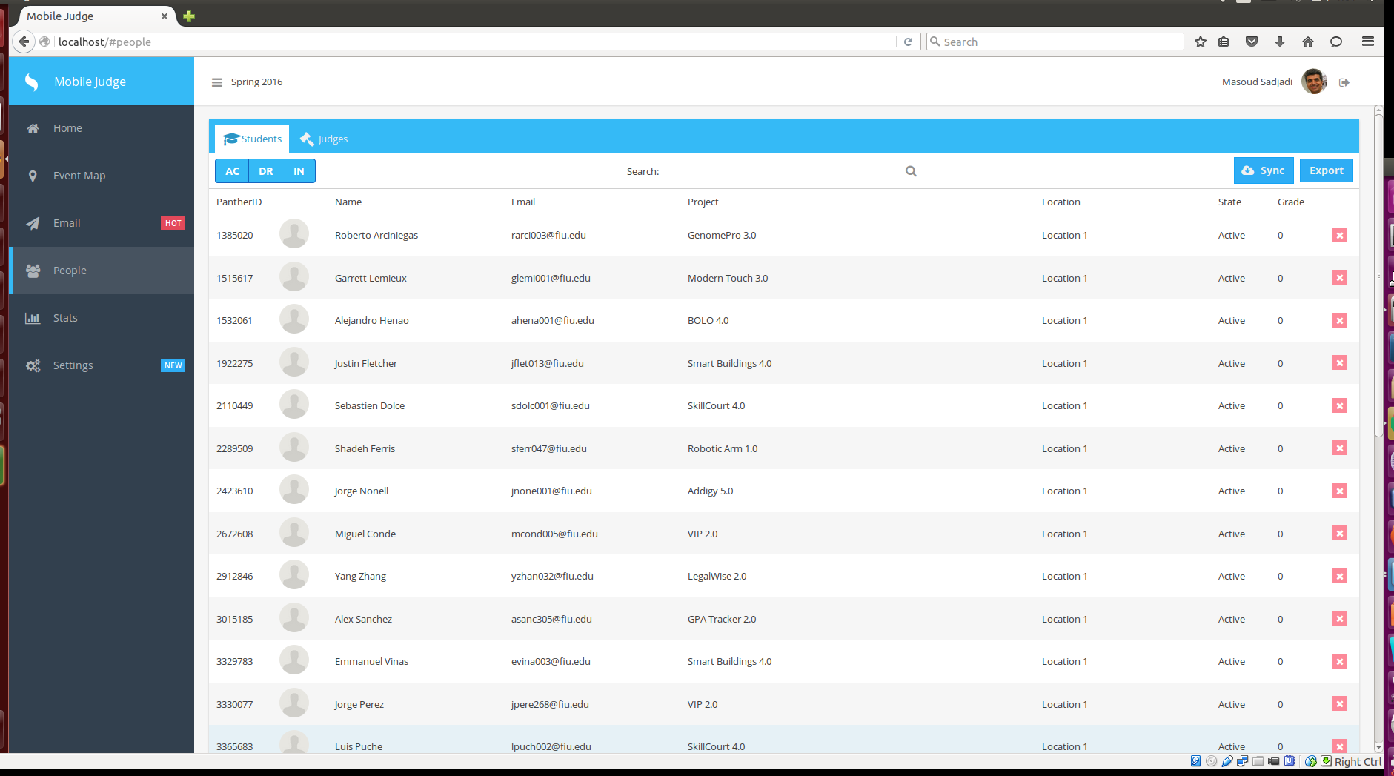

* administrator clicks on Export button

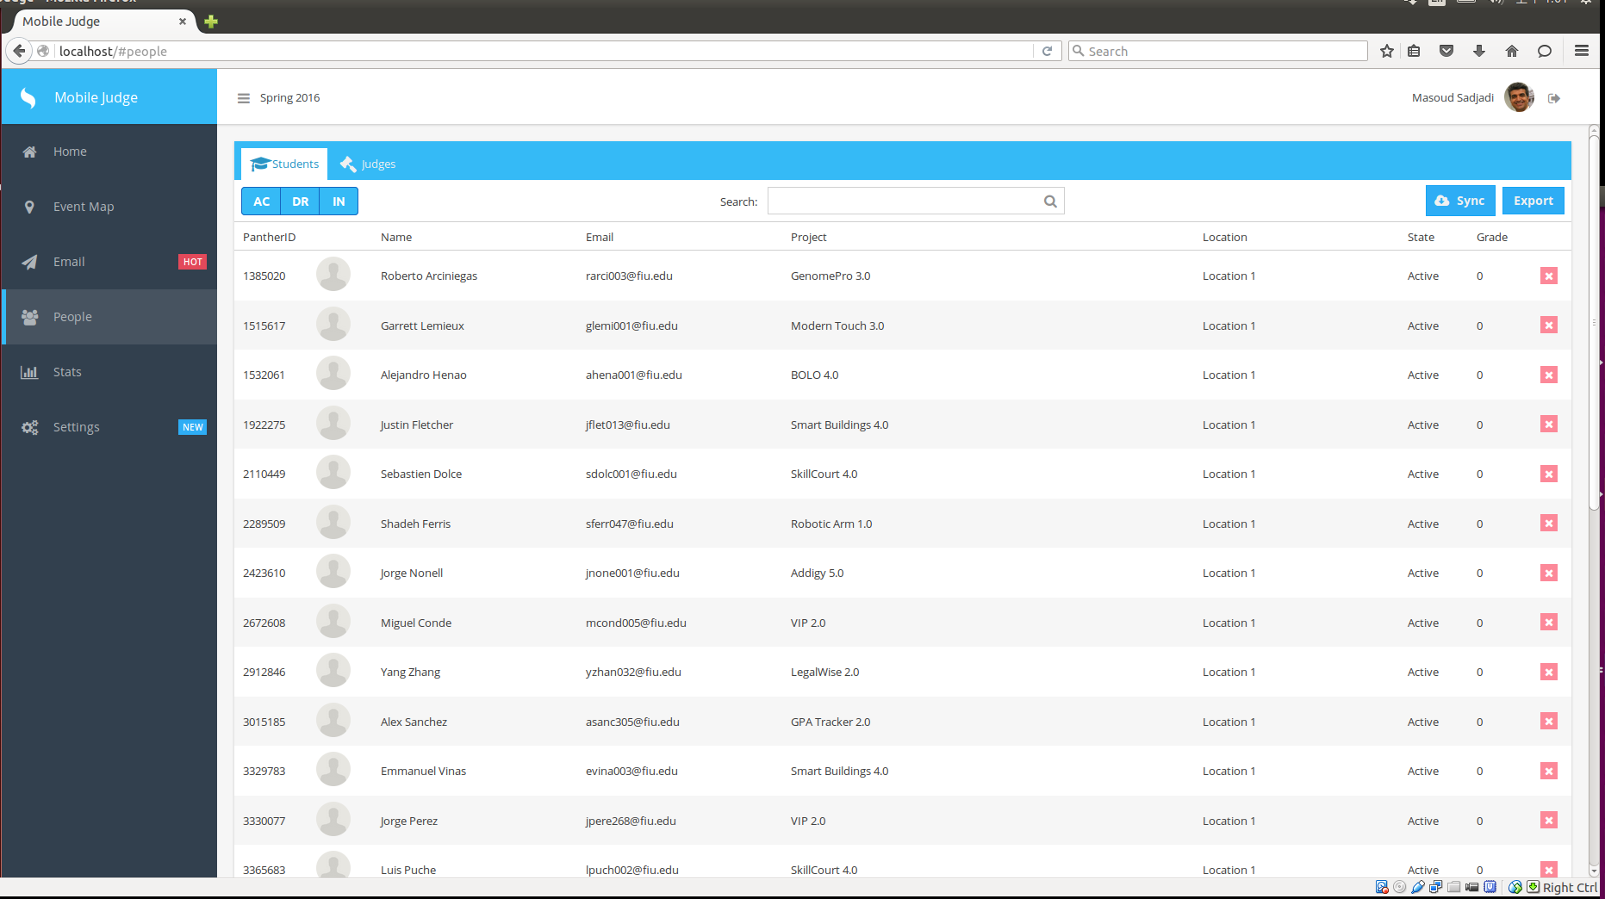

* administrator clicks on save button

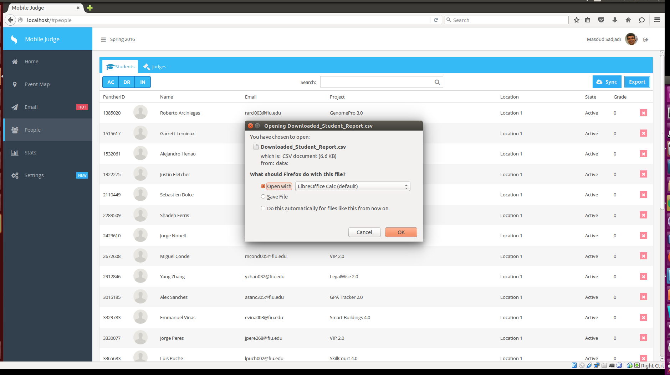

* administrator clicks on OK button

