*Florida International University*

*School of Computing and Information Sciences*

CIS 4911 - Senior Capstone Project

Software Engineering Focus

Feature Document

User Story #519

Link Login Accounts

**Team Member:**

Tiago Moore

**Product Owner(s)**:

Masoud Sadjadi

**Mentor(s)**:

Frank Hernandez

**Instructor**: Masoud Sadjadi

# **User Story**

Link Login Accounts

* As a user, I would like to be able to login using my accounts on other supported networks, such as , Google, LinkedIn, Facebook, and Twitter.

**Use Case**

**Use Case ID: MJ519 : Link Login Accounts**

Details:

Actor: Admin

Pre-conditions:

1. Admin has successfully logged onto the system.
2. Admin is using the Profile feature.

Description:

1. Use case begins when the admin clicks his name or picture.
2. The system shall boxes which icons for which account the user would like to link.
3. The Actor shall click the icon for the account he would like to link.
4. The system will prompt the user to enter his credentials .
5. The system will link the accounts for any subsequent logins.

Post-conditions:

1. The account selected will be linked.
2. Subsequent login attempts will log user in appropriately.

Decision Support:

Frequency: Low. Estimated average of one addition per application execution.

Criticality: Low. Allows the Member to add data into existing app function .

Risk: Medium. Unlink feature will require additional time.

Constraints:

1. Usability:
   1. No training time  required.
   2. Account buttons are visible on Profile tab.
2. Reliability:
   1. Mean time to Failure – 1% failure is acceptable.
   2. Availability – Always available.
3. Performance:
   1. There should be no lag or delay during button selections.
   2. Authentication should be done immediately after click.
4. Supportability:
   1. Feature must appear on mobile and non-mobile devices.

Modification History:

Owner: Tiago Moore.

Initiation date: 02/15/2015

Date last modified: 02/22/2015

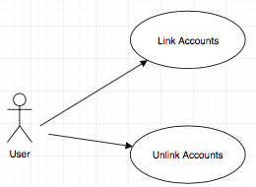

## **Sequence Diagram**

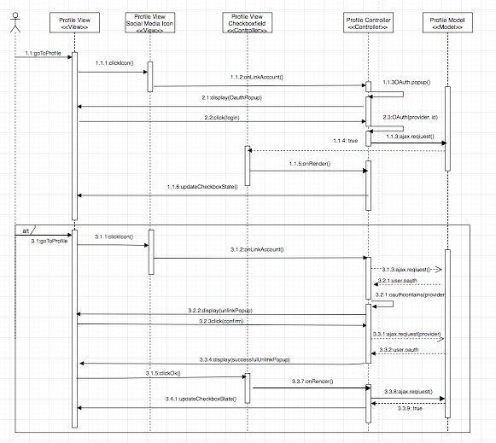

## **Class Diagram**

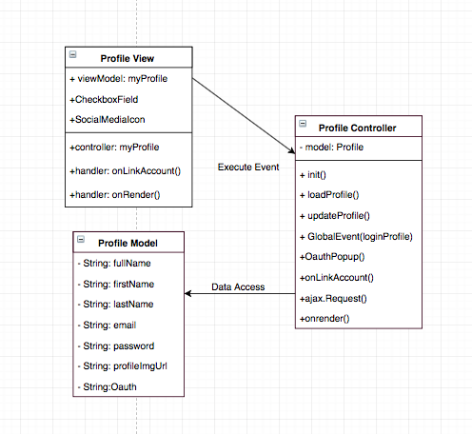

## **Unit & Integration Test**

**Test Case 1 (Sunny Day)**

**ID: MJ-SD-519-01**

**Purpose**

* Test if authentication works after icon click.

**Precondition**

* Admin has successfully logged onto the system.
* Admin is using the Profile feature.

**Input**

* User clicks on social media icon

**Expected Result**

* A pop up window comes up for authentication
* A user enters his login information
* The user account gets linked to the social media account.

**Actual Result**

* A pop up window comes up for authentication
* A user enters his login information
* The user account gets linked to the social media account.

**Test Case 2 (Sunny Day)**

**ID: MJ-SD-519-02**

**Purpose**

* Test if authentication works after icon click.

**Precondition**

* Admin has successfully logged onto the system.
* Admin is using the Profile feature.

**Input**

* User clicks on social media icon

**Expected Result**

* A pop up window comes up for authentication
* A user enters his login information
* The user account gets linked to the social media account.

**Actual Result**

* A pop up window comes up for authentication
* A user enters his login information
* The user account gets linked to the social media account.

**Test Case 3 (Sunny Day)**

**ID: MJ-SD-519-03**

**Purpose**

* Test if authentication works after icon click.

**Precondition**

* Admin has successfully logged onto the system.
* Admin is using the Profile feature.

**Input**

* User clicks on social media icon

**Expected Result**

* A pop up window comes up for authentication
* A user enters his login information
* The user account gets linked to the social media account.

**Actual Result**

* A pop up window comes up for authentication
* A user enters his login information
* The user account gets linked to the social media account.

**Test Case 4 (Rainy Day)**

**ID: MJ-SD-519-04**

**Purpose**

* Test if accounts are linked upon a failed authentication attemp.

**Precondition**

* User has successfully logged onto the system.
* User is using the Profile feature.
* User enters erroneous account information.

**Input**

* User clicks on social media icon
* User inputs wrong username and password

**Expected Result**

* A pop up window comes up for authentication
* A user enters his login information
* The user account does not gets linked to the social media account.

**Actual Result**

* A pop up window comes up for authentication
* A user enters his login information
* The user account does not gets linked to the social media account.

**User Guide**

User is logged on and on the profile page :

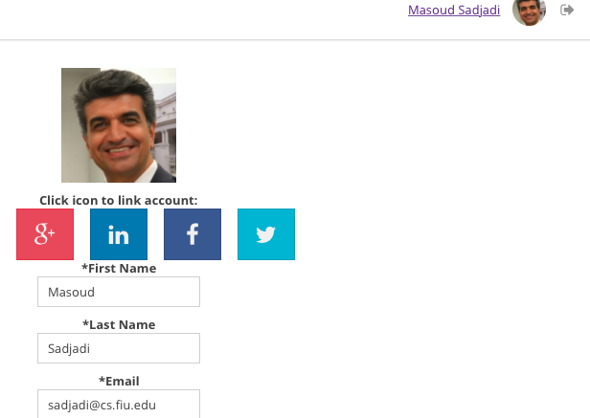

User icon for authentication:

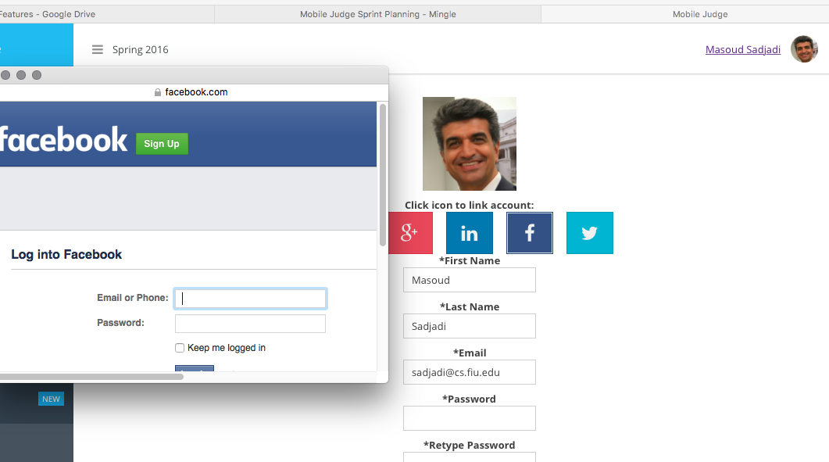

User will be authenticated and linked after the enters credentials.