*Florida International University*

*School of Computing and Information Sciences*

CIS 4911 - Senior Capstone Project

Software Engineering Focus

Feature Document

User Story #520

**Team Member:**

Steven Rowe

**Product Owner(s)**:

Masoud Sadjadi

**Mentor(s)**:

Frank Hernandez

**Instructor**: Masoud Sadjadi

# User Story

Description: Manage Profile

As a user, I want to be able to click on my name and/or profile picture, which should be accessible from all pages, so that I can review and modify my profile, including my profile picture, password, name, etc.

### Acceptance Criteria:

1. After a user logs in he will be able to see his/her name and/or profile picture on all pages.
2. User must be able to click on his name and/or profile picture to manage his/her profile.
3. All changes will be effected immediately when user successfully save the changes.

## Use Case

**Use Case ID: MJ520 - Manage Profile**

Details:

Actor: User

Pre-conditions:

1. Once user is logged in, the user profile information is loaded onto the screen

Description:

1. Use case begins when the user clicks his profile picture or name
2. The system will redirect the user to his profile page
3. Once redirected to the his/her profile page, all the profile information will be able to be edited.
4. The system will be able to save the new profile information changes.
5. Use case ends once the user clicks save.

Post-conditions:

1. n/a

Alternative Courses of Action:

1. n/a

Decision Support:

Frequency: Low. Estimated average of one addition per application execution.

Criticality: Low. Allows the Member to add/edit data into existing app function.

Risk: Medium. Implementing this use case requires Member to learn Sencha framework.

Constraints:

1. Usability:
   1. No training time required.
2. Reliability:
   1. Mean time to Failure – 1% failure is acceptable.
   2. Availability – Always available.
3. Performance:
   1. User information will be saved and all relevant information will be updated with new information
4. Supportability:
   1. Feature must appear on mobile and non-mobile devices.

Modification History:

Owner: Marlon Rowe

Initiation date: 01/26/2015

Date last modified: 02/05/2015

## Sequence Diagram

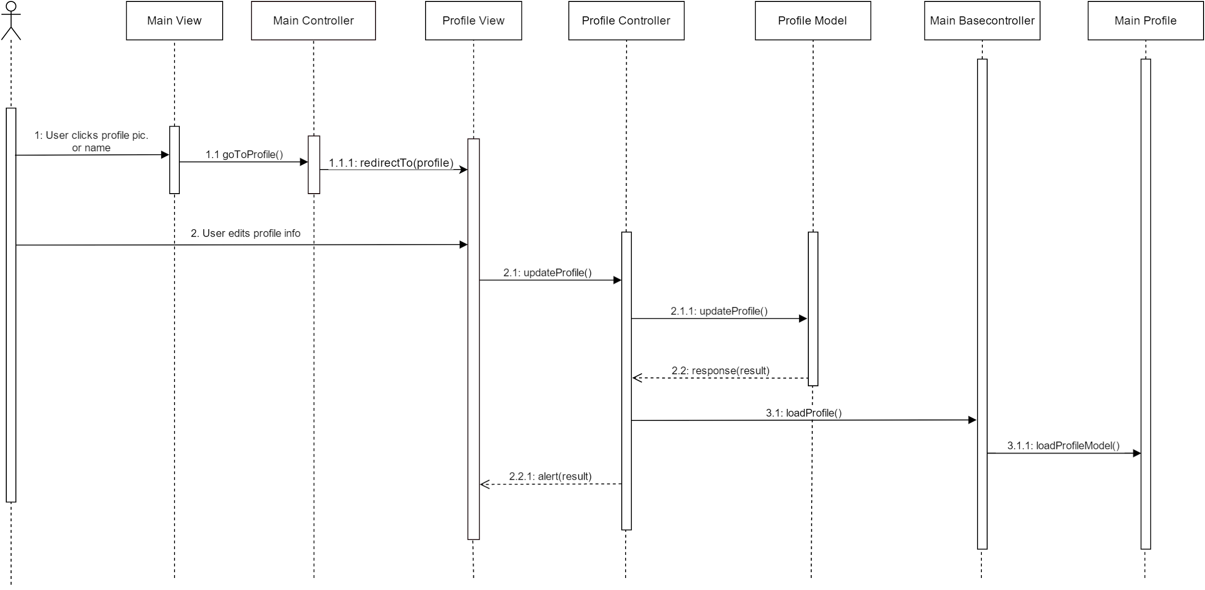

**Class Diagram**

## 

## 

## Unit & Integration Test

**Test Case 1 (Sunny Day)**

**ID: MJ-SD-520-01**

**Purpose**

* Test if user can save new information

**Precondition**

* User has logged into Mobile Judge
* User went to his/her profile page by clicking on his/her picture or name

**Expected Result**

* User was able to save all information on the form

**Actual Result**

* User was able to save all information on the form to the database

**Test Case 1 (Rainy Day)**

**ID: MJ-RD-520-01**

**Purpose**

* Test if user can save first name, last name or email with empty fields

**Precondition**

* User has logged into Mobile Judge
* User went to his/her profile page by clicking on his/her picture or name

**Expected Result**

* User was not able to save first name, last name, or email fields information to database

**Actual Result**

* User was able to save all information on the form to the database

## 

## 

## 

## User Guide

Once a user is logged in, clicking on either the his/her name or profile picture, will redirect them to the profile page.

## 1.jpg

Once in the profile page, the user can edit his/her first name, last name, and email. Once you are satisfied with your update, clicking “Save changes” will update your profile information

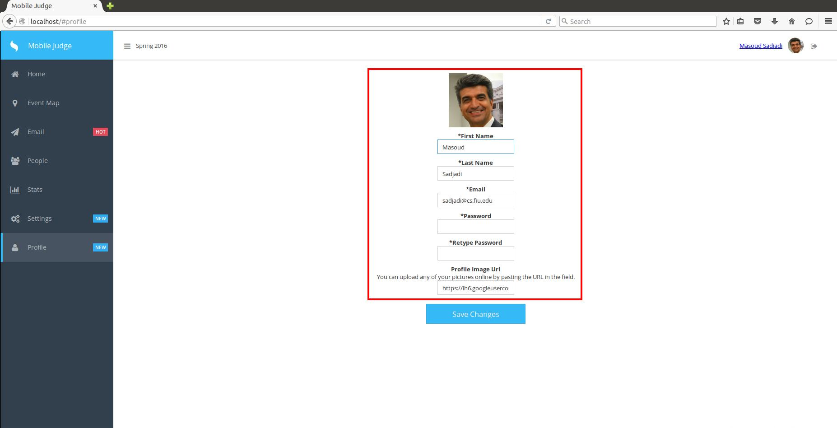

Once the database has been saved with the new information, a popup will appear showing that the profile has been updated.

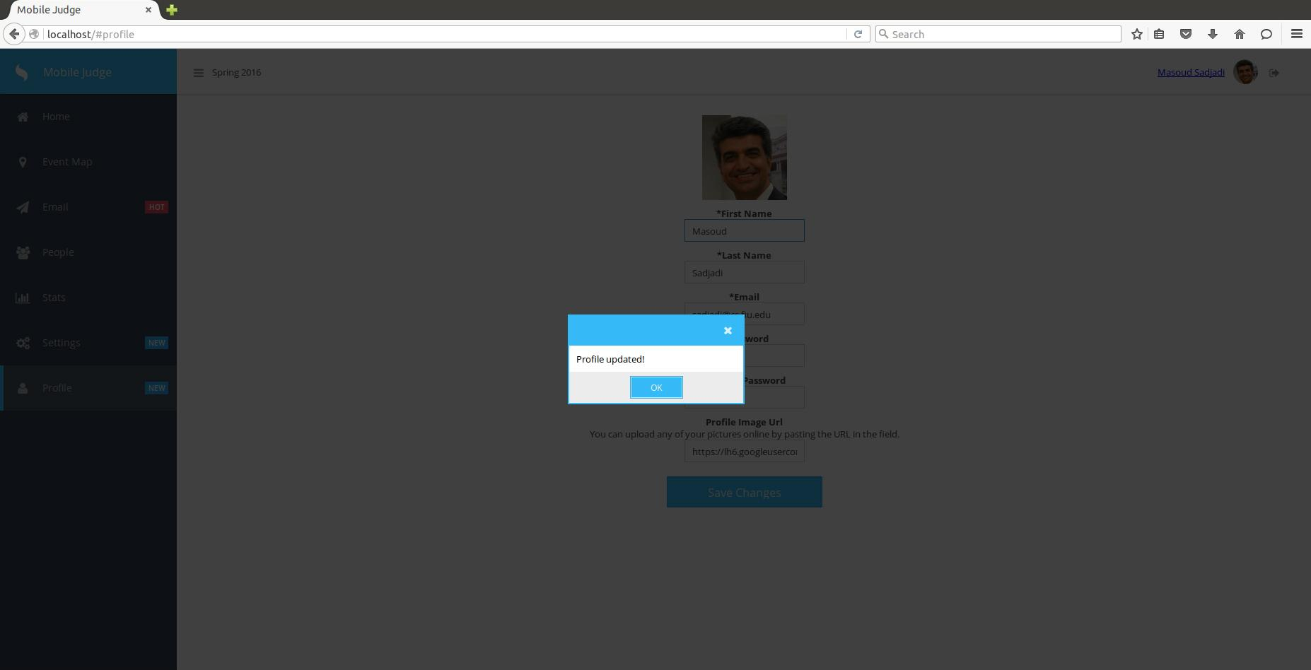

All relevant information on the page will be updated upon receiving the “Profile updated” message.