*Florida International University*

*School of Computing and Information Sciences*

CIS 4911 - Senior Capstone Project

Software Engineering Focus

Feature Document

User Story #522

**Team Member:**

Tiago Moore

**Product Owner(s)**:

Masoud Sadjadi

**Mentor(s)**:

Frank Hernandez

**Instructor**: Masoud Sadjadi

# **User Story**

Export Judge List

* As an admin, I would like to be able to export any filtered list of judges into a csv file.

**Use Case**

**Use Case ID: MJ522 -Export Judge List**

Details:

Actor: Admin

Pre-conditions:

1. Admin has successfully logged onto the system.
2. Admin is using the People tab.
3. Admin has clicked on the Judges tab.

Description:

1. Use case begins when the admin clicks on the people tab as selects students or judge .
2. The admin must click on the Judges tab and click the export button.
3. The system shall prompt the admin to save the csv file of judges.
4. The csv file with judge information shall be saved into the actors system.
5. Use case ends when the actor exits the view.

Post-conditions:

1. There are judges to export

Alternative Courses of Action:

1. Actor has option of using filters.

Decision Support:

Frequency: Low. Estimated average of one addition per application execution.

Criticality: Low. Allows the Member to add data into existing app function .

Risk: Medium. Implementing this use case requires Member to learn Sencha framework.

Constraints:

1. Usability:
   1. No training time  required.
   2. Button should be visible aligned to filter boxes.
2. Reliability:
   1. Mean time to Failure – 1% failure is acceptable.
   2. Availability – Always available.
3. Performance:
   1. There should be no lag or delay between selection
   2. Check box should be able to be clicked at will.
4. Supportability:
   1. Feature must appear on mobile and non-mobile devices.

Modification History:

Owner: Tiago Moore.

Initiation date: 01/26/2015

Date last modified: 02/015/2015

## **Sequence Diagram**

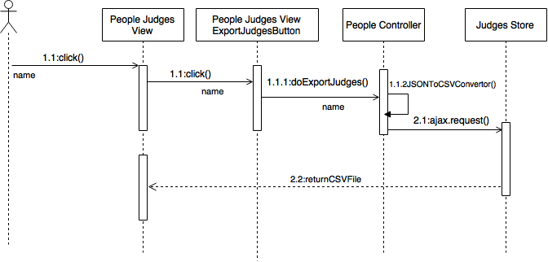

## 

## 

## **Class Diagram**

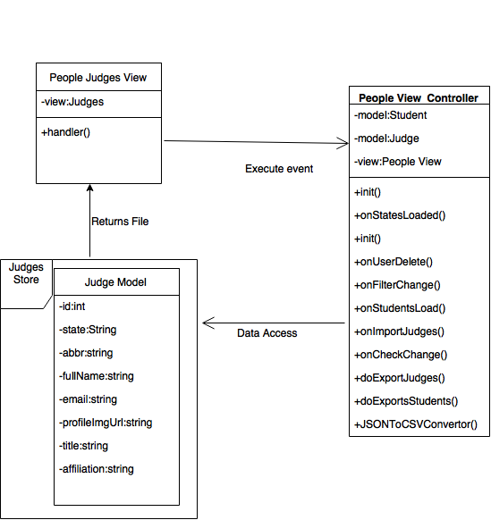

## 

## **Unit & Integration Test**

**Test Case 1 (Sunny Day)**

**ID: MJ-SD-522-01**

**Purpose**

* Test to see if export button returns csv file

**Precondition**

* User has logged on mobile judge
* User has clicked on the People tab
* User has clicked on judged tab
* The database contains judge information
* User has clicked the export button

**Input**

* A click activated by the user on the button.

**Expected Result**

* All filters should be selected.
* A CSV file with all judge information.

**Actual Result**

* A CSV file with all judge information.

**Test Case 2**

**ID: MJ-SD-542-02**

**Purpose**

* Test if checkbox returned selected list of judges with filter applied .

**Precondition**

* User has logged on mobile judge.
* User has clicked on the People tab.
* User has clicked on judged tab.
* The database contains student information.
* User has clicked the export button.

**Input**

* Admin clicks on the export judges button.

**Expected Result**

* A CSV file with selected judges should be returned

**Actual Result**

* All judges were returned FAILED

**Test Case 3 (Rainy Day)**

**ID: MJ-RD-522-01**

**Purpose**

* Test if CSV file with judges is returned when there is an empty database.

**Precondition**

* User has logged on mobile judge.
* User has clicked on the People tab.
* User has clicked on judged tab.
* The database is empty.
* User has clicked the export button.

**Input**

* Admin clicks on the export judges button.

**Expected Output**

* All filters should be selected
* Grid should be populated

**Actual Result**

* All filters were selected
* Grid was populated

**User Guide**

* Admin will login and browse to People tab

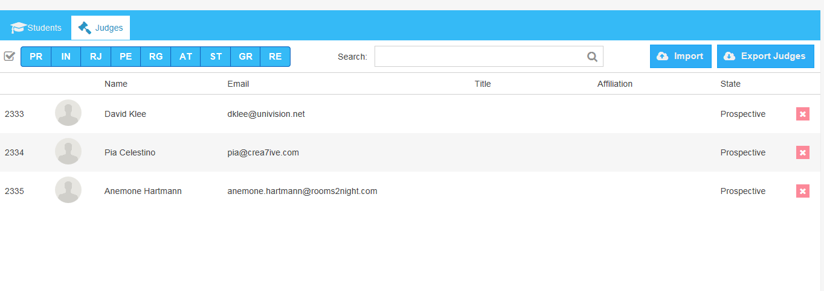

* The admin clicked on Judges tab
* The admin clicked on export judges tab
* A promtwill show to save file 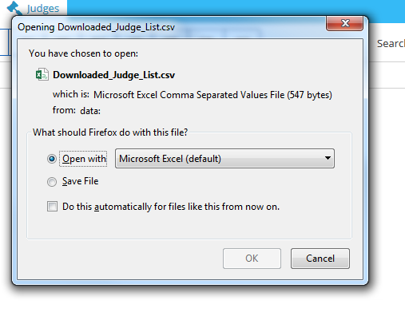
* The CSV file will show the judge list .

