*Florida International University*

*School of Computing and Information Sciences*

CIS 4911 - Senior Capstone Project

Software Engineering Focus

Feature Document

User Story #523

# 

**Team Member:**

Miguel Conde

**Product Owner(s)**:

Masoud Sadjadi

**Mentor(s)**:

Frank hernandez

**Instructor**: Masoud Sadjadi

# 

# User Story

### Description:

* As an admin, I want to search for a name when using the email wizard tool.

### Acceptance Criteria:

1. Search bar will be same style as the one in People tab.
2. The search bar is available in Step 2 of the wizard.
3. The admin should be able to choose all students in Step 1, for example, and then in Step 2, he/she can filter some names, unselect them, and then go to the next step.
4. It should always keep track of the selections in Step 2, no matter what the filter currently shows.
5. If the user goes back to Step 1, the user should be warned that the changes made in Step 2, if any, will be lost. If there is no changes in Step 2, no need for such a warning.

## 

## Use Case

**Use Case ID:**(MJ-523) - Admin filters results in email wizard

**Details:**

**Actor:** MobileJudge Admin

**Pre-conditions:**

1. Admin is logged into MobileJudge system
2. Admin is on Refine Search( 2nd tab) of email wizard

**Description:**

1. Use case begins when Admin types in search criteria in search bar and clicks on search icon.
2. The system shall reload the student and judge models that match search criteria based on name or email.
3. The system shall add clear icon on search bar.
4. The admin clicks on clear icon on search bar.
5. The system shall remove clear icon on search bar.
6. Use Case ends when model has been properly updated with any changes made by Admin.

**Relevant requirements:**

1.none

**Post-conditions:**

1. Model is properly updated with filter applied.
2. Model is properly updated with filter removed.

**Alternative Courses of Action:**

1. Admin clicks on Previous button
2. The system shall display message warning admin that all changes will be lost if he navigates back
3. Admin clicks yes
4. The system shall display previous view.

**Exceptions:**

none

**Related Use Cases:**

none

**Decision Support**

**Frequency:**  One average <5 searches are performed per navigation to page.

**Criticality:** Medium. Allows Admin to search for specific student/judge.

**Risk:** Low. Invoking this use case involves standard web based technology.

**Constraints:**

Usability:

* No previous training time required.
* On average, it should take the user less that 1 second to update model information.

Reliability:

* Mean time to failure - 1% for every attempt is acceptable.

Performance:

* Response time - system should react to a user input within 100ms - 500ms.
* Throughput - the system should accomplish the work within 50ms.
* Availability - always available unless the system is down for maintenance.

Supportability:

* Adaptability - should work on mobile devices of multiple screen sizes.
* Maintainability - changes to the application should work with these web browsers Chrome, Firefox, IE11.

**Modification History**

**Owner:** Miguel Conde

**Initiation date:** 01/22/2016

**Date last modified:** 01/28/201

## Sequence Diagram

## Class Diagram

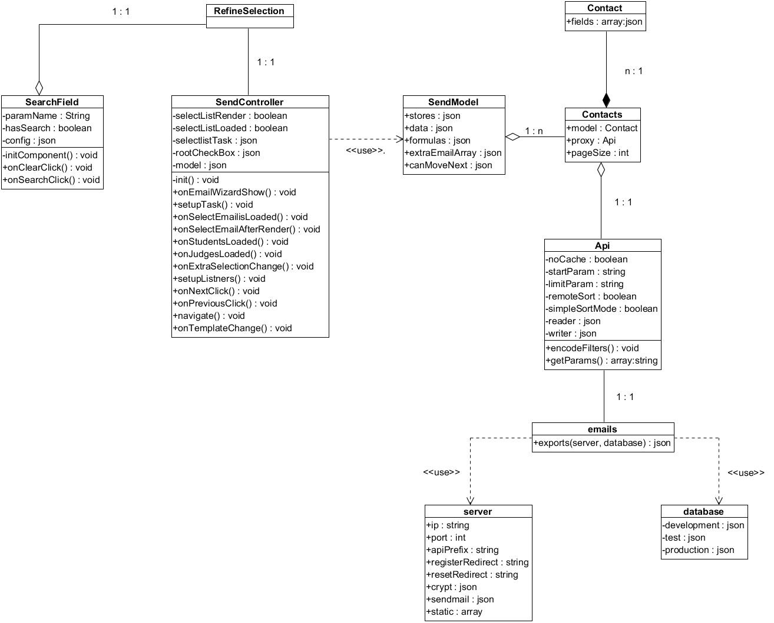

**Unit & Integration Tests**

## Unit & Integration Test

**Test Case 1 (Sunny Day)**

**ID: MJ-SD-523-01**

**Purpose**

* Test if Student name is found on valid search

**Precondition**

* User has logged on mobile judge
* User is on the second tab of the email Wizard

**Input**

* User types in name in the search bar and clicks enter with students grid open

**Expected Result**

* Grid returns Student record that name matches search criteria
* The student record must be selectable
* Text “(must be cleared to proceed to next) should appear in red, bold color/font
* Next button is disabled

**Actual Result**

* Grid returns Student record that name matches search criteria
* The student record is selectable
* Text “(must be cleared to proceed to next) appears in red, bold color/font
* Next button is disabled

**Test Case 2**

**ID: MJ-SD-523-02**

**Purpose**

* Test if Judge name is found on valid search

**Precondition**

* User has logged on mobile judge
* User is on the second tab of the email Wizard

**Input**

* User types in name in the search bar and clicks enter with judge grid open

**Expected Result**

* Grid returns Judge record that name matches search criteria
* The judge record must be selectable
* Text “(must be cleared to proceed to next) should appear in red, bold color/font
* Next button is disabled

**Actual Result**

* Grid returns judge record that name matches search criteria
* The judge record is selectable
* Text “(must be cleared to proceed to next) appears in red, bold color/font
* Next button is disabled

**Test Case 3**

**ID: MJ-SD-523-03**

**Purpose**

* Test if warning box displays when user clicks previous button

**Precondition**

* User has logged on mobile judge
* User is on the second tab of the email Wizard

**Input**

* User clicks on the previous button

**Expected Result**

* Warning message is displayed

**Actual Result**

* Warning message is displayed

**Test Case 4**

**ID: MJ-SD-523-04**

**Purpose**

* Test if clicking yes on warning message navigates user to previous tab

**Precondition**

* User has logged on mobile judge
* User is on the second tab of the email Wizard
* User has clicked previous button and warning message is displayed

**Input**

* User clicks on Yes button

**Expected Result**

* User is navigated to previous tab

**Actual Result**

* User is navigated to previous tab

**Test Case 5**

**ID: MJ-SD-523-05**

**Purpose**

* Test if clicking ‘x’ on search filter text field displays full list and enables next

**Precondition**

* User has logged on mobile judge
* User is on the second tab of the email Wizard
* User has a search filter active

**Input**

* User clicks on ‘x’ button on search filter text field

**Expected Result**

* All grids return to their original state before search filter was applied.
* Records are selectable
* Text “(must be cleared to proceed to next) should disappear
* Next button is enabled

**Actual Result**

* All grids return to their original state before search filter was applied.
* Records are selectable
* Text “(must be cleared to proceed to next) should disappear
* Next button is enabled

**Test Case 6 (Rainy Day)**

**ID: MJ-SD-523-06**

**Purpose**

* Test if clicking no on warning message removes message box without navigating user

**Precondition**

* User has logged on mobile judge
* User is on the second tab of the email Wizard
* User has clicked previous button and warning message is displayed

**Input**

* User clicks on No button

**Expected Result**

* User is not navigated to previous tab and message box disappears

**Actual Result**

* User is not navigated to previous tab and message box disappears

## 

## 

## 

## User Guide

Upon reaching the 2nd tab of the email wizard, you will be able to filter the results by entering the student/judge name or email address on the search bar. Once the name has been entered click on the magnifying glass on the search bar to initiate the search. To clear the search filter click on the ‘x’ icon on the search bar.

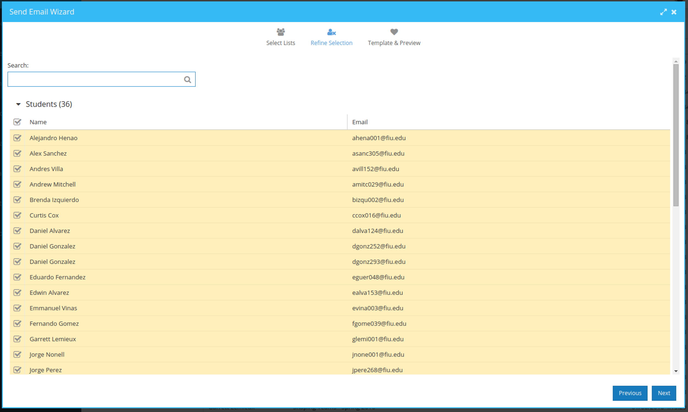

On search it will return the names that match your query, it will also remember the state(checked, or unchecked) of the results. The next button will become disabled and the search field must be cleared to enable it once again.

