*Florida International University*

*School of Computing and Information Sciences*

CIS 4911 - Senior Capstone Project

Software Engineering Focus

**Feature Document**

User Story #524

**Team Member:**

Jorge Perez

**Product Owner(s)**:

Masoud Sadjadi

**Mentor(s)**:

Frank Hernandez

**Instructor**: Masoud Sadjadi

**User Story**

Manage List Sizes

* As an admin, I want a setting to choose how many items to be included in the list on each page, so that I can easily scroll up or down with the amount of data I would like to view in one shot.

**Use Case**

**Use Case ID: MJ524 - Manage List Sizes**

Details:

Actor: Admin

Pre-conditions:

1. Admin has successfully logged onto the system.
2. Admin is on the Email or People tab.

Description:

1. The use case begins when the admin clicks the list size combo box on the Email or People view.
2. The admin then clicks on one of the list size options.
3. The size of the list then updates to only show the size that the admin selected.

Post-conditions:

1. List is now the size that the admin selected.

Exceptions:

1. Error updating the list size.

Related Uses Case:

Decision Support:

Frequency: Admins are expected to change list sizes at least 2 times per login.

Criticality: This use case is of medium importance. Helps the admin adjust list size depending on how many roles selected or filters applied.

Risk: Low risk involved. Feature should take about 16 hours of developer times.

Constraints:

1. Usability:
   1. Feature is implemented on many different platforms therefore, admin should not need training.
   2. If training is needed, admin should be trained and able to understand the functionality in 5 minutes.
2. Reliability:
   1. Mean time to Failure - 7 days
   2. Availability - 95% uptime
3. Performance:
   1. Admin should have list updated within 1 second of clicking the list size link or ‘OK’.
4. Supportability:
   1. Option to change list size should be available on Desktop and Mobile platforms.

Modification History:

Owner: Jorge Perez

Initiation date: 01/26/2016

Date last modified: 01/28/2016

**Sequence Diagram**

524 - Sequence Diagram.png

## 

## 

## 

## **Class Diagram**

524_Class Diagram.png

**Testing**

**Test Case 1 (Sunny Day)**

**ID: MJ-SD-524-01**

**Purpose**

* Test if the ‘10’ list size button changes the list to 10 items when the default size list size is shown (25).

**Precondition**

* User is logged into the system
* User is in the People page
* User is in the Students Tab.

**Input**

* User clicks List Size Button ‘10’

**Expected Result**

* List size of students changes from 25 to 10.

**Actual Result**

* List size of students changes from 25 to 10.

**Test Case 2 (Sunny Day)**

**ID: MJ-SD-524-02**

**Purpose**

* Test if the ‘50’ list size button changes the list to 50 items when the default size list size is shown (25).

**Precondition**

* User is logged into the system
* User is in the People page
* User is in the Students Tab.

**Input**

* User clicks List Size Button ‘25’

**Expected Result**

* List size of students changes from 10 to 25.

**Actual Result**

* List size of students changes from 10 to 25.

**Test Case 2 (Rainy Day)**

**ID: MJ-SD-524-01**

**Purpose**

* Test if the list size changes when 25 is clicked and the list size is already 25.

**Precondition**

* User has logged onto mobile judge
* User has clicked on the People tab
* User has clicked on the student tab of the people page
* List size is already 25

**Input**

* User clicks the List Size Button ‘25’

**Expected Output**

* List size stays at 25

**Actual Result**

* List size stays at 25

## 

## 

## **User Guide**

* The admin will login and navigate to the People Page

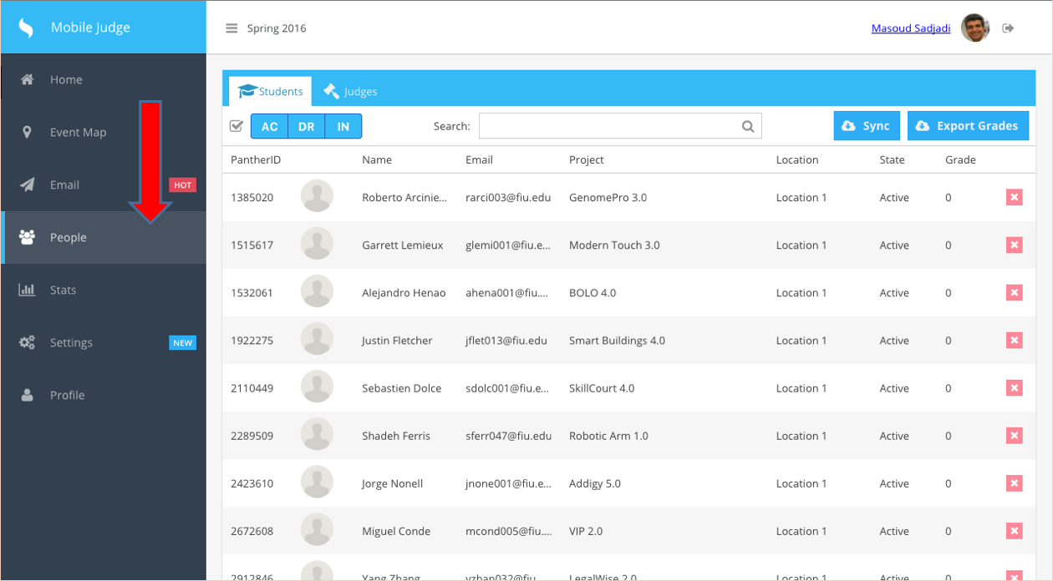

* Scroll down until you see the bottom of the list. This is called the Paging Toolbar.

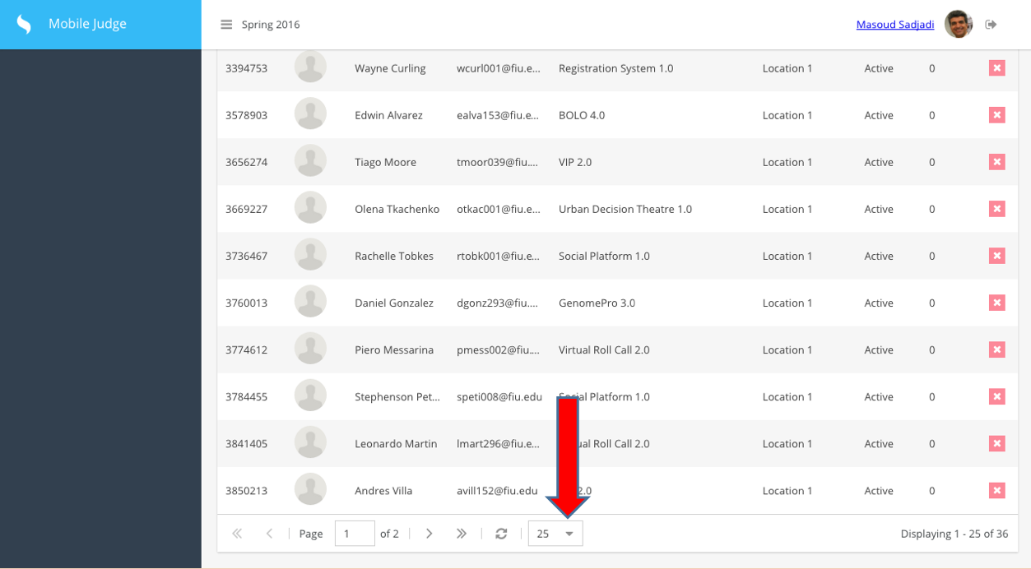

* Click on the Combo Box and a Dropdown menu will appear. Select the new size of the list. (In this case, we selected 10)

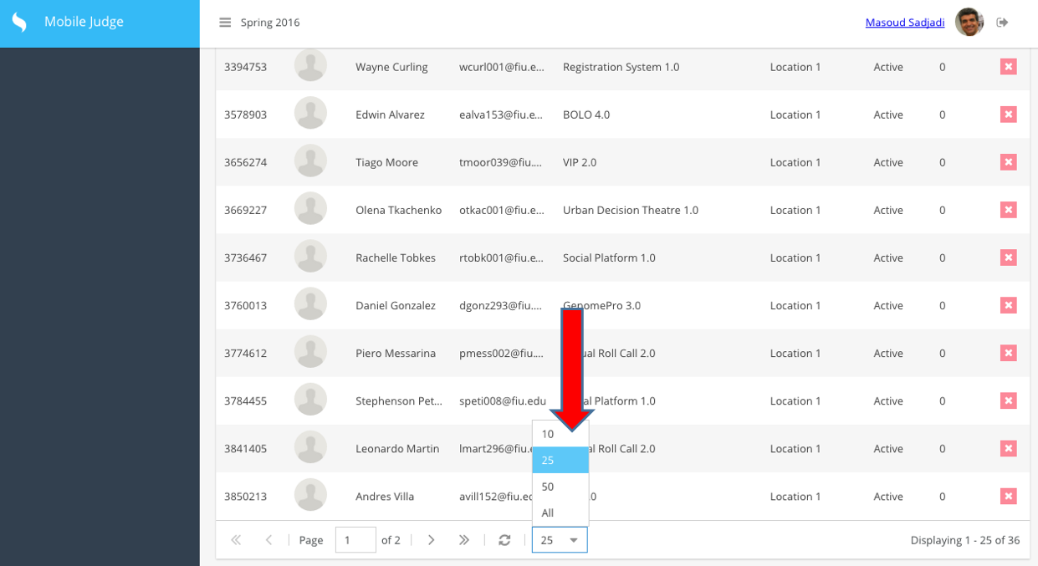

* Once you select the size, the actual list size will change along with the “Displaying …” message in the Paging Toolbar.

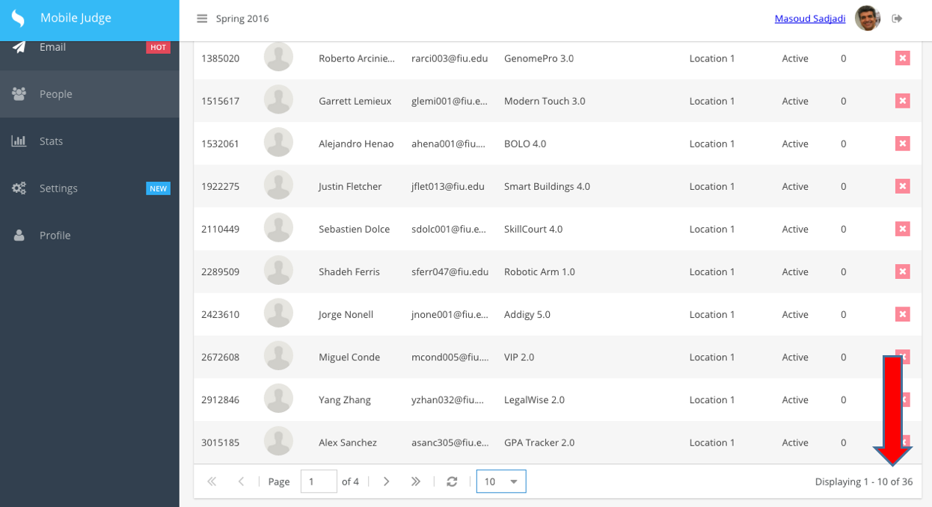

* This functionality will work on any list within the website that has the paging toolbar active.