*Florida International University*

*School of Computing and Information Sciences*

CIS 4911 - Senior Capstone Project

Software Engineering Focus

Feature Document

User Story #525

Accept Grades

**Team Member:**

Rodolfo Viant

**Product Owner(s)**:

Masoud Sadjadi

**Mentor(s)**:

Frank Hernandez

**Instructor**: Masoud Sadjadi

# User Story

# 525 Review Grades

### Description:

* As an admin, I want to be able to Accept or Reject Grades entered by judges, so that I can finalize the grades for the students.

### Acceptance Criteria:

1. The admin should be able to filter only the Rejected or Accepted grades and work on them.
2. The admin should be able to filter the grades using a search box similar to those in the Students page.
3. The admin should be able to select/deselect some/all of the grades in a filtered list and Reject/Accept the selected ones using one click.
4. This feature must be available on Mobile devices too.

## Use Case

Use Case ID:(MJ-525-1) - Admin Accepts Grades

**Details**:

**Actor**: Mobile Judge Admin Masoud Sadjadi

**Pre-conditions**:

1. Admin is logged into MJ system.

2. Admin is on the Grade Page

**Description**:

1. Use case begins when Admin clicks on the “Traffic Light” icon for one or

more students.

2. The system shall update the student’s grades in the Database.

3. The system shall then reload the Grade page with the updated data.

4. The system shall change the Traffic light to green for the selected student or all the students.

5. The use case ends when the model has been updated with any changes

made by the system Administrator.

**Post-conditions**: N/A

**Alternative Course of Action**:

1. Admin clicks on a different page.

2. The system shall display the new page.

**Exceptions**: N/A

**Related Use Case**: (MJ-525-2) - Admin Change Grades Status

**Decision Support**

**Frequency**: Used only at the end of semesters after Project Presentation.

**Criticality**: High. Allows Admin to remove unfair Grades or Remove too high Grades.

**Risk**: Low. Simple data fetch and update operation.

**Constraints**

**Usability**: No training required. It should take less than a minute to Accept/Reject a

grade.

**Reliability**: System should be able to query and update the required information in a

timely manner

**Performance**: System should be able to gather information and load the response in one

minute max.

**Supportability**

**Adaptability**: Should work on devices of multiple screen sizes.

**Maintainability**: Changes to the use case should be easy to perform and should be

reflected on all the devices supported.

**Modification History**:

*Owner*: Rodolfo Viant Rodriguez

*Initiation Date*: 01/28/2016.

*Termination Date*: 02/1/2016.

## Sequence Diagram

Updated User Story #525 Sequence Diagram first.png

## Class Diagram

Class Diagram.png

Unit & Integration Test

**Test Case 1 (Sunny Day)**

**ID: MJ-SD-525-01**

Purpose

* Test if change grade status for a student.

Precondition

* Admin has successfully logged onto the system.
* Judges have graded the students.

Input

* Admin clicks on green traffic light icon .

Expected Result

* Traffic Light changes color to red.
* Traffic Light icon tooltip changed to “Rejected”.

Actual Result

* Traffic Light changed color to red
* Traffic Light tooltip changed to “Rejected”

## 

## User Guide

* Admin will login and navigate to the Grade page by clicking in the Grade option on the side panel.

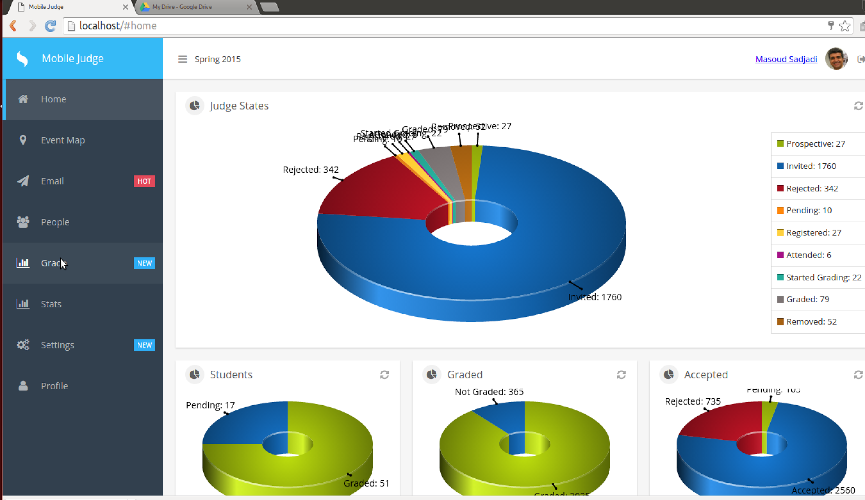

* A grid containing the student’s info and grade will appear.

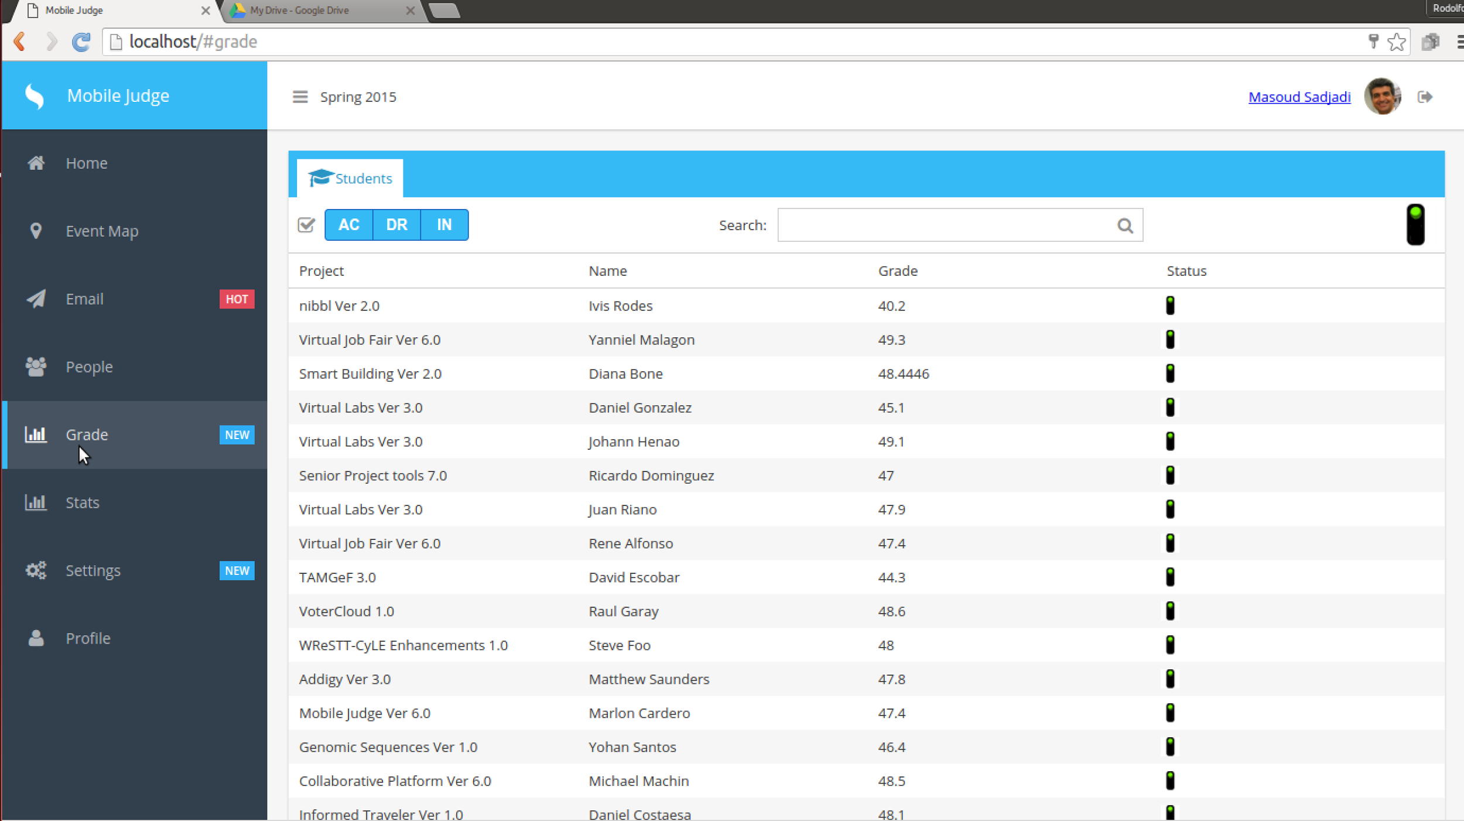

* You can filter the grid by clicking the AC, DR, IN buttons or you can use the search bar.
* To Accept/Reject/Make_Pending a grade you can click on the traffic light for each student or you can click on the traffic light next to the search bar to for all the students shown in the grid.
  + Note: Please note that more students may be on next page of grid changes made in this page only apply to students shown in this grid.
* To edit each students grade individually by judge you can click on a row, and a model will appear showing you the averages of each judge for the selected student.

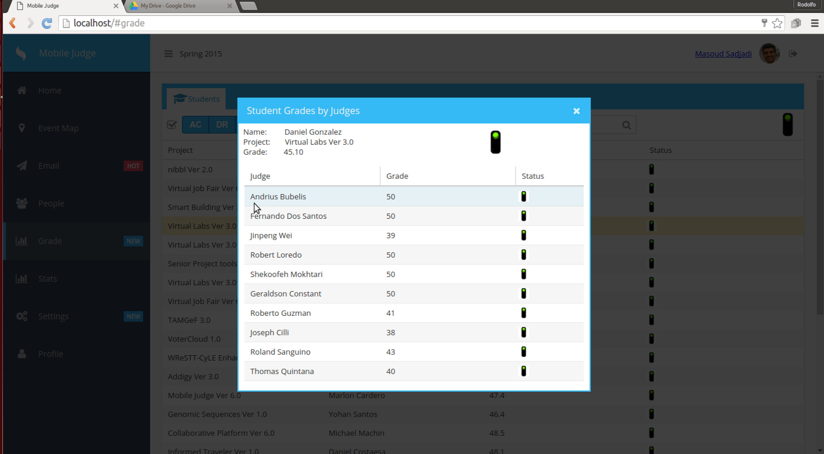

* You can also change the Accept/Reject/Make_Pending by clicking the traffic light for each Judge which will only modify the grades status for the selected judge or you can click the traffic light at the top of the Modal to modify the status for all the judges for this student.
* To edit each grade for an individual judge you can click on a row and it will open another Modal that will show all the grades for all the questions for the selected judge.

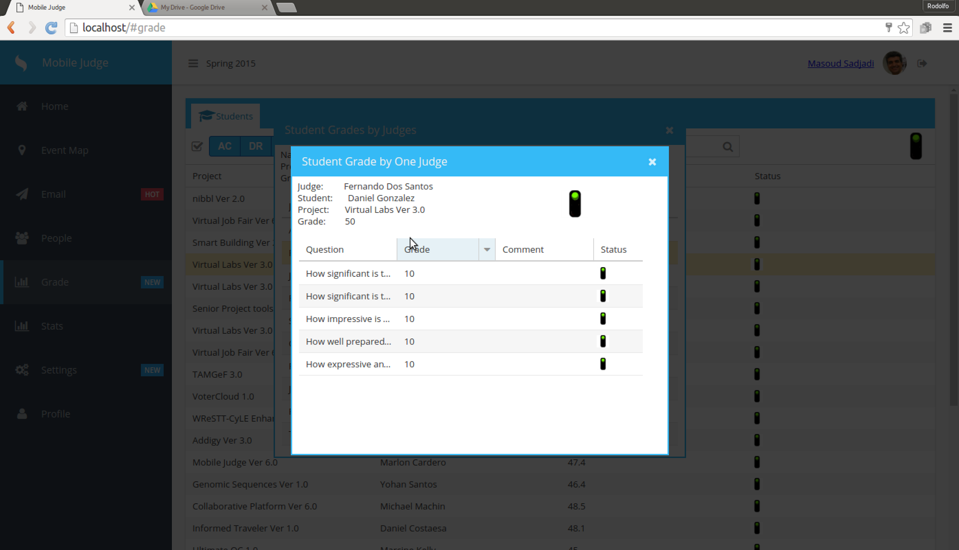

* In this Modal you can Accept/Reject/Make_Pending the grades for each question and also modify the grade value to a value between 0 and 10.

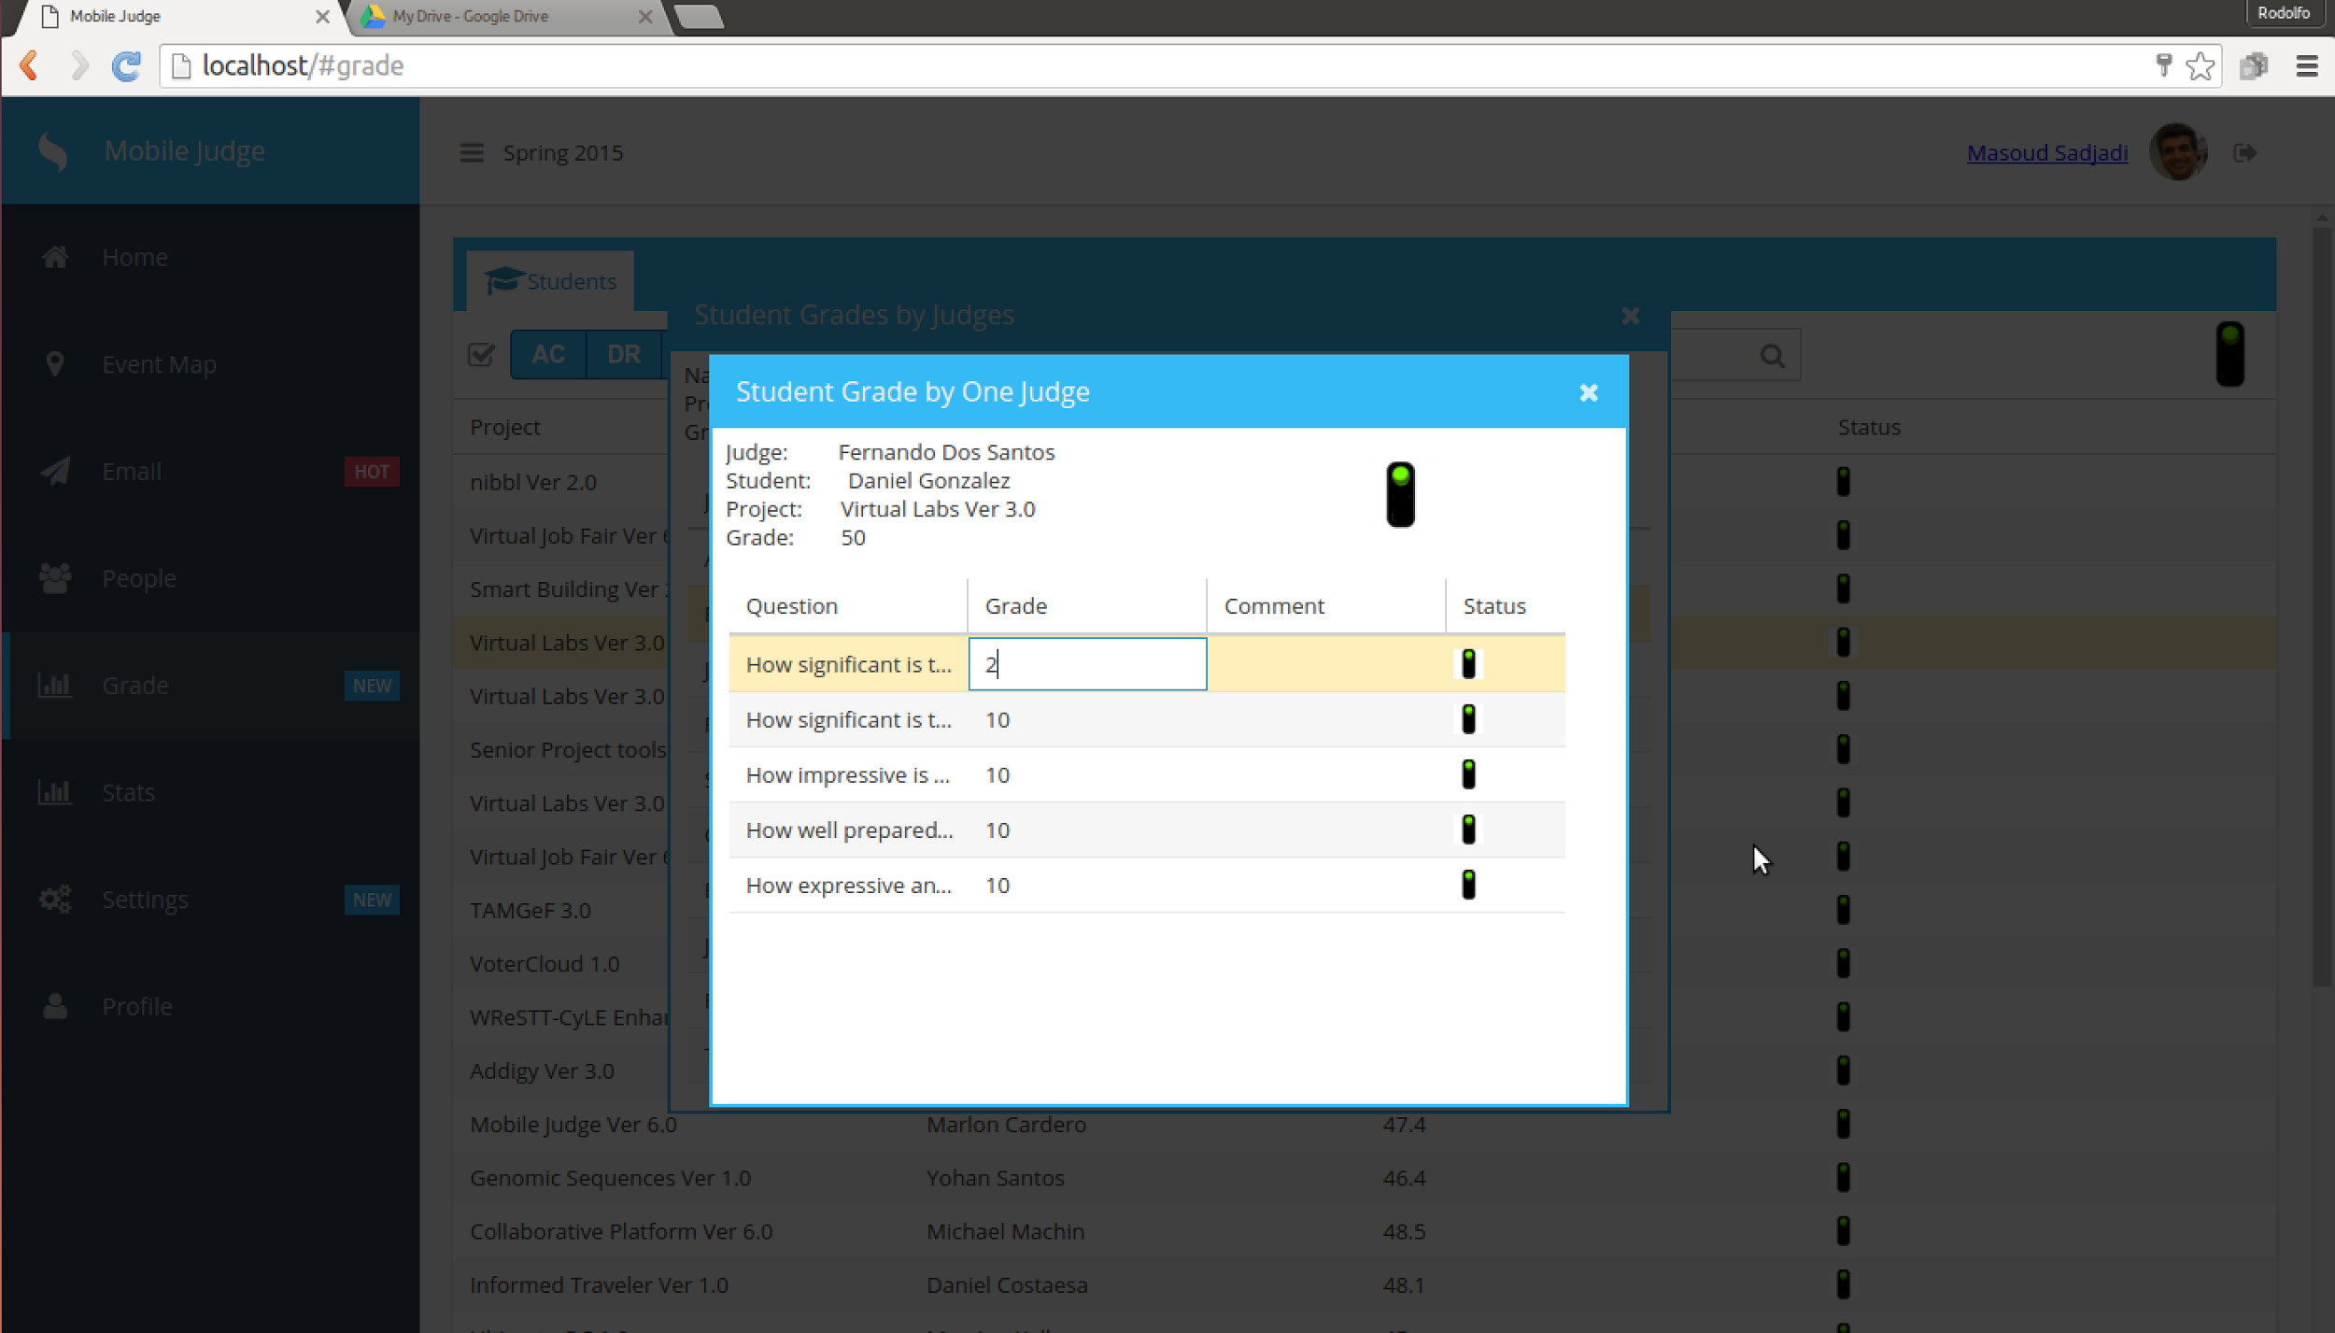

* As you exit the Modals the grades will automatically update for the previous views.