*Florida International University*

*School of Computing and Information Sciences*

CIS 4911 - Senior Capstone Project

Software Engineering Focus

Feature Document

User Story #542

**Team Member:**

Tiago Moore

**Product Owner(s)**:

Masoud Sadjadi

**Mentor(s)**:

Frank Hernandez

**Instructor**: Masoud Sadjadi

# **User Story**

Add Check Box on Filters for People Selection

* As an admin, i want to have a check box to select and deselect all filter types on the people tab.

**Use Case**

**Use Case ID: MJ542 - Add Check Box on Filters for People Selection**

Details:

Actor: Admin

Pre-conditions:

1. Admin has successfully logged onto the system.
2. Admin is using the People tab.

Description:

1. Use case begins when the admin clicks on the people tab as selects students or judge .
2. The system shall provide a checkbox to the left of the filters tab when selected students or judges.
3. The Actor shall click the checkbox to have all filters simultaneously selected.
4. The system shall select or unselect all filter boxes and return data accordingly.
5. Use case ends when all filters have been applied or unapplied and Actor exits the view.

Post-conditions:

1. The filters are all simultaneously selected.
2. All data has been returned accordingly.

Alternative Courses of Action:

1. Actor has option of using filters individually.

Decision Support:

Frequency: Low. Estimated average of one addition per application execution.

Criticality: Low. Allows the Member to add data into existing app function .

Risk: Medium. Implementing this use case requires Member to learn Sencha framework.

Constraints:

1. Usability:
   1. No training time  required.
   2. Button should be visible aligned to filter boxes.
2. Reliability:
   1. Mean time to Failure – 1% failure is acceptable.
   2. Availability – Always available.
3. Performance:
   1. There should be no lag or delay between selection
   2. Check box should be able to be clicked at will.
4. Supportability:
   1. Feature must appear on mobile and non-mobile devices.

Modification History:

Owner: Tiago Moore.

Initiation date: 01/26/2015

Date last modified: 02/01/2015

## **Sequence Diagram**

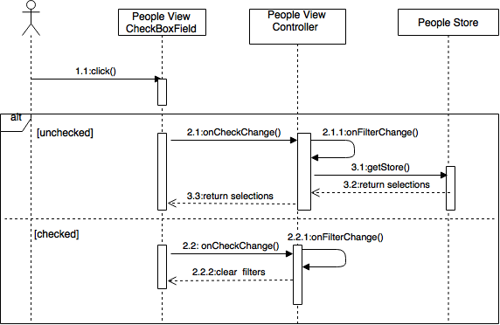

## **Class Diagram**

Untitled Diagram (1).png

## **Unit & Integration Test**

**Test Case 1 (Sunny Day)**

**ID: MJ-SD-542-01**

**Purpose**

* Test if checkbox selects all student filters

**Precondition**

* User has logged on mobile judge
* User has clicked on the People tab
* User has clicked on the student tab of the people page
* The database contains student information
* Check box is in the unchecked state

**Input**

* User clicks on the checkbox with all the filters selected

**Expected Result**

* All filters should be selected
* The grid should be populated with all the students

**Actual Result**

* Grid was populated with all the students

**Test Case 2**

**ID: MJ-SD-542-02**

**Purpose**

* Test if checkbox selects all student filters when one or more filters unchecked

**Precondition**

* User has logged on mobile judge
* User has clicked on the People tab
* User has clicked on the student tab of the people page
* The database contains student information
* One or more filters are unchecked
* Check box is in the unchecked state

**Input**

* User clicks on the checkbox with all the filters selected

**Expected Result**

* All filters should be selected
* The grid should be populated with all the students

**Actual Result**

* All filters were selected
* Grid was populated with all the students

**Test Case 3**

**ID: MJ-SD-542-03**

**Purpose**

* Test if checkbox unselects all filters when or more filters unchecked

**Precondition**

* User has logged on mobile judge
* User has clicked on the People tab
* User has clicked on the student tab of the people page
* The database contains student information
* Check box is in the checked state

**Input**

* User clicks on the checkbox with or more filters unchecked

**Expected Result**

* All filters should be unselected
* The grid show be empty

**Actual Result**

* All filters were unselected
* Grid is empty

**Test Case 4**

**ID: MJ-SD-542-04**

**Purpose**

* Test if checkbox unselects all filters when all filters are checked

**Precondition**

* User has logged on mobile judge
* User has clicked on the People tab
* User has clicked on the student tab of the people page
* The database contains student information
* Check box is in the checked state

**Input**

* User clicks on the checkbox with all the filters selected

**Expected Result**

* 404 Error

**Actual Result**

* 404 Error

**Test Case 5 (Rainy Day)**

**ID: MJ-RD-542-04**

**Purpose**

* Test if checkbox selects all filters when loss of internet connection

**Precondition**

* User has logged on mobile judge
* User has clicked on the People tab
* User has clicked on the student tab of the people page
* The database contains student information
* Check box is in the checked state
* No internet connection

**Input**

* User clicked on checkbox when selected

**Expected Output**

* All filters should be selected
* Grid should be populated

**Actual Result**

* All filters were selected
* Grid was populated

**User Guide**

* Admin will login and browse to People tab

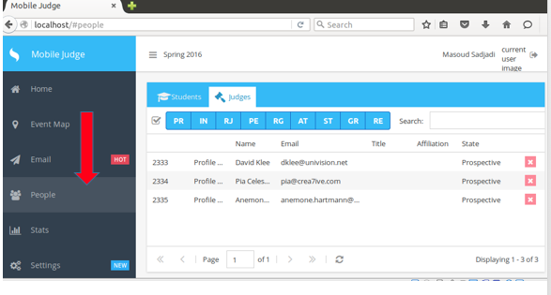

* Select the checkbox to select all filters and return all people data.
* A checkbox will be available adjacent to the filter boxes under the student or judge subtab.

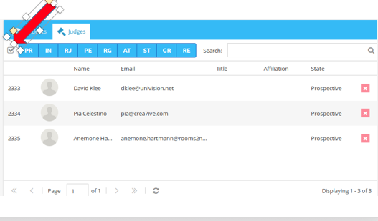

* Unselect the checkbox to clear all filters and clear all people data.

