*Florida International University*

*School of Computing and Information Sciences*

CIS 4911 - Senior Capstone Project

Software Engineering Focus

Feature Document

User Story #543

Manage Judge

**Team Member:**

Marlon Rowe

**Product Owner(s)**:

Masoud Sadjadi

**Mentor(s)**:

Frank Hernadez

**Instructor**: Masoud Sadjadi

# User Story

### Description:

* As an admin, I would like to be able to add/delete/modify judges, so that I can better manage them.

### Acceptance Criteria:

1. The screen should be very similar to the one under Settings → Questions with respect to adding new, delete, modify, refresh, etc.

## Use Case



**Use Case ID: MJ543 - Manage Judge**

Details:

Actor: Admin

Pre-conditions:

1. User must be logged in as admin

Description:

1. Use case begins when the admin double clicks on a row in the Peoples -> Judges tab.
2. The fields that are able to be modified become editable.
3. The admin can edit firstname, lastname, email, password, title, affiliation, and state
4. Once changes have been made, clicking on the ‘Update’ button, the store autoSyncs the data to the Judges API Route. Then saves the data to the backend.
5. Use case ends once fields return to normal, the data has been saved, and there are no errors.

Post-conditions:

1. n/a

Alternative Courses of Action:

1. n/a

Decision Support:

Frequency: Low. Estimated average of one addition per application execution.

Criticality: Low. Allows the Admin to edit data into existing app function.

Risk: High. Implementing this use case requires Member to learn Sencha framework, Nodejs, and SQL database.

Constraints:

1. Usability:
   1. No training time required.
2. Reliability:
   1. Mean time to Failure – 1% failure is acceptable.
   2. Availability – Always available.
3. Performance:
   1. Updated information will be saved to the database
4. Supportability:
   1. Feature must appear on desktop devices only.

Modification History:

Owner: Marlon Rowe

Initiation date: 02/14/2016

Date last modified: 02/26/2016

## 

## Sequence Diagram

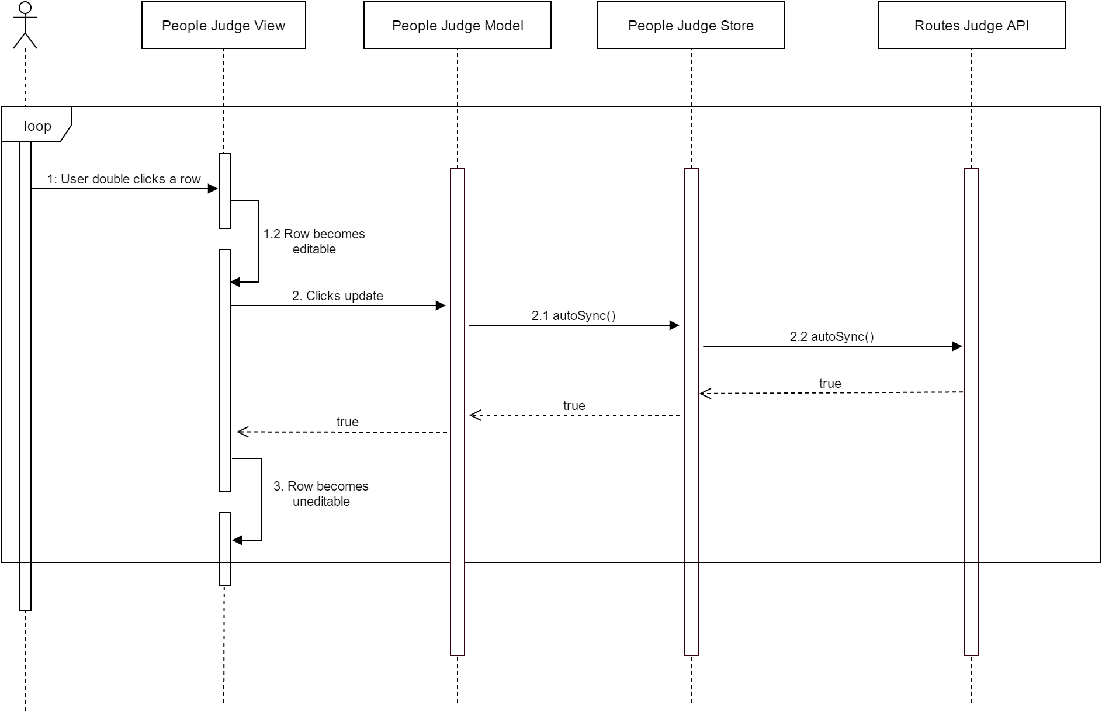

## 

## Class Diagram

## 

## Unit & Integration Test

**Test Case 1 (Sunny Day)**

**ID: MJ-SD-543-01**

**Purpose**

* Test if admin can modify judge information

**Precondition**

* User has logged into Mobile Judge as a admin
* User navigated to People->Judges page

**Expected Result**

* User was able to save changed information

**Actual Result**

* User was able to save the information he/she changed on the judge

**Test Case 2 (Sunny Day)**

**ID: MJ-SD-543-02**

**Purpose**

* Test if admin can update a judges email that already exists in the database

**Precondition**

* User has logged into Mobile Judge as a admin
* User navigated to People->Judges page

**Expected Result**

* User was not able to change judges email due to it already existing in the database

**Actual Result**

* User was not able to change judges email due to it already existing in the database

**Test Case 1 (Rainy Day)**

**ID: MJ-RD-543-01**

**Purpose**

* Test if user can remove title and/or affiliation, leaving the field blank

**Precondition**

* User has logged into Mobile Judge as a admin
* User navigated to People->Judges page

**Expected Result**

* User was able to delete the value in the field, leaving the field blank in the database

**Actual Result**

* Judge still has previous value as before, title/affiliation did not get updated.

## User Guide

Once admin is logged in, navigate to the Judges tab, by clicking on the Peoples tab in the navigation pane.

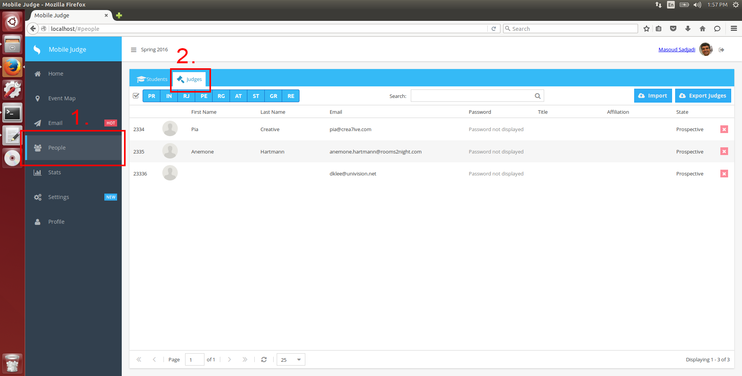

Here, the admin can double click any row, and then the data that can be modified will become into editable fields

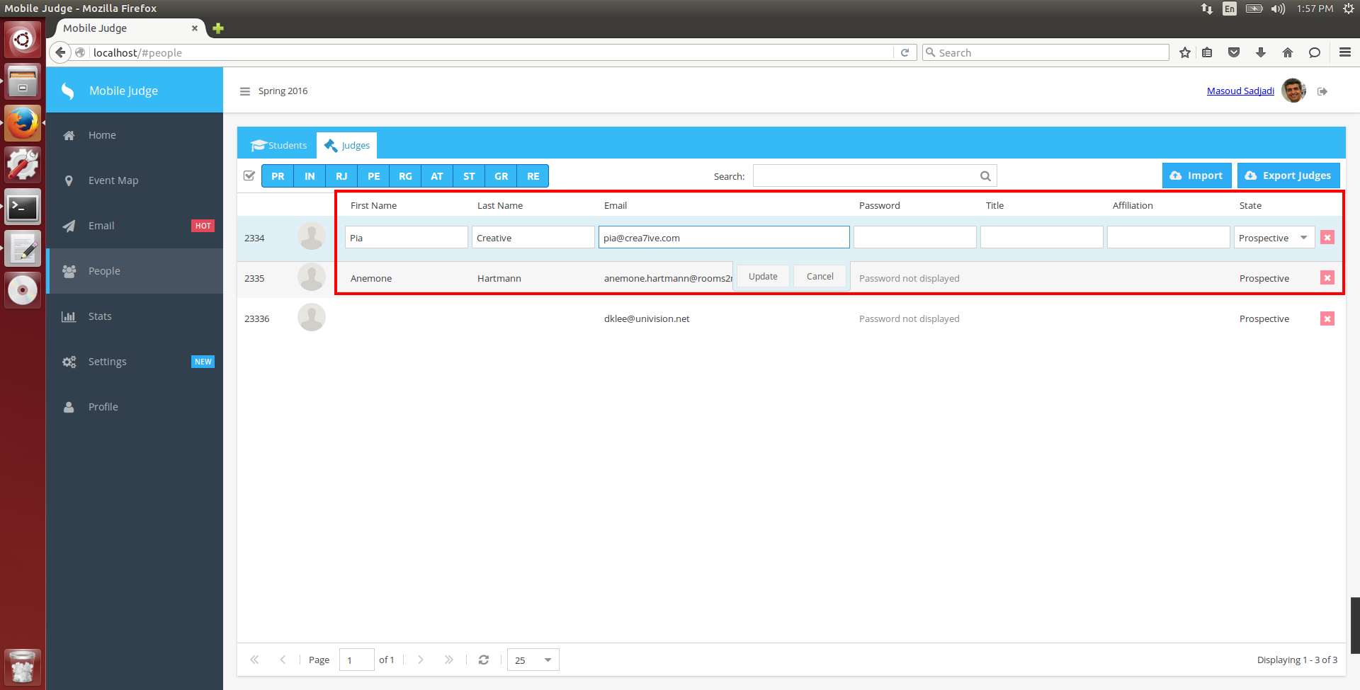

Admin is able to freely type into First name, Last name, Email, Password, TItle and Affiliation, and choose from a dropdown for the State value.

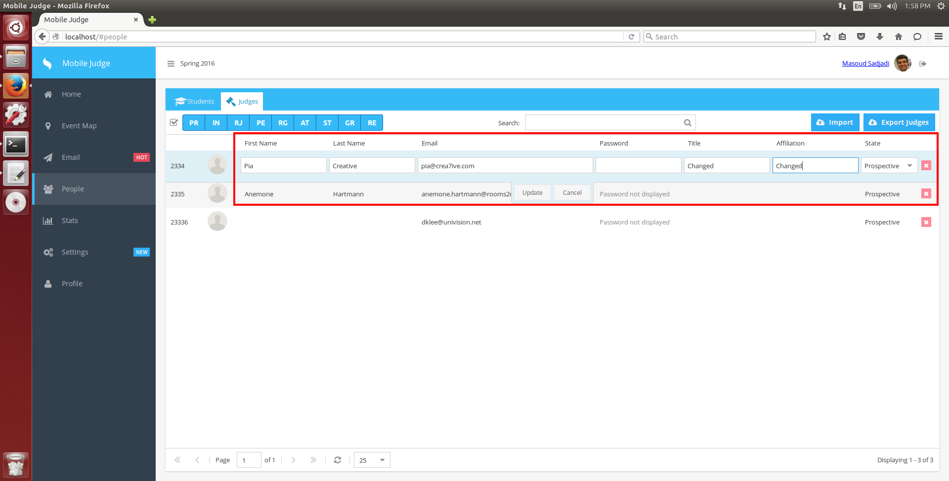

Once changes have been made. clicking update, will notify the store to autoSync, and update appropriate fields in the database.

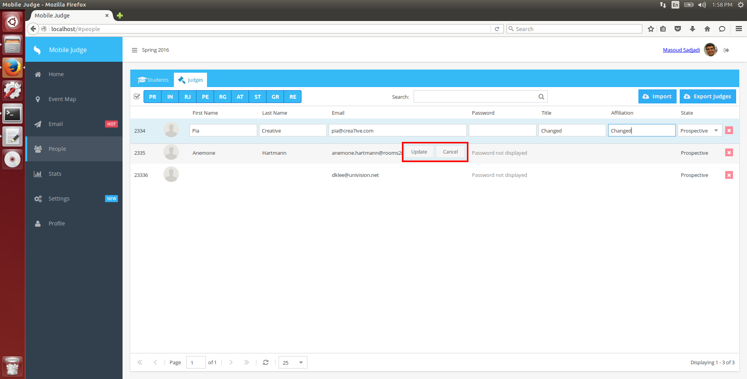

If no errors occurred, then the changes have been set.

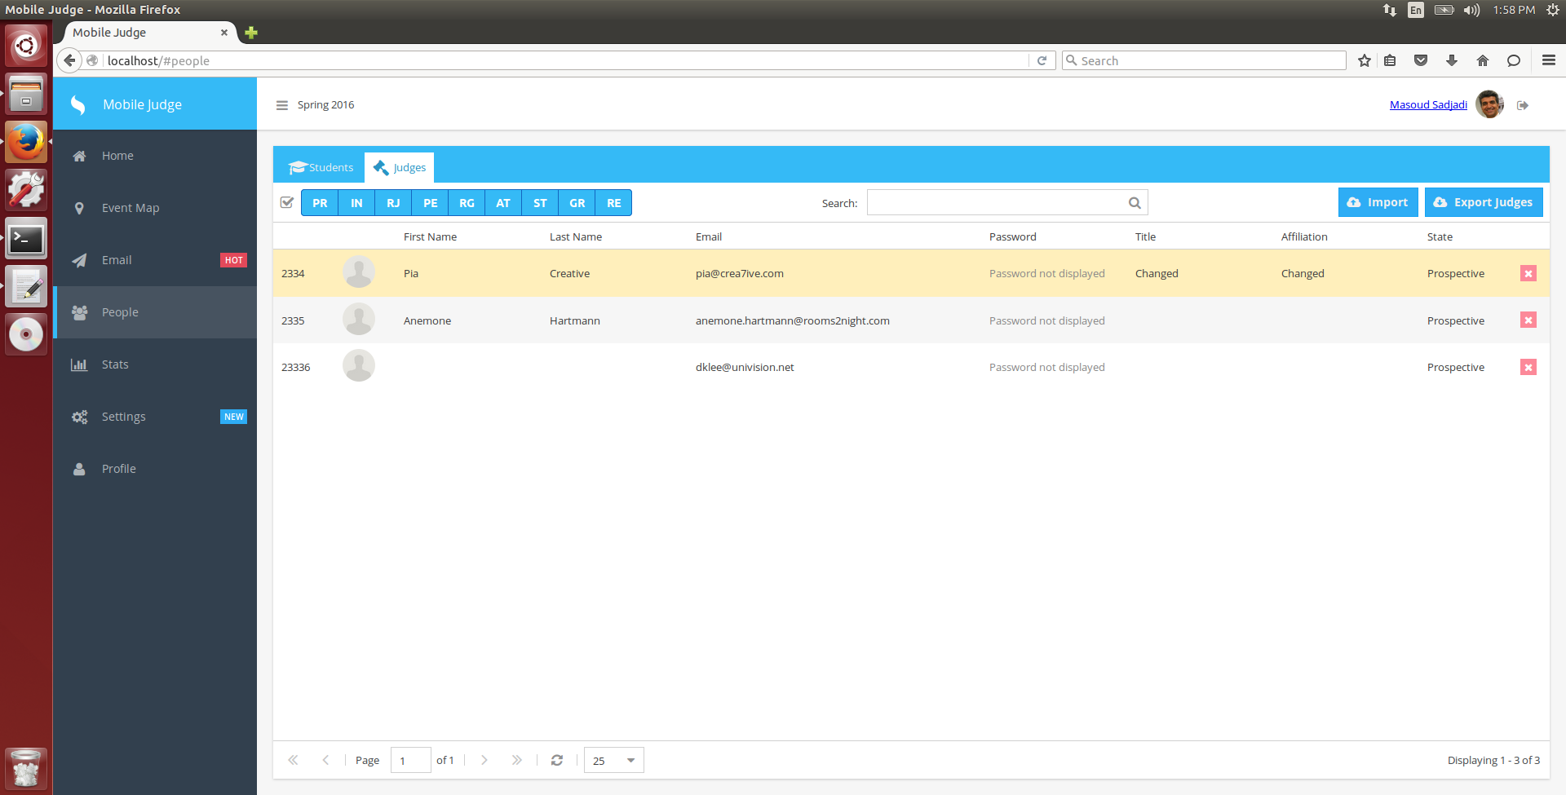

If an error has occurred then, you will be presented with a popup message telling the admin that a field had an error. The error message will correspond to what error happened in the form.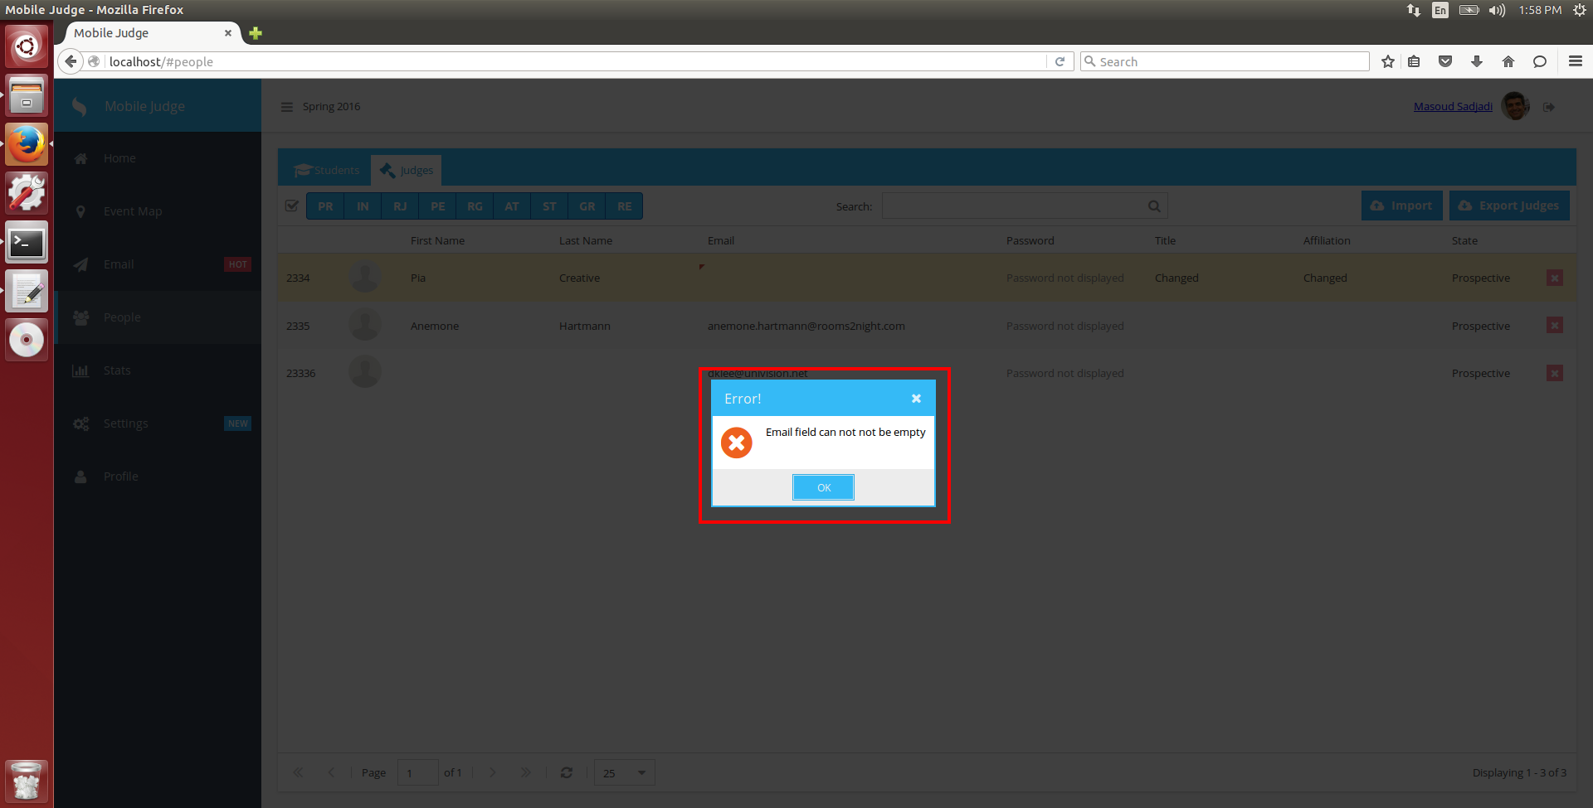

The red arrow in the corner of the input field, means that’s where the error has taken place, and can be fixed, by taking appropriate action.

