*Florida International University*

*School of Computing and Information Sciences*

CIS 4911 - Senior Capstone Project

Software Engineering Focus

Feature Document

User Story #544

Manage Student

**Team Member:**

Marlon Rowe

**Product Owner(s)**:

Masoud Sadjadi

**Mentor(s)**:

Frank Hernadez

**Instructor**: Masoud Sadjadi

# User Story

### Description:

* As an admin, I would like to be able to add/delete/modify students, so that I can better manage them.

### Acceptance Criteria:

1. The screen should be very similar to the one under Settings → Questions with respect to adding new, delete, modify, refresh, etc.
2. After using the Sync button on the Students page, the Sync should still work exactly as before with one extra feature. The prompt should give the option not to delete extra users, just add and modify.

## Use Case



**Use Case ID: MJ544 - Manage Student**

Details:

Actor: Admin

Pre-conditions:

1. User must be logged in as admin

Description:

1. Use case begins when the admin double clicks on a row in the Peoples -> Student tab.
2. The fields that are able to be modified become editable.
3. The admin can edit Location by typing freely and State from a dropdown list.
4. Once changes have been made, clicking on the ‘Update’ button, the store gets notified and autoSyncs the data to the Student API route, then saves the data to the database.
5. Use case ends once the data has been saved and no errors have occured.

Post-conditions:

1. n/a

Alternative Courses of Action:

1. n/a

Decision Support:

Frequency: Low. Estimated average of one addition per application execution.

Criticality: Low. Allows the Admin to edit data into existing app function.

Risk: High. Implementing this use case requires Member to learn Sencha framework, Nodejs, and SQL database.

Constraints:

1. Usability:
   1. No training time required.
2. Reliability:
   1. Mean time to Failure – 1% failure is acceptable.
   2. Availability – Always available.
3. Performance:
   1. Updated information will be saved to the database
4. Supportability:
   1. Feature must appear on desktop devices only.

Modification History:

Owner: Marlon Rowe

Initiation date: 02/14/2016

Date last modified: 02/21/2016

## 

## Sequence Diagram

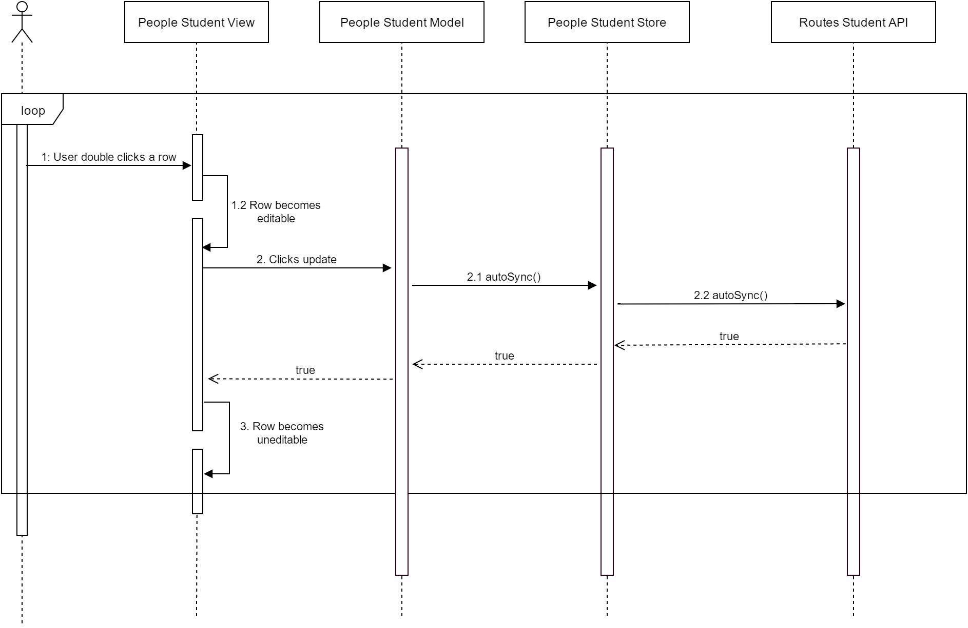

## 

## Class Diagram

## 

## Unit & Integration Test

**Test Case 1 (Sunny Day)**

**ID: MJ-SD-544-01**

**Purpose**

* Test if admin can modify student information

**Precondition**

* User has logged into Mobile Judge as a admin
* User navigated to People->Students page

**Expected Result**

* User was able to save only changed information

**Actual Result**

* User was able to save only the information he/she changed on the student

**Test Case 2 (Sunny Day)**

**ID: MJ-SD-544-02**

**Purpose**

* Test if admin can remove a student completely from the database

**Precondition**

* User has logged into Mobile Judge as a admin
* User navigated to People->Students page

**Expected Result**

* User was able to delete the record of the student from the entire database

**Actual Result**

* User was able to delete the student and all records from the entire database

**Test Case 1 (Rainy Day)**

**ID: MJ-RD-544-01**

**Purpose**

* Test if user can delete a student from the database

**Precondition**

* User has logged into Mobile Judge as a admin
* User navigated to People->Students page

**Expected Result**

* User was able to delete the student from the database

**Actual Result**

* User still shows up in other parts of the database, so not entirely deleted.

## User Guide

Editing information:

Once an admin is logged, he/she is must click on the People tab on the left navigation bar.

The students tab is always going to be selected first since it is first in column.

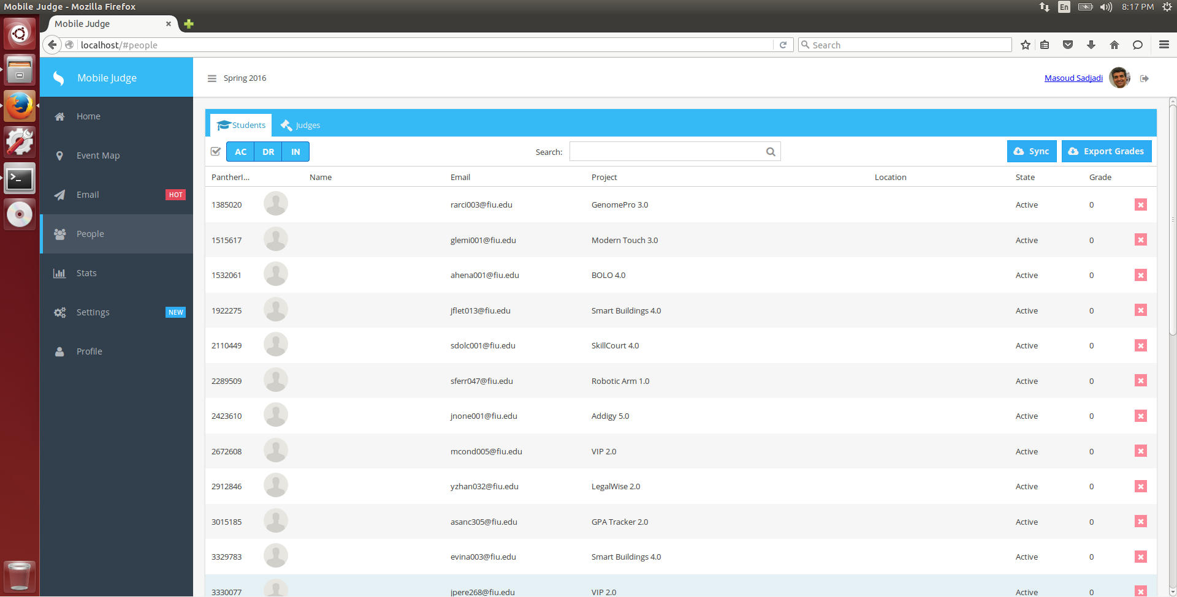

Admin must double click any row to be able to edit. Once double clicked, the fields that are editable, will change and the admin can edit information.

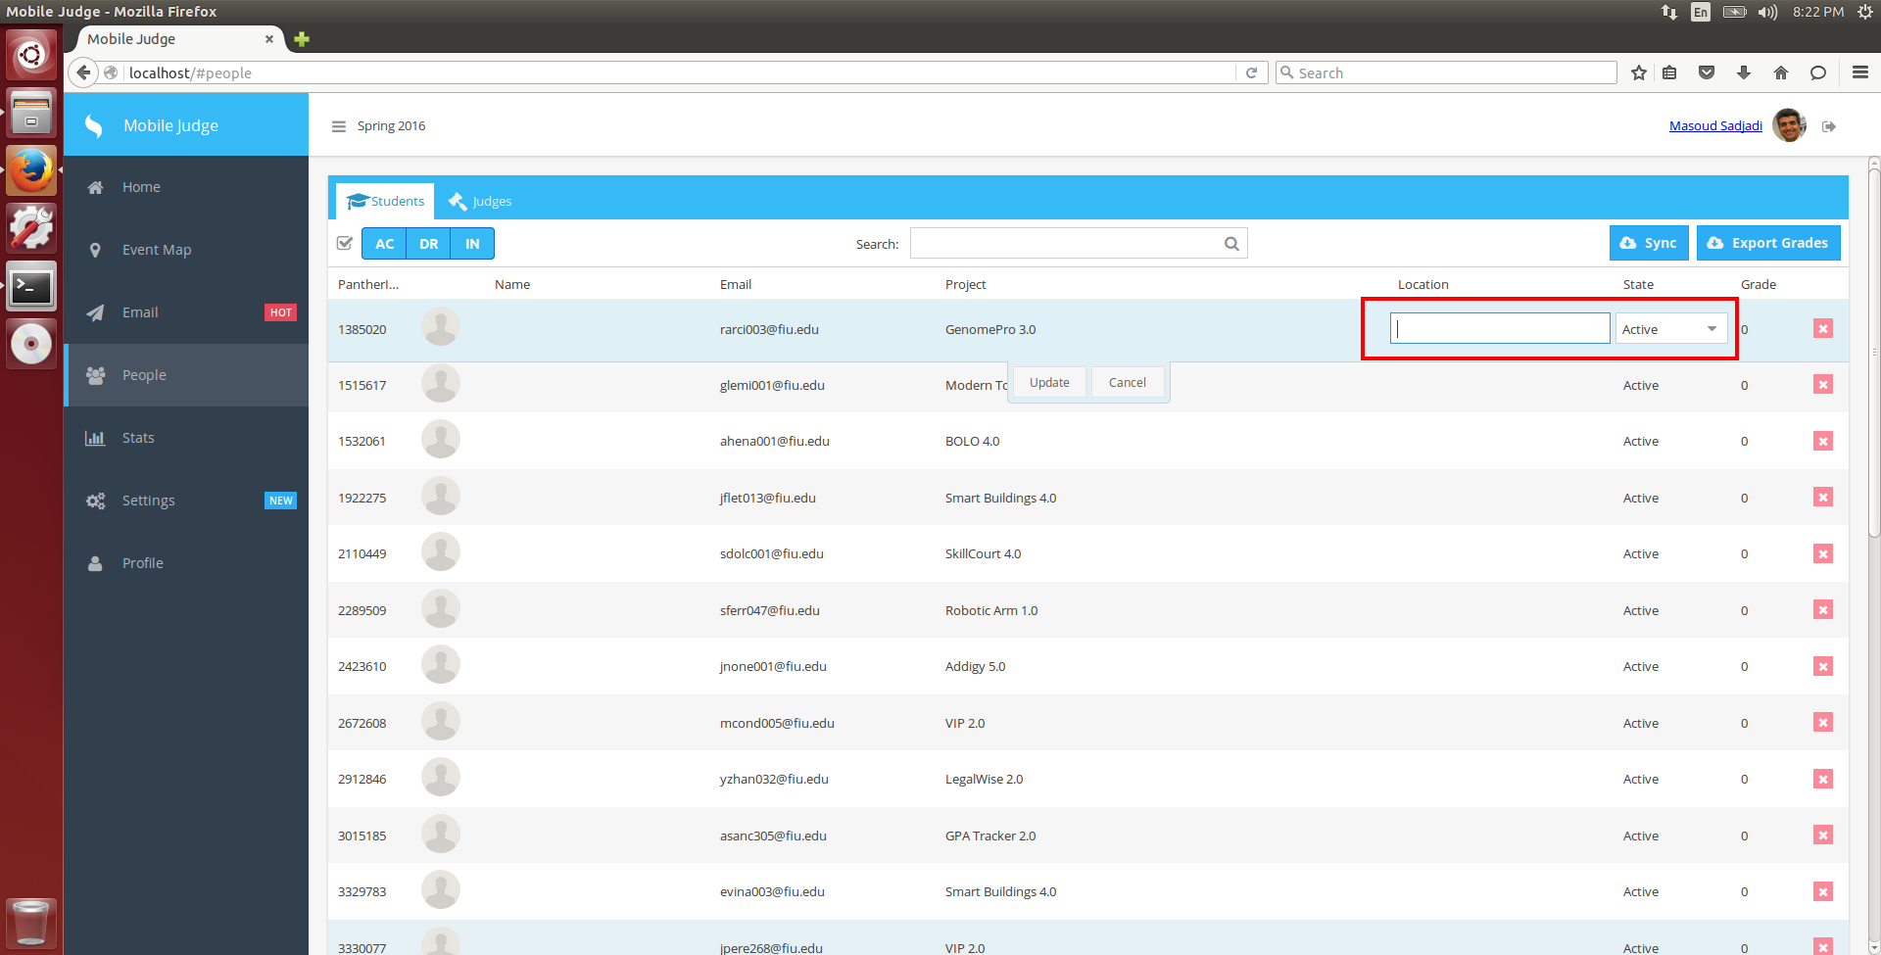

The location field can be edited by typing anything the admin wants. The state can be changed by clicking on the field, presenting a dropdown, and then selecting one state.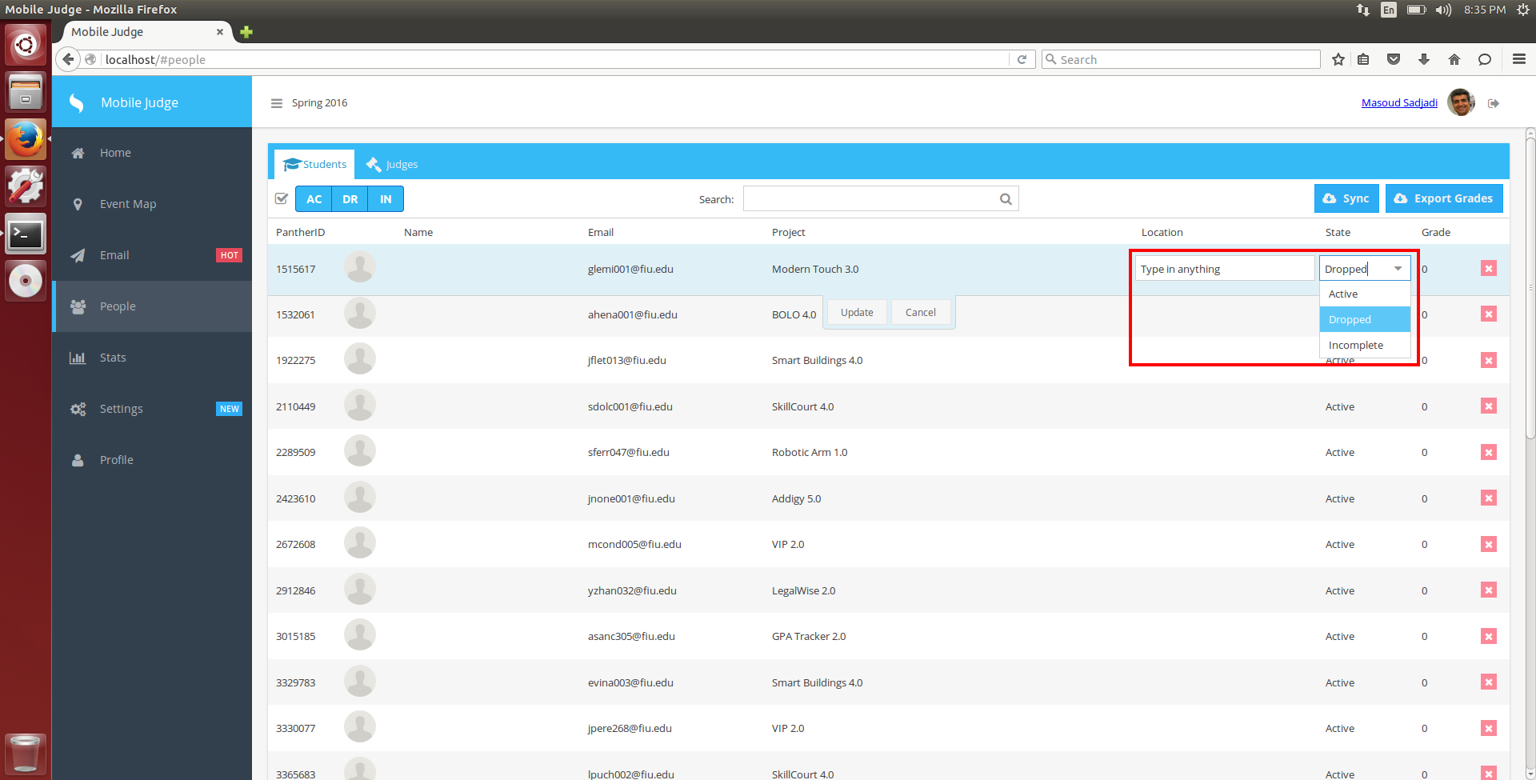

Once the desired changes have been made, then selecting update will make the row back to normal and update the information in the database.

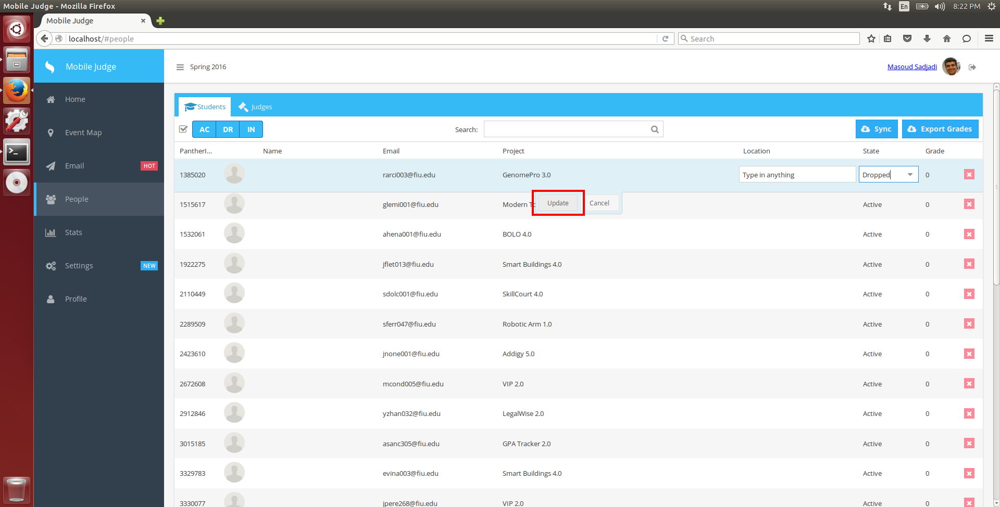

Information has been updated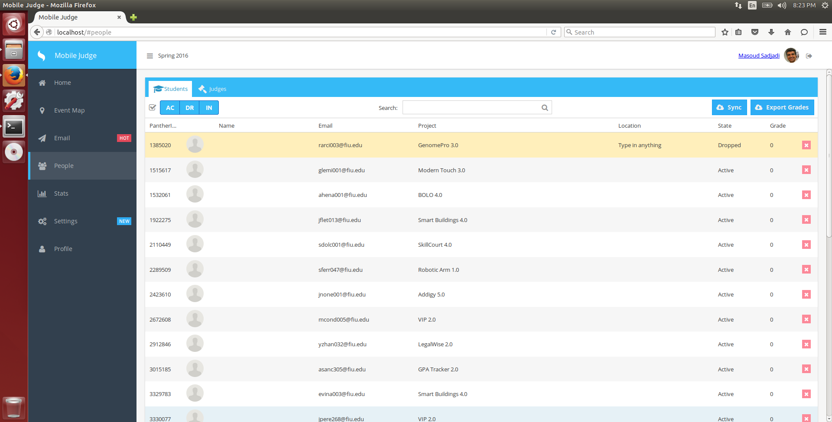

Deleting student:

Clicking on the red X button, will cause a student to be deleted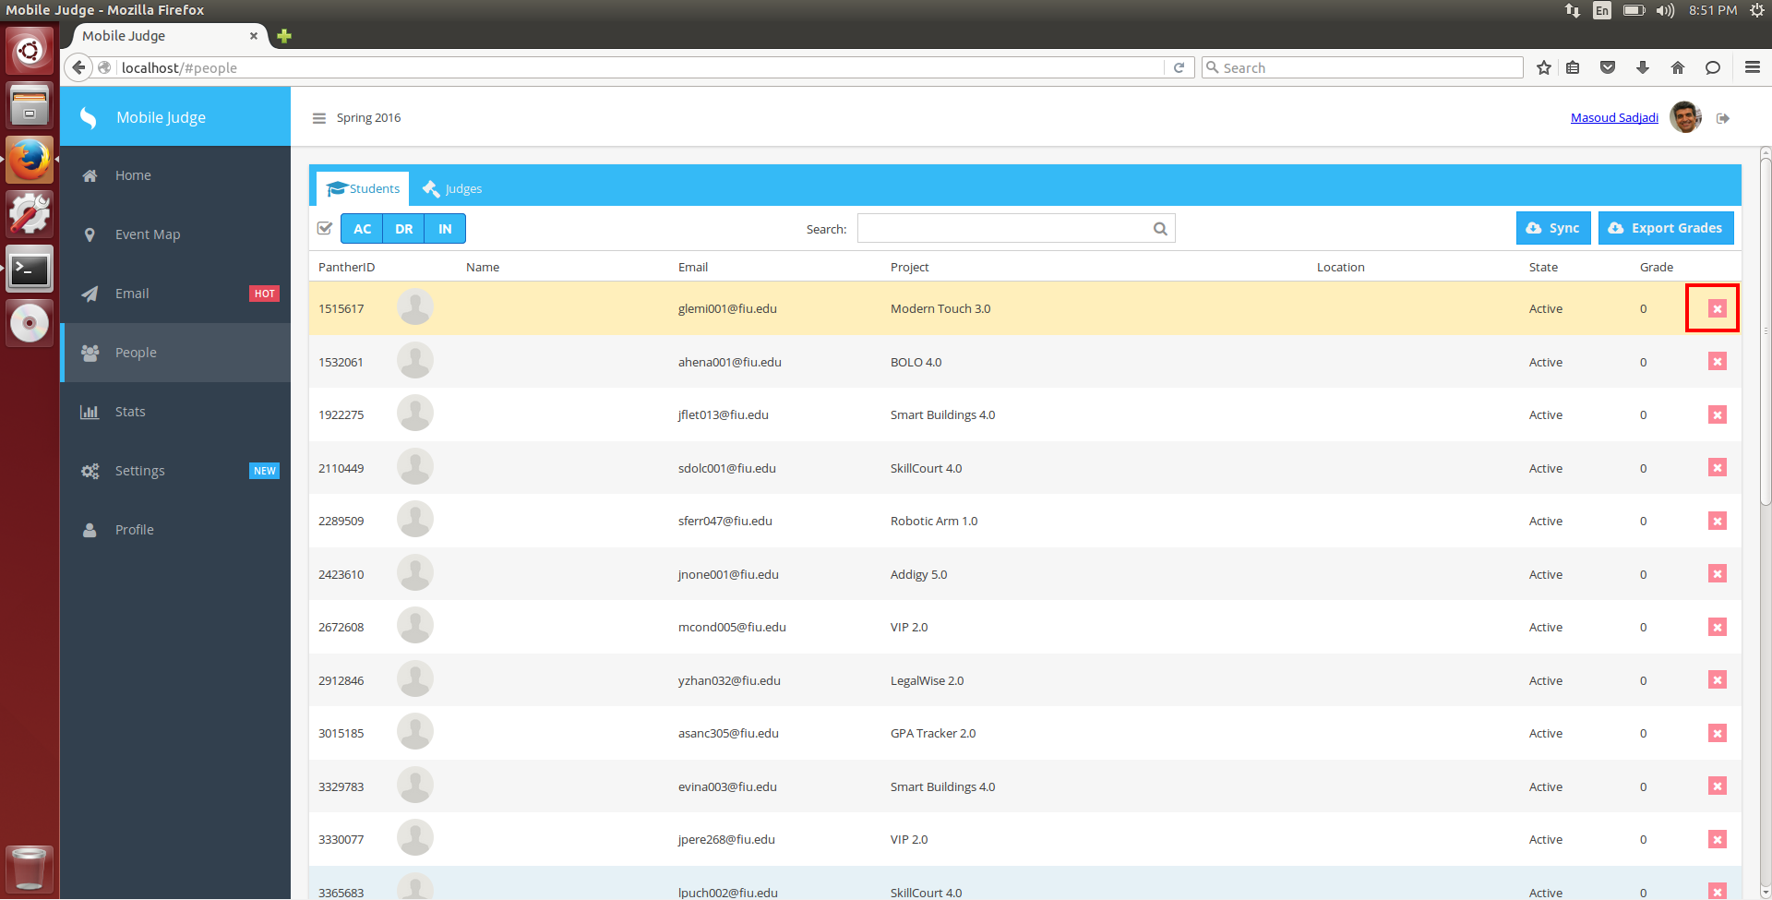

A confirmation dialog message will appear, asking if the admin is sure he/she wants to make delete the student.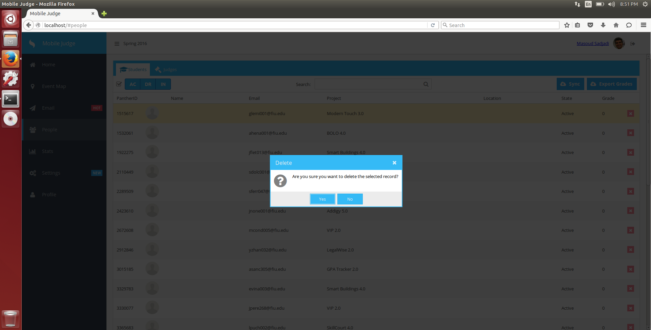

User will be deleted after clicking yes. Or, if no is clicked, the dialog will disappear and nothing changes.