*Florida International University*

*School of Computing and Information Sciences*

CIS 4911 - Senior Capstone Project

Software Engineering Focus

Feature Document

User Story #622

UnLink Login Accounts

**Team Member:**

Tiago Moore & Andres Villa

**Product Owner(s)**:

Masoud Sadjadi

**Mentor(s)**:

Frank Hernandez

**Instructor**: Masoud Sadjadi

# **User Story**

UnLink Login Accounts

* As a user, I would like to be able to unlink my social media with my mobile judge account.

**Use Case**

**Use Case ID: MJ622 - Unlink Accounts**

Details:

Actor: Admin

Pre-conditions:

1. Admin has successfully logged onto the system.
2. Admin is using the Profile feature.
3. An account has to be previously unlinked.
4. A checkbox will display a linked account.

Description:

1. Use case begins when the admin clicks his name or picture.
2. The system shall boxes which icons for which account the user would like to unlink.
3. The Actor shall click the icon for the account he would like to unlink.
4. The system will prompt with a confirmation alert.

Post-conditions:

1. The account will be unlinked until it is relinked.

Alternate:

1. An admin will database access will manually remove linked accounts.

Decision Support:

Frequency: Low. Estimated average of one addition per application execution.

Criticality: Low. Allows the Member to add data into existing app function .

Risk: Medium. Unlink feature will require additional time.

Constraints:

1. Usability:
   1. No training time  required.
   2. Account buttons are visible on Profile tab.
   3. Visual will display an already linked account.
2. Reliability:
   1. Mean time to Failure – 1% failure is acceptable.
   2. Availability – Always available.
3. Performance:
   1. There should be no lag or delay during button selections.
   2. Authentication should be done immediately after click.
4. Supportability:
   1. Feature must appear on mobile and non-mobile devices.

Modification History:

Owner: Tiago Moore.

Initiation date: 02/22/2015

Date last modified: 02/29/2015

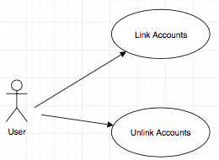

## **Sequence Diagram**

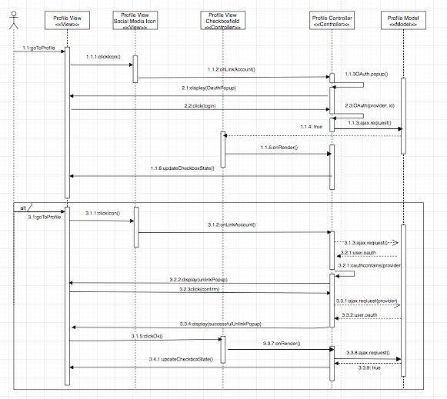

## **Class Diagram**

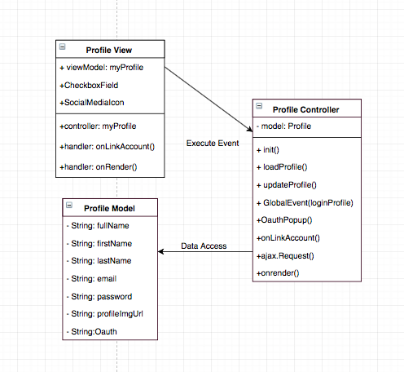

## **Unit & Integration Test**

**Test Case 1 (Sunny Day)**

**ID: MJ-SD-622-01**

**Purpose**

* Test if account removed works after confirmation .

**Precondition**

* User has successfully logged onto the system.
* User is using the Profile feature.
* User is linked to an account.

**Input**

* User clicks on social media icon .

**Expected Result**

* A pop up window comes up for confirmation
* A user clicks yes to confirm.
* The user account social media account gets unlinked.

**Actual Result**

* A pop up window comes up for authentication
* A user enters his login information
* The user account gets linked to the social media account.

**Test Case 2 (Sunny Day)**

**ID: MJ-SD-622-02**

**Purpose**

* Test if account is properly unlinked.

**Precondition**

* User has previously linked accounts.

**Input**

* User clicks on social media icon.

**Expected Result**

* A pop up window comes up for confirmation
* The social media account is unlinked.

**Actual Result**

* A pop up window comes up for confirmation
* The social media account is unlinked.

**Test Case 3 (Rainy Day)**

**ID: MJ-RD-622-01**

**Purpose**

* Account is not unlinked if confirmation fails

**Precondition**

* User has successfully logged onto the system.
* User is using the Profile feature.
* The user clicks no on unlink confirmation promt

**Input**

* User clicks on social media icon
* User clicks no on confirmation promt

**Expected Result**

* A pop up window comes for confirmation.
* The user account does not get unlinked to the social media account.

**Actual Result**

* A pop up window comes for confirmation.
* The user account does not get unlinked to the social media account.

**Test Case 4 (Rainy Day)**

**ID: MJ-RD-622-02**

**Purpose**

* Ensure feedback is provided if popups are disabled

**Precondition**

* User has successfully logged onto the system.
* User is using the Profile feature.
* The user clicks no on unlink confirmation promt

**Input**

* User clicks on social media icon
* User has pop-ups blocked

**Expected Result**

* An alert comes up notifying the user that the Oauth popup could not come up
* The alert signals to the user the cause

**Actual Result**

* An alert comes up notifying the user that the Oauth popup could not come up
* The alert signals to the user the cause

**User Guide**

User is logged on and on the profile page :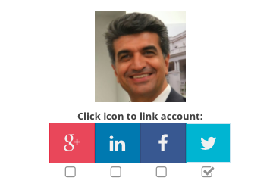

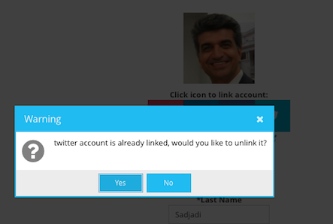

User clicks yes for confirmation:

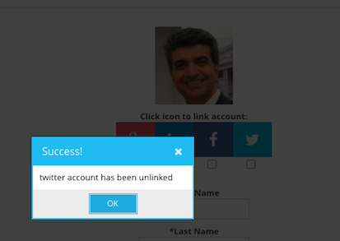

User social media account gets unliked: