*Florida International University*

*School of Computing and Information Sciences*

CIS 4911 - Senior Capstone Project

Software Engineering Focus

Feature Document

User Story #623

Link Login Visual

**Team Member:**

Tiago Moore & Andres Villa

**Product Owner(s)**:

Masoud Sadjadi

**Mentor(s)**:

Frank Hernandez

**Instructor**: Masoud Sadjadi

# **User Story**

Link Login Visual

* As a user, I would like to see which accounts are currently linked so that I can link or unlink any accounts.

**Use Case**

**Use Case ID: MJ623 - Visualize Linked accounts**

Details:

Actor: Admin

Pre-conditions:

1. Admin has successfully logged onto the system.
2. Admin is using the Profile feature.
3. A checkbox will display a linked account.

Description:

1. Use case begins when the admin clicks his name or picture.
2. The system shall checkboxes which icons for which account the user would like to unlink or unlink .
3. The Actor shall click the icon for the account he would like to unlink.
4. The checkbox shall update accordingly if the account is linked or not.

Post-conditions:

1. If the account is linked, checkbox will be checked.
2. If account is unlinked, checkbox will be unchecked.

Alternate:

1. An admin will check the database to see if accounts are linked or not.

Decision Support:

Frequency: Low. Estimated average of one addition per application execution.

Criticality: Low. Allows the Member to add data into existing app function .

Risk: Medium. Unlink feature will require additional time.

Constraints:

1. Usability:
   1. No training time  required.
   2. Account buttons are visible on Profile tab.
   3. Visual will display an already linked account.
2. Reliability:
   1. Mean time to Failure – 1% failure is acceptable.
   2. Availability – Always available.
3. Performance:
   1. Checkboxes should update immediately after linking and unlinking.
4. Supportability:
   1. Feature must appear on mobile and non-mobile devices.

Modification History:

Owner: Tiago Moore.

Initiation date: 02/22/2015

Date last modified: 02/29/2015

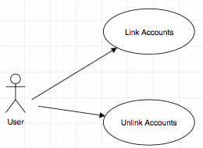

## **Sequence Diagram**

## **Class Diagram**

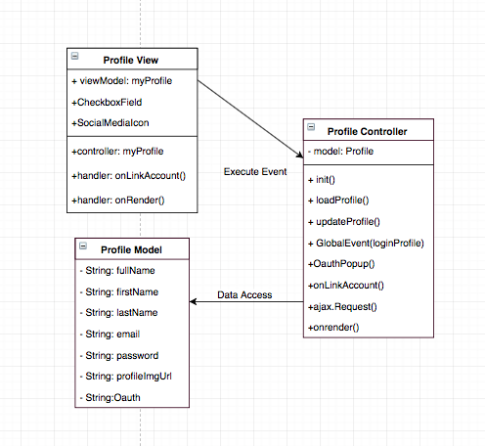

## **Unit & Integration Test**

**Test Case 1 (Sunny Day)**

**ID: MJ-SD-623-01**

**Purpose**

* Test if checbox is checked after linking account.

**Precondition**

* User has successfully logged onto the system.
* User is using the Profile feature.
* A user links his account.

**Input**

* User clicks social icon and enters authentication.

**Expected Result**

* A pop up window comes up for confirmation
* A user clicks yes to confirm.
* The user account social media account gets linked.
* The checkbox is checked.

**Actual Result**

* A pop up window comes up for confirmation
* A user clicks yes to confirm.
* The user account social media account gets linked.
* The checkbox is checked.

**Test Case 2 (Sunny Day)**

**ID: MJ-SD-623-02**

**Purpose**

* Test to see if checkbox is unchecked if user unlinks account.

**Precondition**

* User has previously linked accounts.

**Input**

* User clicks on social media icon and unlinks account.

**Expected Result**

* A pop up window comes up for confirmation .
* The social media account is unlinked.
* The previously checked box will be unchecked.

**Actual Result**

* A pop up window comes up for confirmation .
* The social media account is unlinked.
* The previously checked box will is unchecked.

**Test Case 3 (Rainy Day)**

**ID: MJ-SR-623-03**

**Purpose**

* Test to see if checkbox remains unchecked after incorrect user authentication.

**Precondition**

* User has successfully logged onto the system.
* User is using the Profile feature.
* User start link account process.

**Input**

* User entered incorrect login information.

**Expected Result**

* A pop up window comes for authentication.
* The checkbox is not checked.

**Actual Result**

* A pop up window comes for authentication.
* The checkbox is not checked.

**User Guide**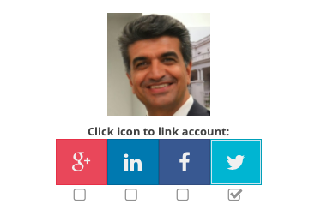

User is logged on and on the profile page :

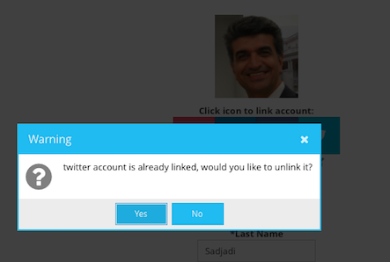

User clicks yes for confirmation:

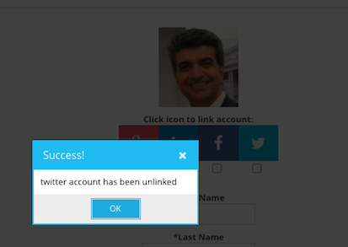

User social media account gets unliked:

New visual shows unlinked account: 