*Florida International University*

*School of Computing and Information Sciences*

Software Engineering Focus

Feature Document

User Story #**126**

**Team Member:**

Nelson Cruz

**Product Owner(s)**:

Mohsen Taheri

**Mentor(s)**:

Mohsen Taheri

**Instructor**: Masoud Sadjadi

**User Story** Implement User Registration

* As a User I would like to register a new account so that I can log in to Neat

Acceptance Criteria

* A new account is created if the user does not exist.
* I user exists, inform the user and present the user with a login screen

**Use Case** #**126**

**Use case name**

User Registration

**Participating actors**

Initiated by Neat User

**Flow of events**

1. While at login screen click on register

2. The user is prompted with the registration screen

3. User enters required information

**Entry condition**

The user is at the login screen

**Exit condition**

The user is taken to the dashboard

**Quality requirements**

The user is acknowledged of success or failure to register within 5 seconds.

OS X:Users:macbook:Downloads:Registration_usecase(1).png

**Use Case Diagram**

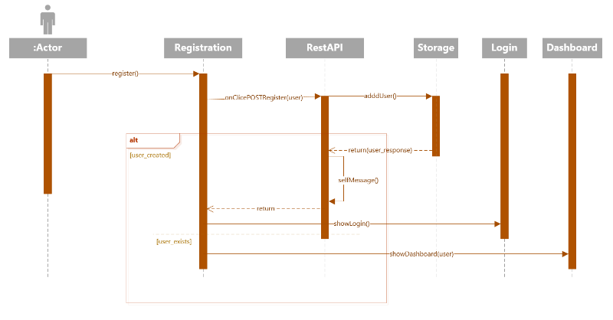

**Sequence Diagram**

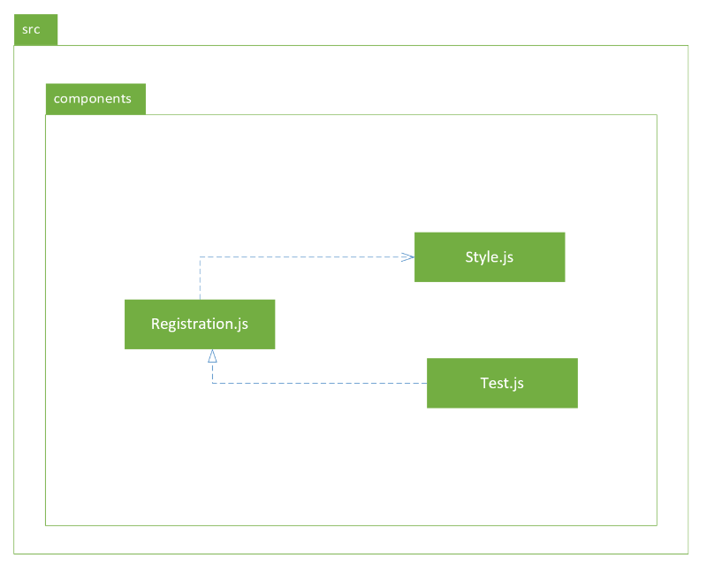

**Package Diagram**

OS X:Users:macbook:Pictures:Registration_class_diagram.png

**Class Diagram**

**Unit Test**

**Test Case 1 (Sunny Day)**

**Purpose**

* Ensures that valid information is accepted by the system

**Precondition**

* All fields are filled with valid information

**Input**

* Username, password, e-mail address, user-info

**Expected Result**

* A new user is registered, and user is taken to the dashboard

**Actual Result**

* A new user is added to the system

**Test Case 2 (Rainy Day)**

**Purpose**

* Ensure the system validates the information before requesting registration

**Precondition**

* Register button is pressed without any information filled

**Input**

* Null on all fields

**Expected Result**

* All empty fields are highlighted in red

**Actual Result**

* No request is made to backend

**Visual User Guide**

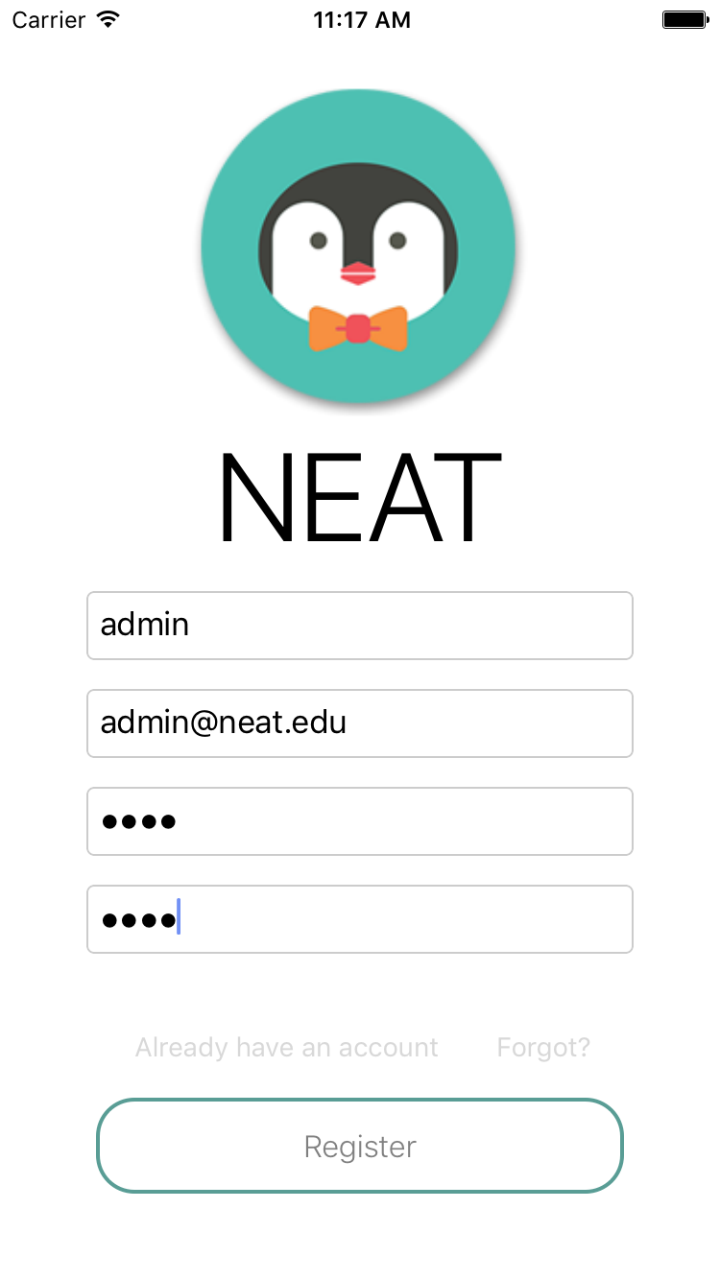 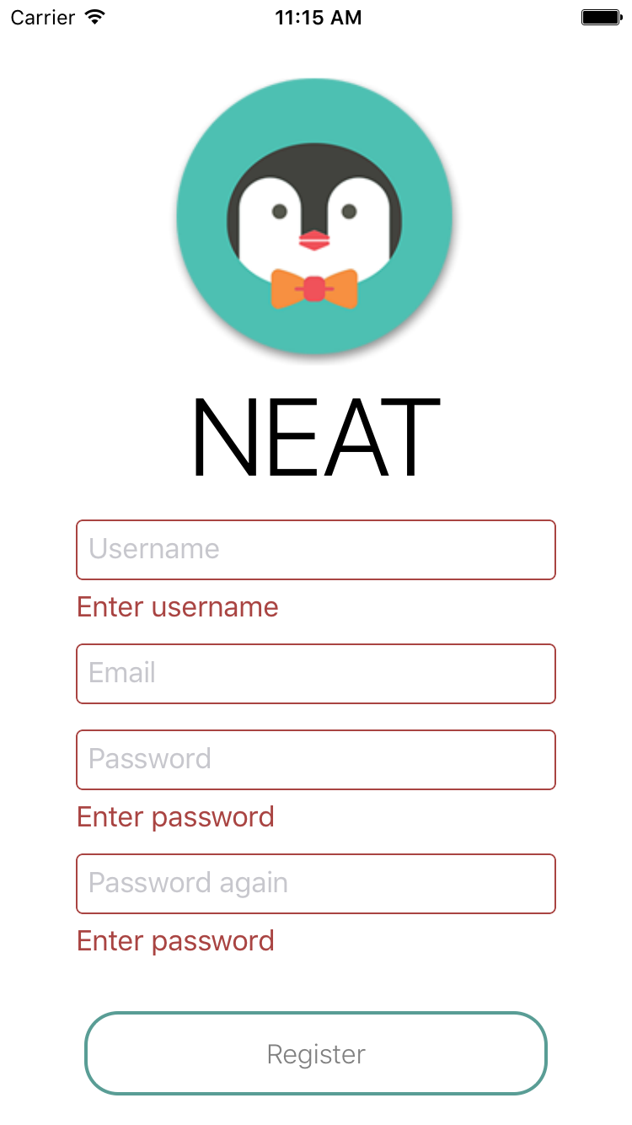

Registration page with valid information Registration page with invalid information

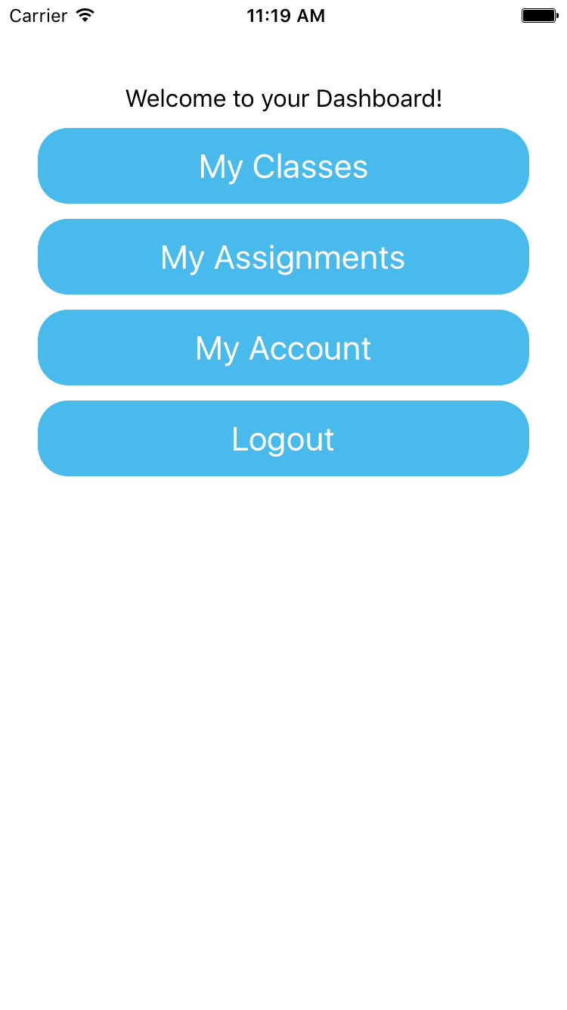

Dashboard after registration