*Florida International University*

*School of Computing and Information Sciences*

Software Engineering Focus

Feature Document

User Story #**234**

**Team Member:**

Nelson Cruz

**Product Owner(s)**:

Mohsen Taheri

**Mentor(s)**:

Mohsen Taheri

**Instructor**: Masoud Sadjadi

**User Story** Create “class ranking” page

* As a user I would like to see my assignments progress compared to other students in the class, so that i can evaluate my progress

Acceptance Criteria

* user progress is displayed against the rest of the class

**Use Case** #**234**

**Use case name**

Create class ranking page for assignments

**Participating actors**

Initiated by Neat User

**Flow of events**

1. While on assignment dashboard, user clicks on progress circle

2. The user is prompted with the ranking page

3. The user progress is shown along with progress for the rest of the class

**Entry condition**

The user is at the assignment dashboard

**Exit condition**

The user goes back to the assignment dashboard

**Quality requirements**

The user is shown the result within 3 seconds.

**Use Case Diagram**

C:\Users\ncruz\Downloads\Usecase_collab.png

**Sequence Diagram**

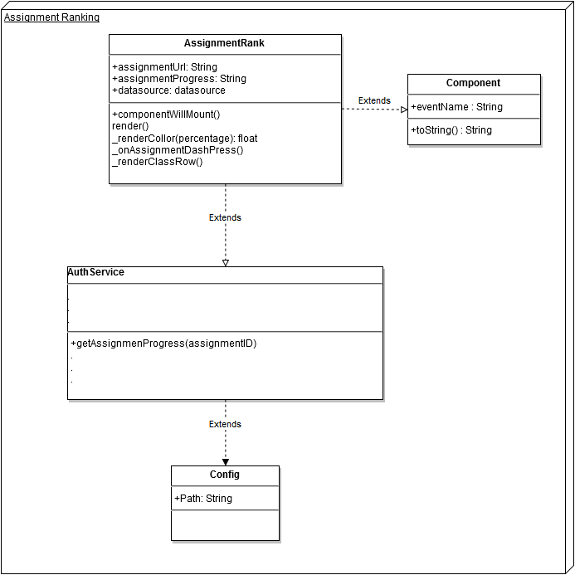

**Class Diagram**

**Unit Test**

**Test Case 1 (Sunny Day)**

**Purpose**

* Ensure the system reports a correct ranking

**Precondition**

* All assignments for a user are selected as finished

**Input**

* N/A

**Expected Result**

* User is ranked as first or tied for first

**Actual Result**

* User progress bar is displayed in green percentage is shown as 100%

**Test Case 2 (Rainy Day)**

**Purpose**

* Ensures system displays a corrected ranking by completion date/time when users are tied

**Precondition**

* Multiple user with 100% completion

**Input**

* For multiple users all assignments are marked as completed

**Expected Result**

* Only one user is marked as first based on time of completion

**Actual Result**

* Actual ranking number is displayed on the page

**Visual User Guide**

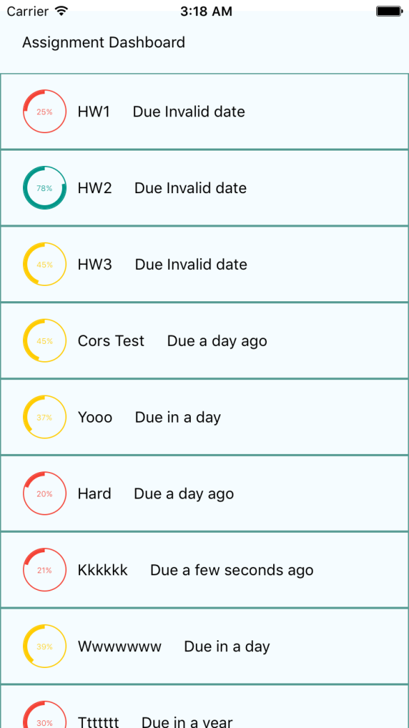

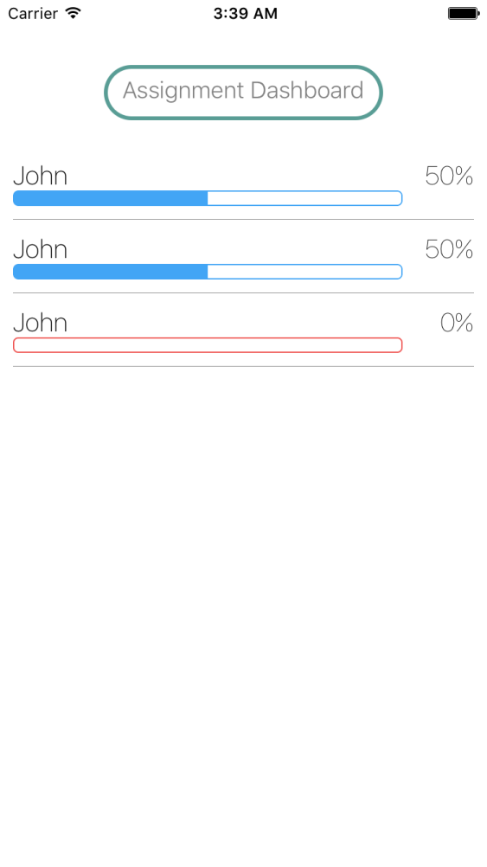

Assignment dashboard Class ranking page

