*Florida International University*

*School of Computing and Information Sciences*

Software Engineering Focus

Feature Document

User Story #**126**

**Team Member:**

Nelson Cruz

**Product Owner(s)**:

Mohsen Taheri

**Mentor(s)**:

Mohsen Taheri

**Instructor**: Masoud Sadjadi

**User Story** Implement User Registration

* As a User I would like to register a new account so that I can login to Neat system

**Acceptance Criteria**

* There exists a mechanism for a new account to be created if the user does not exist.
* If user exists, inform the user and present the user with a login screen

**Use Case** #**001-Register a New Account**

**Actors**

Initiated by Neat User

**Entry condition**

The user is at the login screen

**Flow of events**

1. While at the login page, user clicks on register

2. The user is prompted with the registration page

3. User enters required information and clicks on Register

4. Users is taken to back to the Login page

**Exit condition**

The user is taken to the Login page

**Alternate flow of events**

* 3a.
* The user enters an incorrect email address and is prompted with a warning message
* 5a.
* User enters invalid information and is prompted with a warning message

C:\Users\ncruz\Downloads\Registration_usecase.png

**Use Case Diagram**

C:\Users\ncruz\Downloads\neat-registration-sequence_diagram.png

**Sequence Diagram**

OS X:Users:macbook:Pictures:Registration_class_diagram.png

**Class Diagram**

**Unit Test**

**Test Case 1 (Sunny Day)**

**Purpose**

* Ensures that valid information is accepted by the system

**Precondition**

* All fields are filled with valid information

**Input**

* Username, password, e-mail address

**Expected Result**

* A new user is registered, and user is taken to the Login page

**Actual Result**

* A new user is added to the system

**Test Case 2 (Rainy Day)**

**Purpose**

* Ensure the system validates the information before requesting registration

**Precondition**

* Register button is pressed without any information filled

**Input**

* Null on all fields

**Expected Result**

* All empty fields are highlighted in red

**Actual Result**

* No request is made to backend

**Visual User Guide**

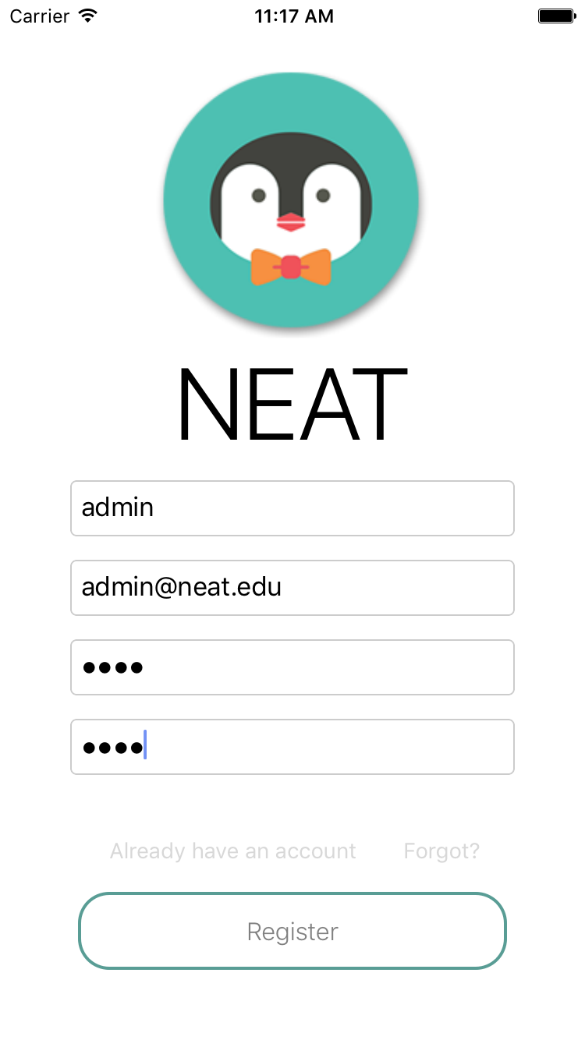 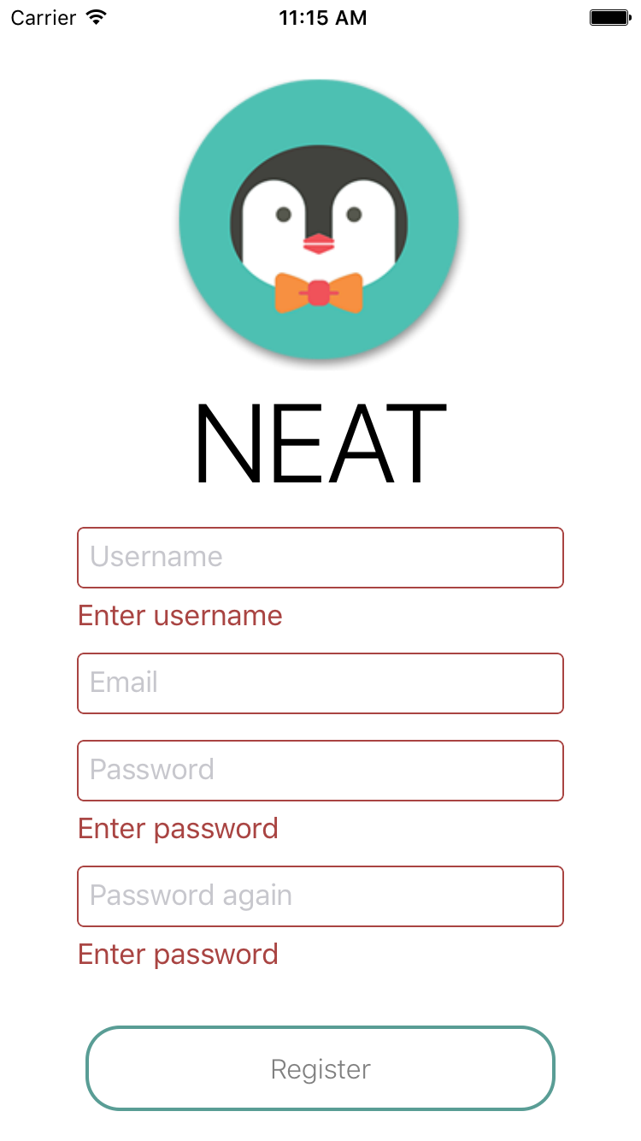

Registration page with valid information Registration page with invalid information

OS X:Users:macbook:Desktop:Simulator Screen Shot Nov 7, 2016, 12.29.22 PM.png

Login after registration