*Florida International University*

*School of Computing and Information Sciences*

CIS 4911 - Senior Capstone Project

Software Engineering Focus

User Manual

Project Title:

Robotic Arm 1.0

Team Members:

Curtis Cox

Shadeh Ferris-Francis

Product Owner(s):

Nagarajan Prabakar

Mentor(s):

Nagarajan Prabakar

Instructor: Masoud Sadjadi

**Telebot Arm Servo Feedback Tester App:**

1. Ensure that the DDS Slave program is not running on Telebot.
2. Load ServoFeedbackTestApp.jar onto the computer in Telebot.
3. Run ServoFeedbackTestApp.jar.
4. The Telebot Arm Servo Feedback Tester App will set each servo in Telebot’s head and arm to their rest position. This process will take approximately 15 seconds.
5. When all servos have been set to their rest position the “Telebot Arm Servo Feedback Tester App” window will open (See figure 1).

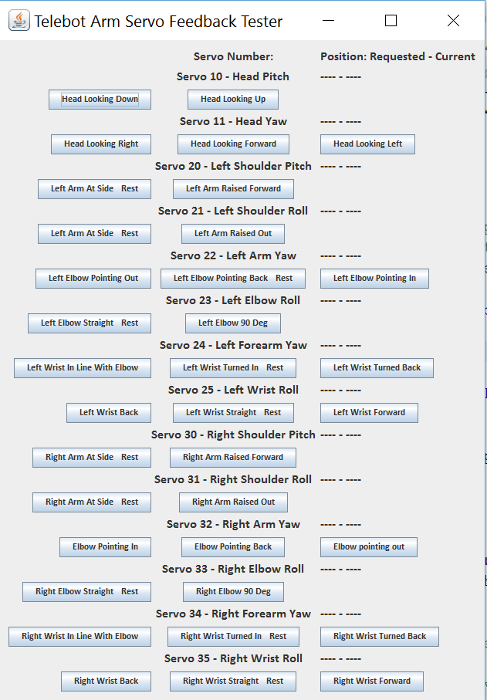

Figure 1.

1. Choose an action that you would like to test and click on that button.
2. If a different servo in the same arm as the servo you selected is not at its rest position, that servo will be set to its rest position.
3. Once all other servos in the same arm as the servo you selected have been set to their rest position, the servo you selected will be set to the position you selected.
4. The feedback label for the servo you selected will be populated with the requested position and current position of that servo. If the current and requested positions differ by more than 50 degrees, the label text will be set to red to call your attention to the misaligned servo (see figure 2).

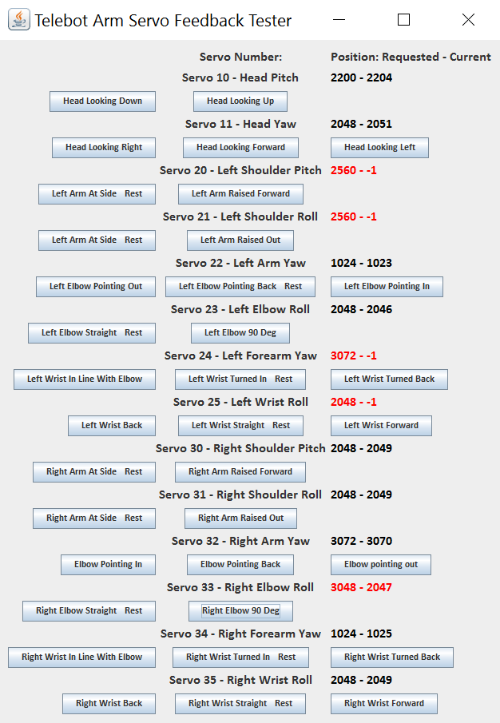

Figure 2.

1. Each time a new servo position is requested, all servo feedback labels will be refreshed to show the most current data.
2. Confirm that the configuration of Telebot’s arm matches the configuration you selected from the “Telebot Arm Servo Tester” window.
3. Repeat the servo selection process until you are sure all servos are working properly.
4. To exit the application, click the “X” Button in the upper right corner of the window frame (the standard close window button).

**Motion Capture Control:**

**Setup:**

1. Boot Telebot.
2. Ensure Telebot is connected to the dlink-telebot wireless network.
3. Start the Slave/Subscriber program on Telebot.
4. Boot the remote computer.
5. Ensure the remote computer is connected to the dlink-telebot wireless network.
6. Start the IMU Master/Publisher program dated April 14, 2016 on the remote computer.
7. Ensure that the YEI bluetooth receiver dongle is plugged into a USB port on the remote computer.
8. Power on the YEI 3 Space sensors.
9. Attach the YEI 3 Space sensors to the Telebot Operator’s arms, head and torso as shown in Figures 3 and 4. 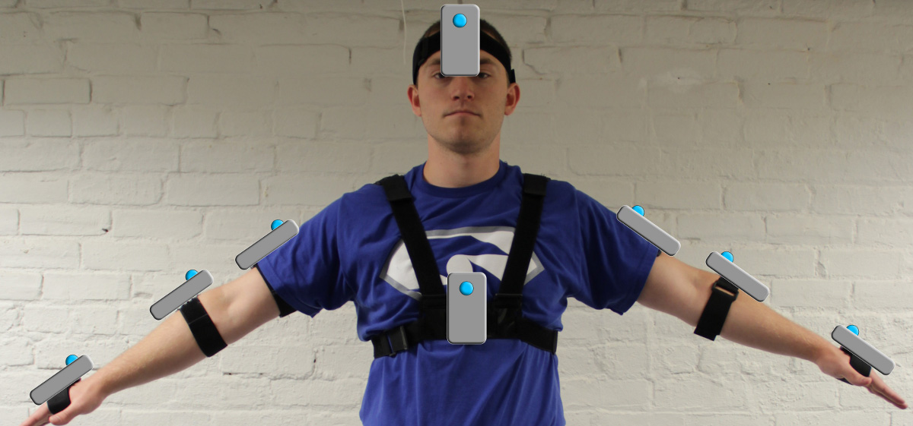Figure 3.

YEI 3 Space Sensor orientations (front view)

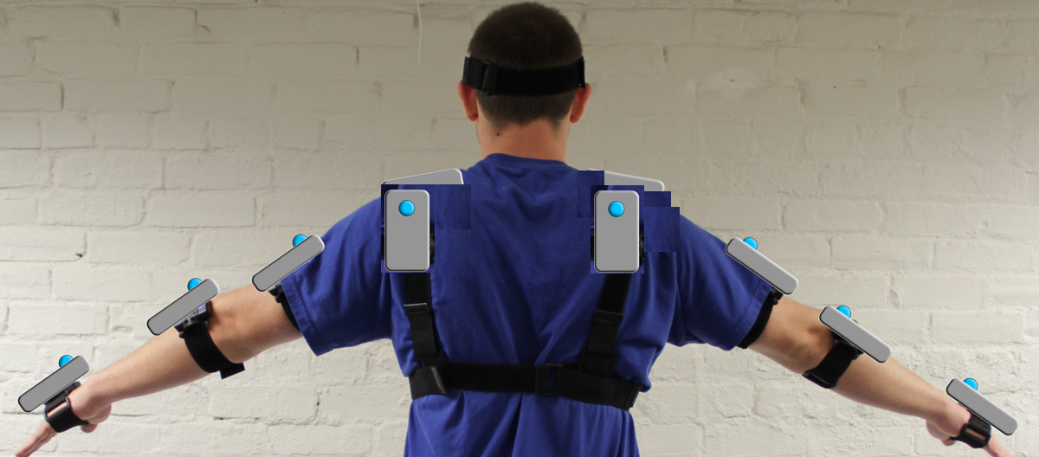

Figure 4.

YEI 3 Space Sensor orientations (back view)

**Configure Mocap Studio:**

1. Run animator-0406-2016-cox.py on the remote computer to open Mocap Studio.
2. As Mocap Studio loads, it will connect to the YEI receiver dongle and read the list of paired YEI 3 Space Sensors from the dongle. In the “Unknown Ports Dialog” popup window (Figure 5), click “Ignore Ports”.

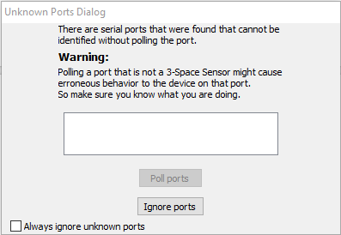

Figure 5.

1. From the menu bar of the “TeleBot Motion Controller” window, select “Import->TSH” (Figure 6).

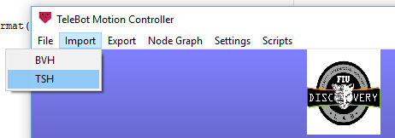

Figure 6.

1. In the “Choose a *.tsh file” popup window, select “TeleBot-v8” and click “Open”.

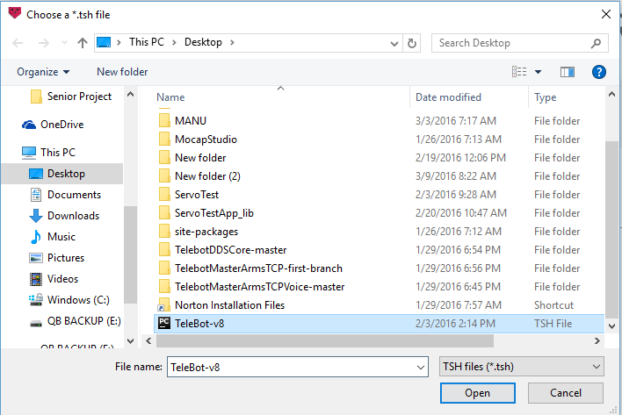

Figure 7.

1. A dialog box will open asking, “Do you want to load the Node Graph Configuration associated with this file?”. Click “Yes”.
2. In the “Choose a *.xml file” popup window, select “TeleBot-v8” and click “Open”.
3. Once the TSH and XML files have loaded, from the menu bar of the “TeleBot Motion Controller” window, select “Node Graph->Configure Node Graph”.
4. The “YEI Node Graph” window will open (Figure 8). The serial number of the YEI 3 Space Sensor worn by the Telebot Operator should appear in the “TSS Input Node” box that is linked to the corresponding bone.

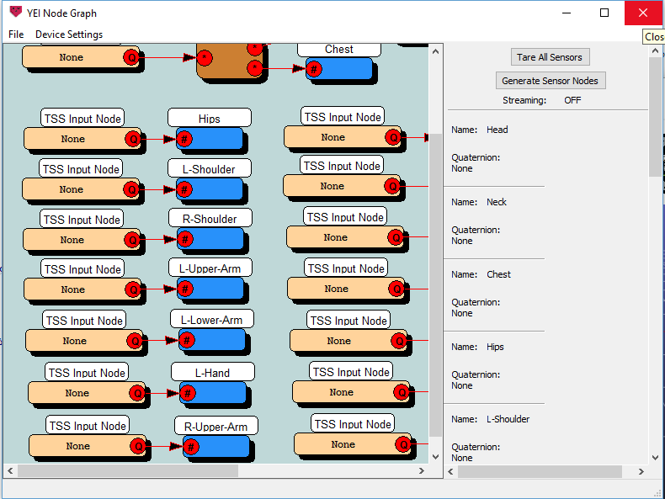

Figure 8.

1. Ensure that the correct serial number appears for each of the following bones:
   1. L-Shoulder
   2. R-Shoulder
   3. L-Upper-Arm
   4. L-Lower-Arm
   5. L-Hand
   6. R-Upper-Arm
   7. R-Lower-Arm
   8. R-Hand
   9. Head
   10. Chest
2. If any of the TSS Input Nodes boxes for any of those bones shows “None”, right click on that box and select “Properties” from the menu that opens under the mouse pointer (Figure 9). This will open the TSS Input Node “Properties” window (Figure 10).

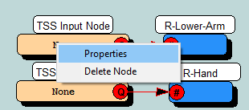

Figure 9.

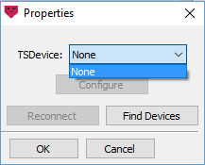

Figure 10.

TSS Input Node Properties window

1. The TSDevice drop down list will show all of the YEI 3 Space Sensors that are paired with the YEI bluetooth receiver dongle AND connected to the dongle when it was discovered by the program AND not associated with a TSS Input Node in the Node Graph. If the sensor for that bone is listed, select that sensor and click “OK”. If The sensor is not listed, as in Figure 8, Ensure that the sensor is powered on and in range of the dongle. Click “Find Devices” to re-poll the YEI bluetooth receiver dongle. The sensor should now appear in the TSDevice drop down list. Select the sensor and click “OK”.
2. Repeat step 20 until all sensors are associated with their appropriate bones.
3. When all TSS Input Nodes are properly configured, click the “X” at the top right of the “YEI Node Graph” window to close the window.
4. From the “Current Session” drop down box in the “TeleBot Motion Controller” window select “None”.
5. The left side of the “TeleBot Motion Controller” window shows the model of the operator (see figure 11).

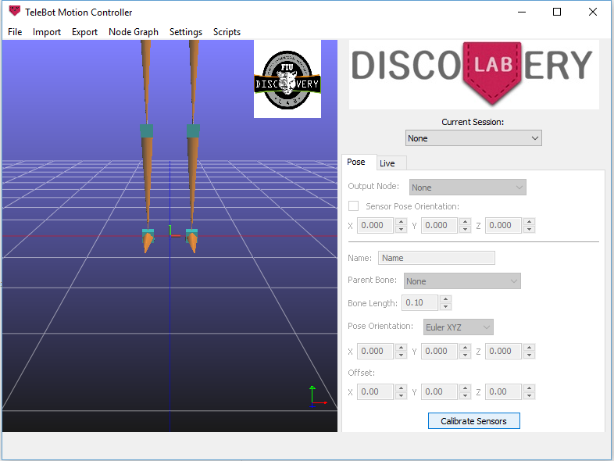

Figure 11.

1. The view port of the model can be controlled using the mouse. The wheel of the mouse will zoom the view. Moving the mouse while clicking and holding down the wheel, will allow you to pan the view. Zoom and pan the model until you can see the entire skeleton and shown in figure 12.

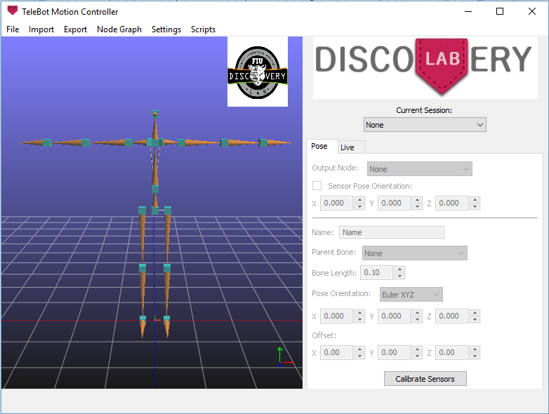

Figure 12.

1. Click the “Calibrate Sensors” button at the bottom right side of the “Telebot Motion Controller” window. This will start the sensor calibration process. Follow the on-screen instructions until you see the “Calibration Successful” dialog window.
2. Click on the “Live” tab on the right side ow the “TeleBot Motion Controller” window.
3. Ensure that all of the sensors have been selected in the list at the bottom of the “Live” panel.
4. Click the “Start Streaming” shown in Figure 13.

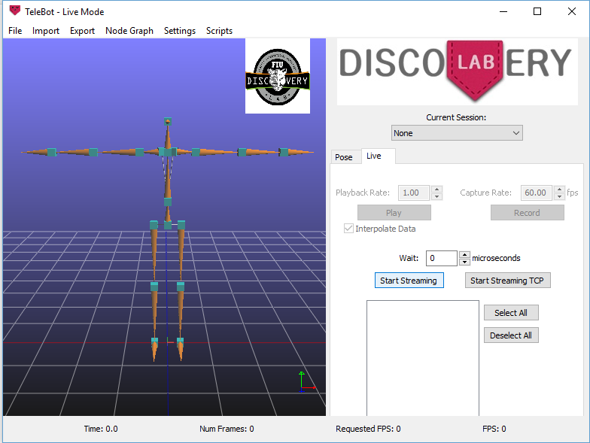

Figure 13.

1. The skeleton should start to mimic the movements of the TeleBot Operator’s arms and head. Take a moment to confirm that the movements are accurate.
2. Click the “Start Streaming TCP” button to open the “Angle Calculator TCP” window (figure 14).

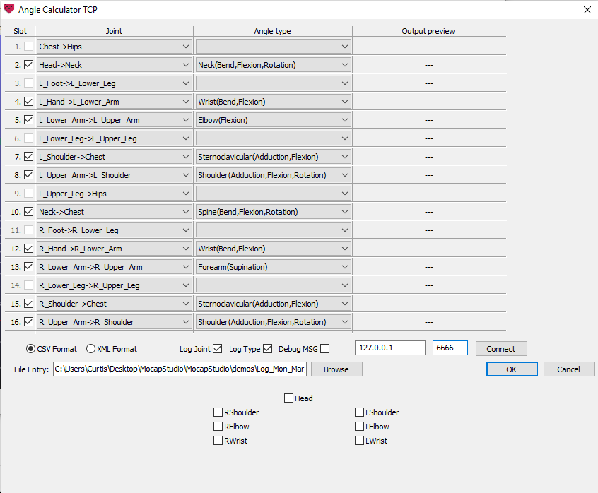

Figure 14.

1. Using figure 12 as a guide, set the Angle type for the selected Joints.
2. Enter the IP Address and port number of the IMU Master/Publisher program in the boxes below the Output preview column. When running Mocap Studio and IMU Master/Publisher on the same computer, the IP Address should be 127.0.0.1 and the port number should be set to 6666, as shown in figure 14.
3. Click “Connect” to connect to the IMU Master/Publisher program.
4. The Output preview column will be populated with the current angle values for each joint.
5. The bottom of the “Angle Calculator TCP” window has 7 checkboxes, one for each joint in the skeleton. When a box is checked, the angle values for that joint will be streamed to the IMU Master/Publisher program.

**Auto Calibration of Telebot:**

1. Mocap Studio finds the angle of a joint in the arms by determining the 3 dimensional rotation of the sensor on one side of the joint compared to the sensor on the other side of the joint. The relation of the X, Y, and Z components of this rotation to the angle formed by the joint will vary from one trial to the next based on the exact position of the sensors. To correct for this error, Mocap Studio will calibrate the angle data that it outputs to ensure that the angles are always in the range of 0 to the maximum angle that the given servo on Telebot can move to. In order to keep the angles in this range, Mocap Studio will offset the actual angle formed by two sensors by the lowest actual value recorded. When the Telebot Operator starts to stream data to the IMU Master/Publisher, he should move each of his joints in his arms through the range of motion that the corresponding servo on Telebot is capable of moving. This will allow Mocap Studio to find the appropriate minimum value.
2. The minimum value offset that Mocap Studio uses is set by a sliding window to allow for correction from erroneous outlying data points. If Telebot’s movements for a given servo no longer mimic the Telebot Operator’s movements, the Telebot Operator should once again move his joint through the range of movement of that servo to reset the bounds of that window.
3. Mocap Studio finds the angle of the pan and tilt of the head by comparing the 3 dimensional rotation of the sensor on the head to that of the sensor on the chest. The TeleBot Operator should turn his head about 45 degrees to the left of center and about 45 degrees to the right of center. He should then tilt his head up and down to allow Mocap Studio to find the limits of the head movement.
4. If the Telebot Operator maintains his movements within the range of movement that TeleBot is capable of, the calibration should steadily improve as operation progresses.

**Disconnecting from IMU Master/Publisher:**

1. To disconnect from the IMU Master/Publisher program click “Connected” (figure 15).

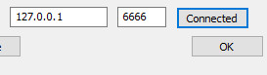

Figure 15.

**Voice Control:**

1. Launch BitVoicer, BitVoicer.

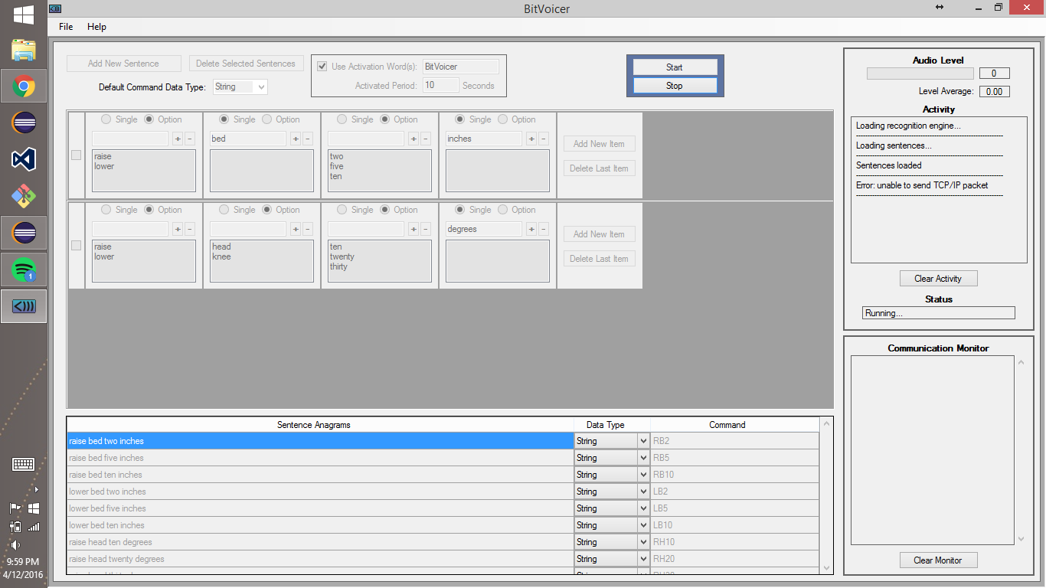

.

2. In BitVoicer, in the File menu, click Open, and in the respective location on your filesystem where it is saved, choose the TelebotVoiceControlSchema voice profile. Check off all commands.

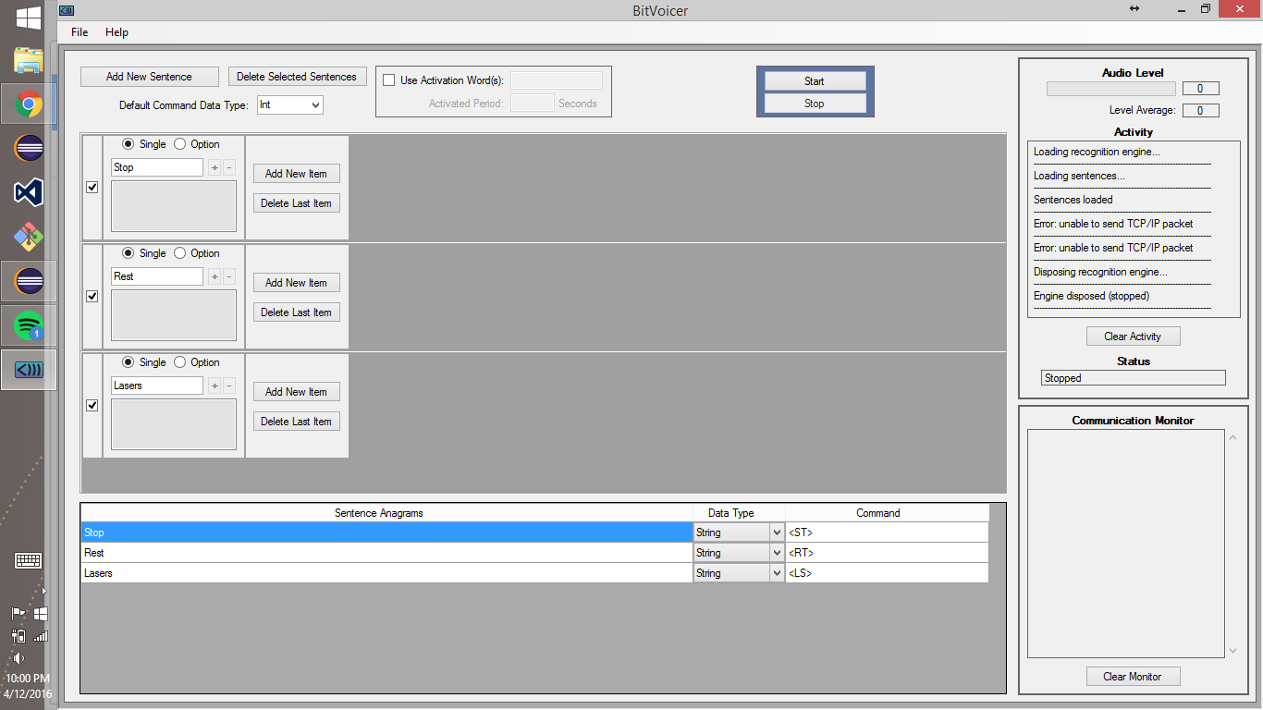

3. Go to the File menu and click Preferences. Select Use TCP/IP Communication, and under IP Address, enter 127.0.0.1, and under port number, enter the port number that you will be using for communication.

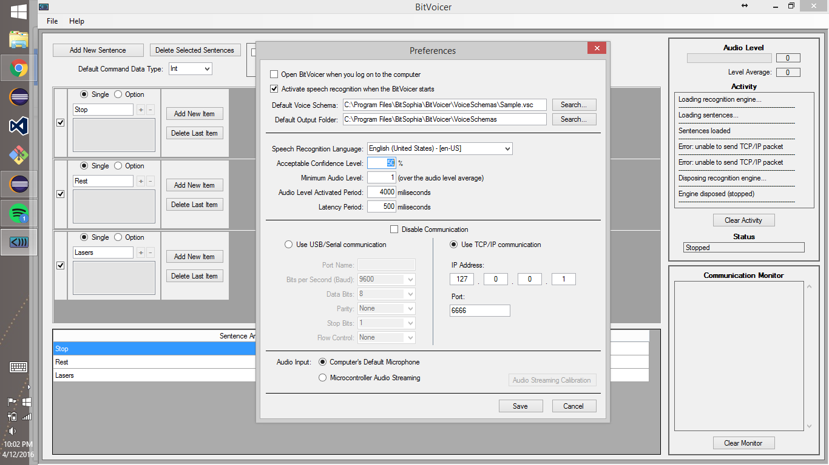

4. Launch the Voice Master/Publisher Program.

5. In the Voice Master/Publisher GUI, enter the port number and click Listen.

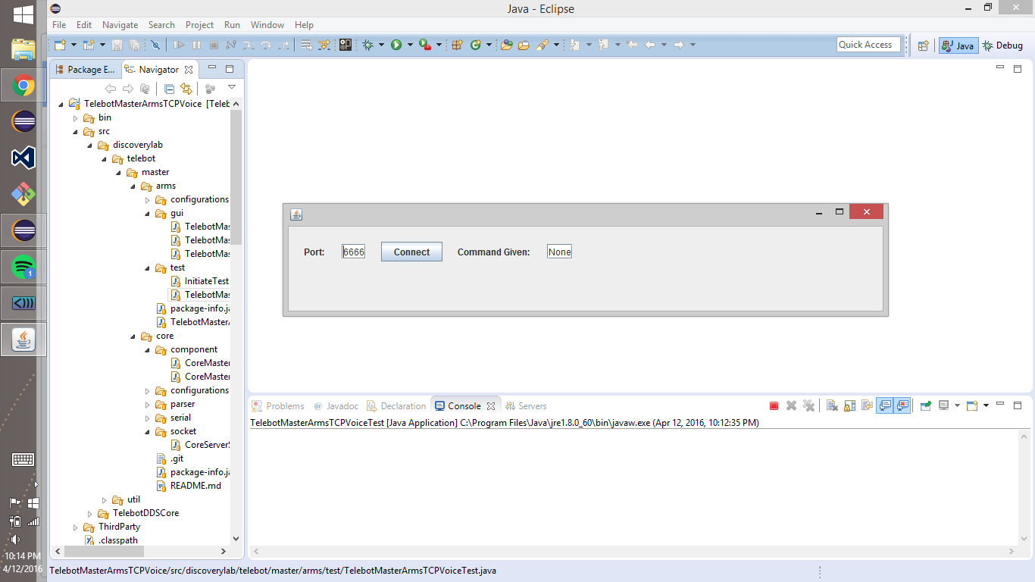

6. In BitVoicer, click Start.

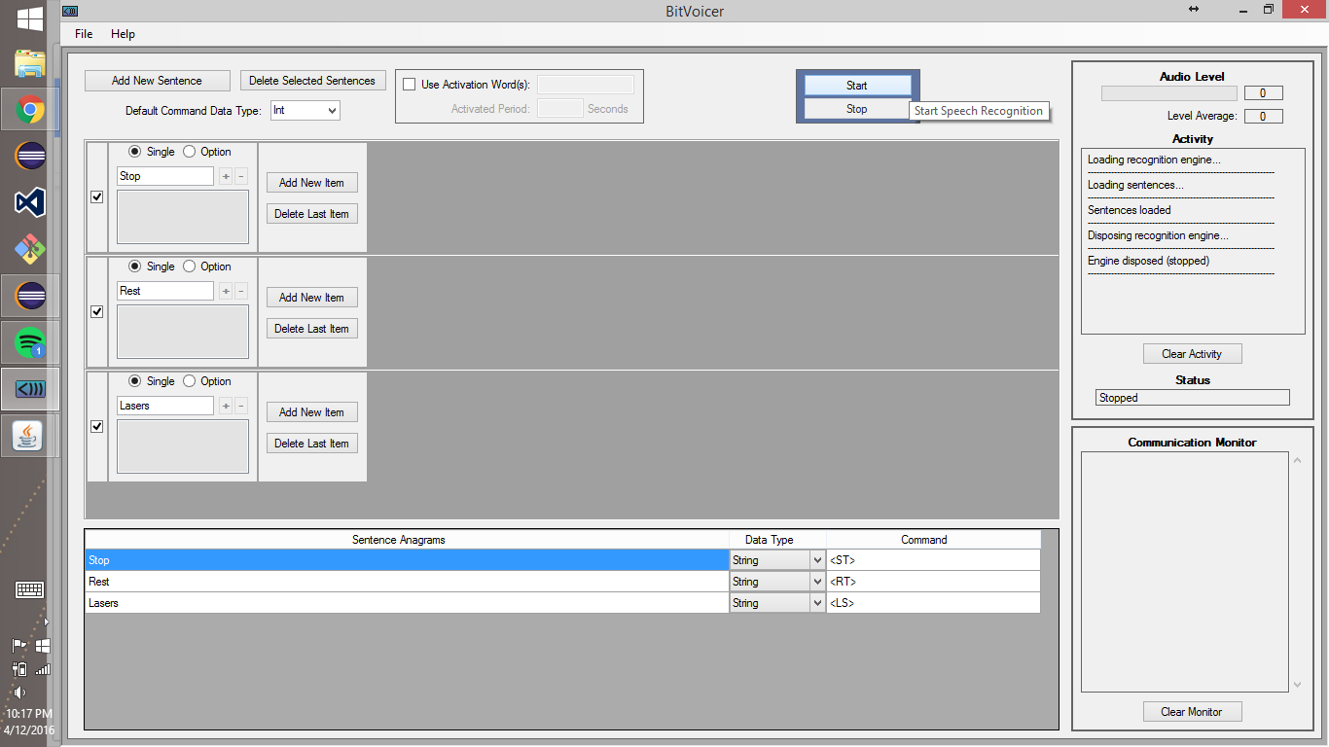

7. The left panel of BitVoicer should indicate that the system is active and connected to the Voice Master/Publisher Program.

