

Head Professor User Guide: Matchmaking

Senior Project Website

**Copyright**

*All title, including but not limited to copyrights, in and to the SENIOR PROJECT WEBSITE are owned by School of Computing and Information Sciences Faculty of Florida International University. All title and intellectual property rights in and to the content which may be accessed through use of the SENIOR PROJECT WEBSITE is the property of the respective content owner and may be protected by applicable copyright or other intellectual property laws and treaties. This EULA grants you no rights to use such content. All rights not expressly granted are reserved by School of Computing and Information Sciences Faculty of Florida International University.*

**Overview**

This user guide is designed to help a person who will be fulfilling Head Professor role in the Senior Project Website. This document will provide a walkthrough for the matchmaking feature. The specification for executing those actions will be provided. Additionally, to aid understandability, screenshots of the corresponding user interface elements are included to help the user.

Glossary

**NRMP**- National Residency Matchmaking Process, the manner by which medical residents are assigned residency programs wherein residents rank programs and programs rank residents, residents get the program they want unless someone the program wants more comes along (displacement) and there’s no more room

**Displacement-** To take another’s position in NRMP applied to the website it has the connotation of a criteria i.e. a project displaces a student by interest of student (whoever wants the project more wins) or by more skilled student with regards to project requirement

**Friendly –** Means geared towards students, in VIP matchmaking friendly means projects positions are filled by students who want the project. For Other Project matchmaking means displacement by student interest as the criteria

**Scientific** –Means geared towards head professor in VIP matchmaking means all students are filled for project position even against their will.

**Compromise-**  Means geared towards balance for students and projects during other project matchmaking, the criteria is the skill-based displacement.

**Heuristics**- Common-sense approach, in computer science has the connotation of using a common sense approach to guide a result, aka greedy algorithm

**VIPs-** very important projects, projects you rank 2-100, higher means more priority which means gets filled up first with better students

**Other Projects-** projects you rank 1 which means you are leaving matching hands off to an extent other than choosing NRMP criteria for displacement

**Automatic VIP Matching**­- Matches all VIP at once and allows head professor choose all scientific or all friendly

**Manual VIP Matching-** Matches VIP one at a time allowing mix and match of scientific and friendly, also allows to run rest of VIP as automatic at any moment

Match Page Meaning

On each match page the same UI comes up the following defines the UI elements. The blue number at the side corresponds to the listing below.

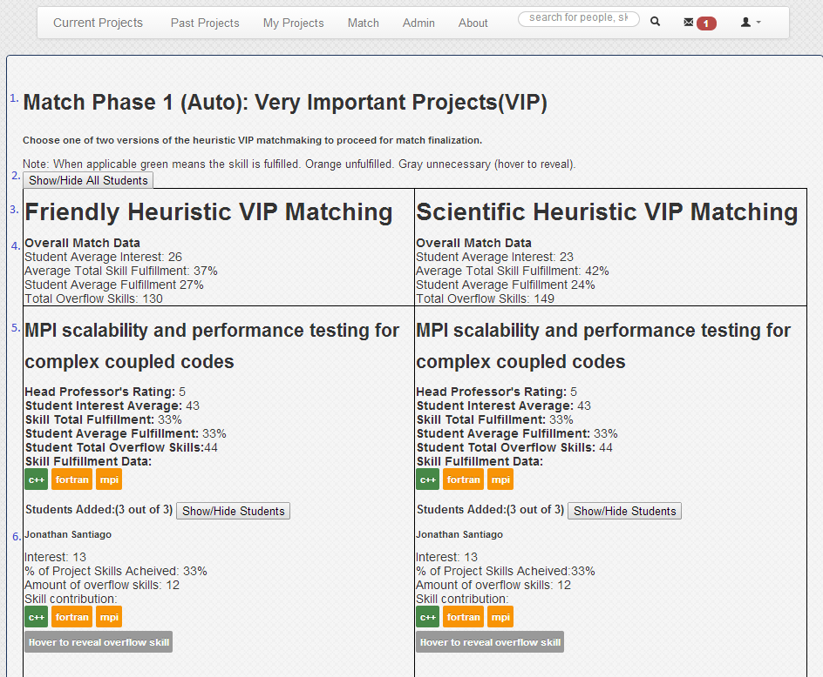

1. Defines the title state of match pages (Auto) (VIP), (Manual) (VIP), Match Phase 1 VIP Confirmation etc.
2. Hides and shows all students (by default all hidden)
3. Title of match criteria (what separates one column from the next)
4. Statistical data regarding the match overall
   1. Student average interest is average of students interest across all the averages of all the projects in that column
   2. Average total skill fulfillment is average of skill total fulfillment for all projects
   3. Student average fulfillment is the average of every projects student average fulfillment
   4. Total overflow skills is how many skills are not utilized by every student in the match
5. Title of the project along with statistical data for the project
   1. Head professor rating is the rating the head professor gave this project (applies to VIP only)
   2. Student interest average is the interest average of the team
   3. Skill total fulfillment is the amount of skills the team provides the project that it needs / amount of skills the project needs
   4. Student average fulfillment is the average of each team members % of Project Skills achieved
   5. Student total overflow skills is how many skills are not utilized by the project’s team
   6. Skill fulfillment data shows all the project’s skill needs, green ones are fulfilled, orange are not
6. Name of student along with statistical data
   1. Interest is the rating the student gave the project, if -1 they were forced, if 1 they likely let the system do matching for them and did not rank any projects, anything else is there actual interest
   2. % of project skills achieved is how many skills they contribute to the project / how many skills the project needs
   3. Amount of overflow are skills not utilized for them for the project
   4. Skill contribution is the skills contributing to the project’s need if green they have that skill for the project, if orange they do not
   5. Below that if hovered over shows all of a student’s “wasted” skills that are not utilized by the project

Ranking and Preparation Phase

After having projects in the systems and students in the system go to admin.

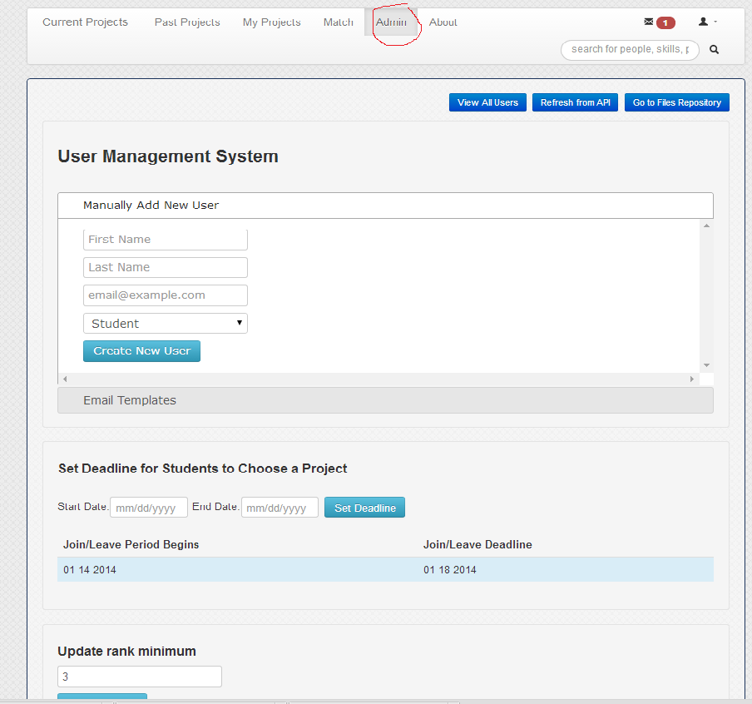

There set up the deadline for when students have to rank projects by.

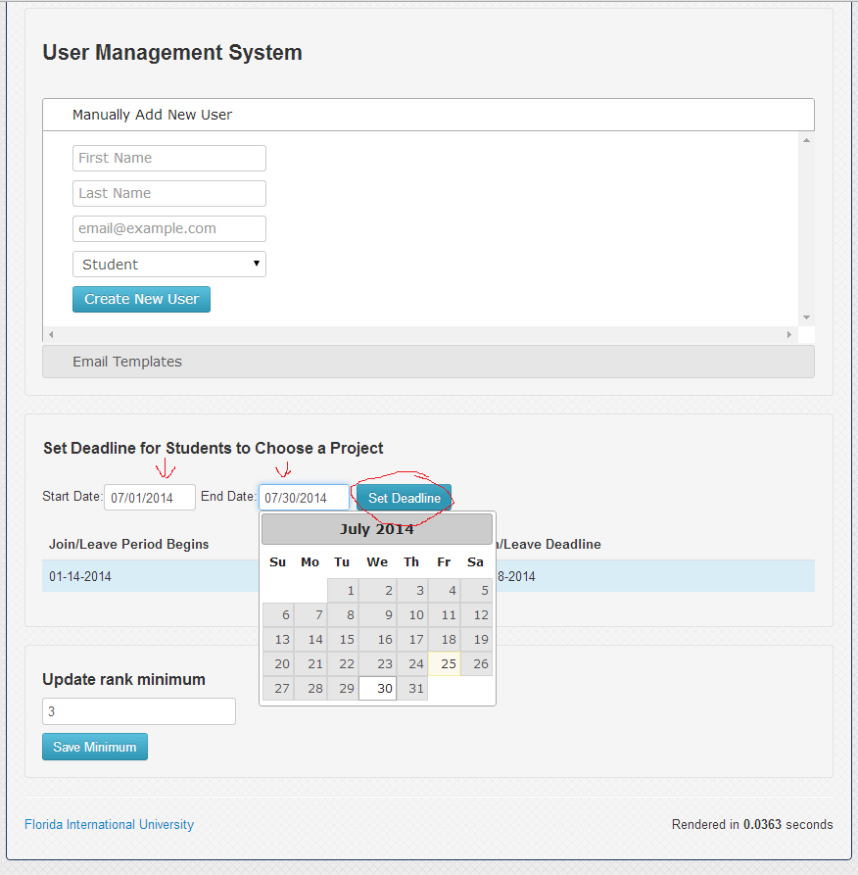

Set the update minimum (minimum projects a student must rank for their ranking to matter)

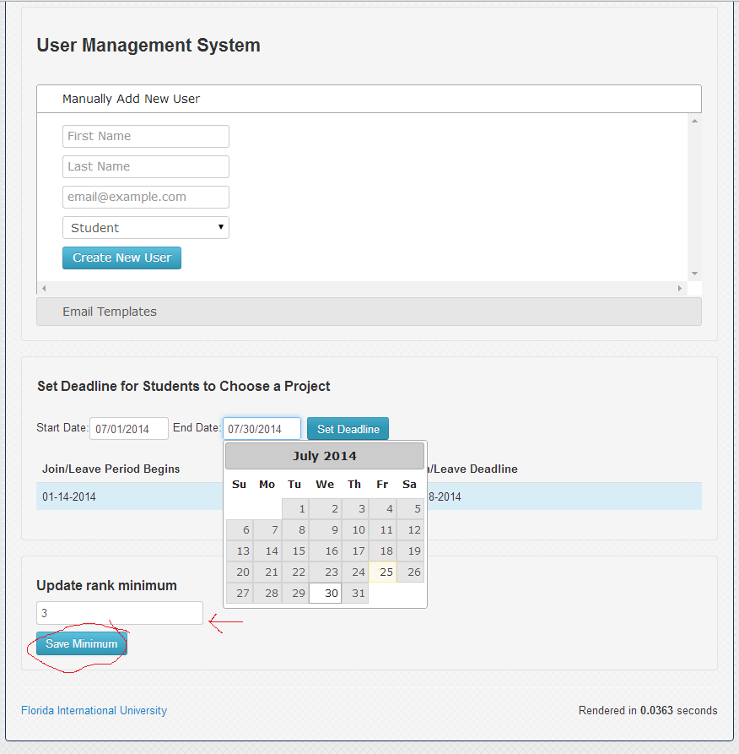

Now click on match at the top navigation bar

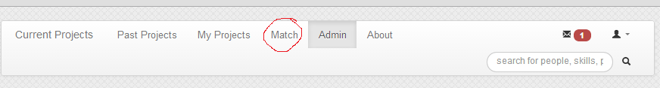

Now click Go to Project Priority

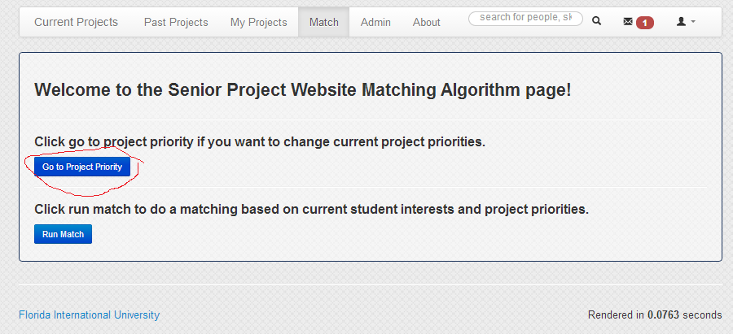

Now you rank the projects as the head professors according to the guideline at the top. Note: From here you can customize the system to work entirely by National Residency Matchmaking Program algorithm wherein the students get to choose projects as they wish; more or less (rank all projects 1). Alternatively you can micromanage and optimize all projects in a certain order (rank all projects 2-100). In ties the project with more skill requirements go first.

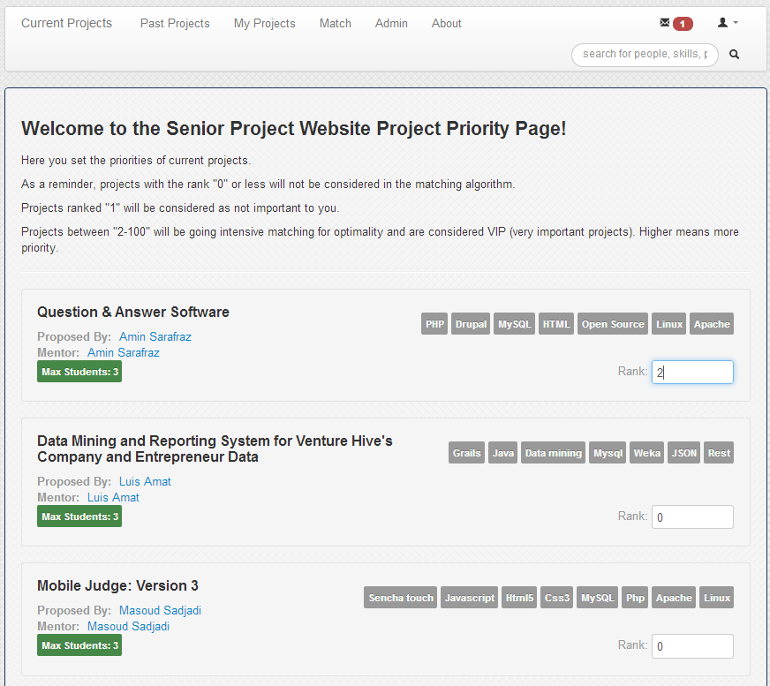

Then click save at the bottom

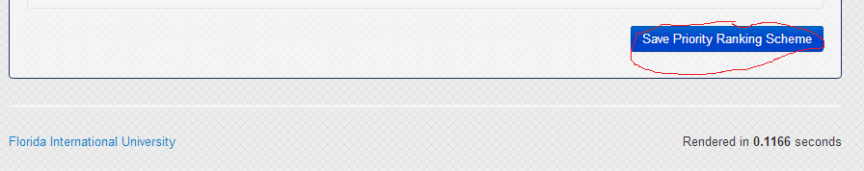

You have now saved your own rankings, and set up the deadline student must rank by and minimum project numbers a student must rank.

Now in class instruct the students to enter the senior project website. Instruct them to enter their skills (or synchronize it with LinkedIn) and to rank projects if they wish. Note they can choose to not rank project and in such a case they will be matched by the system according to their skills.

Now wait until the deadline to continue on to the matching phase.

Matchmaking Phase

After the deadline happens you can now start the matchmaking process. After logging back in go to the match tab.



And click run match.

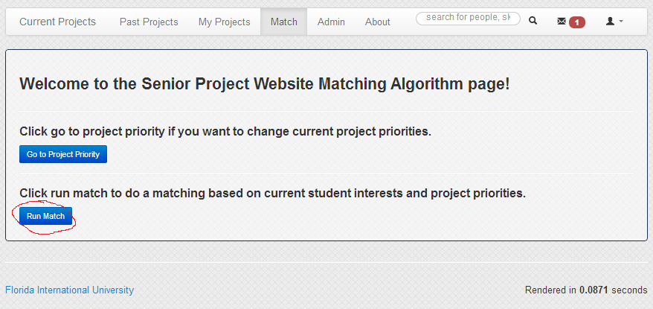

Here you will have the option to run very important project in two manners: automatically, and manually. In both cases two categories, “friendly” and “scientific” will be allowed, choosing the former means your important projects are filled with the best students who want the project, the latter means all students consider making it more likely for a better match overall. You should want to choose one where students are not forced if its bearable else you might lead to student dissatisfaction. So choose one of the two options. Eventually your choice will collapse together. We will start with automatic.

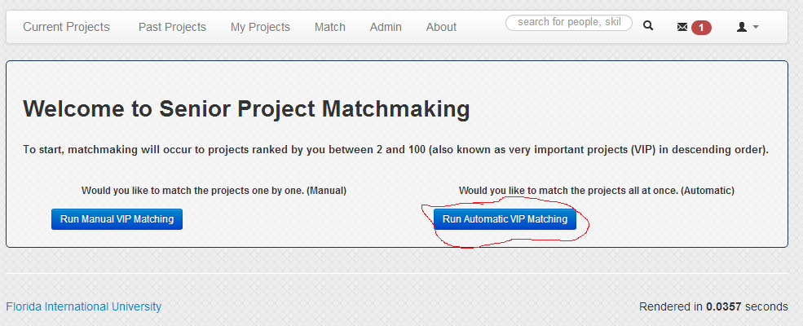

Automatic page looks like this.

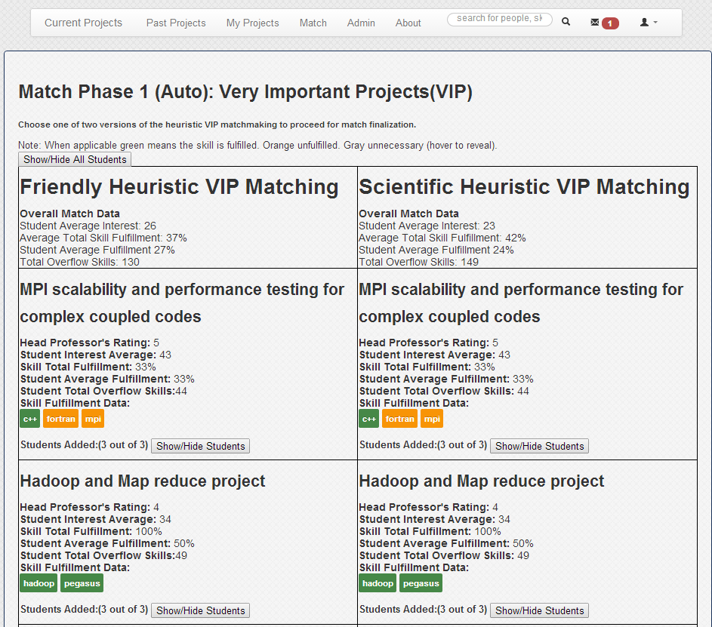

After reviewing the options in auto choose one and continue.

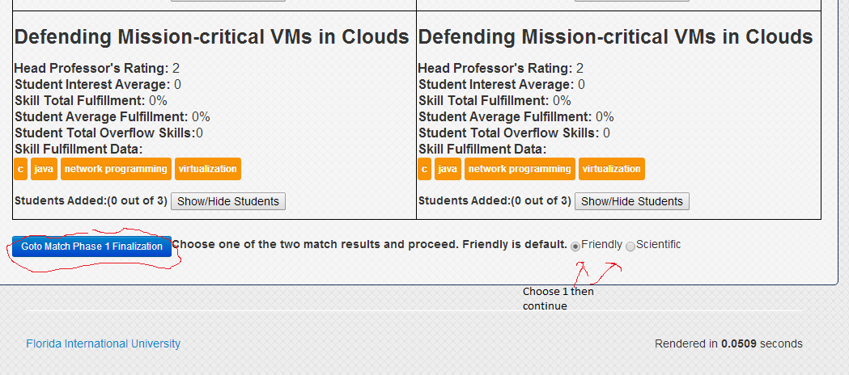

Continuing leads to a confirmation page for the first phase

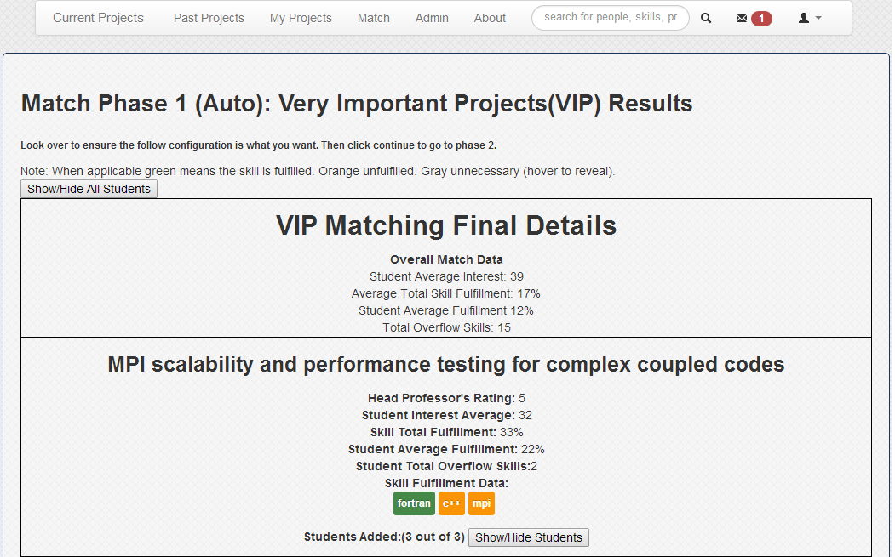

Click continue at the bottom to go the phase 2



If you choose to go manual instead of auto you do the following for each page

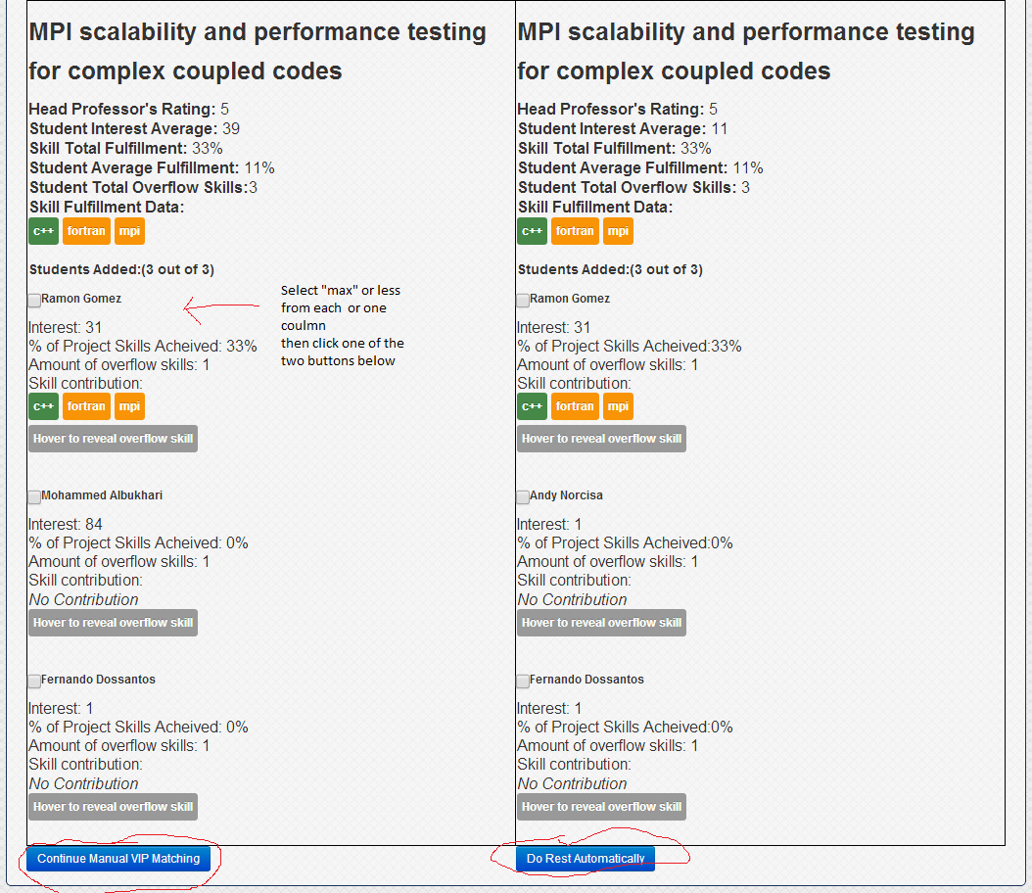

Clicking continue on manual does this for each project until you are done, which will lead to the confirmation on page 13, do rest automatically loads the “automatically” page with the remaining projects.

After clicking continue to phase 2 the following page loads similar to automatic VIP matchmaking

In this context NRMP matchmaking means the NRMP algorithm is applied which essentially means each student get the project that they want. The left column friendly means that if a lot of students want a certain project the one who gets that project is the one who wanted it the most. Contrast to compromise where the one who is more skilled for the project gets the contested position. Displaced students get rematches until either all projects are filled (meaning there’s no more project for anyone to join) or all project they wanted are filled.

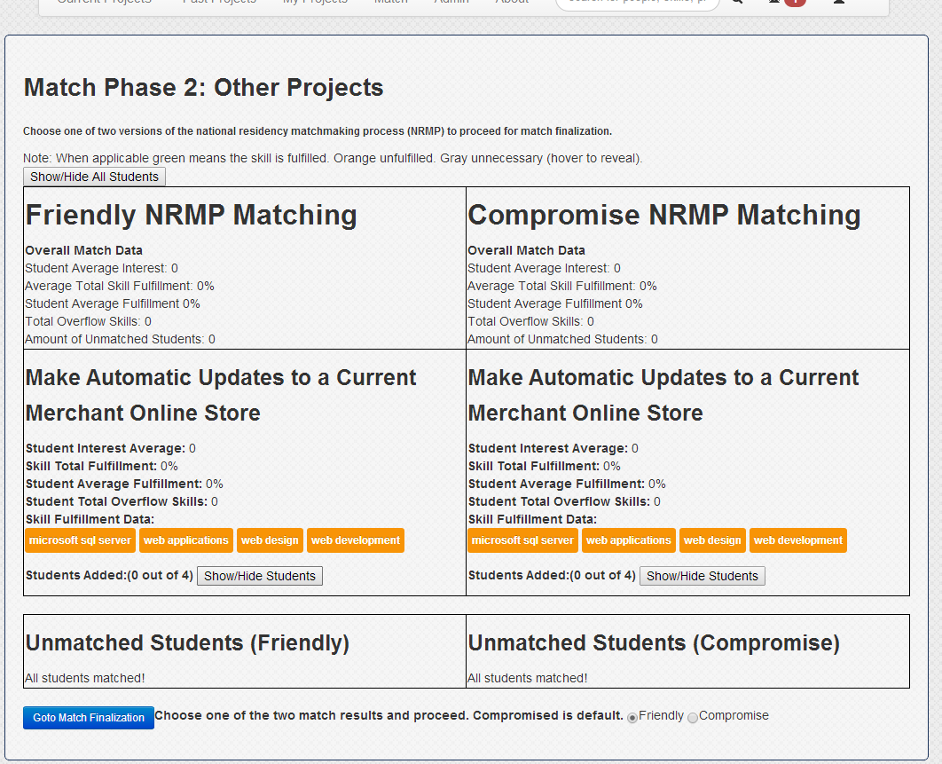

Choose one as before and continue

A final screen shows up showing all of the prior choices realized. Clicking “Save Match Configuration” here finishes the matchmaking process and saves the configuration to the database and redirects to the match home page. Congratulations in completing a matchmaking process. **Note: clicking “Save match configurations” overrides prior database data regarding a student’s matching to a project**

