Florida International University
Senior Project – Spring 2015
Skillcourt Backend
Design Document
Andy Martinez & Matthew Santiago
Professor Masoud Sadjadi



Copyright © by Florida International University – Senior Project – SkillCourt Backend
All rights reserved. No part of the SkillCourt Backend Project may be reproduced or transmitted in any form or by any means without prior written consent.

Executive Summary
There is a lot involved with the training of soccer players. The current system for training is primitive usually involving an instructor and a physical field for playing. The primary objective is to produce a new, modern, and system for training soccer players. The system will be a program with features that will assist players for learning the skills required on their own.
Implementing this system is revolutionary to the way avid players train in the sport. With the functionality and portability that SkillCourt offers, the user can create a personalized regimen for improving skills; thus, SkillCourt offers an overall improvement to both the soccer training and playing experience for players.
This document summarizes the functional and nonfunctional requirements for the SkillCourt Backed system, which were established by the project’s clients and mentors, Guomundur Traustason, and Jaime Borras.

Table of Contents
Executive Summary 3
1. Introduction 6
1.1. Problem definition. 7
1.2. Scope of system. 7
1.3. Over all development methodology. 8
1.4. Terminology 9
1.4.1. Acronyms 9
1.4.2. Definitions 9
1.5. Overview of document 10
2. Feasibility Study 11
2.1. Description of current system. Identify limitations and constraints 11
2.2. Description of alternative solutions considered. 11
2.3. Recommendation with explanation of why the solution was selected. 11
3. Project Plan 12
3.1. Project Organization 12
3.1.1. Project Personnel 12
3.1.2. Hardware and Software Resources 13
3.2. Identification of Tasks, Milestones and Deliverables 14
3.3. Cost of the Project 16
4. System Requirements 17
4.1. Functional and Nonfunctional Requirements: 17
4.2. Requirements Analysis: 20
4.2.1. Scenarios 20
4.2.2. Use case model 21
4.2.3. Static model 21
4.2.4. Dynamic model 21
5. System Design 22
5.1. Overview: 22
5.2. Subsystem Decomposition: 22
5.3. Hardware and Software Mapping: 22
5.4. Persistent Data Management: 22
5.5. Security/Privacy: 22
6. Detailed Design 23
6.1. Overview: 23
6.2. Static model: 23
6.3. Dynamic model: 23
6.4. Code Specification: 23
7. System Validation 24
8. Glossary 25
8.1. Acronyms 25
8.2. Definitions 25
9. Appendix 26
9.1. Appendix A - Project schedule. 26
9.2. Appendix B – All use cases 27
9.3. Appendix C – User Interface designs. 40
9.4. Appendix D – Analysis models 46
9.5. Appendix E – Design models 47
9.6. Appendix F – Documented Class interfaces and constraints. 48
9.7. Appendix G – Documented code for test drivers and stubs. 49
9.8. Appendix H – Diary of meeting and tasks for the entire semester. 50
10. References 60
10.1. For website: 60
10.2. For App: 60
10.3. For Simulator: 60
10.4. For Master Pad (microcontroller): 60

Introduction
SkillCourt Backend provides the user, the player, with a system that can be used to train by means of interacting with it in a one to one manner. Using the illuminating pads and the different combinations of colors provided by the different routines, the players will be able to improve not only their specific skills such as speed, force, accuracy, but also the player will be able to develop a mind-body coordination, which has been proven to be of vital importance during a real life game.
This section introduces the SkillCourt Backend system by first defining the problem it is trying to target, followed by a description of the scope of the system, and a list of the terminology used throughout the document. Lastly, this section presents an overview of the entire document

Problem definition.

Traditionally, the way in which a soccer player trains is by interacting with teammates, the coach, and the ball in a training field. This training, however, depends on others, and the coach cannot assess all players at the same time, therefore, performance reviews are not complete. Additionally, for games like Soccer that require a big field, the availability of space is crucial to training, and lack of space to train is a major setback for individual players, as well as lower-budget soccer teams. For these reasons, among others, soccer training can be a very cumbersome feat for the average person to endeavor unaided. Without proper guidance, progression dwindles and a person may not feel obliged to continue.
Additionally, it is essential for players to develop a high body-mind coordination that allows them to move and perform specific techniques without consciously thinking about it. Extensive training is needed to develop such coordination, and brain efficiency.

Scope of system.

The SkillCourt System will provide athletes and individual players with the ability to train and improve their skills by interacting with it in a one to one manner. The system allows the user to choose from a set of predefined routines to be played in a SkillCourt Room. The users is given the option of modifying certain aspects of these predefined routines by adjusting the timer and number of rounds conditions. The mobile device serves as the connection between the players and the SkillCourt pads so that the user. However, it can also display the player’s performance statistics in order to visualize progress over time. A SkillCourt website has been created as well, so that the player or a coach can access these performance statistics. In the website, the player will be given the option to share these statistics on Facebook. This will allow the user to share his or her performance with friends so that they can also see the progress of the player. The system also provides coaches with the ability to create custom routines and share them with their players so that based on the performance the coach can modify the dynamics of the training.
In addition to the already mentioned abilities of the system, it also has Bluetooth capabilities. It allows the user to locate nearby SkillCourt pads and connect to them and send the chosen routine via Bluetooth. Since the SkillCourt pads are not build yet, the routine will be played on a simulator which has the ability to represent real physical conditions like force when hitting a SkillCourt pad and time between hits. It also keeps track of the points scored by the player and the accuracy.
For future development, the system should be capable of analyzing collected data in order to provide more useful information to the athletes, including predictions based on their progress and also based on the progress of other athletes who are practicing similar skills using similar routines. The system should also start handling more complicated graph problems which deal with pads that are out of reach of the master pad Bluetooth range. The system should also increment the available routines. The system should also allow multiplying.

Over all development methodology.

Agile development methodology was used to begin the process of creating and adding functionality to all parts of the system. Agile is an iterative and incremental development process which allows developing functionalities and testing it along the way. Following this process was key to delivering a quality product that conforms to all standards.
Since the process is iterative, it allows small and concise changes to be made leading to the overall progression of the project as a whole. Below is the methodology diagram used for the completion of the product:
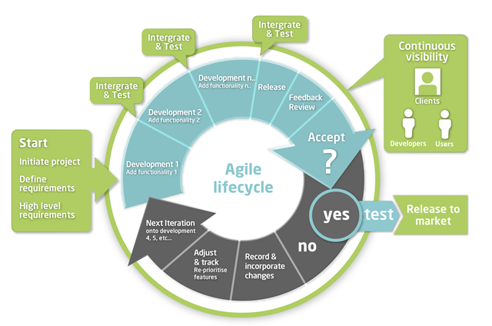
Figure 1 Agile Methodology

For SkillCourt, we used Mingle, a ThoughtWorks agile/scrum service, to track and document the project’s progress and requirements. Mingle allowed for us to break the development process into smaller, digestible, and easy to integrate pieces.

Terminology

Acronyms

- App: Refers to the SkillCourt application in the mobile device.

Definitions

- Pad Simulator: An emulated device which will take the place of SkillCourt pads for testing showcasing purposes. This device will offer all of the features a SkillCourt Pad will offer.
- SkillCourt: A system which uses SkillCourt Pads and a player interface for training soccer.
- SkillCourt Arena: A 20’x40’ room with SkillCourt Pads on the walls used for soccer training.
- SkillCourt Pad: A physical device with a flat surface that can measure and transmit when and how much pressure it received.

Overview of document

The purpose of this document is to explain the SkillCourt system, its requirements, design, etc. The current chapter has served as an introduction to the document, providing the reader with the problem that the system targets to solve, the methodology, and some terminology. The second chapter, the feasibility study, describes the description the current system, and a description of the alternatives analyzed, finalizing with some recommendation. Chapter 3 describes the Project Plan, starting with a description of the project organization, and the tasks and milestones identified. It concludes with an estimate of the total cost of the proposed system. Chapter 4 describes the system requirements, including both the functional and nonfunctional requirements, and a requirement analysis, including the possible scenarios, the use case, static and dynamic models. Chapter 5 describes the system design, including the architectures used, the subsystem decomposition, the hardware and software mapping, and the security and privacy of the system. Chapter 6 describes a detailed design, including the static, dynamic, and static models. Additionally, this chapter includes some of the code specifications. Chapter 7 describes the system validations used to test the SkillCourt system. Chapter 8 provides the user with a glossary. Chapter 9 describes the appendices, which include the project schedule, all use cases implemented, the user interfaces, the analysis and design models, the documented class interfaces, and ends with a diary of the meetings. Lastly, chapter 10 ends this document with the references used to create it.

Feasibility Study

Description of current system. Identify limitations and constraints

The market lacks any non-traditional training system for Soccer players. There are not many companies addressing this problem right now. Companies such as Axon Sports, for example, have tried to develop a training system that improves brain efficiency with games that use the touch technology. However, no customizable, interactive training system is commercially available for users to buy and use.
The traditional system used for training is primitive, usually involving an instructor and a physical field for playing. The limitations of the traditional training system include the lack of one to one interactivity between the coach and each of the players, and the lack of resources for individual players and low budget teams. Additionally, for games like Soccer that require a big field, the availability of space is crucial to training, and lack of space to train is a major setback in many cases, often leading to the inability to train as desired.

Description of alternative solutions considered.

The following are a list of the alternative solutions to SkillCourt. We will list solutions what solve the problem SkillCourt was designed for. This is, largely, to offer an alternative to traditional Coach/Player on-field training.
- Pay for a professional trainer. This will involve locating and paying for a trainer who is highly skilled and is within a reasonable distance from the customer.
- Self-training through online resources and videos. This will involve researching online and watching videos regarding specific training methods for soccer. Then training yourself with your new-found knowledge

Selection Criteria
In order to be considered a best alternative, we need to find out what best fits the needs of the consumer. The following categories are taken into account for the selection criteria:
- Cost – How much money the consumer will spend
- Time – How long it will take for the consumer to see the results wanted
- Effort – How much effort must be exerted by the consumer to begin the program
- Travel – The distance the consumer have to go for the training
- Convenience – How can this alternative method fit into a consumer’s schedule

Analysis of Alternatives
Points are considered on a scale of 1 (Worst) to 10 (Best)

 | Personal Trainer | Online Research and Training | SkillCourt
Cost | 1 | 10 | 7
Time | 3 | 2 | 5
Results | 10 | 2 | 6
Travel | Varies (on average 5) | 10 | 10
Convenience | 2 | 10 | 10
Total points | 21/50 = 42% | 34/50 = 68% | 38/50 = 76%

Recommendation:

As the chart above shows, SkillCourt is able to deliver the most consumer-friendly product while still offering a similar level of opportunities for growth as a player. Being both low cost and extremely convenient for its users allows SkillCourt to take an edge over its competition.

Project Plan
As part of our project’s development process, we have created a detailed plan to organize our work throughout the semester. By following it, we will be able to keep track of both the project’s progress and our performance according to our requirements. This plan includes our individual roles, the personnel organization, and the hardware and software resources needed. It also includes a description of our tasks, milestones and deliverables.

Project Organization

This section discusses the roles of all team members as well as the technologies that will be used to develop the SkillCourt system.

Project Personnel

This section lists the main role of each of the 2 team members working on the project.

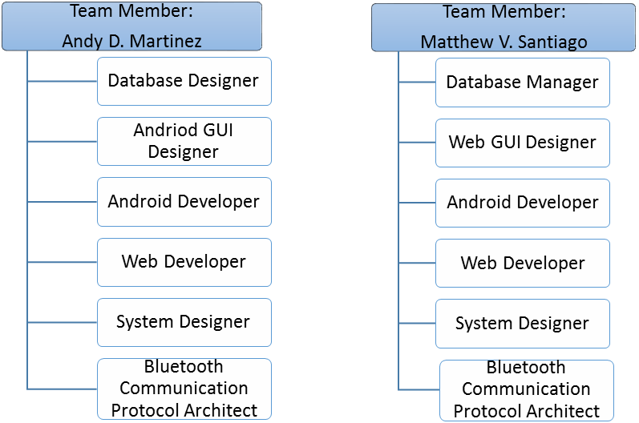
Figure 2 Project Personnel Organization

Hardware and Software Resources

The hardware needed for SkillCourt Backend includes an Android device with Bluetooth capabilities to be able to run the SkillCourt Application, an Arduino Microcontroller with a Bluetooth module, and a computer to run the simulator.
For the software, Android Studio is recommended for developing the application, and Processing has been used so far to create and run the SkillCourt room simulator. To create the code for the Arduino, Arduino Software was used.
Identification of Tasks, Milestones and Deliverables

Table 1 Description of tasks, milestones, and deliverables
Tasks | Start time | End Time
- Collect User Stories | 01/21/2015 | 01/21/2015
- Requirement Analysis | 01/22/2015 | 01/22/2015
- Create Product Backlog | 01/23/2015 | 01/22/2015
- Setup Development Environment | 01/26/2015 | 01/26/2015
- Initial Feasibility Study | 01/27/2015 | 01/27/2015
- Initial Project Plan | 01/28/2015 | 01/28/2015
- Initial System Design | 01/29/2015 | 01/29/2015
- Initial Object Design | 01/30/2015 | 01/30/2015
Milestone: Project Introduction Presentation | 02/02/2015 | 02/02/2015
- Finish Account Creation User Story | 02/02/2015 | 02/13/2015
- Finish Enter as Guest User Story | 02/02/2015 | 02/13/2015
- Finish Login User Story | 02/02/2015 | 02/13/2015
- Finish Logout User Story | 02/02/2015 | 02/13/2015
- Finish App Interface User Story | 02/02/2015 | 02/13/2015
Milestone: Sprint 1 Meeting with Clients | 02/13/2015 | 02/13/2015
- Sprint 1 presentation | 02/16/2015 | 02/27/2015
- Finish Account Management User Story | 02/16/2015 | 02/27/2015
- Finish Cognitive Skills User Story | 02/16/2015 | 02/27/2015
- Finish Connect to Pads User Story | 02/16/2015 | 02/27/2015
- Finish Recover Username/Password User Story | 02/16/2015 | 02/27/2015
Milestone: Sprint 2 Meeting with Clients | 02/27/2015 | 02/27/2015
- Sprint 2 presentation | 03/02/2015 | 03/20/2015
- Finish Login/Logout SkillCourt Website User Story | 03/02/2015 | 03/20/2015
- Finish Access Performance Statistics User Story | 03/02/2015 | 03/20/2015
- Finish Collect Performance Statistics User Story | 03/02/2015 | 03/20/2015
Milestone: Sprint 3 Meeting with Clients | 03/20/2015 | 03/20/2015
- Spring 3 Presentation | 03/23/2015 | 03/23/2015
- Finish Access Performance Statistics User Story | 03/23/2015 | 04/03/2015
- Finish Collect Performance Statistics User Story | 03/23/2015 | 04/03/2015
- Finish Create Account – Coach User Story | 03/23/2015 | 04/03/2015
- Finish Logout – Coach User Story | 03/23/2015 | 04/03/2015
- Finish Login – Coach User Story | 03/23/2015 | 04/03/2015
- Finish Create Custom Chase Routine User Story | 03/23/2015 | 04/03/2015
- Finish Start Routine User Story | 03/23/2015 | 04/03/2015
- Finish Higher Two Rows Routine User Story | 03/23/2015 | 04/03/2015
- Finish Lowest Row Routine User Story | 03/23/2015 | 04/03/2015
- Finish Chase Routine User Story | 03/23/2015 | 04/03/2015
Milestone: Sprint 4 Meeting with Clients | 04/03/2015 | 04/03/2015
- Spring 4 Presentation | 04/06/2015 | 04/06/2015
- Finish Access Performance Statistics User Story | 04/06/2015 | 04/17/2015
- Finish Create Player Profile User Story | 04/06/2015 | 04/17/2015
- Finish Create Bluetooth connection User Story | 04/06/2015 | 04/17/2015
- Finish Share on Social Media User Story | 04/06/2015 | 04/17/2015
- Finish Convert Statistics to Visuals User Story | 04/06/2015 | 04/17/2015
- Finish Set up New App Visuals User Story | 04/06/2015 | 04/17/2015
- Finish Save Performance Statistics User Story | 04/06/2015 | 04/17/2015
- Finish Add Game Results Screen User Story | 04/06/2015 | 04/17/2015
Milestone: Sprint 5 Meeting with Clients | 04/17/2015 | 04/17/2015
- Spring 5 Presentation | 04/20/2015 | 04/20/2015
- Finalize Feasibility Study and Project Plan Document | 04/20/2015 | 04/30/2015
- Finalize Design Document | 04/20/2015 | 04/30/2015
- Finalize the "Final Document" | 04/20/2015 | 04/30/2015
- Develop Your Poster | 04/20/2015 | 04/27/2015
- Develop an Introductory Video | 04/20/2015 | 04/30/2015
- Develop a User Guide Video | 04/20/2015 | 04/30/2015
- Develop a Shortcoming & Wish list Video | 04/20/2015 | 04/30/2015
- Develop an Installation & Maintenance Video | 04/20/2015 | 04/30/2015
Milestone: Final Meeting with clients | 05/01/2015 | 05/01/2015
Milestone: Final Presentation and Showcase | 05/01/2015 | 05/01/2015

Cost of the Project

Table 2 Cost Matrix
Item | Description | Quantity | Cost (each)
Human Resources | Team members working on the design, development, and testing processes | 2 | $ 0.00
Hardware Resources | Personal computer | 2 | $ 0.00
Hardware Resources | Localhost Server to host website | 1 | $ 0.00
Hardware Resources | Android mobile devices | 1 | $ 0.00
Hardware Resources | Arduino microcontroller | 2 | $ 27.41
Hardware Resources | Arduino wireless Bluetooth Transceiver Module | 2 | $ 9.99
Hardware Resources | Solderless BreadBoard | 2 | $5.50
Software Resources | Software (All open source) | - | $ 0.00
Total |  |  | $ 85.80

System Requirements
This chapter defines the requirements that will be implemented in the SkillCourt-Backend system. It starts by presenting a description of the system in section 4.1. This description is based on the functional and nonfunctional requirements of the system. Then, section 4.2 follows with an analysis of the listed system requirements.

Functional and Nonfunctional Requirements:

This section presents the functional requirements of the SkillCourt-Backend system. The requirements have been classified in three groups: “The mobile device”, which includes the requirements having to do with the functions of the application in mobile device, “the webpage”, which includes the requirements having to do with the functions of the webpage, and the SkillCourt Simulator.

The mobile device application

- The system shall allow the player to create a new account with new credentials
- Usability: User Interface must be easy to follow.
- Reliability: With a stable internet connection, the system must be reliable 99% of the time.
- Performance: Data must be saved in database within 5 seconds.
- Supportability: This functionality must work for any Android device.

- The system shall allow the player to sign in using his or her credentials
- Usability: User Interface must be easy to follow.
- Reliability: With a stable internet connection, the system must be reliable 99% of the time.
- Performance: Data must be checked within 5 seconds.
- Supportability: This functionality must work for any Android device.

- The system shall allow the player to enter the application as a guest
- Usability: User Interface must be easy to follow.
- Reliability: System must work flawlessly 100% of the time.
- Performance: App must move to next screen in less than a second
- Supportability: This functionality must work for any Android device.

- The system shall allow the player to choose to connect to the pads
- Usability: User Interface must be easy to follow.
- Reliability: System must work flawlessly 70% of the time and, if failing, alert the user to retry.
- Performance: Connection must be established or rejected in less than 10 seconds.
- Supportability: This functionality must work for any Android device.

- The system shall allow the player to choose a cognitive skill to practice
- Usability: User Interface must be easy to follow.
- Reliability: System must work flawlessly 100% of the time.
- Performance: List of routine must be displayed in less than ½ seconds.
- Supportability: This functionality must work for any Android device.

- The system shall allow the player to play different routines
- Usability: User Interface must be easy to follow.
- Reliability: System must work flawlessly 70% and, if failing, alert the user to retry.
- Performance: Data must be transferred via Bluetooth to the master pad in less than 10 seconds.
- Supportability: This functionality must work for any Android device.

- The system shall allow the player to play his custom routine
- Usability: User Interface must be easy to follow.
- Reliability: System must work flawlessly 70% and, if failing, alert the user to retry.
- Performance: Data must be transferred via Bluetooth to the master pad in less than 10 seconds.
- Supportability: This functionality must work for any Android device.

- The system shall allow the player to access his/her statistics
- Usability: User Interface must be easy to follow.
- Reliability: With a stable internet connection the system must be reliable 99% of the time.
- Performance: Data must be saved within 5 seconds.
- Supportability: This functionality must work for any Android device.

The webpage

- The system shall allow the player or coach to create account with new credentials
- Usability: User Interface must be easy to follow.
- Reliability: System must work flawlessly 99% of the time.
- Performance: Data must be saved within 5s seconds.
- Supportability: This functionality must work for any browser.

- The system shall allow the player to share his/her performance in social media
- Usability: User Interface must be easy to follow.
- Reliability: System must work flawlessly 99% of the time.
- Performance: Data must be shared within 2 seconds.
- Supportability: This functionality must work for any browser.

- The system shall allow the player or coach to sign in using his/her credentials
- Usability: User Interface must be easy to follow.
- Reliability: System must work flawlessly 99% of the time.
- Performance: Data must be saved within 5 seconds.
- Supportability: This functionality must work for any browser.

The SkillCourt room simulator

- The system shall allow the player to play any of the selected routines
- Usability: The illuminating patterns on the simulator must be equivalent to the illuminating patterns on real pads.
- Reliability: System must work flawlessly 99% of the time.
- Performance: Colors of the pads must be changed instantaneously when it is their turn.
- Supportability: This functionality must work on any mac running processing.

Requirements Analysis:

This section describes further the functional requirements of the SkillCourt-Backend system. It describes some possible scenarios for some system requirements. Also, it includes different models that help understand the system and its requirements.

Scenarios

Scenario 1:
Iron Man presses the create account button. Then a screen is shown to Iron Man so that he can enter his username, password and email which must be unique. Iron Man enters unique information: “tonystark”, “GeniusBillionairePlayboyPhilanthropist,” “iamthebest@starkindustries.com” and presses next. An email is sent to Iron Man with a code “28365” in order to make sure that that email actually belongs to the super hero. Also, a new screen on the app appears asking for the code that was sent. He enters the correct code and presses verify. Another screen then requests the first and last name of the user so he types Tony on the first space and Stark on the second one. Then he presses next and another screen appears where the system asks Iron Man the username of his coach and the position he plays so he enters the requested information “nickfiury”, “attacker” and presses next. Then a new screen appears alerting Iron Man that he already has an account in SkillCourt.

Scenario 2:
Andy presses the log in button and types his correct username and password “andy1”, “123” then presses login and the system moves to the Home Screen.

Scenario 3:
Matthew is on the home screen and he wants to logout so he presses the icon showing an open door on the top right corner and the app moves to the welcome screen.

Scenario 4:
Jaime wants to enter as a guest because he does not want to reveal any information about himself so he presses “enter as a guest”. He realizes that the system shows him a message alerting him that as a guest his performance data will not be recorded.

Scenario 5:
Gummi wants to see how well he has been performing so far, so in the home screen, he presses access performance statistics. A new screen is shown to him with his best performances metrics. Then he presses his best force and a line graph is shown to him with performance number in the x-axis and force measurements in the y –axis.

Scenario 6:
The Incredible Hulk wants to play a chase routine in a SkillCourt room so he first presses select pad and a list of available Bluetooth devices is displayed. He selects one called “Pad1”. So “Pad1” assumes the role of a master pad. He then goes to play and selects to play 3 rounds of chase routine and then presses play. Then the app sends the routine to master pad “Pad1” and the pads start illuminating so that the Incredible Hulk can start hitting the pads (or smashing them).

Scenario 7:
Daniela wants to share her performance so far in Facebook so she accesses the SkillCourt website and enters her username “daniela1” and password “12345” then she clicks “my stats” and then the system shows her a new screen which contains a share in Facebook icon so she clicks it and her performance get published in Facebook.

Use case model

This UML diagram, see Appendix D, shows all the Use Cases that were implemented so far in the SkillCourt system. Its objective is to make easier the understanding of the current functionalities that the system is providing and to explain the associations between the different actors and the use cases

Static model

This diagram represents the classes that are needed in order implement the current SkillCourt System and how they are related to each other. It was developed using UML so that future Senior Project students can follow it to have a better understanding of the system (Refer to Appendix D).

Dynamic model

These diagrams shows the interaction between the users and the different components of the system. It was developed in UML and its objective is to make easier the understanding of the interaction between SkillCourt System and the user (Refer to appendix E).

System Design
This chapter gives insight into the system’s architectural patterns used. SkillCourt was divided into subsystems, each one with specific functionality that adds richness to the sports training process. In this chapter, an overview of the system’s design is introduced. Then, the decomposition of the system into subsystems is explained. Moreover, hardware and software mapping and persistent data management aspects of the project are discussed. Finally, the security and privacy issues of the system are explained.

The Mobile Application shall allow:
• Players to create a new player account
• Players to log in with their account credentials
• Players to log in as a guest player
• Players to view their account information
• Players to change their account information
• Players to view their statistics
• Players to connect to SkillCourt Pads
• Players to select default routines
• Players to play default routines
• Players to select custom routines
• Players to play custom routines
• Players to select coach routines
• Players to play coach routines
• Players to view game score and info
• Players to disconnect from pads
• Players to log out

The Website shall allow:
• Coaches to create a new coach account
• Coaches to log in with their account credentials
• Coaches to log off
• Coaches to view player roster
• Coaches to view their players’ info
• Coaches to view their players’ statistics
• Coaches to view their custom routines
• Coaches to create custom routines
• Players to log in with their account credentials
• Players to log off
• Players to create a new player account
• Players to view their account info
• Players to view their account statistics
• Players to edit their account info
• Players to create custom routines
• Players to view their custom routines
• Users to view a public player’s statistics
• Users to view a public player’s account info

The Simulator shall allow:
• The app to begin a routine
• The app to receive routine statistics
• The app to connect to pads
• The player to arrange pads as desired

Overview:

This version of SkillCourt is the first release, so all functionalities resemble work done in Ver. 1. SkillCourt was implemented using the Model-View-Controller architecture.

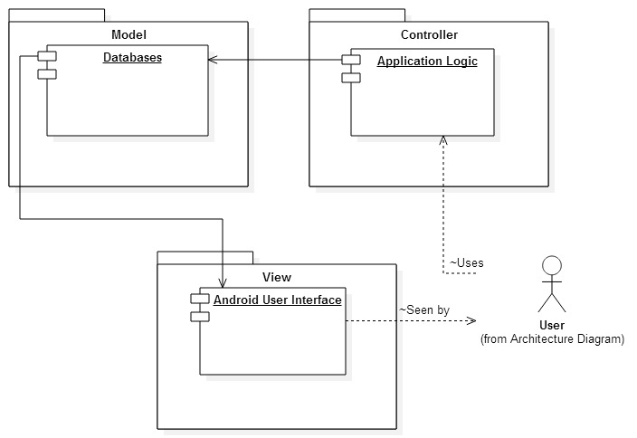
Figure 3 MVC Architecture
Also used by the system is a 3-tier architecture which is used to obtain data from the database. The following diagram demonstrates this architecture:

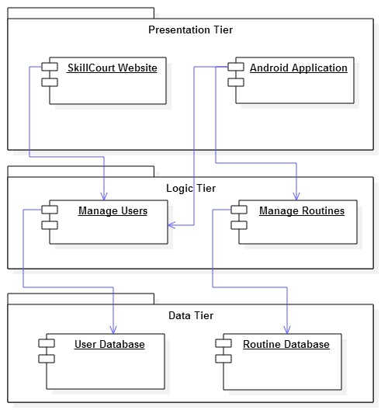
Figure 4 3-tier Architecture

Subsystem Decomposition:

SkillCourt is broken down into 3 systems: The App, the Website, and the Simulator. Each system can further be broken down into subsystems. The following diagrams represent the subsystems for each of the 3 systems.

The Application System

The SkillCourt app is a mobile application which offers interaction between the player and the simulator as well as the database. As the core UX for the player, the app offers a subsystem for the following:

Account Management

This subsystem gives the player control of all account information associated with the player’s account. This includes personal information, such as first and last name; account information, like username, password, email address; coach information, like coach’s username; and player information, ranging from position played to average statistics.

Statistics

As a player, statistics are a way of gauging the level of performance achieved. The statistics subsystem gives access to a range of player’s statistical information throughout the player’s lifetime with SkillCourt.

Play

The final subsystem of the app, play gives the player access to the game. It allows the player to send routine information to the simulator and allows the app to receive information about the played routine from the simulator
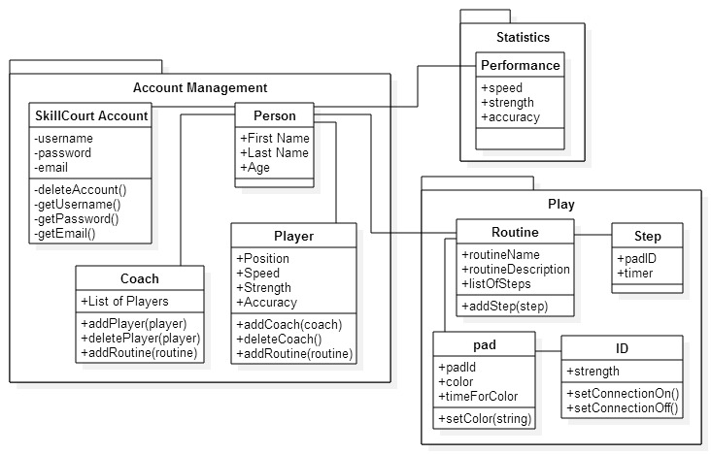
Figure 5 App Subsystem Decomposition Diagram

The Website System:

This systems is further divided into 3 subsystems. These include Account Management, Player Statistics, and User Routines.

Account Management

While this subsystem is similar to the App’s account management subsystem, it differs in that a different set of users has access. Coaches only have access to the website, so this subsystem considers coaches as well as players.

Player Statistics

As a player, statistics are a way of gauging the level of performance achieved. The statistics subsystem gives access to a range of player’s statistical information throughout the player’s lifetime with SkillCourt.

User Routines

As a SkillCourt coach or player, customized variations of the default routines can be created for use by players on the App. This subsystem allows for the creation of new custom user routines which will set the variables for them to the user’s choosing.

The Simulator System

The final system for SkillCourt is the simulator. The simulator is a system which emulates the SkillCourt Arena. It is broken down as follows:

SkillCourt Room

The SkillCourt room represents the 20’ by 20’ arena which has SkillCourt pads on the walls. This room is represented by a 5x5 square representing the floor and 4 3x5 “walls” surrounding it. Each square on the floor and the walls are a pad.

Statistics

As a player, statistics are a way of gauging the level of performance achieved. The statistics subsystem is a generator of the player’s statistics from information obtained while the player interacts with the simulator. Data gathered includes force, time between strikes, number of shots attempted, number of correct targets hit, etc.

Routine

The routine subsystem parses information related to a routine sent by the app. The routine information parsed includes the routine type, how long it will be played, the level of difficulty, etc.

Hardware and Software Mapping:

The main components of SkillCourt are the android mobile app, the PHP website, the simulator, and the MySQL database. Both the app and the website are connected to the database and do so using PHP scripts located on the server. All models in each component are mapped to tables in the MySQL environment set up on the same machine. The browser communicated with the server using HTTP.

Persistent Data Management:

Coach Information Storage

The system stores the information from the coach when he/she registers to make an account. This information includes the coach’s username, email, password, and some personal information such as first name, last name, and age

Player Information Storage

The system stores the information from the player when he/she registers to make an account. This information includes the player’s username, email, password, and some personal information such as first name, last name, and age. Additionally, the system will store the position of the player in the field.

Routine Storage

When a player creates a custom routine, the system will store this new routine. It will save to the database the routine name given by the player as he/she creates it, a unique ID created by the system and a string that will be converted to the series of steps in the routine. Additionally, the system will automatically have stored several routines for the player to choose from.

Performance Statistics Storage

The performance of the player while using the pads will be stored by the system. Statistics from the performance will include strength, speed, accuracy and time.

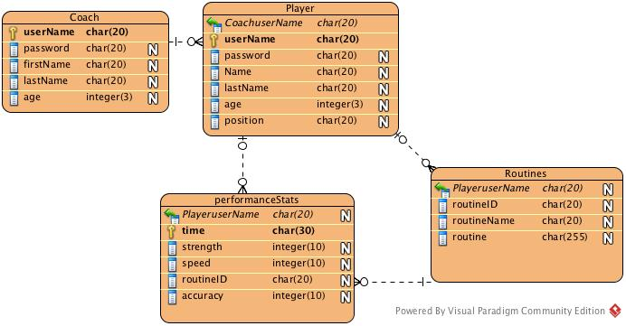
Figure 6 Database table

Security/Privacy:

Credential Authentication

The SkillCourt-Backend system will be accessed by players and coaches who have previously registered their credentials by making an account. In the mobile device, only players will be allowed to log in. As they enter the application, the system will provide them with a form to sing in using their previously created username and password. The system will then verify their credentials and verify that they have previously registered as “Players.” Once logged in, players will be restricted to access only their information and statistics. They will not have access to other player’s information.
In the case of coaches, they will not be allowed to sign in through the mobile device application. As they try to log in with their credentials, the system will check that they are not registered as “Player”, but as “Coach” and will return a message stating they cannot log in through the mobile device application. Additionally, users will be allowed to continue on the application as “guest,” but they will have no access to information.
In the webpage, both players and coaches will be allowed to log in by submitting their username and password. In both cases the system will verify that they have registered as players or coaches and will give each the appropriate access to information. Once logged in, players will only be allowed to access their information, while coaches will be allowed to access the information of all players they are connected to. No guests will be allowed on the webpage. In both, the webpage and the mobile application, users will no registered credentials will not be allowed to access any information

Data Encryption

Currently the SkillCourt system is not using any encryption mechanism to encrypt the data stored in the database. This is a dangerous situation that must be taken into consideration for next iterations of the project.

Detailed Design
This chapter introduces the system in terms of subsystems and the relationships among them. Initially the system is decomposed into several subsystems, each of which is described in terms of behavior and structure. Then the static model is introduced in terms of subsystems and the descriptions of each. After, the dynamic model is presented in terms of sequence diagrams. Finally the class interfaces and constraints for the main control object in each subsystem are presented.

Overview:

The Application System

Account Management

This subsystem gives the player control of all account information associated with the player’s account. This includes personal information, such as first and last name; account information, like username, password, email address; coach information, like coach’s username; and player information, ranging from position played to average statistics.

Statistics

As a player, statistics are a way of gauging the level of performance achieved. The statistics subsystem gives access to a range of player’s statistical information throughout the player’s lifetime with SkillCourt.

Play

The final subsystem of the app, play gives the player access to the game. It allows the player to send routine information to the simulator and allows the app to receive information about the played routine from the simulator

The Website System

Account Management

While this subsystem is similar to the App’s account management subsystem, it differs in that a different set of users has access. Coaches only have access to the website, so this subsystem considers coaches as well as players.

Player Statistics

As a player, statistics are a way of gauging the level of performance achieved. The statistics subsystem gives access to a range of player’s statistical information throughout the player’s lifetime with SkillCourt.

User Routines

As a SkillCourt coach or player, customized variations of the default routines can be created for use by players on the App. This subsystem allows for the creation of new custom user routines which will set the variables for them to the user’s choosing.

The Simulator System

SkillCourt Room

The SkillCourt room represents the 20’ by 20’ arena which has SkillCourt pads on the walls. This room is represented by a 5x5 square representing the floor and 4 3x5 “walls” surrounding it. Each square on the floor and the walls are a pad.

Statistics

As a player, statistics are a way of gauging the level of performance achieved. The statistics subsystem is a generator of the player’s statistics from information obtained while the player interacts with the simulator. Data gathered includes force, time between strikes, number of shots attempted, number of correct targets hit, etc.

Routine

The routine subsystem parses information related to a routine sent by the app. The routine information parsed includes the routine type, how long it will be played, the level of difficulty, etc.

Static model:

This diagram represents the classes that are needed in order implement the current SkillCourt System and how they are related to each other. It was developed using UML so that future Senior Project students can follow it to have a better understanding of the system (Refer to Appendix D).

Dynamic model:

These diagrams shows the interaction between the users and the different components of the system. It was developed in UML and its objective is to make easier the understanding of the interaction between SkillCourt System and the user (Refer to appendix E).

Code Specifications:

System Validation

Tests and evaluations:

Test Case ID: | Test_Login_1
Purpose: | Test that a user can log into an account that does exist in the Database
Prerequisites: | The user is on the login page  The user has access to the Internet
Test Data: | username = {Valid, Invalid}  password = {Valid, Invalid}
Steps: | - Enter username  - Enter password  - Click Login button
Expected Results: | See the Home page with username displayed
Actual Results: | As Expected

Test Case ID: | Test_Login_2
Purpose: | Test that a user can’t log into an account that does not exist in the Database
Prerequisites: | The user is on the login page  The user has access to the Internet
Test Data: | username = {Valid, Invalid}  password = {Valid, Invalid}
Steps: | - Enter invalid username  - Enter invalid password  - Click Login button
Expected Results: | See dialog which displays that a in incorrect username/password combination was entered
Actual Results: | As Expected

Test Case ID: | Test_Logout_1
Purpose: | Test that a user can log out of an account that is currently logged in
Prerequisites: | The user is on the home page after logging in
Test Data: | {None}
Steps: | - Click the menu button in the action bar or click the system menu button
Expected Results: | See welcome page
Actual Results: | As Expected

Test Case ID: | Access_Performance_Statistics_1
Purpose: | Test that the user with credentials can access metrics about his performances
Prerequisites: | The user has login
Test Data: | None
Steps: | - The user presses View Stats Enter password
Expected Results: | The performance Screen is displayed to the user with the correct performance data
Actual Results: | As Expected

Test Case ID: | Access_Performance_Statistics_2
Purpose: | Test that the user who enters as a guest can’t see any performance statistics
Prerequisites: | The enters as a guest
Test Data: | None
Steps: | - The user presses View Stats Enter password
Expected Results: | A message is displayed saying that as a guest he cant access any performance Statistics
Actual Results: | As Expected

Test Case ID: | Test_Create_Account_1
Purpose: | Test that a user can create a new account with a username that does not exist in the database
Prerequisites: | The user is on the Create Account page
Test Data: | username = {Valid, Invalid}  password = {valid}  email = {Valid, Invalid}  First Name = {Valid}  Last Name = {Valid}  DOB = {Valid}  Coach Username = {Valid, Invalid}  Position = {Valid}
Steps: | - Enter valid username  - Enter password  - Enter valid Email  - Click next button  - Enter optional first name  - Enter optional last name  - Enter optional DOB  - Click next button  - Enter optional Coach username  - Enter optional position  - Click next button
Expected Results: | See account created page, new user data has been added to the database
Actual Results: | As Expected

Test Case ID: | Test_Create_Account_2
Purpose: | Test that a user cannot create a new account with a username that does exist in the database
Prerequisites: | The user is on the Create Account page
Test Data: | username = {Valid, Invalid}  password = {valid}  email = {Valid, Invalid}
Steps: | - Enter valid username  - Enter password  - Enter valid Email  - Click next button
Expected Results: | See dialog that username already exists
Actual Results: | As Expected

Test Case ID: | Test_Enter_as_Guest_1
Purpose: | Test that a user can enter the application as a guest
Prerequisites: | The user has opened up the SkillCourt application and has access to the internet
Test Data: | None
Steps: | - Click on enter as guest button on Welcome page  - Read dialog and press OK
Expected Results: | User is displayed the SkillCourt Homepage
Actual Results: | As Expected

Test Case ID: | Test_Enter_as_Guest_2
Purpose: | Test that a user can create an account from a guest account
Prerequisites: | The user has logged in as a Guest
Test Data: | username = {Valid, Invalid}  password = {valid}  email = {Valid, Invalid}  First Name = {Valid}  Last Name = {Valid}  DOB = {Valid}  Coach Username = {Valid, Invalid}  Position = {Valid}
Steps: | - Enter valid username  - Enter password  - Enter valid Email  - Click next button  - Enter optional first name  - Enter optional last name  - Enter optional DOB  - Click next button  - Enter optional Coach username  - Enter optional position  - Click next button
Expected Results: | See account created page, new user data has been added to the database
Actual Results: | As Expected

Test Case ID: | Test_Logout_1
Purpose: | Test that a user can logout of their account
Prerequisites: | The user has logged in
Test Data: | None
Steps: | - Click logout button
Expected Results: | The user is displayed the SkillCourt welcome page
Actual Results: | As Expected

Test Case ID: | Test_Logout_2
Purpose: | Test that a user can logout of a guest account
Prerequisites: | The user has logged in as a guest
Test Data: | None
Steps: | - Click logout button
Expected Results: | The user is displayed the SkillCourt welcome page
Actual Results: | As Expected

Test Case ID: | Connect_to_pads_1
Purpose: | Test that a user can connect to a skillcourt pad via bluetooth
Prerequisites: | The user has logged in or enter as a guest
Test Data: | None
Steps: | - Press the scan for pads button  - Selects the correct skill court pad
Expected Results: | The user is displayed the SkillCourt Home page with a message telling him that he is connected to the specific Bluetooth device he selected
Actual Results: | As Expected

Test Case ID: | Connect_to_pads_2
Purpose: | Test that a user can’t connect to a non skillcourt pad Bluetooth device
Prerequisites: | The user has logged in or enter as a guest
Test Data: | None
Steps: | - Press the scan for pads button  - Selects a Bluetooth device which is not a skill court pad
Expected Results: | The user is displayed a dialog saying that the device he selected is not a skillcourt pad
Actual Results: | As Expected

Test Case ID: | Play_Chase_Routine_1
Purpose: | Test that a user can play chase routine
Prerequisites: | The user has logged in or enter as a guest
Test Data: | Rounds = {valid, invalid}  Routine = {valid}
Steps: | - The user presses play on the home screen  - The user selects a number of rounds  - The user selects the chase routine  - The user presses play
Expected Results: | The Simulator should start illuminating with the chase routine
Actual Results: | As Expected

Test Case ID: | Play_Chase_Routine_2
Purpose: | Test that a user can’t play chase if he is not connected to a pad
Prerequisites: | The user has logged in or enter as a guest
Test Data: | None
Steps: | - Press play
Expected Results: | The System should not allow the user to go to Play screen instead it should move to connect to pads.
Actual Results: | As Expected

Test Case ID: | Play_Lower_Rows_Routine_1
Purpose: | Test that a user can play chase routine
Prerequisites: | The user has logged in or enter as a guest
Test Data: | Rounds = {valid, invalid}  Routine = {valid}
Steps: | - The user presses play on the home screen  - The user selects a number of rounds  - The user selects the Lowest Rows routine  - The user presses play
Expected Results: | The Simulator should start illuminating with the Lowest Rows routine
Actual Results: | As Expected

Test Case ID: | Play_Lower_Rows_Routine_2
Purpose: | Test that a user can’t play Lowest Two Rows if he is not connected to a pad
Prerequisites: | The user has logged in or enter as a guest
Test Data: | None
Steps: | - Press play
Expected Results: | The System should not allow the user to go to Play screen instead it should move to connect to pads.
Actual Results: | As Expected

Test Case ID: | Play_Upper_Two_Rows_Routine_1
Purpose: | Test that a user can play chase routine
Prerequisites: | The user has logged in or enter as a guest
Test Data: | Rounds = {valid, invalid}  Routine = {valid}
Steps: | - The user presses play on the home screen  - The user selects a number of rounds  - The user selects the Higher Two Rows routine  - The user presses play
Expected Results: | The Simulator should start illuminating with the Upper Two Rows routine
Actual Results: | As Expected

Test Case ID: | Play_Upper_Two_Rows_Routine_2
Purpose: | Test that a user can’t play Upper Two Rows if he is not connected to a pad
Prerequisites: | The user has logged in or enter as a guest
Test Data: | None
Steps: | - Press play
Expected Results: | The System should not allow the user to go to Play screen instead it should move to connect to pads.
Actual Results: | As Expected

Glossary

- App | Refers to the SkillCourt Application in the Mobile Device
- Pad Simulator | An emulated device which will take the place of SkillCourt pads for testing showcasing purposes. This device will offer all of the features a SkillCourt Pad will offer
- SkillCourt | A system which uses SkillCourt Pads and a player interface for training soccer
- SkillCourt Arena | A 20’x40’ room with SkillCourt Pads on the walls used for soccer training.
- SkillCourt Pad | A physical device with a flat surface that can measure and transmit when and how much pressure it received
- Class Diagram | A pictorial representation of all the classes in the system
- Functional Requirement | A function supported by the system, where a function is a set of inputs, the behavior, and outputs.
- Non-Functional Requirement | A requirement that specifies criteria that can be used to judge the operation of a system, rather than specific behaviors.
- Object Diagram | A pictorial representation of an instance of a class with example of how the data of the class will be populated
- Sequence Diagram: | A pictorial representation of how processes operate with one another and the user during the course of a specific piece of functionality.
- Use Case | List of steps defining the interaction between the user and the system to achieve a goal

Appendix

Appendix A - Project schedule.
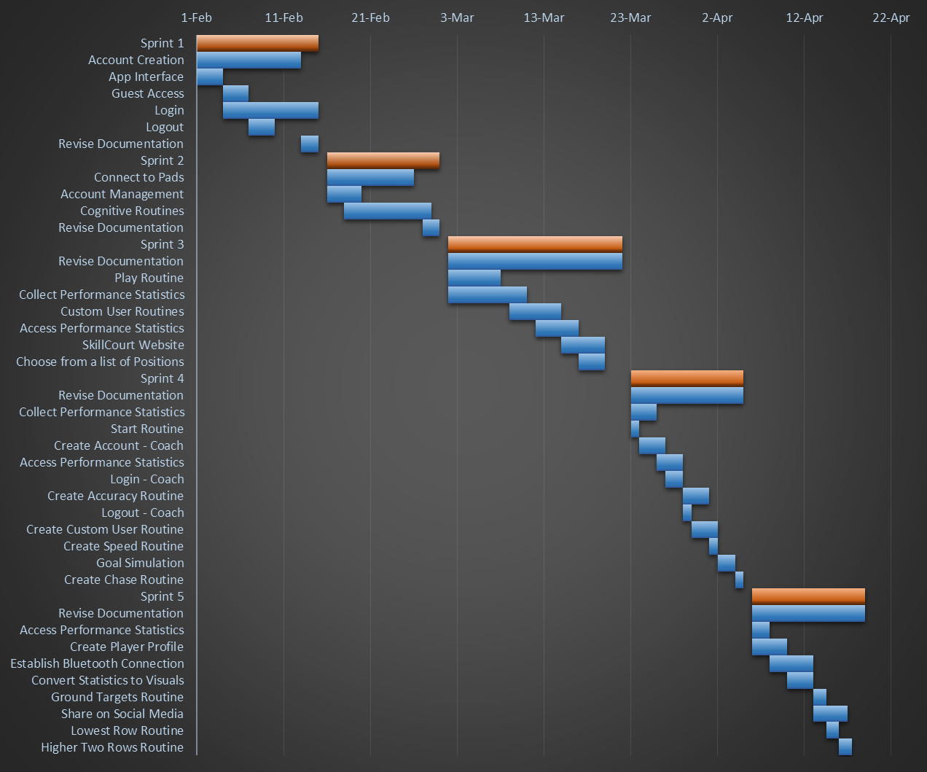

Figure 7 Gantt chart showing Project Schedule

Appendix B – All use cases

The mobile device application:

Use case ID: | SkillCourt-Backend #109
Name: | Access Performance Statistics
Details: | This use case will allow the user to access his statistics
Actors: | Player
Pre-Conditions:
- Player has logged in with his credentials
Description
- As a player I want to be able to access the statistics of my performances so that I can isolate weaknesses and see my improvements to focus in the areas of training that I need the most.
Steps:
- Use case begins when the user presses the “Statistics” button
- The use case ends when the system accesses and displays the player’s statistics

Use case ID: | SkillCourt-Backend #112
Name: | Account Creation
Details: | This use case allows the players to create their SkillCourt accounts using their credentials
Actors: | Player
Pre-Conditions:
- Player has entered the application in the mobile device
Description:
- As a player, I want to be able to create an account so that I can log in and log out.
Steps:
- Use case begins when user presses the “Create Account” button
- The system should provide the user with a form to be filled, which includes name, username, email address, password, date of birth, and coach username (optional).
- The user should fill out the provided form and press “Submit”
- System should record the user’s information in the database and increment the number of members by 1
- The use case ends when the system provides the user with a confirmation of the new account creation.
Post-Conditions:
- The user information must be stored in the database

Use case ID: | SkillCourt-Backend #141
Name: | Enter Application as Guest
Details: | This use case will allow the user to enter the application without logging in to an account
Actors: | Player
Pre-Conditions:
- Player has entered the application in the mobile device
Description:
- As a player, I want to be able to enter the application as a guest so that I can play without having to enter my credentials.
Steps:
- Use case begins when user presses the “Log in as Guest” button
- The system should show a warning saying that if the user enters as a guest, his performance will not be recorded, and present two options: “Accept”, “Go back”
- The user presses “Accept”
- The use case ends when the system displays the Guest Home View.

Post-Conditions:
- The system is aware that the user is a guest and is ready to handle it as such

Use case ID: | SkillCourt-Backend #142
Name: | Connect to Pads
Details: | This use case allows the player to find pads that are closed to him and connect to them via Bluetooth.
Actors: | Player
Pre-Conditions:
- The player has already logged into the account or entered as a guest
Description:
- As a player I want my application to connect to the pads so that I can send information to the pads regarding what routine to play.
Steps:
- Use case begins when user presses the search for pads button.
- The system will display a list of possible pads.
- The user will select the pad he wants to connect to.
- The use case ends when the system uses the Bluetooth address to establish a connection.
Post-Conditions:
- The system has all the information needed from the pad in order to start to transfer data.

Use case ID: | SkillCourt-Backend #143
Name: | Log in
Details: | This use case allows a user to log in to his personal account
Actors: | Player
Pre-Conditions:
- The player has created an account already
Description:
- As a player, I want to be able to log into my SkillCourt account so that I can have data saved to my account to track my progress.
Steps:
- Use case begins when the user hits the log in button on the home page
- The system asks the user to input a correct username/password combination
- The user enters the username/password combination
- The use case ends when the system has accepted a correct username/password combination and has redirected the user to the welcome activity
Post-Conditions:
- The player has access to his account.

Use case ID: | SkillCourt-Backend #144
Name: | Log out
Details: | This use case allows a user to log out of the skillcourt app
Actors: | Player
Pre-Conditions:
- The player has logged in
Description:
- As a player, I want to be able to log out of the app so that others may log in.
Steps:
- Use case begins when the player hits the log out button on the upper bar.
- The system deletes the local user-associated data
- The use case ends when the system has redirected the user to the home page.
Post-Conditions:
- Another player may log in.

Use case ID: | SkillCourt-Backend #145
Name: | Collect Performance Statistics
Details: | This use case will allow the user to have his performance statistics stored.
Actors: | Player
Pre-Conditions:
- The user is already connected to a set of pads
Description:
- As a player I want to be able to record my performance statistics so that they are stored.
Steps:
- Use case begins when the user chooses the routine he wants to play
- The Android application will use the name of the routine to get the routine’s specifications from the database and will transmit every step to the pads
- The pads will receive the routine and will start illuminating the corresponding lights
- The user will hit the illuminated pads
- The pads will send information about the user’s hits to the Android application
- The Android application will store the information provided by the pads in the database
- The use case ends when the pads inform the Android application that the time for the entire routine has expired
Post-Conditions:
- All performances of the player are stored in the database

Use case ID: | SkillCourt-Backend #192
Name: | Account Management
Details: | This use case allows the player to change his account information after his account has been created
Actors: | Player
Pre-Conditions:
- The player has already created an account and is logged into said account
Description:
- As a user I want to be able to modify my account information so that I can make changes and updates as needed
Steps:
- Use case begins when user presses the edit account button.
- The system will display the user’s account information
- The user will press edit Information
- The system will allow the user to modify his information
- The user will change the information he wants to change and press done
- The use case ends when the system moves to User’s profile view.
Post-Conditions:
- The user’s new account settings will be properly changed in the database

Use case ID: | SkillCourt-Backend #197
Name: | Recover Username/Password
Details: | This use case allows a player to get the credentials to the account if it was forgotten.
Actors: | Player
Pre-Conditions
- I’ve made a SkillCourt account already
Description:
- As a player, I want to recover my account credentials so that I can have them if I forget them.
Steps:
- Use case begins when a user clicks on the “Trouble Logging In?” button on the login interface
- The system redirects the user to the account recovery activity.
- The player enters the email address associated with the account.
- The use case ends when the system has sent an email to the associated email address containing the username and password
Post-Conditions:
- The player can log into his account.

Use case ID: | SkillCourt-Backend #264
Name: | Start Routine
Details: | This use case allows a user to select a routine to start.
Actors: | Player
Pre-Conditions:
- The player has logged in and connected to pads.
- The player is on the Play Activity
Description:
- As a player, I want to be able to choose a routine to play so that I can train my skills with SkillCourt
Steps:
- Use case begins when the user has arrived on the play interface
- The user selects the type of routine to play.
- The user selects a difficulty
- The user selects how long to play the routine
- The user presses play.
- The use case ends when the user has configured SkillCourt to the desired game configuration and the system has accepted it.
Post-Conditions:

Use case ID: | SkillCourt-Backend #273
Name: | Higher Two Rows
Details: | This use case allows the player to play the higher two rows routine in the simulator
Actors: | Player
Pre-Conditions:
- Connection between mobile device and pads has been established
- The user has selected to play the higher two rows game, and has selected which level and number of rounds will be played.
Description:
- As a player, I want to practice elevating the ball and also my reaction time to the visual cues
Steps:
- Use case begins when the master pad receives a command from the mobile device to start this specific routine.
- The simulator will verify if the setup of the room is appropriate for the specified routine.
- The entire room with start a count of 10 seconds to allow player to position himself.
- Pads for this routine will start illuminating with the correct colors to expect the player’s hit.
- The use case ends when the simulator starts playing the routine
Post-Conditions:
- The user is capable of playing the routine

Use case ID: | SkillCourt-Backend # 274
Name: | Lowest Row Routine
Details: | This use case allows the player to play the lowest row routine in the simulator
Actors: | Player
Pre-Conditions:
- Connection between mobile device and pads has been established
- The user has selected to play the lowest rows game, and has selected which level and number of rounds will be played.
Description:
- As a player I want to be able to practice my skills with reaction time
Steps:
- Use case begins when the master pad receives a command from the mobile device to start this specific routine.
- The simulator will verify if the setup of the room is appropriate for the specified routine.
- The entire room with start a count of 10 seconds to allow player to position himself.
- Pads for this routine will start illuminating with the correct colors to expect the player’s hit.
- The use case ends when the simulator starts playing the routine
Post-Conditions:
- The user is capable of playing the routine

Use case ID: | SkillCourt-Backend #340
Name: | Chase Routine
Details: | This use case allows the player to play the chase routine in the simulator
Actors: | Player
Pre-Conditions:
- Connection between mobile device and pads has been established
- The user has selected to play the chase routine, and has selected which level and number of rounds will be played.
Description:
- As a player, I want to play a chase routine so that I can practice my coordination with the ball
Steps:
- Use case begins when the master pad receives a command from the mobile device to start this specific routine.
- The simulator will verify if the setup of the room is appropriate for the specified routine.
- The entire room with start a count of 10 seconds to allow player to position himself.
- Pads for this routine will start illuminating with the correct colors to expect the player’s hit.
- The use case ends when the simulator starts playing the routine
Post-Conditions:
- The user is capable of playing the routine

Use case ID: | SkillCourt-Backend #393
Name: | Create Bluetooth Data Transfer between App and Simulator
Details: | This use case allows the player to establish a Bluetooth data transfer between the master pad and the mobile device.
Actors: | Player
Pre-Conditions:
- The user should have already logged in or entered the application as a guest.
Description:
- As a player, I want to be able to send and receive information to and from the pads via Bluetooth so that I can play and receive my performance statistics.
Steps:
- Use case begins when the user presses “Play.”
- The mobile device sends the routine to the master pad
- The use case ends when the master pad receives the routine
Post-Conditions:
- The master pad has the necessary data to know the specifications of the routine to be played.

Use case ID: | SkillCourt-Backend #426
Name: | View Game Results
Details: | This use case allows the user to view how he did in a game.
Actors: | Player
Pre-Conditions:
- The player has played a game
Description:
- As a player, I want to be able to see how I did in a game I just completed.
Steps:
- Use case begins when the player finishes a SkillCourt routine.
- The system receives the player’s statistics from that game.
- The system redirects the view to the game results screen
- The system displays the player’s statistics to the screen
- The use case ends when the player views the statistics on the results screen
Post-Conditions:
- The player can view the statistics from the routine.

The webpage

Use case ID: | SkillCourt-Backend #124
Name: | Share on Social Media
Details: | This use case allows a user to share his profile on Facebook
Actors: | Player
Pre-Conditions:
- The player has logged into the website
Description:
- As a player, I want to be able to share my profile on social media so that my friends can see how I am doing
Steps:
- Use case begins when the player hits the “share” button on the statistics page
- The system opens a dialog to log into Facebook
- The system opens a dialog that allows the player to enter a personalized message
- The use case ends when the player hits the “post” button
Post-Conditions:
- The system posts the player’s profile link to Facebook.

Use case ID: | SkillCourt-Backend #134
Name: | Login – SkillCourt Website
Details: | This use case allows a player to log into the website
Actors: | Player
Pre-Conditions:
- The player has created a SkillCourt account
Description:
- As a user I want to be able to access my SkillCourt data on the web so that I can access my SkillCourt account from the comfort of my computer
Steps:
- Use case begins when the player enters the SkillCourt website.
- The player inputs his proper credentials and presses login
- The use case ends when the system redirects the player to the Main SkillCourt page
Post-Conditions:
- The player has logged into his account

Use case ID: | SkillCourt-Backend #338
Name: | Website Logout
Details: | This use case allows the user to log out of his account from the website
Actors: | Player
Pre-Conditions:
- The player has logged into the website
Description:
- As a player, I want to be able to log out of my account so that others can log in.
Steps:
- Use case begins when the player hits the log out button
- The system deletes all user info associated to that session
- The system redirects the user to the login page
- The use case ends when the player is on the login page.
Post-Conditions:
- Another player can login

Use case ID: | SkillCourt-Backend #337
Name: | Logout – Coach
Details: | This use case allows a coach to log out of the website.
Actors: | Coach
Pre-Conditions:
- The coach has logged in
Description:
- As a coach, I want to be able to log out of my account so that I can keep my account secure and allow others to log in.
Steps:
- Use case begins when the coach hits the log out button
- The system deletes all user info associated to that session
- The system redirects the user to the login page
- The use case ends when the coach is on the login page.
Post-Conditions:
- Another player or coach can login

Use case ID: | SkillCourt-Backend #338
Name: | Create Account – Coach
Details: | This use case allows a coach to create an account
Actors: | Coach
Pre-Conditions:
- The coach is on the login page
Description:
- As a coach, I want to be able to create an account so that I can have access to my players through SkillCourt.
Steps:
- Use case begins when the coach hits the register button on the login page.
- The coach enters proper credentials and selects to create a coach account
- The use case ends when the coach hits the create button
Post-Conditions:
- The system stored the coach’s information into the database

Use case ID: | SkillCourt-Backend #339
Name: | Login – Coach
Details: | This use case allows a coach to log into his account
Actors: | Coach
Pre-Conditions:
- The coach has created an account
Description:
- As a coach, I want to be able to log in to out of the SkillCourt website so that I can get access to my account.
Steps:
- Use case begins when the coach is on the log in page
- The coach enters his proper credentials
- The use case ends when the system redirects the user to the main page
Post-Conditions:
- The coach has access to his account

Use case ID: | SkillCourt-Backend #392
Name: | Create Player Profile
Details: | This use case allows users to view a player’s profile
Actors: | General
Pre-Conditions:
- The user has a link to a player’s profile
Description:
- As a user, I want to be able to view player’s account information
Steps:
- Use case begins when the user follows a link to a player’s profile
- The system loads the players profile and uses GET to obtain the player’s information to display
- The system loads the player’s information and parses it to HTML
- The use case ends when the profile page has loaded
Post-Conditions:
- The user can see the player’s profile.

Use case ID: | SkillCourt-Backend #396
Name: | Convert Statistics to Visuals
Details: | This use case allows the system to create visualized graphs for users to see.
Actors: | General
Pre-Conditions:
- The user is on a player’s profile
- The player is on his own stats page
Description:
- As a player, I want to be able to be able to see my statistics so that I can track my progress.
- As a user, I want to be able to see a player’s statistics so that their progress can be visualized.
Steps:
- Use case begins when a player or user clicks on the “Force” or “Accuracy” button on the statistics or profile page, respectively
- The system retrieves the player’s statistics data from the database and parses it to the Google Charts API
- The use case ends when the system displays the graph.
Post-Conditions:
- A user can see the selected player’s statistic chart.

Appendix C – User Interface designs.

The Mobile Device Application

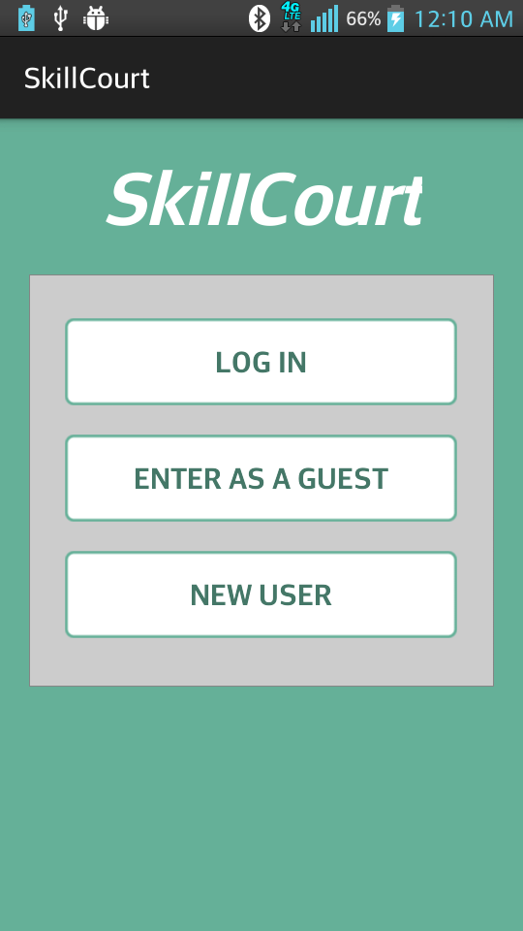  Figure 8 Welcome View | 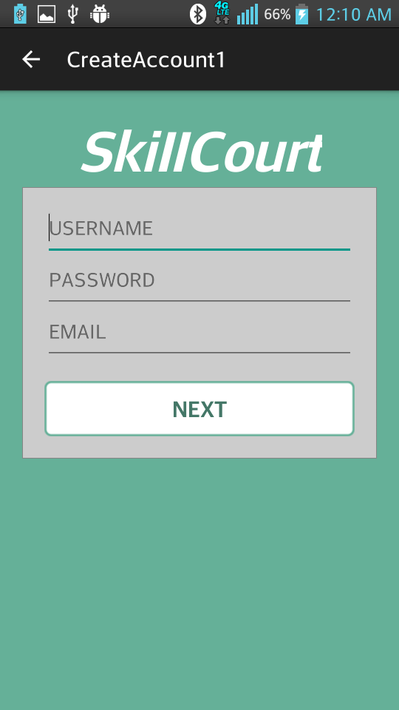  Figure 9 Create Account View
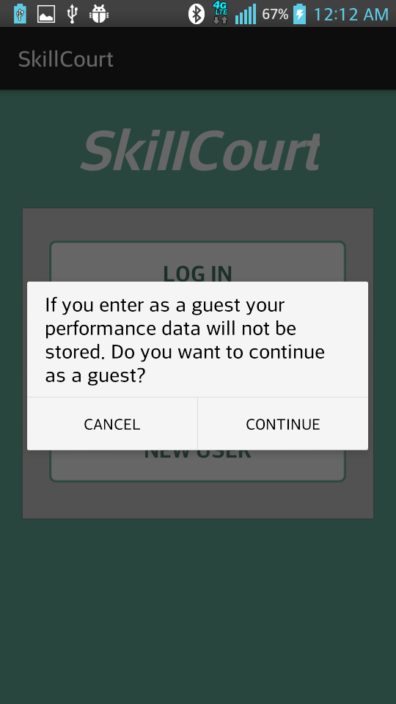  Figure 10 Enter as a Guest Warning View | 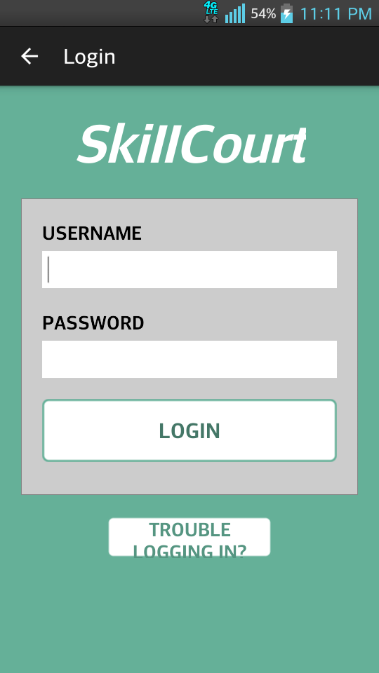  Figure 11 Login View

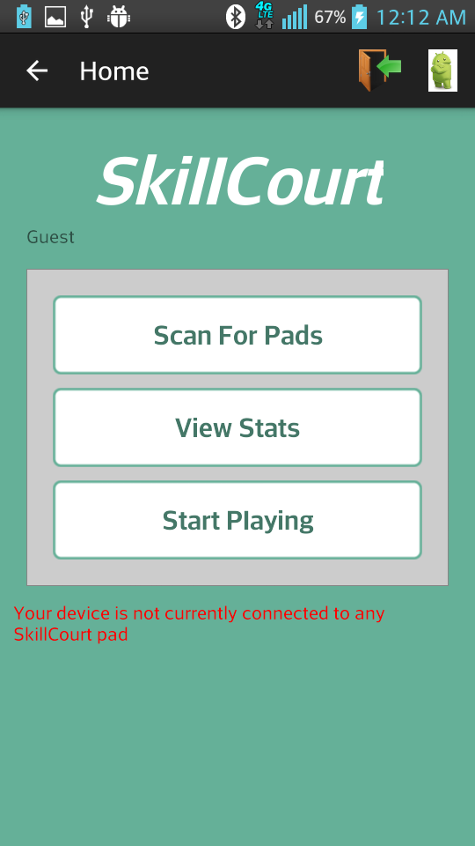  Figure 12 Home View | 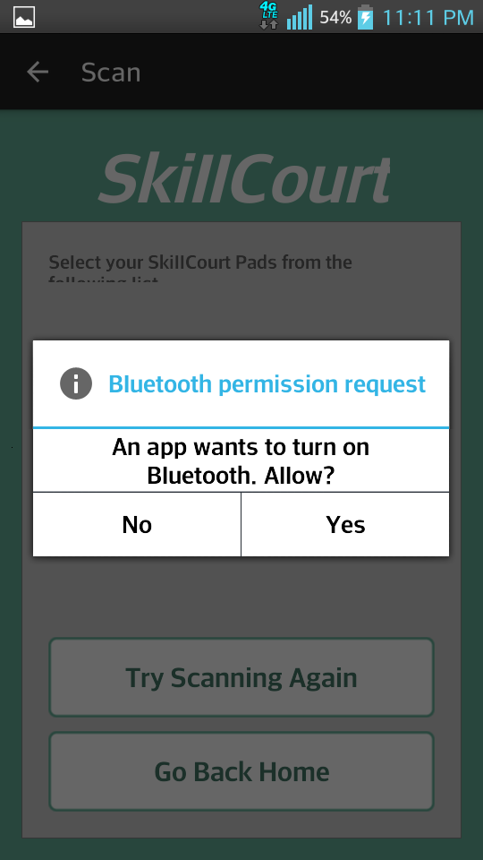  Figure 13 Bluetooth Permission Request View
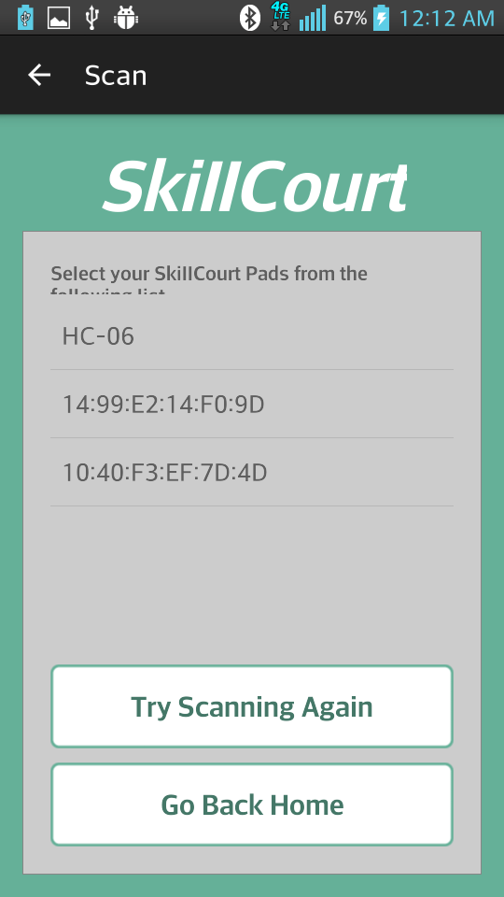  Figure 14 Scanning for Bluetooth Devices View | 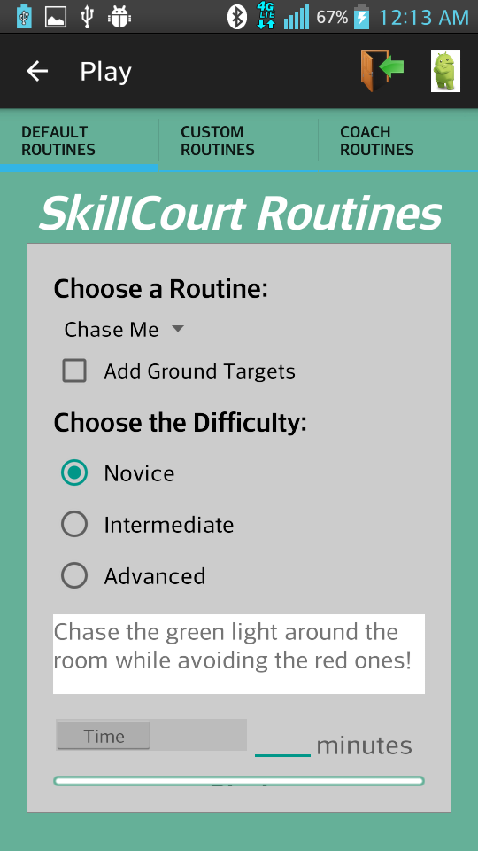  Figure 15 Select Routine View

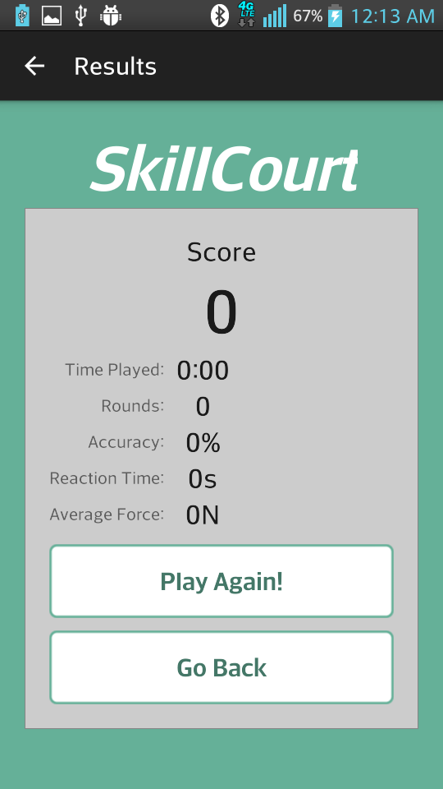  Figure 16 Performance Metrics View | 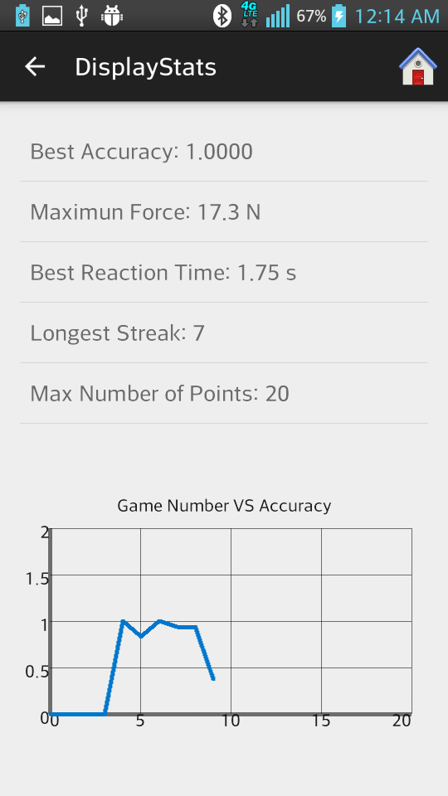  Figure 17 Display Performance Statistics View Option 1
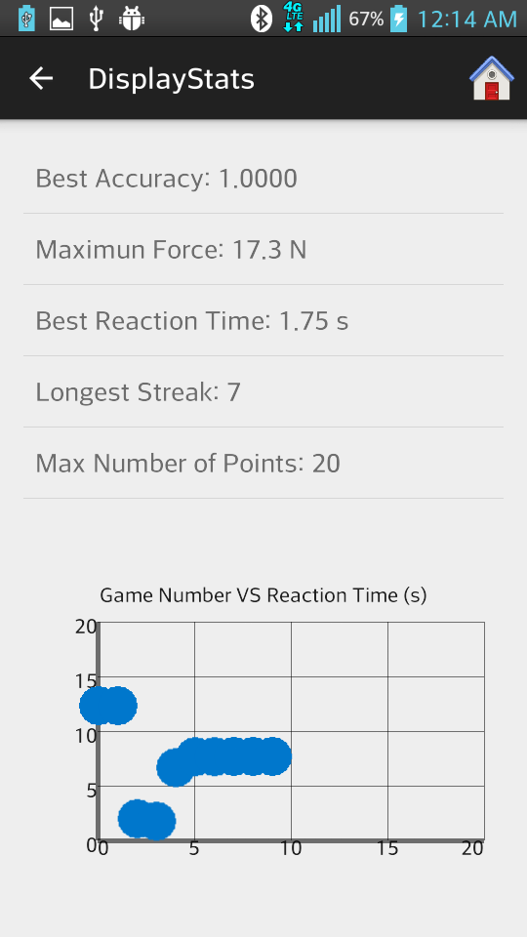
Figure 18 Display Performance Statistics View Option 2

The Simulator

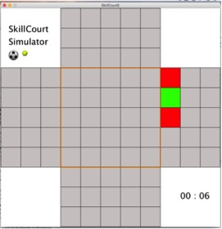
Figure 19 Sample View of Simulator Playing Routine

The Webpage

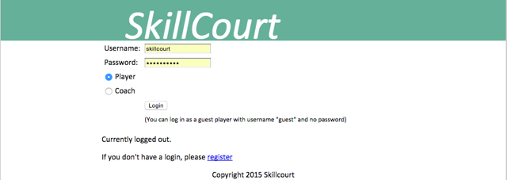

Figure 20 SkillCourt Website Login Page View

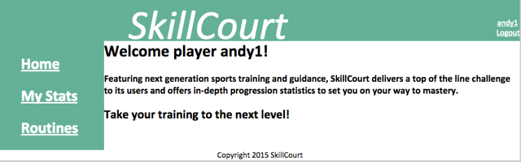

Figure 21 SkillCourt Website’s Welcome View
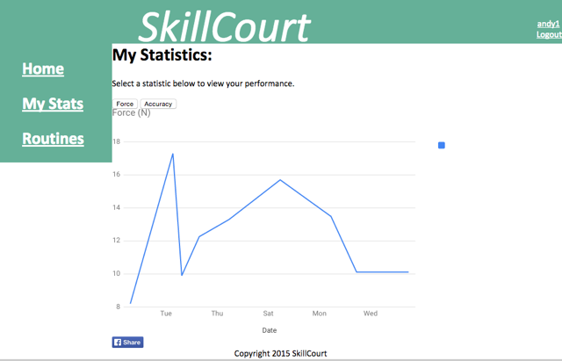

Figure 22 View Statistics and Share in Facebook Page

Appendix D – Analysis models
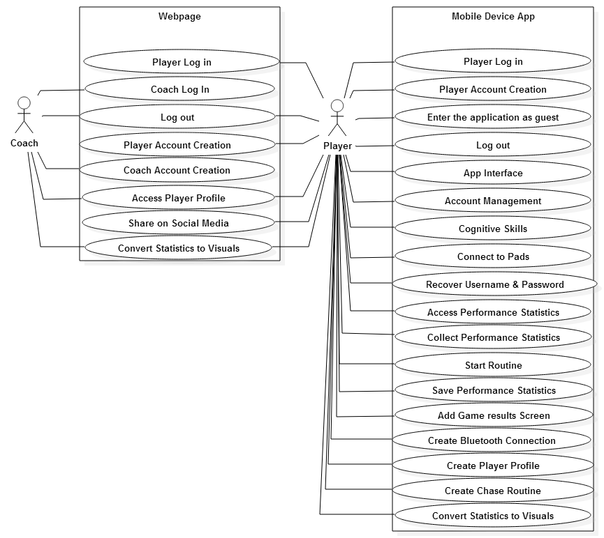
Figure 23 Use case model

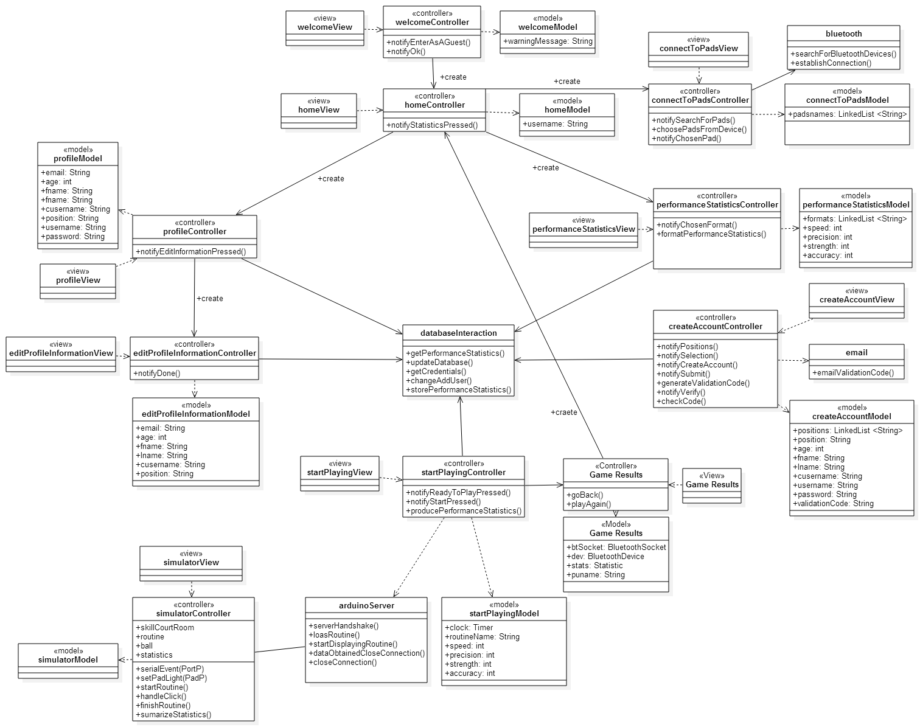
Figure 24 Class Diagram

Appendix E – Design models

Subsystem Decomposition Diagram:
Figure 25 App Subsystem Decomposition Diagram

Sequence Diagrams:

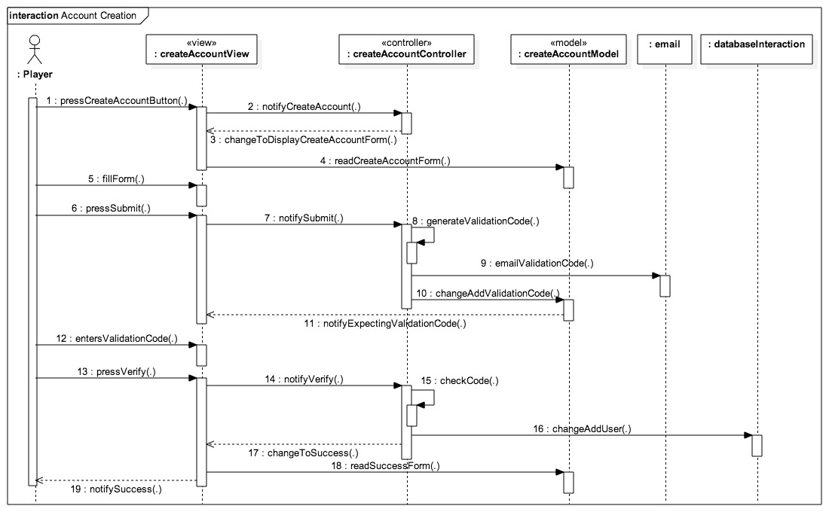
Figure 26 Account Creation Sequence Diagram

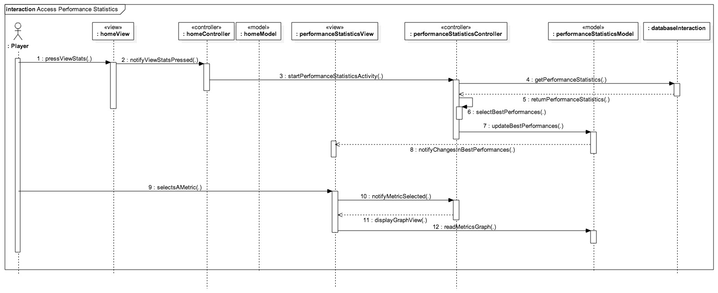
Figure 27 Access Player Statistics Sequence Diagram
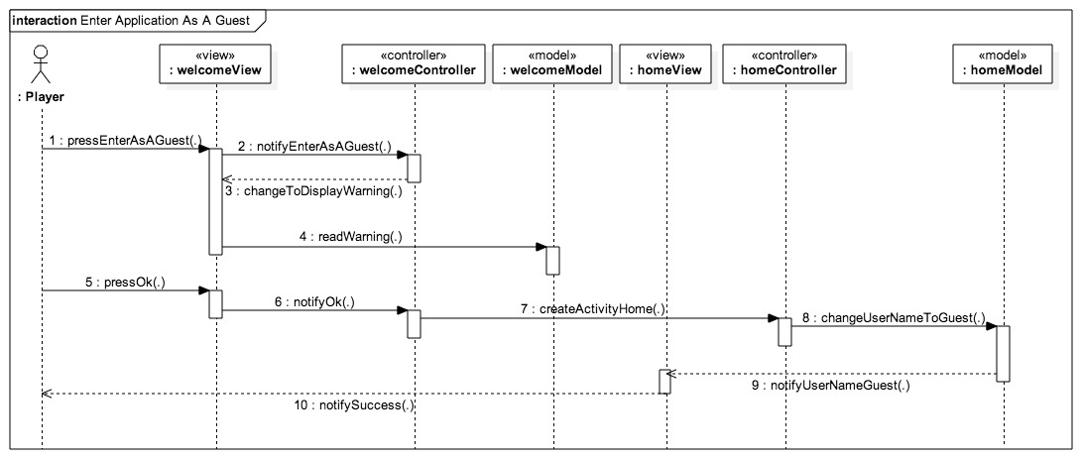
Figure 28 Enter Application as a guest Sequence Diagram

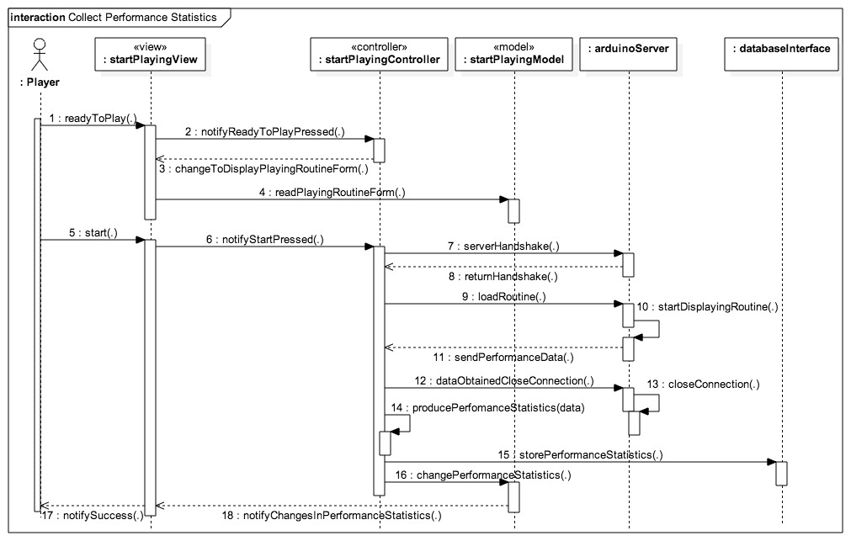
Figure 29 Collect Performance Statistics Sequence Diagram

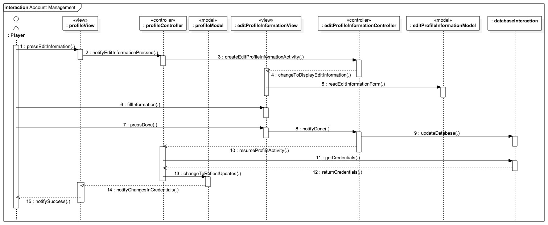
Figure 30 Account management Sequence Diagram

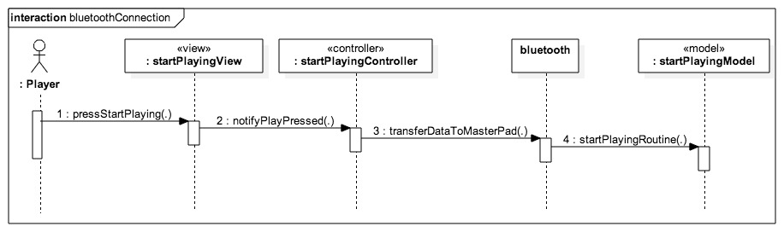
Figure 31 Bluetooth Connection Sequence Diagram

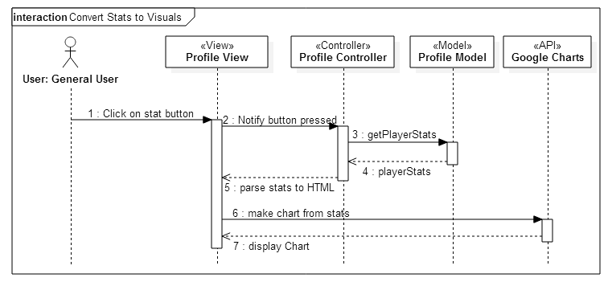
Figure 32 Convert Stats into Visuals Sequence Diagram
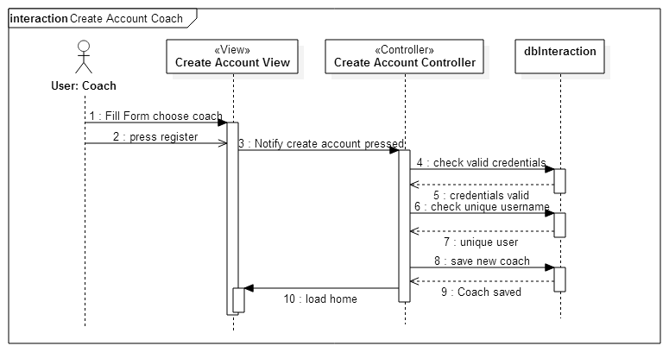
Figure 33 Create Account Coach Sequence Diagram

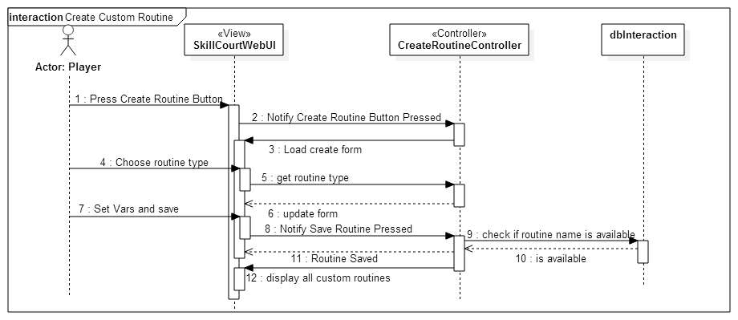
Figure 34 Create Custom Routine Sequence Diagram
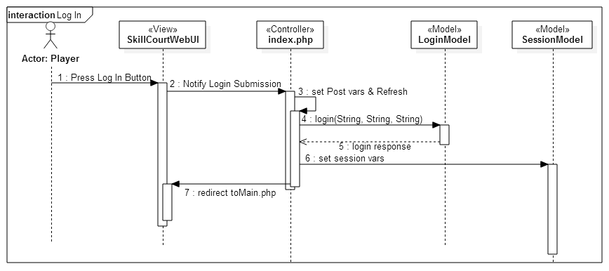
Figure 35 Player Login Sequence Diagram

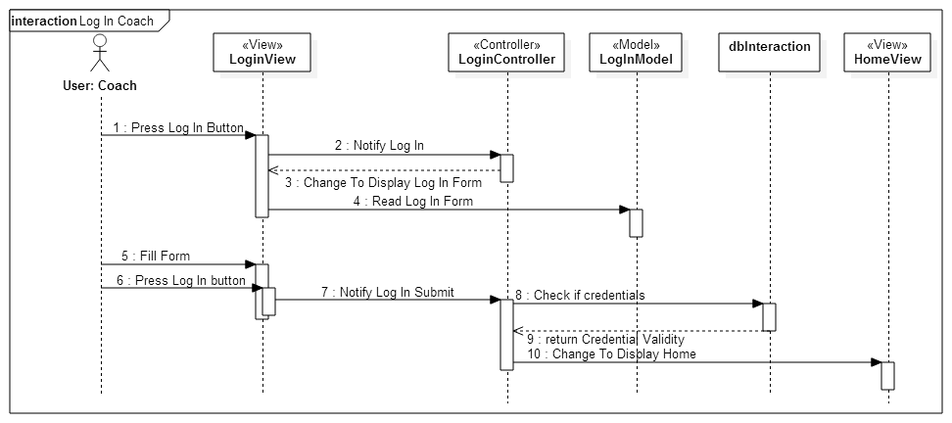
Figure 36 Coach Login Sequence Diagram

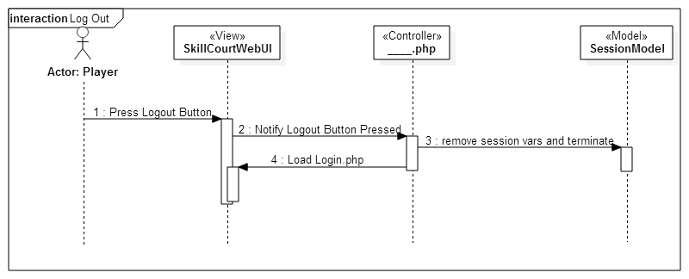
Figure 37 Player Logout Sequence Diagram
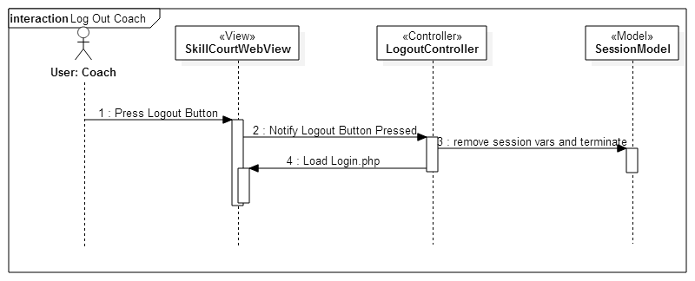
Figure 38 Coach Logout Sequence Diagram

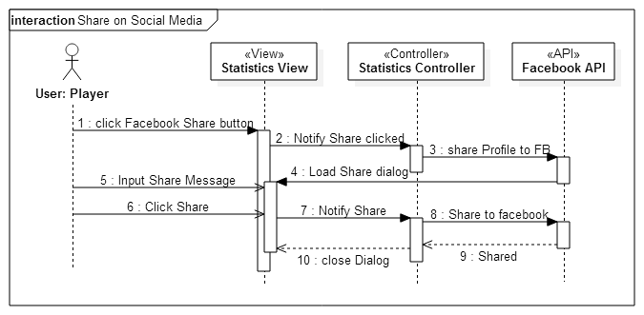
Figure 39 Share to Social Media Sequence Diagram

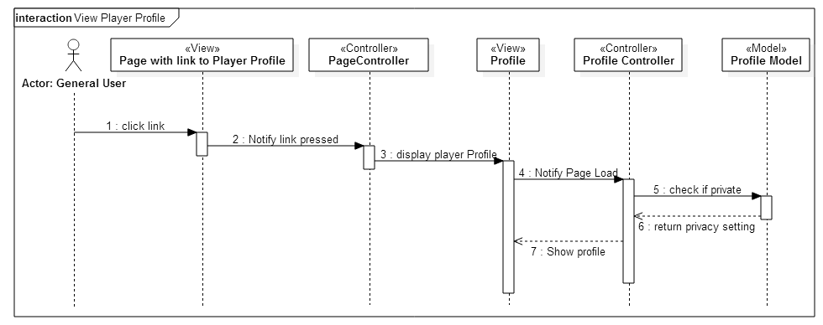
Figure 40 View Profile Sequence Diagram
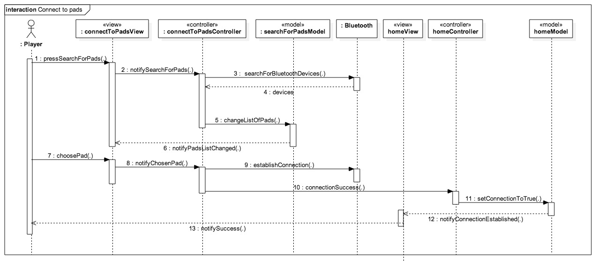
Figure 41 Connect to Pads Sequence Diagram

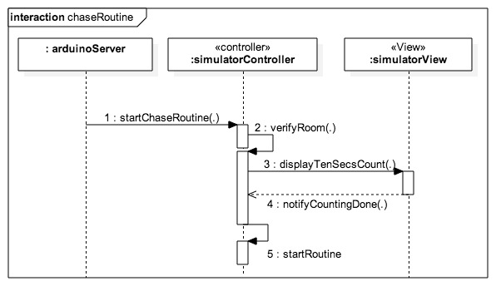
Figure 42 Chase Routine Sequence Diagram

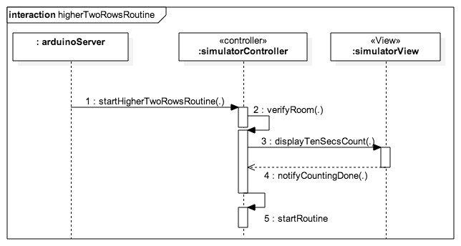
Figure 43 higher Two Rows Routine Sequence Diagram

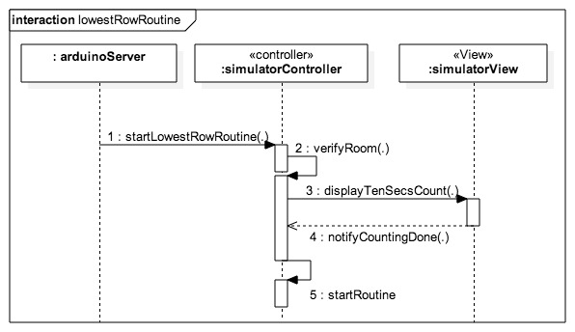
Figure 44 Lowest Row Routine Sequence Diagram
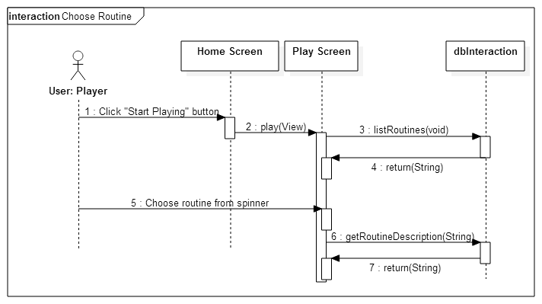
Figure 45 Chase routine Sequence Diagram

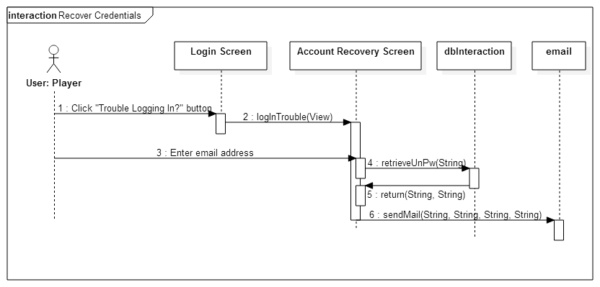
Figure 46 Recover credentials sequence diagram

Appendix F – Documented Class interfaces and constraints.

The following are the classes implemented for the SkillCourt Backend system.

- Welcome Class
  - notifyEnterAsAGuest()
  - notifyOk()

- Home Class
  - notifyStatisticsPressed()

- Connect to pads Class
  - notifySearchForPads()
  - choosePadsFromDevice()
  - notifyChosenPad()

- Performance Statistics Class
  - notifyChosenFormat()
  - formatPerformanceStatistics()

- Create Account Class
  - notifyPositions()
  - notifySelection()
  - notifyCreateAccount()
  - notifySubmit()
  - generateValidationCode()
  - notifyVerify()
  - checkCode()

- Game Results Class
  - goBack()
  - playAgain()

- Start Playing Class
  - notifyReadyToPlayPressed()
  - notifyStartPressed()
  - producePerformanceStatistics()

- Edit Profile Information Class
  - notifyDone()

- Simulator Class
  - serialEvent(PortP)
  - serialPadLight(PadP)
  - startRoutine()
  - handleClick()
  - finishRoutine()
  - sumarizeStatistics()

- Profile Class
  - notifyEditInformationPressed()

Appendix G – Documented code for test drivers and stubs.

There are no test drivers documented

Appendix H – Diary of meeting and tasks for the entire semester.

- Meeting 1:

Monday 1/19/15
@8:57pm
Meeting on Mingle starts
In attendance: Andy Martinez, Matthew Santiago

@9:08pm
Arranging possible meeting times for Requirements Elicitation:
- Tuesday 1/20 9:00 pm
- Wednesday 1/21 before 2:00 pm
- Wednesday 1/21 after 7:30 pm

@9:23pm
Chose for Andy Martinez to be Scrum Master for the first sprint

@9:28pm
Sent message to @Product Owner for their preferred meeting time:
- Awaiting reply…
- 1/20 @10:43am Reply Received, Meeting Tuesday 1/20 at 9:00 pm confirmed

@9:33pm
Meeting Dismissed

- Meeting 2:
Tuesday 1/20/15
@9:00 pm
Conference Call Started
In attendance: Matthew Santiago, Andy Martinez, Jaime Borras, Gummi

@9:02 pm
Introductions

@9:12 pm
Stories:
- Skill development (accuracy, speed, intensity)
  - User chooses skill to train from Android App
  - Measure pressure, time
  - 3 colors red blue green
  - Change to red when underperforming
  - Ball should take 5 seconds to hit the pad, turn red if user takes too long
- Tracking and analysis
  - accuracy, speed, intensity, reaction time
- Single Player/2 Player
  - Social Media Connection
- Mapping a game
  - Pad light up, hit pad with ball in proper time, another pad lights up, hit with ball in proper time, continue until you make goal (certain number of successful iterations)
  - Beginner, Intermediate, and advanced levels
- Simulator (simulate a pad)
  - Android application?
- (Backend look at particular game (real game) and simulate a player or play within that game)

@9:32 pm
Set meeting with Gummi on 1/21 at 11:00 am in GL 693

@9:38 pm
Meeting Dismissed

- Meeting 3:
Thursday 1/22/15
@9:00
Conference Call start
In attendance: Andy Martinez, Matthew Santiago, Jaime Borras

@9:07
Review stories
Predetermined Routines:
- Separate Goal Simulation into its own story
Performance Statistics:
- Add statistics about specific game
Competition Mode:
- Separation of social media into a new story is good
- Have different routines for single and multiplayer
Custom User Routine:

Pads Simulator:

Real Game Simulation:
Social Media Sharing:
Website:
- (Differentiate between coach and player?)
- Webpage access

@9:46
Meeting Dismissed

- Meeting 4:
Tuesday 1/27/15
@ 6:30 pm
Meeting starts
In attendance: Jaime Borras, Andy Martinez, Matthew Santiago

Github upload schedule:
Matthew upload from 10:00pm - 10:59pm
Andy upload from 11:00pm - 11:59pm

Weekly in-person meeting:
Thursday between 2:00pm - 6:00pm to prepare for weekly meetings with project owners

Coding standards
Comment Convention:
/**
* Comment goes here
* and here
*/
fun()
{
random code
}

Indentation:
1 tab per pair of curly braces

Variable names:
private _variableName
public variableName

Reports:
Matthew: Feasibility report & Initial System Design
Andy: Project Plan & Initial Object Design

Read up on:
Android Bluetooth library
Java Databases

- Meeting 5:
Tuesday 1/30/15
@ 4:00 pm
Conference Call starts
In attendance: Jaime Borras, Andy Martinez, Matthew Santiago, Gummy

- Review stories
- Decide which stories to assign to sprint

@ 5:00pm
Meeting Dismissed

- Meeting 6:
Thursday 2/13/15
Start @ 3:15
In attendance: Andy, Matthew, Jaime, Gummi (Remote)
- Summary of current state of the app
- Add administrator view
- Coach: Should a coach have access to SkillCourt Web and Mobile, or just website?
- Demonstrated create account and log-in features
- Finish for sprint 1:
  - Option for forgot username/password (email library)
  - Verify email address
  - Password restrictions
- Sprint 2 will include the 2 most crucial stories for continuing development:
  - Cognitive Skills -> This will require a lot of input from Gummi
  - Connect to Pads: App to pad simulator functionality
- Near end of development :
  - Ask about life of server post-class, and possibly move database to a more permanent server
  - Look into adding app to Google Play store
End at 4:00

- Meeting 7:
Thursday 2/16/15
@10:00am
Meeting starts
In attendance: Andy Martinez, Matthew Santiago

- Retrospective Meeting
  - Decided what works best, and what we should do more often
- Deciding what tasks to assign to each user story, what the steps are, and how to organize them.

- Meeting 8:
Thursday 3/02/15
@10:00am
Meeting starts
In attendance: Andy Martinez, Matthew Santiago

- Retrospective Meeting
  - Decided what works best, and what we should do more often
- Deciding what tasks to assign to each user story, what the steps are, and how to organize them.

- Meeting 9:
Thursday 3/20/15
@10:00am
Meeting at Green Library starts
In attendance: Andy Martinez, Matthew Santiago, Jaime Borras, Gummy

- Review stories from Sprint
  - All stories were approved
  - No specific comments

- Meeting 10:
Thursday 3/23/15
@10:00am
Meeting starts
In attendance: Andy Martinez, Matthew Santiago

- Retrospective Meeting
  - Decided what works best, and what we should do more often
- Deciding what tasks to assign to each user story, what the steps are, and how to organize them.

- Meeting 11:
Thursday 4/03/15
@10:00am
Meeting at Green Library starts
In attendance: Andy Martinez, Matthew Santiago, Jaime Borras, Gummy

- Review stories from Sprint
  - All stories were approved
  - No specific comments

- Meeting 12:
Thursday 4/06/15
@10:00am
Meeting starts
In attendance: Andy Martinez, Matthew Santiago

- Retrospective Meeting
  - Decided what works best, and what we should do more often
- Deciding what tasks to assign to each user story, what the steps are, and how to organize them.

- Meeting 13:
Thursday 4/13/15
@10:00am
Meeting at Green Library starts
In attendance: Andy Martinez, Matthew Santiago, Jaime Borras, Gummy

1- Must complete the return sequence from the Simulator to the mobile App. This allows the transfer of the Simulator data to the App and hence to the database and the online web browser...........Andy

2- Simulator must send the finish play variable and reset the App. This is necessary to avoid the manual resets at the end of every simulation.................Andy

3- Mobile App must allow the user to select the different levels for the Simulator i.e. Novice/Intermediate/Advance. It was hardwired for today's demonstration of "Chase".........Matt

4- Add to mobile App the selection for Time based or Sequence or Round based simulation............Matt

5- We agreed in the "Outcome" screen to show the following for all games:
- Score_________
- Time Played_______
- Number of Rounds_______
- Accuracy = (# of Rounds/# of Shots)X100
- Reaction Time______ sec.
- Avg. Force_________ Newtons

6- Status Matrix
Original Game Name | New Game Name | Existing Constraints | Simulator | Web App | Comments
Chase Sequenced | Chase Me | 3 or 4 walls | X |  | Bottom Row Only
Chase Time Based | Chase Me if you can | 3 or 4 walls | X |  | Bottom Row Only
Top 2 Rows Seq. | Fly Me | Min. of 4 pads | X
Top 2 Rows Time | Fly Me if you can | Min. of 4 pads | X
Ground Chase Seq. | Drive To Chase Me
Ground Chase Time | Drive To Chase Me if you can
Ground 2 top rows Seq. | Drive To Fly Me
Ground 2 top rows Time | Drive To Fly Me if you can
X = Available as of 4/13/15

7- In addition, the following User Stories are planned to be completed at the end of Sprint 5:
a- Access Performance Statistics:
Best Performances: Score_____
Reaction Time_____
Accuracy_______
Avg. Force_______
- Average: Score_____
Reaction Time_____
Accuracy_______
Avg. Force_______
Gummi will work on an equation to place a weighting factor on these parameters to be included if there is time.

b- Share Outcomes on Social Media

- Meeting 14:
Thursday 4/17/15
@10:00am
Meeting at Green Library starts
In attendance: Andy Martinez, Matthew Santiago, Jaime Borras, Gummy

Jaime: All items outlined on the April 13, 2015 meeting minutes were completed, and the UI was very nicely improved

We proceeded to test the Android Mobile App connected to the PC Simulator via Bluetooth (BT) and the Arduino board which was serially connected to the laptop. For proper PC Simulator functionality there needs to be a double click on the same pad to record the force of the striking force simulation.

New Issues Observed .......................................................................................and the follow up actions:
1- Database showed zero for accuracy during Analytics............................................Matt to investigate
2- The Rounds statistics is really the number of "shots on target"........................Matt to change it to "Targets Hit" or similar
3- Add the proper UI background to Analytics..............................................................Matt to update
4- Play again did not disconnected Bluetooth........................................................Fixed during meeting
5- Display of Statistics do not distinguished between classes of data i.e. N/I/A.................Andy to fix
6- Change default to Rounds selection rather than Time................................................Matt to do
7- While playing Time base, there should be some sort of animation to show game is active...........Future
8- The Back Button is not programmed to go back.........................................................Future
9- Initial connection time from App to BT/Arduino/PC Simulator is very random.................Future Investigation
10- During initial connection time there should be a progress bar......................................Future

Other Actions:
1- Andy to order two sets of Arduino boards, Bluetooth modules and small assembly breadboard for Gummi and Jaime to test next Monday, April 27. Andy to send total cost so that we can bring a check.
2- Matt to package Android App with final App version and send APK prior to Monday's meeting.
3- PC Simulator stand-alone version was discussed to be implemented in the future
4- We also discussed Andy and Matt's desire to continue optimizing SkillCourt during the Summer.
5- After Graduation, Andy and Matt to proposed potential Summer tasks for discussion.
6- Andy and Matt to propose Restaurant for Graduation/Thank you dinner sponsored by SkillCourt.

Post Meeting Observations for Future:
1- PC Simulator should return the ball to the middle of the court after every strike.

- Meeting 15:
Thursday 4/20/15
@10:00am
Meeting starts
In attendance: Andy Martinez, Matthew Santiago

- Retrospective Meeting
  - Decided what works best, and what we should do more often
- Deciding what tasks to assign to each user story, what the steps are, and how to organize them.

References

For website:
- http://www.w3schools.com

For App:
- https://developer.android.com/training/basics/firstapp/index.html
- http://www.android-graphview.org

For Simulator:
- https://processing.org
- http://www.soccerballworld.com/Physics.htm

For Master Pad (microcontroller):
- http://www.arduino.cc/en/Guide/HomePage

