FLORIDA INTERNATIONAL UNIVERSITY
School of Computing and Information Sciences
CIS 4911 Senior Capstone Project

Smart Systems for Occupancy and Building Energy Control (SSOBEC)
Design Document (DD)

Instructor: Dr. Masoud Sadjadi

Mentor: Dr. Leonardo Bobadilla

Mentor: Dr. Ali Mostafavi

01/23/2015

Group Member:
Maria Eugenia Presa Reyes
Dalaidis Hidalgo Arencibia

Copyright and trademark notices, restrictions on copying or distributing the documentation
- Copyright and trademark notices, restrictions on copying or distributing the documentation, information for contacting the issuing organization (reader’s comments), warranties, contractual obligations or disclaimers, and general warnings and cautions.

Abstract – one or two paragraphs giving a brief overview of the document.

Table of Contents
1. Introduction 5
1.1 Problem definition 5
1.2 Design methodology 5
1.3 Definitions, acronyms, and abbreviations. 5
1.4 Overview of document 5
2. System Design 6
2.1 Overview 6
2.2 Subsystem Decomposition 7
2.3 Hardware and Software Mapping 8
2.4 Persistent Data Management 8
2.5 Security/Privacy 8
3. Detailed Design 9
3.1 Overview 9
3.2 Static model 9
3.3 Dynamic model 10
3.4 Code Specification 10
4. Glossary 11
5. Appendix 12
5.1 Appendix A - Use case diagram for use cases being implemented. 12
5.2 Appendix B 12
5.3 Appendix C 12
5.4 Appendix D 12
6. References 15

1. Introduction
Introduce the introduction (one or two paragraphs)
1.1 Problem definition
1.2 Design methodology
1.3 Definitions, acronyms, and abbreviations.
Below is a list of definitions, acronyms, and abbreviations.
DEFINITIONS:
Facility Manager: Person that has elevated privileges in the application.
Room Owner: Person with limited access, who uses the application to track energy consumption for just his own rooms.
Android Studio: Is the official IDE that it is used by Android application development based on IntelliJ IDEA.

ACRONYMS AND ABBREVIATIONS:
SSOBEC: Is an app which aims to help people learn to reduce the consume of energy.
EIA: U.S. Energy Information Administration
DB: Database
FIU: Florida International University
SCIS: School of Computing & Information Sciences
App: Application

1.4 Overview of document

2. System Design
Introduce the system decomposition chapter (one or two paragraphs).
2.1 Overview

The two architectural are Model View Controller (MVC) and Three-tier architecture.
The three-tier architecture is compose of a interface layer, application layer and storage:
- Interface layer: the view of the system, it includes all boundary objects such as: buttons, input text fields and more.
- Application layer: is the controller of the system, it includes all the android activities.
- Storage: is the model of the system that realizes the storage and retrieval of persistent objects from either our SQLite database or the external MySQL Database.
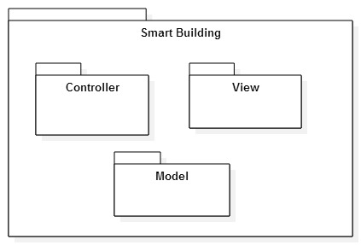
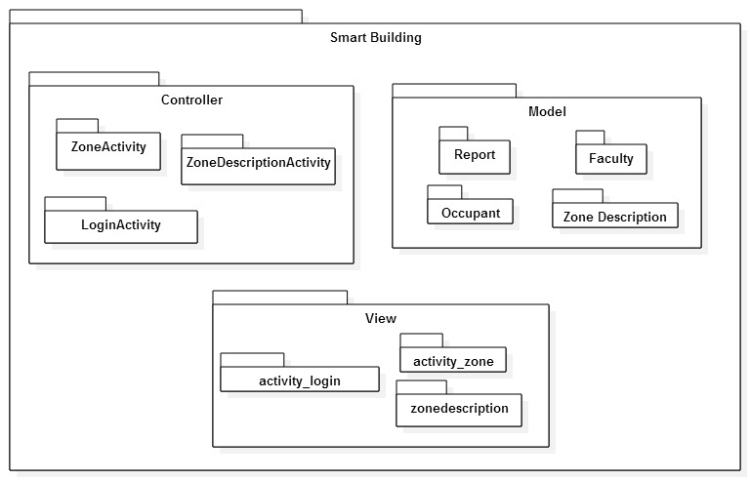

2.2 Subsystem Decomposition
Activity: Symbolizes a single user interface class. It is frequently packaged together to form the UI components of the application. That is why, controller has ZoneActivity, ZoneDescription Activity and Login Activity.
Model: Permit the access to the database like SQLite and My SQL Database. In brief, the logical sense is to tie the user interface components with the data store components.
View: The objective of this pattern is to separate the components of user interface. View is defined by the XML file.
Login: This will welcome the users (Facility Manager or Occupant) when the application started.
Zone activity: This will display the zones to the user. At the same time wait for an action.
Zone description: This will display the description of all his/her zones for the facility manager and only specify description for occupant that is the responsible of only one room.
Report: This will display all the information that user can. Permit manipulate the information that user can have access. Also, they can manipulate the information and show statistic and graph.
Report of Limited Zones: The occupant will have a limited report of his/her zone.
SQLite: This is an internal Database of the device.
My SQL Database: This is an external Database.

2.3 Hardware and Software Mapping – map subsystems to h/w and s/w. The h/w and s/w are for the systems to be implemented. May include a deployment diagram showing the associations between the subsystems and hardware.
2.4 Persistent Data Management
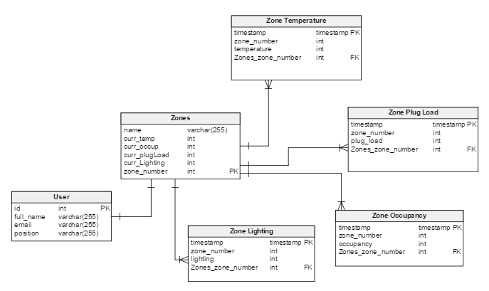

2.5 Security/Privacy
Android applications use an advance hardware and software, and it is designed to be truly open. To guarantee this protection its platform offer an application environment that ensures the security of data, users, applications, the devices, and the network. Android provide protection for all users of the platform. An application’s process is a secure sandbox that permit gain some security. Also the sandbox can isolates apps from each other, so they cannot tamper which each other, except by explicitly declaring the permissions it needs for additional capabilities not provided by the basic sandbox.

.

3. Detailed Design
Introduce the detailed design chapter (one or two paragraphs)
3.1 Overview – briefly describe the behavior and structure of each subsystem.
3.2 Static model – detailed description of the structure for each subsystem. May include detailed class diagrams. Place diagrams (e.g., minimal class diagram, detailed class diagram per subsystem) inline. Use at least four (4) design patterns.
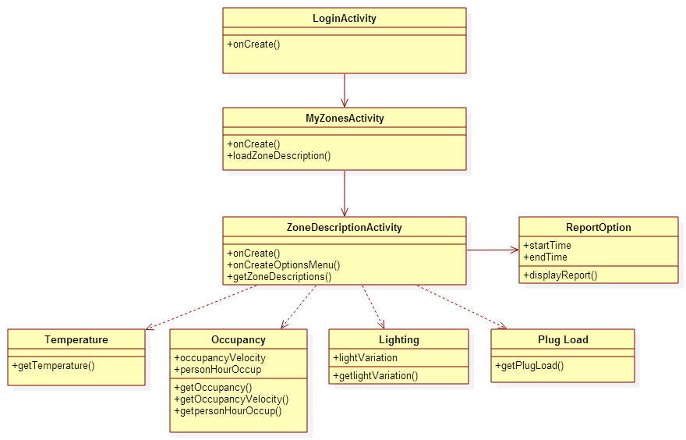
3.3 Dynamic model
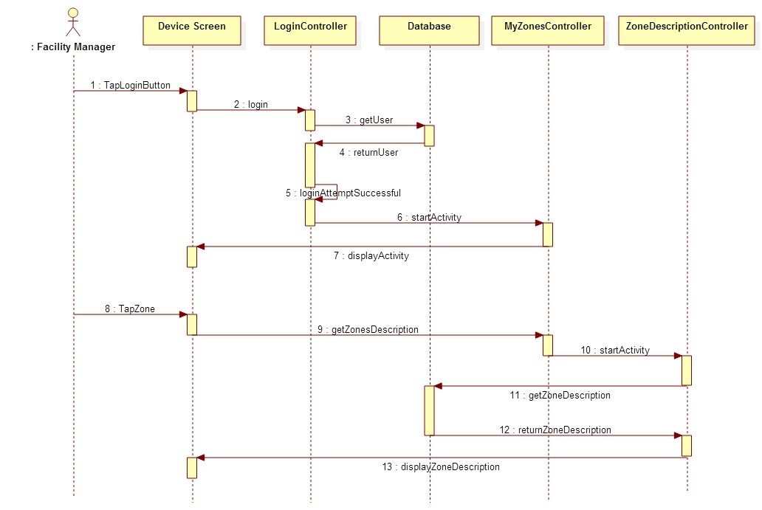
3.4 Code Specification - describe the class interfaces (attributes and method signatures) and constraint (invariants, pre-condition and post-conditions) for the main control object in each system. Code should be in Appendix C.

4. Glossary
Class Diagram: An illustration of all the classes in the system.
Sequence Diagram: An illustration on how processes operate with one another and the user during the execution of one specific functionality.
Use Case: List of steps describing the interaction between a user and a system to achieve one goal.
Task: A piece of job that require to be done within a certain time.

5. Appendix
5.1 Appendix A - Use case diagram for use cases being implemented.
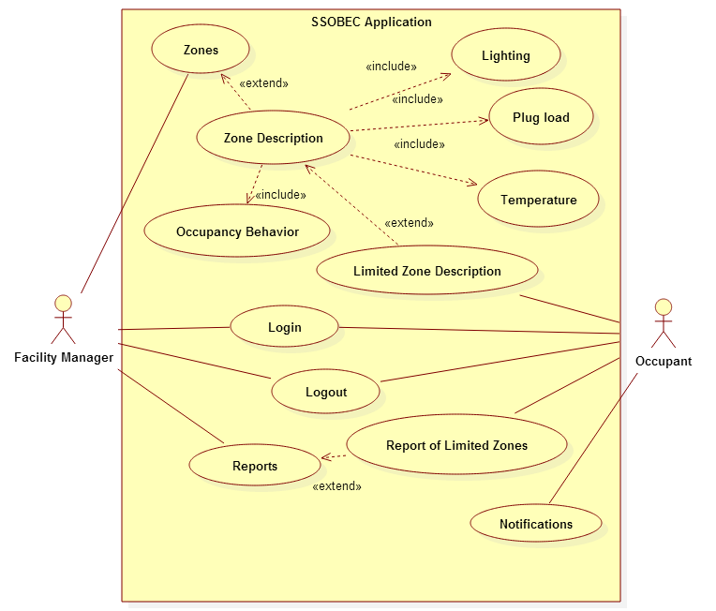
5.2 Appendix B - Use cases being implemented (from the RD).

5.3 Appendix C – Documented class interfaces (code) for the subsystem(s) you will implement and the constraints.
5.4 Appendix D - Diary of meeting and tasks.
Following are the diary entries for all of our meetings throughout the semester.

DATE | January 21, 2015
Location | FIU Modesto A. Maidique Campus ECS 212B
Start | 5:00 pm
End | 6:30 pm
In Attendance | Leonardo Bobadilla  Ali Mostafavi  Maria Presa Reyes  Dalaidis Hidalgo Arencibia
Late | N/A
Agenda | - General Background of the project  - Collect User Stories  - Begin to work with Feasibility Study
Summary of Discussion | -Meeting Time (All weeks)
Assigned Tasks | -Create Google Drive to share our document between us.  - Continue working with user stories to improve our work.

DATE | January 26, 2015
Location | FIU Modesto A. Maidique Campus ECS 212B
Start | 4:00 pm
End | 5:10 pm
In Attendance | Leonardo Bobadilla  Ali Mostafavi  Maria Presa Reyes  Dalaidis Hidalgo Arencibia
Late | N/A
Agenda | - Product Backlog  - Feasibility Study  -Project Plan  -System Design  -Object Design  -Name Android Application
Summary of Discussion | -Programs and tool to use in our application.
Assigned Tasks | -Dr. Leonardo Bobadilla and Dr. Ali Mostafavi make the selection of the Name of the Android Application.  -Continue working with the documentation in order to try to do the most that we can.  -Make a selection of the Linux machine for the Database.

DATE | January 30, 2015
Location | FIU Modesto A. Maidique Campus ECS 212B
Start | 4:00 pm
End | 5:00 pm
In Attendance | Leonardo Bobadilla  Ali Mostafavi  Maria Presa Reyes  Dalaidis Hidalgo Arencibia
Late | N/A
Agenda | - Check the Name of the Android Application  - Check our ideas of the Product Backlog with our mentors  - Check Feasibility Study  - Check Project Plan  - Check System Design  - Check Object Design  - Continue working of the documentation  -Continue thinking on the design of different diagrams  -Prepare the PorwerPoint for the presentation
Summary of Discussion
Assigned Tasks

DATE
Location | FIU Modesto A. Maidique Campus ECS 212B
Start | 4:00 pm
End | 5:00 pm
In Attendance | Leonardo Bobadilla  Ali Mostafavi  Maria Presa Reyes  Dalaidis Hidalgo Arencibia
Late | N/A
Agenda
Summary of Discussion
Assigned Tasks

DATE
Location | FIU Modesto A. Maidique Campus ECS 212B
Start | 4:00 pm
End | 5:00 pm
In Attendance | Leonardo Bobadilla  Ali Mostafavi  Maria Presa Reyes  Dalaidis Hidalgo Arencibia
Late | N/A
Agenda
Summary of Discussion
Assigned Tasks

6. References

