*Florida International University*

*School of Computing and Information Sciences*

SOCIAL APP VERSION 1.0

Advanced Software Engineering

Installation Guide

**Team Members:**

Sirisha Singaraju, Shamsed mahmud

**Product Owner(s)**:

Rick Little

**Mentor(s)**:

Mohsen Taheri

**Instructor**:

Masoud Sadjadi

**Installation Guide:**

In order to successfully build and run the project, please do the following steps:

1. Install the latest version of Android Studio.
2. Download the zip file from github and unzip it.
3. Open Android Studio.
4. Go to open existing project and open the downloaded project. (You should automatically see the android studio icon in the folder where you have unzipped the project)
5. Use Build 🡪 Rebuild project and Run 🡪 Run App options to build and run the app

(Note: Please use rar file in case the e-SToPP folder in github gives any issues. )

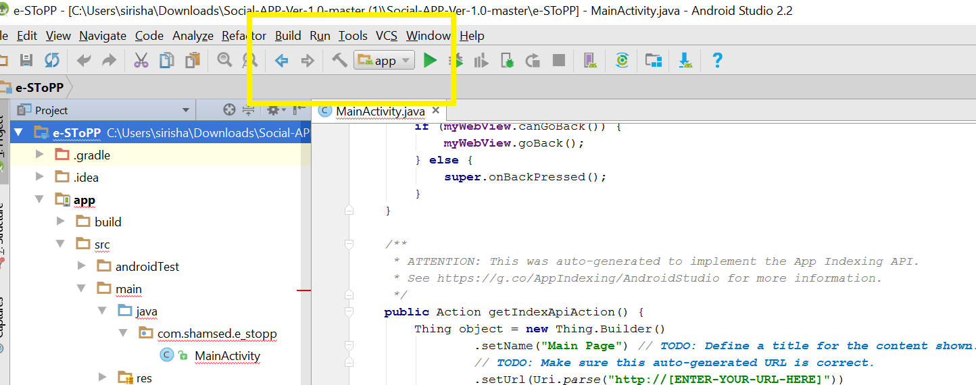

In order to generate signed APK :

1. Build 🡪 Generate Signed APK

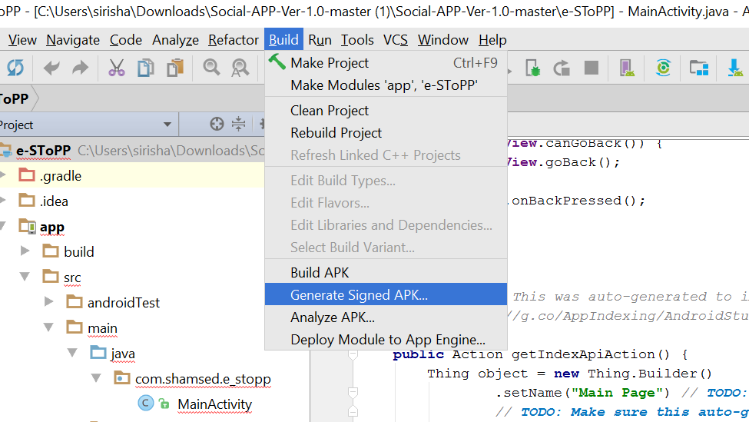

1. Browse and select e-SToPP.jks file path in the key store path. This file is included in e-SToPP folder in github.

Key password same as key store password.

Password and alias in apk_pwd file which is encrypted.

Click on next then finish.

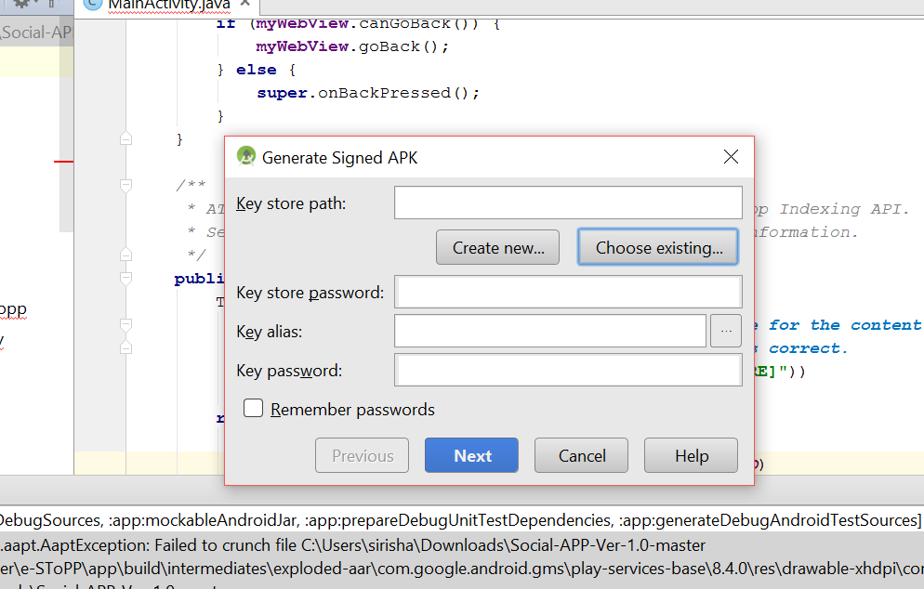

1. Right click on app in Android Studio to select ‘Module Settings’

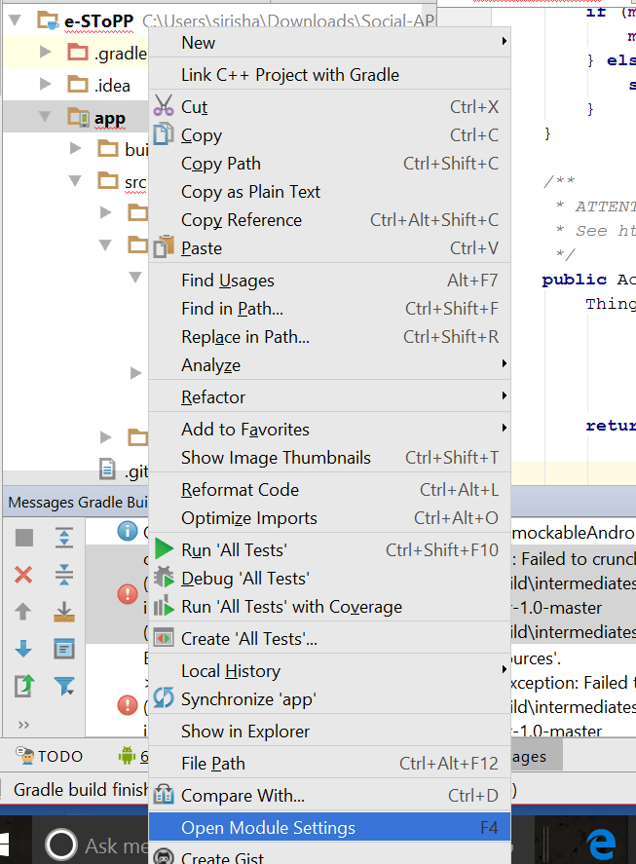

1. Go to app --- > Signing

Fill information similar to previous one

Store file -🡪 Give path to store apk file

Flavors -- > Change version code if required

Build Type 🡪 Select Release **DONE**

