Florida International University
School of Computing and Information Sciences
CIS 4911 Senior Capstone Project – Software Engineering Focus
Format of Deliverable 3 - Design Document (DD)

CIS 4911 U01
Senior Project
Fall 2015
Ultimate QC 1.0
Project Team #17
Marcine Kelly
09/11/15
Instructor: Masoud Sadjadi
Product Owner: Rodrigo Morales
- Not to be published or publicly distributed without permission by the publisher. Publisher contact information: mkell008@fiu.edu, Product Owner contact information: rmorales@produceinspectors.com.
- Abstract
This document is divided into six chapters. It starts with the Introduction, which states the problem and gives a description of the design methodology used for this system. In the remainder of the document, the structure and behavior of the subsystems are described and the use case that are to be implemented are given.
- Table of Contents
- Introduction ……………………………………………………………………..5
  - Problem definition …………………………………………………………5
  - Design methodology used …………………………………………………5
  - Definitions, acronyms, and abbreviations …………………………………5
  - Overview of document …………………………………………………….5
- System Design ………………………………………………………………….7
  - Overview …………………………………………………………………..7
  - Subsystem Decomposition ………………………………………………...8
  - Hardware and Software Mapping …………………………………………9
  - Persistent Data Management …………………………………………...…9
  - Security/Privacy ………………………………………………………….10
- Detailed Design ……………………………………………………………….11
  - Overview …………………………………………………………………11
  - Static model ………………………………………………………………11
  - Dynamic model …………………………………………………………..12
  - Code Specification ……………………………………………………….13
- Glossary ……………………………………………………….………………14
- Appendix …………………………………………………………………...…15
  - Appendix A - Use case diagram …………………………………………15
  - Appendix B - Use cases ………………………………………………….15
  - Appendix C – Documented class interfaces ……………………………..22
  - Appendix D - Diary of meeting and tasks ……………………………….24
- References ……………………………………………………………………34

- Introduction
In this chapter, the problem that this project will provide a solution to is described. You will find a description of the design methodology used for this system and a quick overview of what to expect in the remainder of the document.
  - Problem definition
Most of the modern day practices used to inspect produce is visual. Visual inspections can result in human errors even with trained QC inspectors. They can miscount produce, fail to notice defects, and have typing errors in their reports to name a few examples. This process is slow and it takes a substantial amount of time to get a single QC report completed. The QC report is used by Produce Inspectors of America’s customers to make a decision as to whom and where to sell the produce to get the best profit for their merchandise possible. Therefore the longer it takes for the QC report to be completed the longer the produce sits there and the worse the quality of the produce becomes _{[1]}.
  - Design methodology used
The RD was created with the Unified Software Process Model in mind, so naturally I created use cases for the system as well as an accompanying use case diagram. From the RD, I was able to derive class diagrams, as well as UML sequence diagrams, as you will see later in this document. At this stage in the design process, I have been able to incorporate the information from the RD without too much need for update/improvement.
  - Definitions, acronyms, and abbreviations.
PIA – Produce Inspectors of America
QC – quality control
RD – Requirements Document
  - Overview of document
Chapter 2 goes over the system decomposition and the architectural patterns used in the system. Chapter 3 describes the behavior and structure of the subsystems and interface. Chapter 4 contains the glossary and Chapter 5 contains the use cases that are being implemented and the documented class interface for the subsystems.
- System Design
In this section, you will find the architectural patterns used in the system. There is a deployment diagram showing the associations between the subsystems and hardware. As well as a data dictionary that identifies the data and the structure of the data that needs to be stored relating to the use cases.
  - Overview
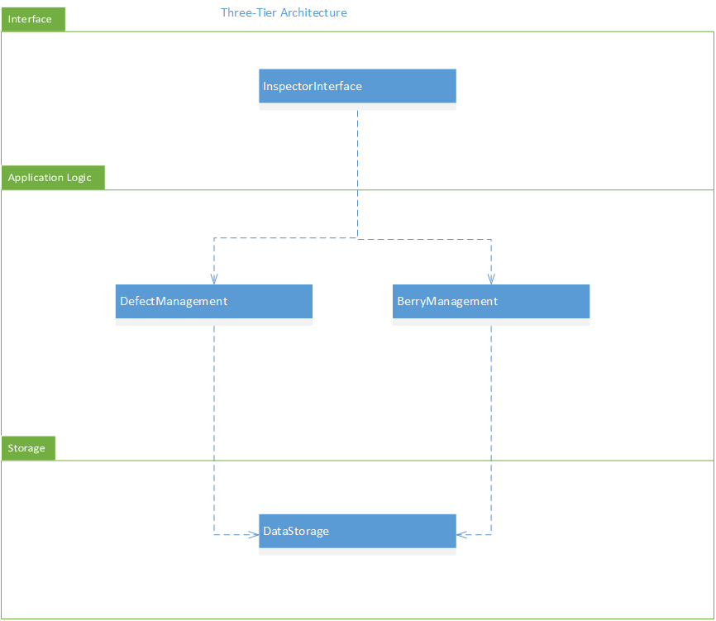
Three-tier architecture – The interface layer includes the InspectorInterface subsystem because it deals with everything the user interacts with like making a request to get the count of the berries. The application logic layer includes the DefectManagement and BerryManagement subsystems. This layer processes the images, determining if there are blueberries, counts them and then looks for defects. The storage layer includes the DataStorage subsystem which deals with the storage and retrieval of images.
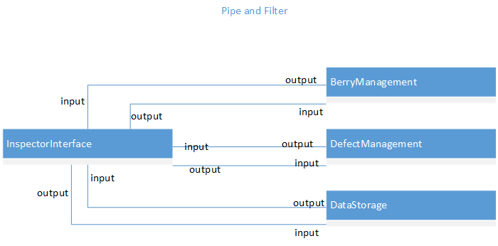
Pipe and filter architecture – The InspectorInterface subsystem gets an image and sends it to the DataStorage subsystem or gets images from the DataStorage subsystem, and then it outputs that into the BerryManagement subsystem. The BerryManagement subsystem processes the image and sends its output to the InspectorInterface subsystem. The InspectorInterface sends information from this output to both the DefectManagemant and DataStorage subsystems. The DefectManagement subsystem processes the input and sends its output to the InspectorInterface which sends information to the DataStorage subsystem.
  - Subsystem Decomposition
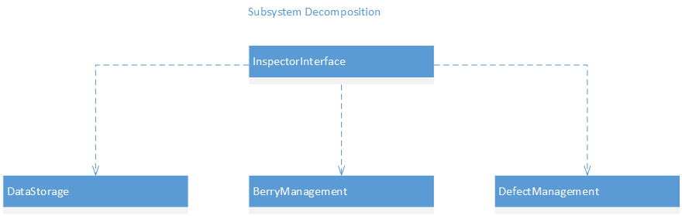
The InspectorInterface subsystem is responsible for realizing the user interface for the inspector. It sends the user requests for counting blueberries, detecting defects, and retrieving images to the appropriate subsystems. The BerryManagement subsystem is responsible for the detection of blueberries and its counting. The DefectManagement subsystem is responsible for the detection of defects and calculating the percentages for each defect. The DataStorage subsystem is responsible for the creation and storage of photos.

  - Hardware and Software Mapping
The InspectorInterface subsystem will reside on any computer that the system is installed on and it is connected to the DataStorage subsystem that resides on a server so that any computer that has the system installed on it will have access to all of the same photos and reports. The BerryManagement subsystem and the DefectManagement subsystem also resides on any computer that the system is installed on and they interact with the InspectorInterface subsystem.
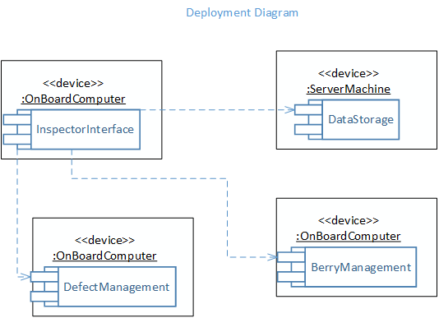
  - Persistent Data Management
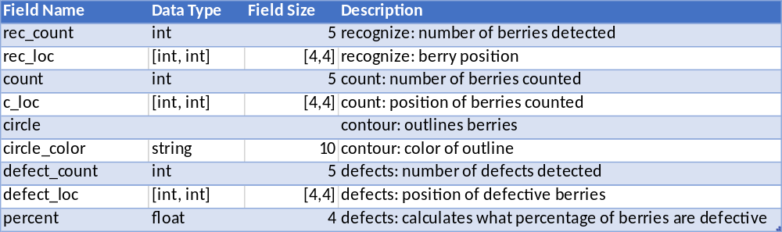
  - Security/Privacy
In the final release of the system, to keep the system secured every inspector will have his own private password. The password along with its associated username will be required in order to log into the system. Once the inspector is recognized, the system will display the software modules. Only an administrator will have access to core system modifications like adding a user to the system or adding produce for recognition. This will help the system to stay protected and not just anyone can modify or use the system.
- Detailed Design
In this chapter, the subsystem briefly described. Sequence diagrams for the use case being implemented in the system and a description of the detailed class diagram are given. Also the interface code found in Appendix C is explained.
  - Overview
The InspectorInterface subsystem is responsible for realizing the user interface for the inspector. The BerryManagement subsystem is responsible for the detection of blueberries and its counting. The DefectManagement subsystem is responsible for the detection of defects and calculating the percentages. The DataStorage subsystem is responsible for the creation and storage of photos.
  - Static model
The Display class handles the user requests such as select photo, count produce, and find defects. The Count class counts the produce. The Outline class outlines the produce in different colors. The Detector class identifies the produce and the defects. The Storage class stores and uploads the images.
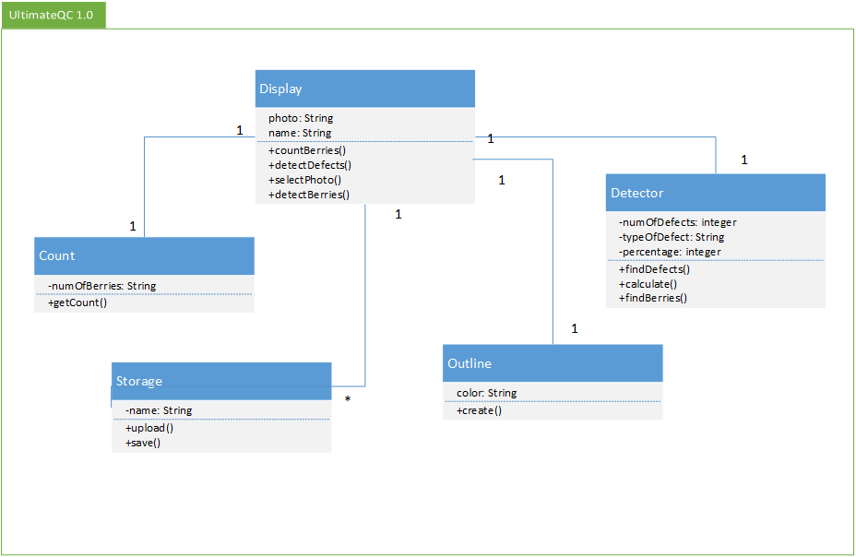

  - Dynamic model
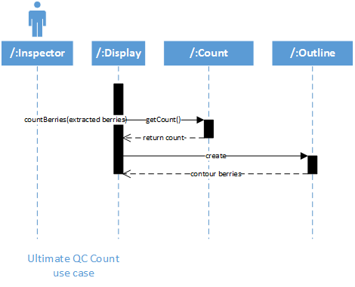
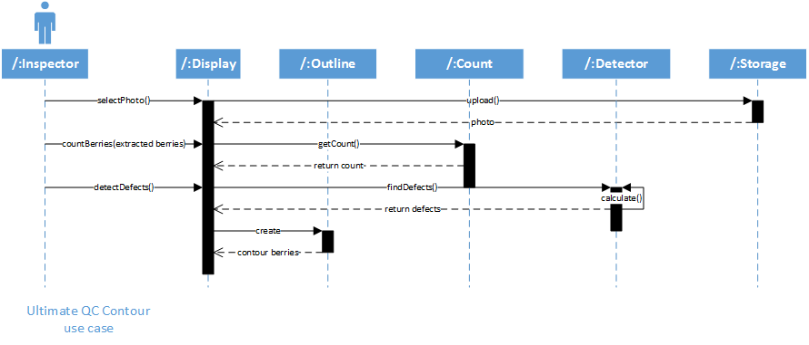
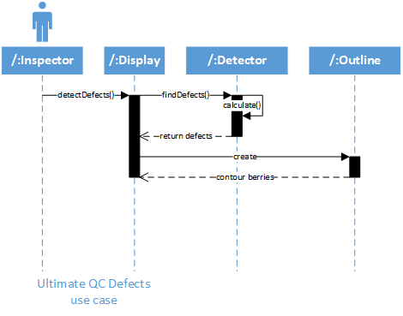
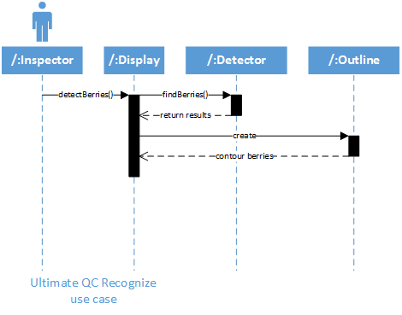
  - Code Specification
The InpsectorInterface allows the inspector to select an image from the DataStorage subsystem. Then it sends the image to the BerryManagement subsystem to detect blueberries. If there are berries in the image the BerryManagement subsystem counts the blueberries. It returns its results to the InspectorInterface where it gets sent to the DefectManagement subsystem. The DefectMangement subsystem detects the immature blueberries, counts them, and then calculates the percentage. The results are sent to the InspectorInterface subsystem and displayed to the inspector. (Code in Appendix C)
- Glossary
PIA – Produce Inspectors of America
QC – quality control
RD – Requirements Document

- Appendix
  - Appendix A - Use case diagram for use cases being implemented.
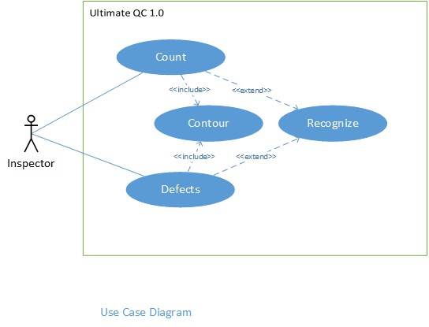
  - Appendix B - Use cases being implemented.
*Use Case ID: UC001 – Recognize
Use Case Level: High-level
*Details:
- Actor: Inspector
- Pre-conditions:
  - User is logged into the system.
- Description:
  - Use case begins when the user selects an image in the system and clicks open.
  - The system shall then detect the produce in the image.
  - Use case ends when the system returns the image with the produce identified.
- Relevant requirements: none.
- Post-conditions:
  - The system displays options to count produce, find defects, or select photo.
*Alternative Courses of:
- In step D.1 (step 1 of the Description section) the user has the option to cancel the request.
- In step D.3 if the system is unable to detect produce in the image the system shall return the image stating that there are no produce detected and disables count produce and find defects buttons.
Extensions: none.
*Exceptions:
- The select photo button in the system is not active.
Concurrent Uses: none.
*Related Use Cases: UC002 – Count and UC004 – Defects.
------------------------------------------------------------------------------------------------------------
Decision Support
*Frequency: High. The user is expected to select images several times a day.
*Criticality: High. System should not proceed to UC002 - Count or UC004 - defect use case if no produce is detected.
*Risk: Low.

Constraints:
- Usability:
  - No previous Training Time
  - On average the user should take no more than 10 secs to select an image.
- Reliability:
  - 0.25% probability of the system not being able identify the produce.
- Performance:
  - The system should identify the produce within 15 secs.
- Supportability:
  - Image format should be supported by the system.

*Use Case ID: UC002 – Count
Use Case Level: High-level
*Details:
- Actor: Inspector
- Pre-conditions:
  - User is logged into the system.
  - The system has identified produce in the image.
- Description:
  - Use case begins when the user selects count produce.
  - The system shall then count the produce in the image.
  - The system shall the outline the produce counted in the image.
  - Use case ends when the system returns the image with the produce counted and outlined.
- Relevant requirements: none.
- Post-conditions:
  - The system displays options to count produce (disabled), find defects, select photo.
*Alternative Courses of: none.
Extensions: UC001 – Recognize.
*Exceptions:
1. The count produce button in the system is not active.
Concurrent Uses: none.
*Related Use Cases: UC003 – Contour.
------------------------------------------------------------------------------------------------------------
Decision Support
*Frequency: High. The user is expected to count produce in images several times a day.
*Criticality: High. System should be able to count produce accurately.
*Risk: Low.

Constraints:
- Usability:
  - No previous Training Time
  - On average the user should take no more than 5 secs to click count produce button.
2. Reliability:
0.10% probability of the system not being able to count all of the produce.
3. Performance:
The system should count the produce within 10 secs.
4. Supportability:
Image format should be supported by the system.

*Use Case ID: UC003 – Contour
Use Case Level: High-level
*Details:
- Actor: Inspector
- Pre-conditions:
  - User is logged into the system.
  - The system has identified produce in the image.
  - The system has counted or detected the produce.
- Description:
  - Use case begins when the user selects find defects or count produce.
  - The system shall outline the produce after the system has counted the produce or detected defects in the image.
  - Use case ends when the system returns the image with the produce outlined.
- Relevant requirements: none.
- Post-conditions:
  - The system displays options to count produce, find defects, select photo.
*Alternative Courses of: none.
Extensions: none.
*Exceptions:
1. none.
Concurrent Uses: none.
*Related Use Cases: UC002 – Count and UC004 – Defects.
------------------------------------------------------------------------------------------------------------
Decision Support
*Frequency: High. The user is expected to count produce and detect defects in images several times a day.
*Criticality: High. System should outline all produce counted or detected.
*Risk: Low.

Constraints:
- Usability:
  - No previous Training Time
- Reliability:
  - 0.05% probability of the system not outlining all of the produce.
- Performance:
  - The system should outline the produce within 5 secs.
- Supportability:
  - Image format should be supported by the system.
------------------------------------------------------------------------------------------------------------

*Use Case ID: UC004 – Defects
Use Case Level: High-level
*Details:
- Actor: Inspector
- Pre-conditions:
  - User is logged into the system.
  - The system has identified produce in the image.
- Description:
  - Use case begins when the user selects find defects.
  - The system shall then detect and count the defects in the produce in the image.
  - The system shall the outline the produce detected in the image.
  - The system shall calculate the percentage.
  - Use case ends when the system returns the percentage the image with the defective produce counted and outlined.
- Relevant requirements: none.
- Post-conditions:
  - The system displays options to count produce, find defects (disabled), select photo.
*Alternative Courses of: none.
Extensions: UC001 – Recognize.
*Exceptions:
1. The find defects button in the system is not active.
Concurrent Uses: none.
*Related Use Cases: UC003 – Contour.
------------------------------------------------------------------------------------------------------------
Decision Support
*Frequency: High. The user is expected to detect defects in images several times a day.
*Criticality: High. System should detect all defective produce.
*Risk: Low.

Constraints:
- Usability:
  - No previous Training Time
  - On average the user should take no more than 5 secs to click find defects button.
- Reliability:
  - 0.10% probability of the system not being able to detect all of the defective produce.
- Performance:
  - The system should detect the defective produce within 15 secs.
- Supportability:
  - Image format should be supported by the system.
------------------------------------------------------------------------------------------------------------

  - Appendix C – Documented class interfaces (code)
/**
*Takes care of handling user requests.
*methods for returning variables.
*/
interface UltimateQC
{
/**
*user selects an image
* @return image $name
*/
public function selectImage();
/**
*getting the variable for whether the image has blueberries.
* @param image $name
* @return integer
*/
public function detectBerries($name);
/**
*return the variable for the blueberry count.
* @param image $name
* @return integer $berry
* @return integer $pos
*/
public function countBlueberries($name);
/**
*returns the variable for the immature defects.
* @param image $name
* @return integer $immature
* @return integer $pos
*/
public function detectDefects($name);
/**
*returns the variable for the calculated percentage of immature berries.
* @param image $berry
* @param image $immature
* @return integer $percent
*/
public function calculate ($berry, $immature);
/**
*outline berries in image
* @param string $color
* @param image $name
* @param integer $pos
* @return line
*/
public function outline($name, $pos, $color);
}

  - Appendix D - Diary of meeting and tasks.
Date: 10/12/15
Attendees: Marcine Kelly
Start time: 8:04
End time: 8:07
Minute Taker: Marcine Kelly
First student:
- What was done since the last scrum meeting?
  - 1 research ways to do the defects
  - 2 research recognition for berry detection and/or defects
- What is planned to be done until the next scrum meeting?
  - 1 look for ways to find defects, ways that can recognize/detect and/or defects
  - 2 uml-sequence diagrams- for count berries programs

Date: 10/13/15
Attendees: Marcine Kelly
Start time: 5:58
End time: 6:01
Minute Taker: Marcine Kelly
First student:
- What was done since the last scrum meeting?
  - 1 looked for ways to find defects, ways that can recognize/detect and/or defects
  - 2 uml-sequence diagrams- for count berries programs
- What is planned to be done until the next scrum meeting?
  - 1 try to use image classification using bag of words to recognize blueberry images from other images

Date: 10/14/15
Attendees: Marcine Kelly
Start time: 12:42
End time: 12:44
Minute Taker: Marcine Kelly
First student:
- What was done since the last scrum meeting?
  - 1 tried to use image classification using bag of words to recognize blueberry images from other images
- What is planned to be done until the next scrum meeting?
  - 1 try to create a bag of visual words using encode
  - 2 image classification using bag of features

Date: 10/15/15
Attendees: Marcine Kelly
Start time: 5:16
End time: 5:19
Minute Taker: Marcine Kelly
First student:
- What was done since the last scrum meeting?
  - 1 tried to create a bag of visual words using encode
  - 2 looked at image retrieval using customized bag of features
  - 3 image classification using bag of features
- What is planned to be done until the next scrum meeting?
  - 1 try to train an image category classifier
  - 2 try to create a feature extractor
- What are the hurdles?
  - 1 matlab is expiring in a couple of days
  - 2 might not be able to recognize any image with blueberries as blueberries because I do not have Statistics and Machine Learning Toolbox

Date: 10/16/15
Attendees: Marcine Kelly
Start time: 1:00
End time: 1:03
Minute Taker: Marcine Kelly
First student:
- What was done since the last scrum meeting?
  - 1 tried to train an image category classifier
  - 2 tried to create a feature extractor
- What is planned to be done until the next scrum meeting?
  - 1 see if image segmentation can be used to find defects

Date: 10/19/15
Attendees: Marcine Kelly
Start time: 8:25
End time: 8:28
Minute Taker: Marcine Kelly
First student:
- What was done since the last scrum meeting?
  - 1 looked at image segmentation
- What is planned to be done until the next scrum meeting?
  - 1 try to find another way to detect berries/defect
  - 2 look at train a stop sign detector tutorial

Date: 10/20/15
Attendees: Marcine Kelly
Start time: 6:58
End time: 7:01
Minute Taker: Marcine Kelly
First student:
- What was done since the last scrum meeting?
  - 1 found cascade object detector
  - 2 stop sign detector tutorial
- What is planned to be done until the next scrum meeting?
  - 1 classification model training on berries - get berry features
  - 2 collect negatives for blueberries

Date: 10/21/15
Attendees: Marcine Kelly
Start time: 6:19
End time: 6:21
Minute Taker: Marcine Kelly
First student:
- What was done since the last scrum meeting?
  - 1 model training on berries
  - 2 collected negatives for blueberries
- What is planned to be done until the next scrum meeting?
  - 1 try to train berry detector using cascade object detector
  - 2 try segmenting berries by color to detect immature berries
- What are the hurdles?
  - 1 think i’m going to need a lot more images

Date: 10/22/15
Attendees: Marcine Kelly
Start time: 5:12
End time: 5:14
Minute Taker: Marcine Kelly
First student:
- What was done since the last scrum meeting?
  - 1 tried to train berry detector using cascade object detector
  - 2 tried segmenting berries by color to detect immature berries
- What is planned to be done until the next scrum meeting?
  - 1 try to detect immature berries using cascade object detector
  - 2 get immature features and negatives
  - 3 uml - sequence diagrams for defect detection

Date: 10/23/15
Attendees: Marcine Kelly
Start time: 1:54
End time: 1:58
Minute Taker: Marcine Kelly
First student:
- What was done since the last scrum meeting?
  - 1 try to detect immature berries using cascade object detector
  - 2 get immature features and negatives
  - 3 uml - sequence diagrams for defect detection
- What is planned to be done until the next scrum meeting?
  - 1 change color map of berries to try to detect immature berries

Date: 10/26/15
Attendees: Marcine Kelly
Start time: 7:29
End time: 7:31
Minute Taker: Marcine Kelly
First student:
- What was done since the last scrum meeting?
  - 1 used hsv colormap on blueberries
- What is planned to be done until the next scrum meeting?
  - 1 static uml diagrams
  - 2 dynamic uml diagrams
- What are the hurdles?
  - 1 do not have MATLAB

Date: 10/27/15
Attendees: Marcine Kelly
Start time: 6:47
End time: 6:50
Minute Taker: Marcine Kelly
First student:
- What was done since the last scrum meeting?
  - 1 use case diagram
  - 2 class diagram
- What is planned to be done until the next scrum meeting?
  - 1 sequence diagrams
  - 2 subsystem decomposition
- What are the hurdles?
  - 1 do not have MATLAB

Date: 10/28/15
Attendees: Marcine Kelly
Start time: 1:56
End time: 1:59
Minute Taker: Marcine Kelly
First student:
- What was done since the last scrum meeting?
  - 1 sequence diagrams
  - 2 subsystem decomposition
- What is planned to be done until the next scrum meeting?
  - 1 architectural patterns
  - 2 deployment diagram
- What are the hurdles?
  - 1 do not have MATLAB

Date: 10/29/15
Attendees: Marcine Kelly
Start time: 5:00
End time: 5:02
Minute Taker: Marcine Kelly
First student:
- What was done since the last scrum meeting?
  - 1 architectural patterns
  - 2 deployment diagram
- What is planned to be done until the next scrum meeting?
  - 1 get hsv features and negatives for image trainer

Date: 10/30/15
Attendees: Marcine Kelly
Start time: 12:36
End time: 12:38
Minute Taker: Marcine Kelly
First student:
- What was done since the last scrum meeting?
  - 1 image trainer hsv berries features and negatives
- What is planned to be done until the next scrum meeting?
  - 1 see if can get surface area of a blueberry/region of interest

Date: 11/02/15
Attendees: Marcine Kelly
Start time: 1:20
End time: 1:22
Minute Taker: Marcine Kelly
First student:
- What was done since the last scrum meeting?
  - 1 surface area - looked at step() which has area variable output for blob analysis
  - 2 image region analyzer has area property for regions
- What is planned to be done until the next scrum meeting?
  - 1 immature blueberry recognition and detection
  - 2 idea: detect blueberry, extract immature color and berry color in each region, get area of both, add for total area, if area of immature is greater than or equal to 20% of total then detect it as immature

Date: 11/3/15
Attendees: Marcine Kelly, Carlos Villabona, Rodrigo Morales
Start time: 3:40
End time: 3:47
Minute Taker: Marcine Kelly
First student:
- What was done since the last scrum meeting?
  - 1 immature blueberry recognition and detection
- What is planned to be done until the next scrum meeting?
  - 1 blueberry recognition and detection
  - 2 set up questions to ask matlab

Date: 11/04/15
Attendees: Marcine Kelly
Start time: 6:24
End time: 6:26
Minute Taker: Marcine Kelly
First student:
- What was done since the last scrum meeting?
  - 1 blueberry recognition and detection
  - 2 set up questions to ask matlab
- What is planned to be done until the next scrum meeting?
  - 1 blueberry recognition and detection

Date: 11/05/15
Attendees: Marcine Kelly
Start time: 5:11
End time: 5:12
Minute Taker: Marcine Kelly
First student:
- What was done since the last scrum meeting?
  - 1 blueberry recognition and detection
- What is planned to be done until the next scrum meeting?
  - 1 blueberry recognition and detection

Date: 11/06/15
Attendees: Marcine Kelly
Start time: 11:23
End time: 11:24
Minute Taker: Marcine Kelly
First student:
- What was done since the last scrum meeting?
  - 1 blueberry recognition and detection
- What is planned to be done until the next scrum meeting?
  - 1 blueberry recognition and detection

Date: 11/09/15
Attendees: Marcine Kelly
Start time: 12:00
End time: 12:02
Minute Taker: Marcine Kelly
First student:
- What was done since the last scrum meeting?
  - 1 worked on blueberry recognition and detection
- What is planned to be done until the next scrum meeting?
  - 1 continue to work on blueberry recognition and detection

Date: 11/10/15
Attendees: Marcine Kelly
Start time: 5:09
End time: 5:11
Minute Taker: Marcine Kelly
First student:
- What was done since the last scrum meeting?
  - 1 worked on blueberry recognition and detection
- What is planned to be done until the next scrum meeting?
  - 1 continue to work on blueberry recognition and detection
- What are the hurdles?
  - 1 need some advice on defect detection

Date: 11/11/15
Attendees: Marcine Kelly
Start time: 12:03
End time: 12:05
Minute Taker: Marcine Kelly
First student:
- What was done since the last scrum meeting?
  - 1 blueberry recognition and detection
- What is planned to be done until the next scrum meeting?
  - 1 blueberry recognition and detection

Date: 11/12/15
Attendees: Marcine Kelly
Start time: 9:47
End time: 9:49
Minute Taker: Marcine Kelly
First student:
- What was done since the last scrum meeting?
  - 1 blueberry recognition and detection
- What is planned to be done until the next scrum meeting?
  - 1 blueberry recognition and detection

Date: 11/13/15
Attendees: Marcine Kelly
Start time: 12:11
End time: 12:13
Minute Taker: Marcine Kelly
First student:
- What was done since the last scrum meeting?
  - 1 blueberry recognition and detection
- What is planned to be done until the next scrum meeting?
  - 1 blueberry recognition and detection

Date: 11/16/15
Attendees: Marcine Kelly
Start time: 10:13
End time: 10:15
Minute Taker: Marcine Kelly
First student:
- What was done since the last scrum meeting?
  - 1 worked on blueberry recognition and detection
- What is planned to be done until the next scrum meeting?
  - 1 continue to work on blueberry recognition and detection

Date: 11/17/15
Attendees: Marcine Kelly
Start time: 5:00
End time: 5:02
Minute Taker: Marcine Kelly
First student:
- What was done since the last scrum meeting?
  - 1 blueberry recognition and detection
- What is planned to be done until the next scrum meeting?
  - 1 work on final documentation
- What are the hurdles?
  - 1 still waiting on mathworks to respond to email

Date: 11/18/15
Attendees: Marcine Kelly
Start time: 1:03
End time: 1:05
Minute Taker: Marcine Kelly
First student:
- What was done since the last scrum meeting?
  - 1 documentation
- What is planned to be done until the next scrum meeting?
  - 1 do some work on final documentation

Date: 11/19/15
Attendees: Marcine Kelly
Start time: 5:18
End time: 5:20
Minute Taker: Marcine Kelly
First student:
- What was done since the last scrum meeting?
  - 1 documentation
- What is planned to be done until the next scrum meeting?
  - 1 documentation -- insert images
- What are the hurdles?
  - 1 the semester is almost over and defects still not completed

Date: 11/20/15
Attendees: Marcine Kelly
Start time: 11:48
End time: 11:50
Minute Taker: Marcine Kelly
First student:
- What was done since the last scrum meeting?
  - 1 documentation
- What is planned to be done until the next scrum meeting?
  - 1 blueberry recognition and detection

Date: 11/23/15
Attendees: Marcine Kelly
Start time:
End time:
Minute Taker: Marcine Kelly
First student:
- What was done since the last scrum meeting?
  - 1 blueberry recognition and detection
- What is planned to be done until the next scrum meeting?
  - 1 immature blueberry detection

Date: 11/24/15
Attendees: Marcine Kelly
Start time: 2:00
End time: 2:00
Minute Taker: Marcine Kelly
First student:
- What was done since the last scrum meeting?
  - 1 immature blueberry detection
  - 2 computer was all glitchy- compromised
- What is planned to be done until the next scrum meeting?
  - 1 couldn’t get my desktop on startup
- What are the hurdles?
  - 1 computer was messed up

Date: 11/25/15
Attendees: Marcine Kelly
Start time: 1:00
End time: 1:00
Minute Taker: Marcine Kelly
First student:
- What was done since the last scrum meeting?
- What is planned to be done until the next scrum meeting?
- What are the hurdles?
  - 1 Don’t have my computer, it's at geek squad

Date: 11/30/15
Attendees: Marcine Kelly
Start time: 12:17
End time: 12:21
Minute Taker: Marcine Kelly
First student:
- What was done since the last scrum meeting?
  - 1 got my computer back this weekend they had to reinstall my OS
- What is planned to be done until the next scrum meeting?
  - 1 change the way images are inputted, rather than inputting manually try to open with a dialog box
  - 2 try to eliminate outliers in count code using suggestion from mathworks

Date: 12/01/15
Attendees: Marcine Kelly
Start time: 3:43
End time: 3:46
Minute Taker: Marcine Kelly
First student:
- What was done since the last scrum meeting?
  - 1 change image input
  - 2 tried to eliminate outliers
- What is planned to be done until the next scrum meeting?
  - 1 try to eliminate outliers by cropping out tray
- What are the hurdles?
  - 1 figuring out how to crop everything outside of the tray

Date: 12/02/15
Attendees: Marcine Kelly
Start time: 11:37
End time: 11:41
Minute Taker: Marcine Kelly
First student:
- What was done since the last scrum meeting?
  - 1 tried to crop images to eliminate outliers
- What is planned to be done until the next scrum meeting?
  - 1 have the code crop images to eliminate outliers
  - 2 immature blueberry detection

Date: 12/03/15
Attendees: Marcine Kelly
Start time: 1:11
End time: 1:17
Minute Taker: Marcine Kelly
First student:
- What was done since the last scrum meeting?
  - 1 have code crop images to eliminate outliers- code can crop image but not all of outliers will be eliminated if the background is in the same color range as blueberries
  - 2 immature blueberry detection
- What is planned to be done until the next scrum meeting?
  - 1 texture analysis on blueberries for wrinkled berry defect
  - 2 make program terminate if it doesn’t detect blueberries before counting

Date: 12/04/15
Attendees: Marcine Kelly
Start time: 10:09
End time: 10:13
Minute Taker: Marcine Kelly
First student:
- What was done since the last scrum meeting?
  - 1 tried texture analysis on blueberries for wrinkled berry defect
  - 2 make program terminate if it doesn’t detect blueberries before counting
- What is planned to be done until the next scrum meeting?
  - 1 try to use extracted immature blueberry color and blueberry counter to find immature blueberries
- References
[1] PIA’s PowerPoint presentation
[2] http://www.mathworks.com/products/matlab/
[3] http://www.mathworks.com/products/computer-vision/
[4] http://www.mathworks.com/products/image/

