Florida International University
School of Computing and Information Sciences
CIS 4911 Senior Project – Software Engineering Focus
Requirements Document (RD)

CIS 4911 U01
Senior Project
Fall 2015
Ultimate QC 1.0
Project Team #17
Marcine Kelly
09/11/15
Instructor: Masoud Sadjadi
Product Owner: Rodrigo Morales
- Not to be published or publicly distributed without permission by the publisher. Publisher contact information: mkell008@fiu.edu, Product Owner contact information: rmorales@produceinspectors.com.
- Abstract
This document is divided into seven chapters. It starts with the Introduction, which states the problem and gives a description of the system that will solve this problem. In the remainder of the document, there is a work break down for the project and an estimation of the cost to develop the system is provided. The system requirements are explained and the use cases are given.
- Table of Contents

- Introduction ………………………………………………………………………....…5
  - Problem Definition ……………………………………………………………….5
  - Scope of system ……………………….………………………………………….5
  - Terminology …………………………………….………………………………..5
  - Overview of document …………………………………………………………...5
- Current System ………………………………………………………………………..6
- Project Plan …………………………………………………………………………...6
  - Project organization ……………………………………………………………...6
  - Work breakdown ………………………………………………………………...6
  - Cost Estimate ……………………………………………………………………6
- Proposed System Requirements …………………………………………….………..7
  - Functional Requirements ……………………………………………….……….7
  - Analysis of System Requirements……………………………………………… 9
    - Scenarios …………………………………………………………………9
    - Use case model …………………………………………………………..9
    - Static model ……………………………………………………………..10
    - Dynamic model ………………………………………………………….10
- Glossary ……………………………………………………………………………..11
- Appendix ……………………………………………………………………………12
  - Appendix A - Complete use cases and project schedule ………………………12
  - Appendix B - Use case diagram using UML …………………………………..22
  - Appendix C - Static UML diagram ……………………………………………22
  - Appendix D - Dynamic UML diagrams ……………………………………….23
  - Appendix E - User Interface designs …………………………………………..26
  - Appendix F - Diary of meeting and tasks ……………………………………...27
- References …………………………………………………………………………..32
- Introduction
In this chapter, the problem that this project will provide a solution to is described. You will find a description of the system that will be implemented and a quick overview of what to expect in the remainder of the document.
  - Problem Definition.
Most of the modern day practices used to inspect produce is visual. Visual inspections can result in human errors even with trained QC inspectors. They can miscount produce, fail to notice defects, and have typing errors in their reports to name a few examples. This process is slow and it takes a substantial amount of time to get a single QC report completed. The QC report is used by Produce Inspectors of America’s customers to make a decision as to whom and where to sell the produce to get the best profit for their merchandise possible. Therefore the longer it takes for the QC report to be completed the longer the produce sits there and the worse the quality of the produce becomes _{[1]}.
  - Scope of system.
The system, Ultimate QC 1.0, will alleviate some of the human error that can occur during the inspection process. Ultimate QC 1.0 will take a picture of the produce and then analyze the image. It will give the number of produce that is in the image, identify and count the defects, and give a percentage of what portion of the produce is defective. This information will then be uploaded into a report.
  - Terminology - Definitions, acronyms, and abbreviations.
PIA – Produce Inspectors of America
QC – quality control
  - Overview of document
Chapter 2 will introduce the current system being used by PIA to inspect produce and its limitations. Chapter 3 goes over the tentative schedule for the entire project and the estimated system development cost. Chapter 4 describes the functional and non-functional requirements of the use cases and discusses the diagrams in the Appendices B – D. Chapter 5 defines terms used in this document. Chapter 6 contains the use cases and the diagrams relating to them as well as a mock-up of the user interface and a diary of meetings.
- Current System (limitations and problems)
The current system for inspecting produce is a visual process. QC inspectors examine crates of produce in a refrigerated environment. They inspect every packet of produce in the crates. They manually count the produce in the packets, look for visible defects, take pictures of the produce and then enter their findings into a report. Spending long periods of time in a refrigerated environment can take its toll on the inspectors. The inspectors can miscount the number of produce that are in the packets, overlook defect, and enter the wrong information into their reports.
- Project Plan
In this section the roles for this project are discussed. A description of the task that are planned to be developed for this project and the milestones are given. You will also find an estimation of the cost to develop this system.
  - Project organization
I will be the developer for this project. I will develop the code that implements the user stories. I will also be the documentation editor and provide the documentation for this project.
  - Work breakdown
As laid out in the schedule in Appendix A, for the first milestone I will develop a function to count the blueberries and outline them. I will also develop a function to connect to a devices camera. For the second milestone I will complete the third deliverable and create a function to detect defects and another to calculate the percentage of produce that is defective for each defect. Finally, for the last milestone I will create a function to identify produce, wrap functions into an app, design the app interface, and complete the final deliverable.
  - Cost Estimate
I am developing the software system on MATLAB with the Computer Vision System Toolbox and Image Processing Toolbox. MATLAB costs about $2,150 _{[2]}, the Computer Vision System Toolbox costs about $1,350 _{[3]}, and the Image Processing Toolbox costs about $1,000 _{[4]}. Therefore the cost to develop the software system costs about $2,150 to $4500.
- Proposed System Requirements
In this chapter, the functional requirements for the system and their associated non-functional requirements are described. The system requirements are analyzed describing the describing the use cases, use case model, class diagram, and sequence diagrams found in Appendix B – D.
  - Functional Requirements
Actor: Inspector
UC001 – Recognize
The system shall recognize the produce in the image.
(See Appendix A use case UC001 – Recognize)
Constraints:
- Usability:
  - No previous Training Time
  - On average the user should take no more than 10 secs to select an image.
- Reliability:
  - 0.25% probability of the system not being able identify the produce.
- Performance:
  - The system should identify the produce within 15 secs.
- Supportability:
  - Image format should be supported by the system.

UC002 – Count
The system shall count the produce in the image.
(See Appendix A use case UC002 – Count)
Constraints:
- Usability:
  - No previous Training Time
  - On average the user should take no more than 5 secs to click count produce button.
2. Reliability:
0.10% probability of the system not being able to count all of the produce.
3. Performance:
The system should count the produce within 10 secs.
4. Supportability:
Image format should be supported by the system.

UC003 – Contour
The system shall outline counted and defective produce.
(See Appendix A use case UC003 – Contour)
Constraints:
- Usability:
  - No previous Training Time
- Reliability:
  - 0.05% probability of the system not outlining all of the produce.
- Performance:
  - The system should outline the produce within 5 secs.
- Supportability:
  - Image format should be supported by the system.

UC004 – Defects
The system shall detect defective produce, count them and give a percentage.
(See Appendix A use case UC004 – Defects)
Constraints:
- Usability:
  - No previous Training Time
  - On average the user should take no more than 5 secs to click find defects button.
- Reliability:
  - 0.10% probability of the system not being able to detect all of the defective produce.
- Performance:
  - The system should detect the defective produce within 15 secs.
- Supportability:
  - Image format should be supported by the system.

UC005 – Camera
The system shall be able to take a picture of the produce.
(See Appendix A use case UC005 – Camera)
Constraints:
- Usability:
  - No previous Training Time
- Reliability:
  - 0.05% probability of the system not being able to connect to the devices camera.
- Performance:
  - The system should be able to take a picture within 5 secs.
- Supportability:
  - Devices camera should be supported by the system.

  - Analysis of System Requirements
    - Scenarios
UC001– Recognize: If the system does not recognize any produce in the image then the user, the inspector, cannot use the count and find defects functions.
UC002 – Count: Once the produce has been identified the system will allow the user to use the count function. The system counts and outlines the produce and displays the count on the screen.
UC003 – Contour: When the system counts the produce or detects defects, the system will outline the produce in a visible color. The colors use for the count and the defects will be different. Each type of defect will have its own color.
UC004 – Defects: Once the produce has been identified the system will allow the user to use the find defects function. The system detects the defects in the image. It counts the total for each type of defect and calculates the percentage for each defect. Then the system outlines the defective produce a different color for each defect.
UC005 – Camera: The system will allow the user to use the devices camera. The user can take a picture, discard the picture, or save the picture.
    - Use case model
For this system there is one actor, the inspector and five use cases: Recognize, Count, Contour, Defects, and Camera. The inspector interacts with the Count, Defects, and Camera use cases. The Recognize use case extends both the Count and Defects use cases. The Contour use case is used by both the Count and Defects use case. (See Appendix B)
    - Static model
The Display class handles the user requests such as take picture, count produce, and find defects. The Camera class takes the pictures. The Count class counts the produce. The Outline class outlines the produce in different colors. The Detector class identifies the produce and the defects. The Storage class stores and uploads the images. (See Appendix C)
    - Dynamic model
Recognize sequence diagram: After the user selects the image in the Display, the Detector will identify the produce in the image and send the results back to the Display. If it does not recognize the produce it will state that it does detect any produce, else the count and find defects functions will be enabled. For the development process the Display will sent the image to the Outline class to outline the produce that was detected to see how well the function works.
Count sequence diagram: After the user has selected an image and the Detector class has identified the produce, the user then selects count produce in the Display. The Count class counts the produce and sends the results back to the Display and the Display sends the image to the Outline class to outline the produce. The Outline class sends the image back to the Display.
Contour sequence diagram: After the system has counted the produce or detected defects in the produce, the Display sends the image to the Outline class to outline the counted or defective produce and the Outline class sends the outlined image back to the Display.
Defects sequence diagram: After the user has selected an image and the Detector class has identified the produce, the user then selects find defects in the Display. The Detector class detects the defective produce, counts them, and calculates the percentages. It sends the results back to the Display class where the image gets sent to the Outline class. The Outline class outlines each type of defect in a different color and sends the image back to the Display.
Camera sequence diagram: The user selects the take picture function on the Display and the Camera class connects to the devices camera and sends the cameras view to the Display. The user presses a button on the Display and the Camera class takes the picture and sends it to the Display. The user clicks save on the Display and the Storage class saves the image. (See Appendix D)
- Glossary
PIA – Produce Inspectors of America
QC – quality control
Defects – attached stems, shriveling, immature berries, mold
- Appendix
  - Appendix A - Complete use cases and Project Schedule
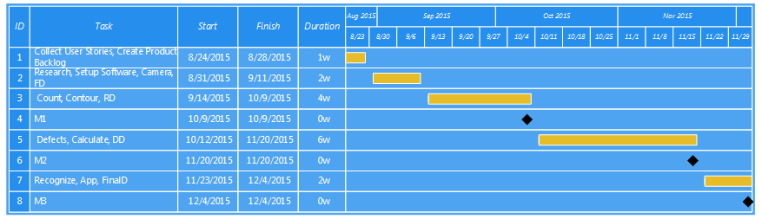
*Use Case ID: UC001 – Recognize
Use Case Level: High-level
*Details:
- Actor: Inspector
- Pre-conditions:
  - User is logged into the system.
- Description:
  - Use case begins when the user selects an image in the system and clicks open.
  - The system shall then detect the produce in the image.
  - Use case ends when the system returns the image with the produce identified.
- Relevant requirements: none.
- Post-conditions:
  - The system displays options to count produce, find defects, or select photo.
*Alternative Courses of:
- In step D.1 (step 1 of the Description section) the user has the option to cancel the request.
- In step D.3 if the system is unable to detect produce in the image the system shall return the image stating that there are no produce detected and disables count produce and find defects buttons.
Extensions: none.
*Exceptions:
- The select photo button in the system is not active.
Concurrent Uses: none.
*Related Use Cases: UC002 – Count and UC004 – Defects.
---------------------------------------------------------------------------------------------------
Decision Support
*Frequency: High. The user is expected to select images several times a day.
*Criticality: High. System should not proceed to UC002 - Count or UC004 - defect use case if no produce is detected.
*Risk: Low.

Constraints:
- Usability:
  - No previous Training Time
  - On average the user should take no more than 10 secs to select an image.
- Reliability:
  - 0.25% probability of the system not being able identify the produce.
- Performance:
  - The system should identify the produce within 15 secs.
- Supportability:
  - Image format should be supported by the system.

*Use Case ID: UC002 – Count
Use Case Level: High-level
*Details:
- Actor: Inspector
- Pre-conditions:
  - User is logged into the system.
  - The system has identified produce in the image.
- Description:
  - Use case begins when the user selects count produce.
  - The system shall then count the produce in the image.
  - The system shall the outline the produce counted in the image.
  - Use case ends when the system returns the image with the produce counted and outlined.
- Relevant requirements: none.
- Post-conditions:
  - The system displays options to count produce (disabled), find defects, select photo.
*Alternative Courses of: none.
Extensions: UC001 – Recognize.
*Exceptions:
1. The count produce button in the system is not active.
Concurrent Uses: none.
*Related Use Cases: UC003 – Contour.
---------------------------------------------------------------------------------------------------
Decision Support
*Frequency: High. The user is expected to count produce in images several times a day.
*Criticality: High. System should be able to count produce accurately.
*Risk: Low.

Constraints:
- Usability:
  - No previous Training Time
  - On average the user should take no more than 5 secs to click count produce button.
2. Reliability:
0.10% probability of the system not being able to count all of the produce.
3. Performance:
The system should count the produce within 10 secs.
4. Supportability:
Image format should be supported by the system.

*Use Case ID: UC003 – Contour
Use Case Level: High-level
*Details:
- Actor: Inspector
- Pre-conditions:
  - User is logged into the system.
  - The system has identified produce in the image.
  - The system has counted or detected the produce.
- Description:
  - Use case begins when the user selects find defects or count produce.
  - The system shall outline the produce after the system has counted the produce or detected defects in the image.
  - Use case ends when the system returns the image with the produce outlined.
- Relevant requirements: none.
- Post-conditions:
  - The system displays options to count produce, find defects, select photo.
*Alternative Courses of: none.
Extensions: none.
*Exceptions:
1. none.
Concurrent Uses: none.
*Related Use Cases: UC002 – Count and UC004 – Defects.
---------------------------------------------------------------------------------------------------
Decision Support
*Frequency: High. The user is expected to count produce and detect defects in images several times a day.
*Criticality: High. System should outline all produce counted or detected.
*Risk: Low.

Constraints:
- Usability:
  - No previous Training Time
- Reliability:
  - 0.05% probability of the system not outlining all of the produce.
- Performance:
  - The system should outline the produce within 5 secs.
- Supportability:
  - Image format should be supported by the system.
---------------------------------------------------------------------------------------------------

*Use Case ID: UC004 – Defects
Use Case Level: High-level
*Details:
- Actor: Inspector
- Pre-conditions:
  - User is logged into the system.
  - The system has identified produce in the image.
- Description:
  - Use case begins when the user selects find defects.
  - The system shall then detect and count the defects in the produce in the image.
  - The system shall the outline the produce detected in the image.
  - The system shall calculate the percentage.
  - Use case ends when the system returns the percentage the image with the defective produce counted and outlined.
- Relevant requirements: none.
- Post-conditions:
  - The system displays options to count produce, find defects (disabled), select photo.
*Alternative Courses of: none.
Extensions: UC001 – Recognize.
*Exceptions:
1. The find defects button in the system is not active.
Concurrent Uses: none.
*Related Use Cases: UC003 – Contour.
---------------------------------------------------------------------------------------------------
Decision Support
*Frequency: High. The user is expected to detect defects in images several times a day.
*Criticality: High. System should detect all defective produce.
*Risk: Low.

Constraints:
- Usability:
  - No previous Training Time
  - On average the user should take no more than 5 secs to click find defects button.
- Reliability:
  - 0.10% probability of the system not being able to detect all of the defective produce.
- Performance:
  - The system should detect the defective produce within 15 secs.
- Supportability:
  - Image format should be supported by the system.

*Use Case ID: UC005 – Camera
Use Case Level: High-level
*Details:
- Actor: Inspector
- Pre-conditions:
  - User is logged into the system.
- Description:
  - Use case begins when the user selects take picture.
  - The system shall then display on the screen a two buttons, one for taking the picture the other to exit, and whatever is in view of the devices camera.
  - The user then takes a picture.
  - Use case ends when the user saves the image.
- Relevant requirements: none.
- Post-conditions:
  - The system displays the image with options to count produce, find defects, select photo.
*Alternative Courses of:
- In step D.2 (step 2 of the Description section) the user has the option to cancel the request.
- In step D.3 the user has the option to discard the image.
Extensions: none.
*Exceptions:
1. The take picture button in the system is not active.
Concurrent Uses: none.
*Related Use Cases:
-----------------------------------------------------------------------------------------------------------
Decision Support
*Frequency: High. The user is expected to take several images a day.
*Criticality: High. System should be able to use the devices camera.
*Risk: Low.

Constraints:
- Usability:
  - No previous Training Time
- Reliability:
  - 0.05% probability of the system not being able to connect to the devices camera.
- Performance:
  - The system should be able to take a picture within 5 secs.
- Supportability:
  - Devices camera should be supported by the system.
---------------------------------------------------------------------------------------------------

  - Appendix B - Use case diagram using UML
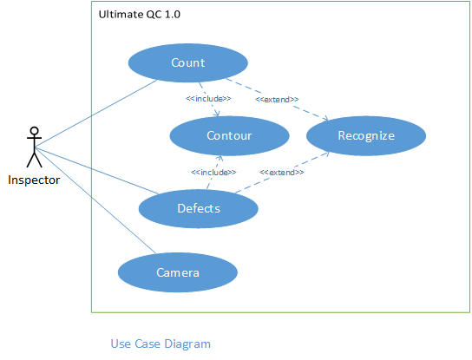
  - Appendix C - Static UML diagram
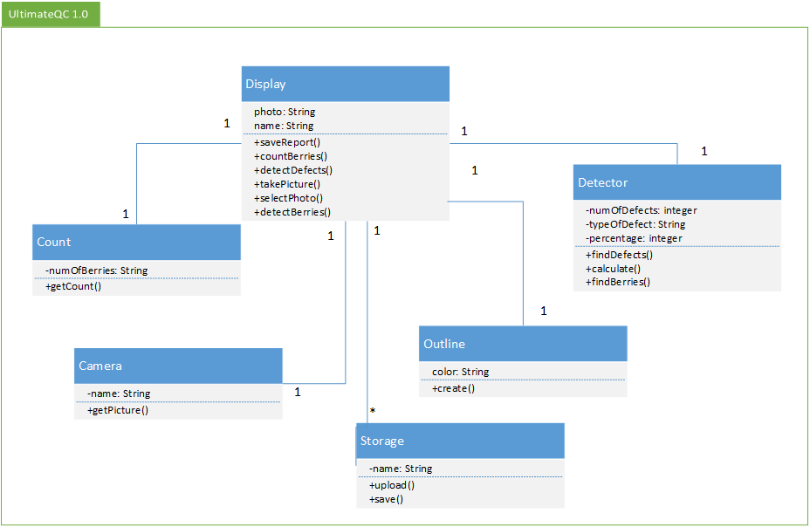
  - Appendix D - Dynamic UML diagrams
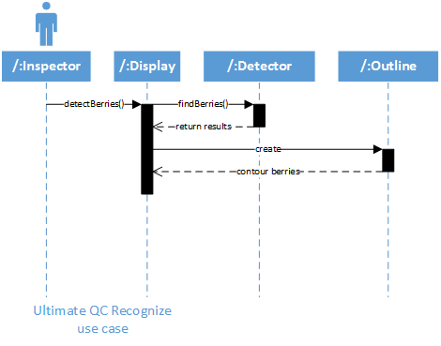
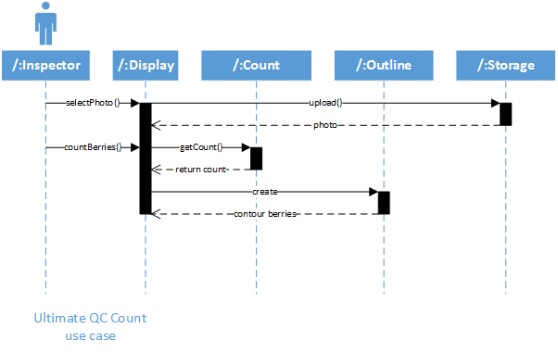
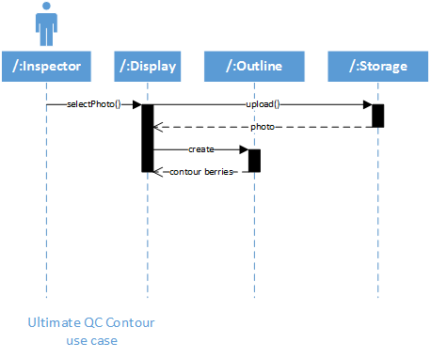
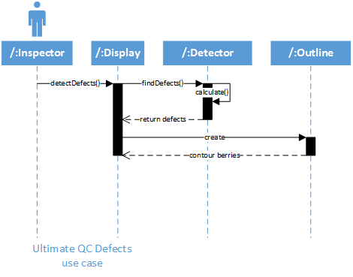
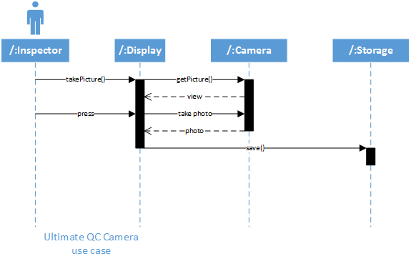
  - Appendix E - User Interface designs.
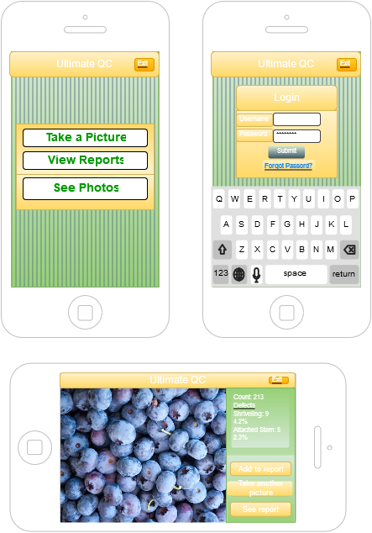
  - Appendix F - Diary of meeting and tasks.
Date: 9/28/15
Attendees: Marcine Kelly
Start time: 2:00
End time: 2:03
Minute Taker: Marcine Kelly
First student:
- What was done since the last scrum meeting?
  - 1 worked on counting code
  - 2 feasibility report
- What is planned to be done until the next scrum meeting?
  - 1 work on counting code and outline
- What are the hurdles?
  - 1 getting code to count correctly

Date: 9/29/15
Attendees: Marcine Kelly
Start time: 5:00
End time: 5:02
Minute Taker: Marcine Kelly
First student:
- What was done since the last scrum meeting?
  - 1 worked on counting code - tried even out photo by changing the image to grayscale and improving the contrast
- What is planned to be done until the next scrum meeting?
  - 1 work on counting code - try to make berries easier to detect
Date: 9/30/15
Attendees: Marcine Kelly
Start time: 12:27
End time: 12:29
Minute Taker: Marcine Kelly
First student:
- What was done since the last scrum meeting?
  - 1 worked on counting code - tried to enhance the color image
- What is planned to be done until the next scrum meeting?
  - 1 work on counting code - try breaking down the radii range (perhaps that is why it is detecting circles that are not there)

Date: 10/1/15
Attendees: Marcine Kelly
Start time: 5:00
End time: 5:04
Minute Taker: Marcine Kelly
First student:
- What was done since the last scrum meeting?
  - 1 worked on counting code discovered that some blueberries are too lite to be detected
  - 2 found that shadows are getting detected which throws off the count
- What is planned to be done until the next scrum meeting?
  - 1 try to remove the background and/or get rid of shadows
  - 2 try to define berries
- What are the hurdles?
  - 1 removing the background and shadows
Date: 10/02/15
Attendees: Marcine Kelly
Start time: 12:00
End time: 12:04
Minute Taker: Marcine Kelly
First student:
- What was done since the last scrum meeting?
  - 1 worked on the counting code - tried to subtract the background from the original image, found edges
- What is planned to be done until the next scrum meeting?
  - 1 try to clean up the edges so that the berries aren’t connected, fill them in so that the berries are clearly defined, and the count and trace them
- What are the hurdles?
  - 1 defining the edges so that they are connected and round

Date: 10/5/15
Attendees: Marcine Kelly
Start time: 1:53
End time: 1:56
Minute Taker: Marcine Kelly
First student:
- What was done since the last scrum meeting?
  - 1 tried counting code with edges, used sobel for the edges and change the edge threshold, dilated the edges to try and remove some of the gaps, tried to fill in some of the interior gaps, smooth it out by eroding some of the edges, and outline the boundaries
- What is planned to be done until the next scrum meeting?
  - 1 sharpen the images (defined edges and more details) to try to improve berry detection
  - 2 segment the images by color to try to remove the background and shadows
- What are the hurdles?
  - 1 distinguishing the berries from everything else in the picture because the software can be a bit sensitive and detect thing that are not berries and not detect all of the berries
Date: 10/6/15
Attendees: Marcine Kelly
Start time: 4:57
End time: 5:01
Minute Taker: Marcine Kelly
First student:
- What was done since the last scrum meeting?
  - 1 was able to segment the most of the background and shadows from some of the pictures and get an accurate count
- What is planned to be done until the next scrum meeting?
  - 1 change color range to try to segment out the background in all of the pictures
  - 2 find setting that can find an accurate count in all of the pictures
  - 3 try to segment out the foreground to keep as many of the berries intact and not have to worry about the background

Date: 10/7/15
Attendees: Marcine Kelly
Start time: 12:01
End time: 12:05
Minute Taker: Marcine Kelly
First student:
- What was done since the last scrum meeting?
  - 1 change color range to try to segment out the background in all the pictures
  - 2 found a setting that could count the berries in the pictures the most accurately
- What is planned to be done until the next scrum meeting?
  - 1 try to segment out the foreground because background is throwing off count in one picture

Date: 11/8/15
Attendees: Marcine Kelly
Start time: 4:55
End time: 4:59
Minute Taker: Marcine Kelly
First student:
- What was done since the last scrum meeting?
  - 1 segmented out the foreground so it is just the color of the berries that it extracts, therefore keeping most of the berries intact
  - 2 got count to work with the berries in most of the pictures
- What is planned to be done until the next scrum meeting?
  - 1 wrote main code that does the image sharpening, does the mask to segment out the berries, and counts and displays the count and outlines the berries on the original picture

Date: 10/9/15
Attendees: Marcine Kelly, Carlos Villabona, Rodrigo Morales, Juan, Johanna
Start time: 10:00am
End time: 10:55
Minute Taker: Marcine Kelly
First student:
- What was done since the last scrum meeting?
  - 1 wrote main script that sharpens the image, does the mask that segments out the berries, runs the count blueberries code, and displays the result on the sharpened image
- What is planned to be done until the next scrum meeting?
  - 1 research ways to do the defects
  - 2 research recognition for berry detection and/or defects
- What are the hurdles?
  - 1 tell the software how to distinguish between defect and normal berries because this is where a human is better at seeing the difference compared to a human
  - 2 translating what a human can detect into something a computer can understand
- References
[1] PIA’s PowerPoint presentation
[2] http://www.mathworks.com/products/matlab/
[3] http://www.mathworks.com/products/computer-vision/
[4] http://www.mathworks.com/products/image/

