Urban Decision Theater 1.0

*User Guide*

Team Members: Olena Tkachenko, Renan Santana

Product Owner: Ali Mostafavi

Project Mentor: Masoud Sadjadi

**Table of Contents**

Moderator------------------------------------------------------------------------------------------3

Decision Maker------------------------------------------------------------------------------------4

# Moderator

Moderator is the first actor to interact with the game. The Moderator sets the city budget for the Decision Maker between 20 and 160 million dollars because Decision Maker is only ever assigned a city budget from someone else. The Moderator also clicks the “Begin” button, which switches the controls over to the Decision Maker.

1. Moderator sets the slider budget on the top left side of Figure 1.
2. Moderator clicks the “Begin” button on the bottom right corner of Figure 1.

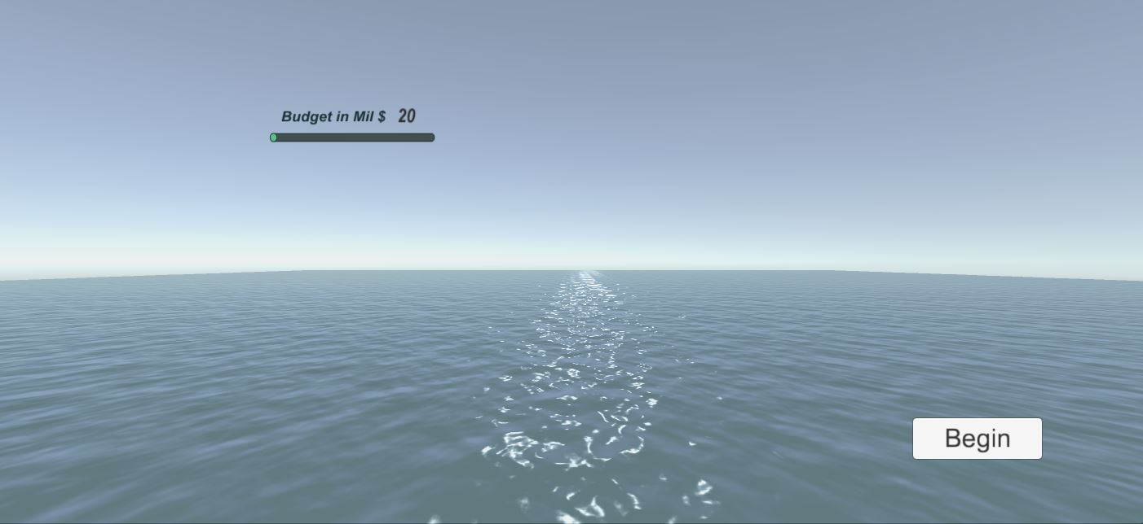

Figure 1

# Decision Maker

Decision Maker’s navigation and movement capabilities:

1. Decision Maker is able to move forward, right, left, and back using the keyboard arrows up, left, right, and down respectively.
2. To look around the scene: use mouse movement (i.e. move mouse to the left or right, up or down)
   1. To disable/enable mouse look press “Shift+Q”
3. To lift in the air or drop to the ground: use mouse scroll away from your person or towards your person respectively. Figure 2, shows the First Person View in the Air.

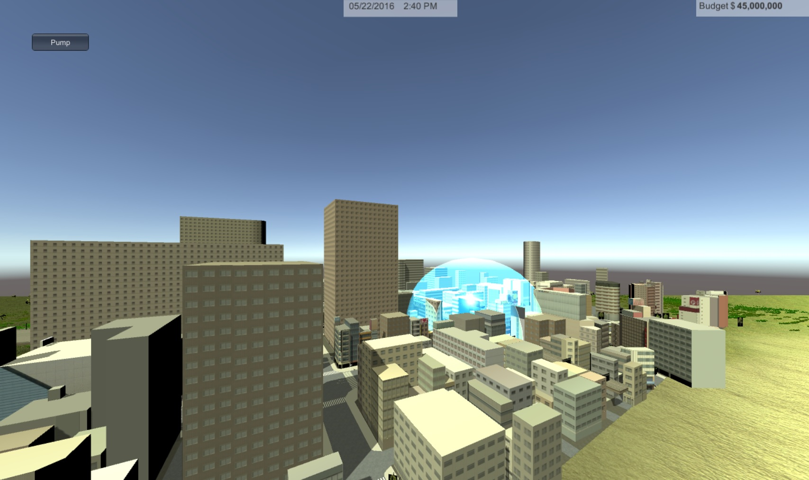

Figure 2

1. To switch to/from Bird’s Eye View: press “Shift+B”. Figure 3 shows Bird’s Eye view snapshot.

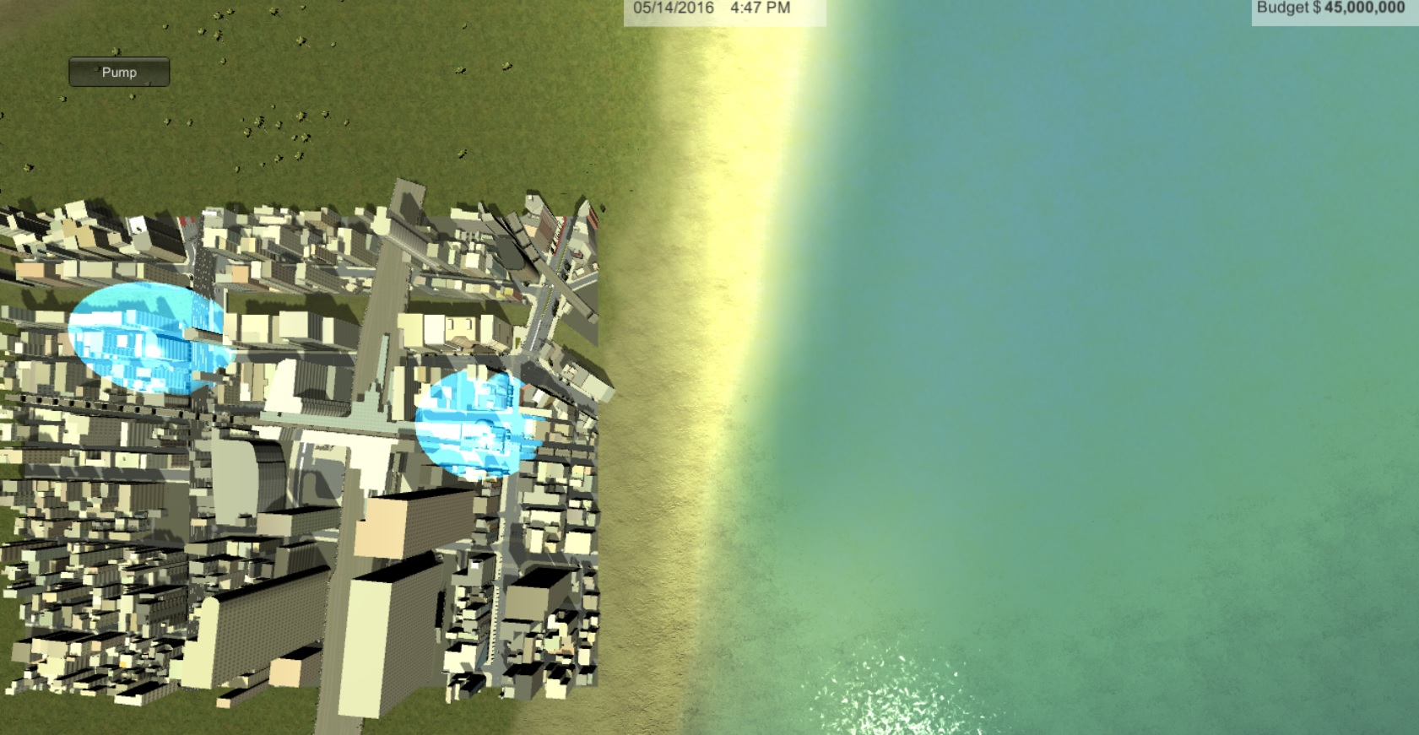

Figure 3

1. To place Pumps: Figure 3 shows the sky blue pump bubble area of flood draining.
   1. Right mouse click “Pump” button on the top right corner of screen.
   2. Move mouse to where u want to place Pump on the ground.
   3. Right mouse button click to place pump on the ground.
2. To View Traffic interactions: continuously press left “Ctrl” key on the keyboard. Figure 4 shows the Traffic View.

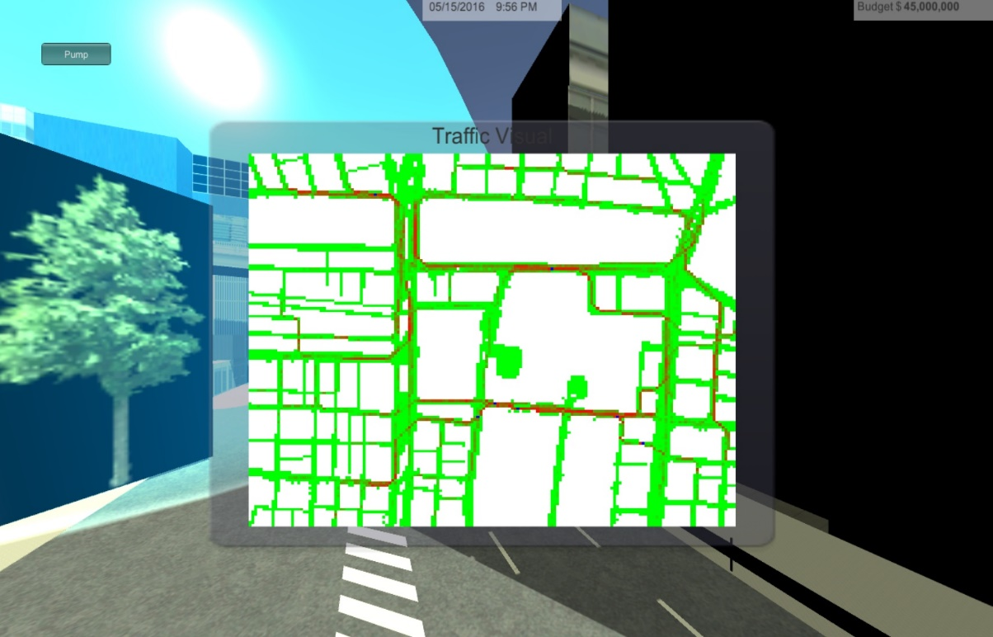

Figure 4

1. To exit game: press “Esc” keyboard key.

**Demo Video:**

<https://youtu.be/1T7ohD2lSIg>