*Florida International University*

*School of Computing and Information Sciences*

Software Engineering Focus

Feature Document

User Story ID #1305

**Name:** Dale Keith

**Team Member(s):** Leon Liang, Dale Keith, Andres Moser, Steve Hirabayashi, Adam Levy

**Project:** VIP Website 7.0

**Product Owner(s)**: Francisco Ortega, Masoud Sadjadi

**Mentor(s)**: Jose Ponce

**Instructor**: Masoud Sadjadi

**User Story Name:** Re-propose projects from previous semester

* Description: As an Faculty member, I want the ability to re-propose a project from previous semester in order to save time and to keep track of all related projects.

Acceptance Criteria

* Upon proposing project, an user can choose from a drop down list of previous projects that they have proposed and re-propose it with a new semester.
* Description of the project should be repopulate with existing information and user may change the description if they like.

**Use Case**

* Name: Faculty repropose previous projects
* Actor: Faculty
* Preconditions: Faculty must be logged with proper privileges and in the propose project page
* Description:

1. Faculty clicks on dropdown to show list of previous projects
2. Faculty selects one of the option from dropdown
3. Page pre-populates with previous information
4. Faculty make changes if necessary
5. Faculty saves project for approval

**Use Case Diagram**

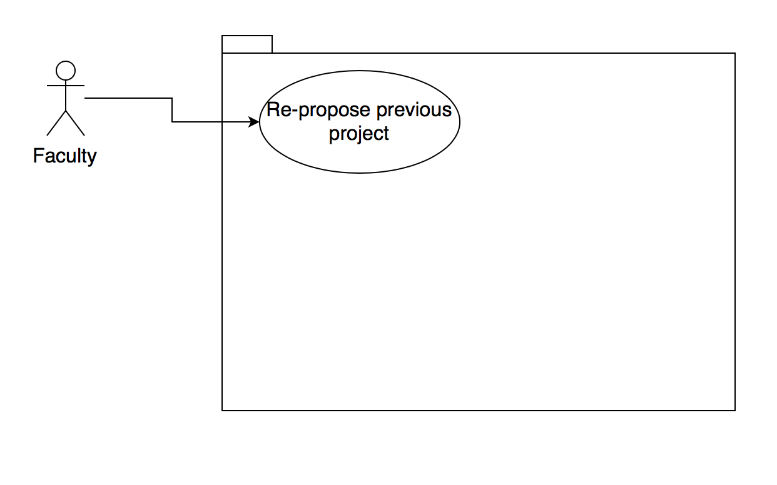

**Sequence Diagram**

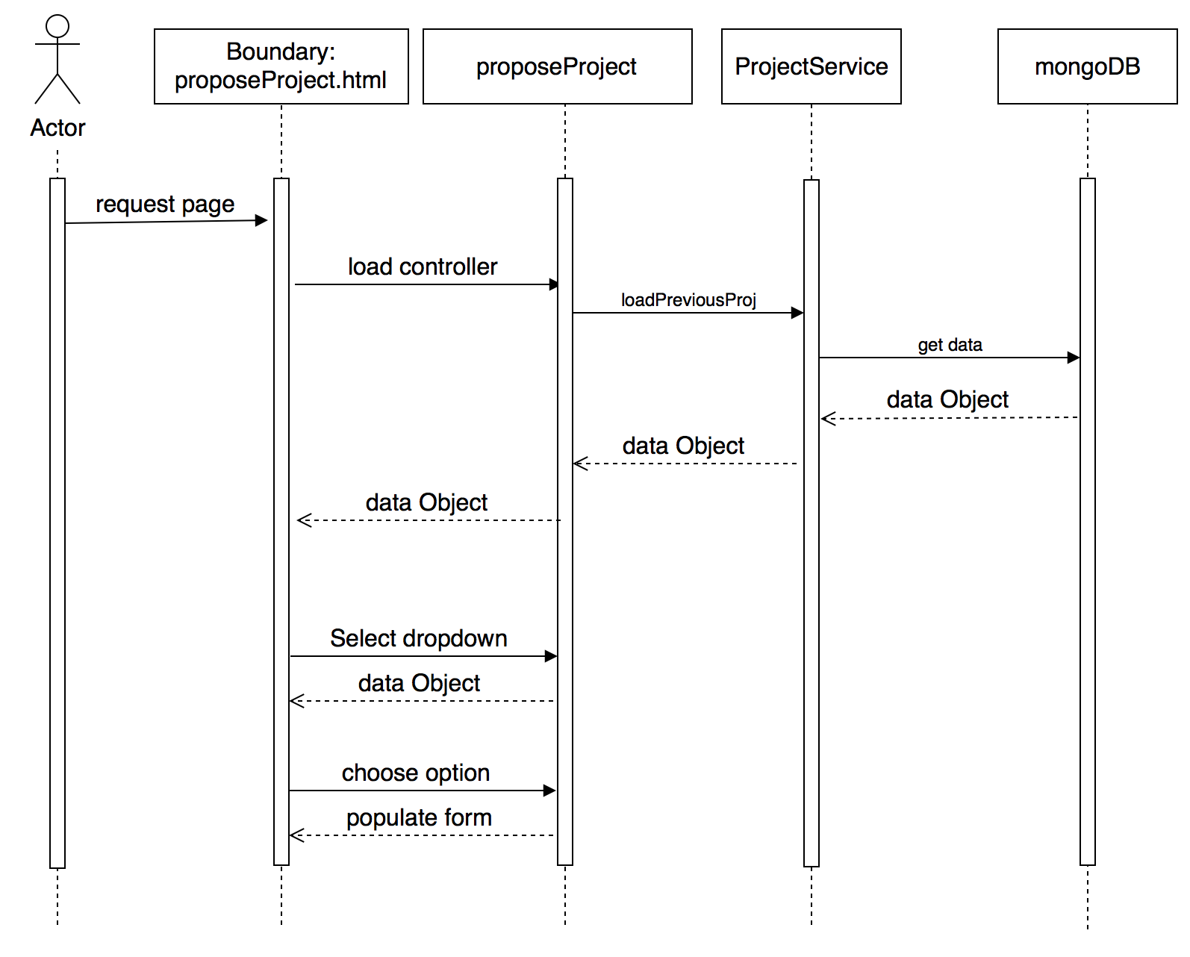

**Class Diagram**

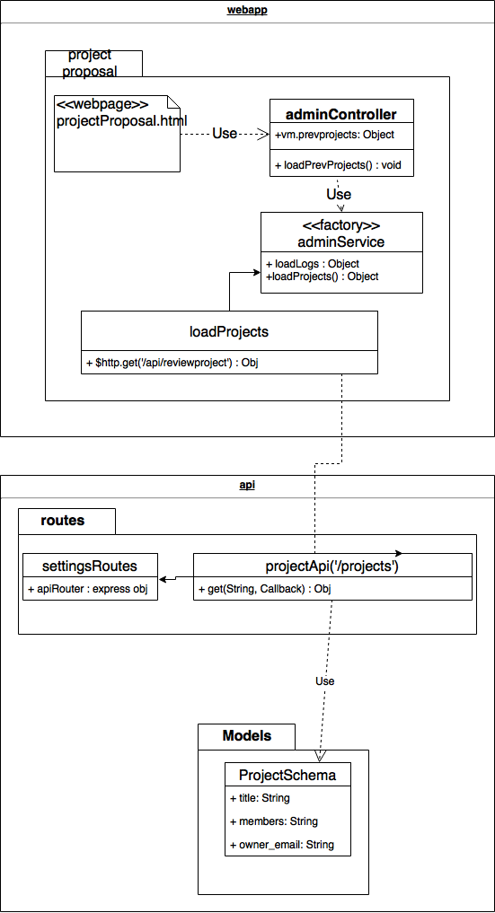

**Unit Test**

* Test case ID: VIP-1305-U1
* Description: Repopulate propose project with previous project informations.
* Summary of Test:

1. Tester selects project from previous project dropdown
2. Tester changes/verify information that have prepopulate
3. Tester submit project for approval

* Test Data
  + Edit Project: Test Project 3
* Pre-condition:

1. Faculty must be logged with proper privileges.
2. Faculty must have previous projects

* Expected Results:

1. Form is prepopulated with information from previous project

* Actual Result:

1. Form is prepopulated with information from previous project.

Status (Fail/Pass): PASS

**Integration Test**

* Test case ID: VIP-1305-G1
* Description: Repopulate propose project with previous project informations.
* Summary of Test:

1. Tester selects project from previous project dropdown
2. Tester changes/verify information that have prepopulate
3. Tester submit project for approval

* Test Data
  + Edit Project: Test Project 3
* Pre-condition:

1. Faculty must be logged with proper privileges.

* Expected Results:

1. Form is prepopulated with information from previous project

* Actual Results

1. Form is prepopulated with information from previous project.

Status (Fail/Pass): PASS

**Visual User Guide**

