*Florida International University*

*School of Computing and Information Sciences*

Software Engineering Focus

Feature Document

User Story #1361

**Name:** Leon Liang

**Team Member(s):** Leon Liang, Dale Keith, Andres Moser, Steve Hirabayashi, Adam Levy

**Project:** V.I.P. Website 7.0

**Product Owner(s)**: Francisco Ortega, Masoud Sadjadi

**Mentor(s)**: Jose Ponce

**Instructor**: Masoud Sadjadi

**User Story Name: Redesign Student Review Page**

As an admin, I want faculty to only see student they are responsible for in order to improve security and reduce human prone errors

Acceptance Criteria

* Upon entering the student review page, the page should pre-populate with only student that registered for the project the user is responsible for
* History log of student should only show projects related to the user

**Use Cases**

* Name: Faculty approves student for their project
* Actor: Faculty
* Preconditions:
* Faculty is already logged in
* Faculty is in the review student page
* Student has applied to a project that the faculty is the owner of
* Faculty is an owner of a project
* Description:

1. Faculty searches for a specific student through the search box
2. The list of student the faculty can review is only limited to the projects that the faculty is in charge of
3. Faculty can approve or reject a student who has applied

* Name: Faculty review student applications history
* Actor: faculty
* Preconditions:
  + Faculty is already logged in
  + Faculty is in the review student page
  + Faculty is an owner of at least one project
* Description:

1. Faculty searches for student or project based on keywords
2. Faculty can undo or delete an application history log

**Use Case Diagram**

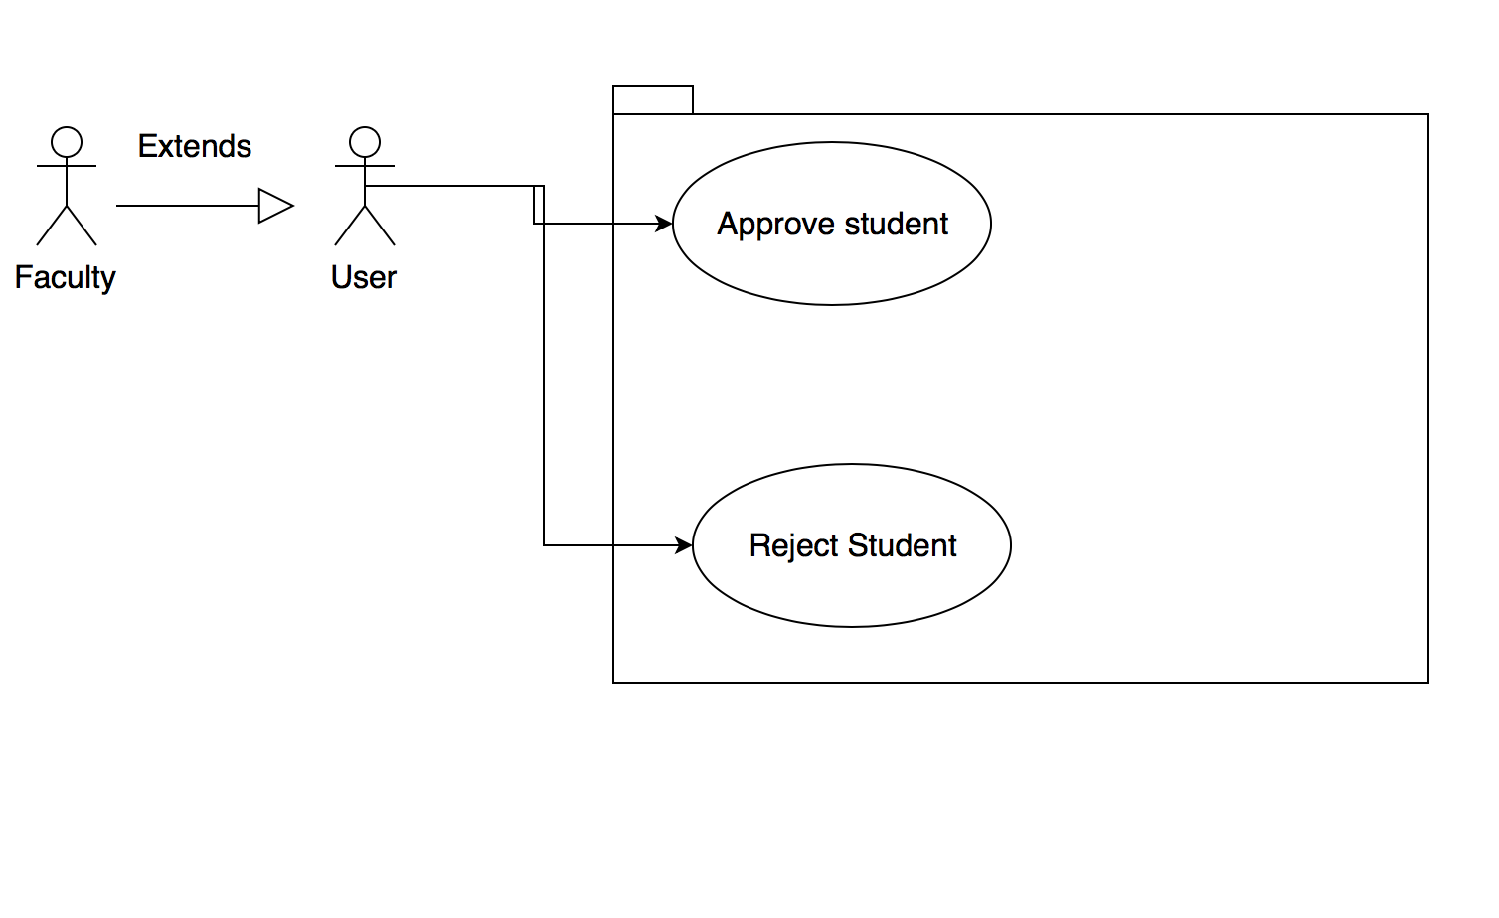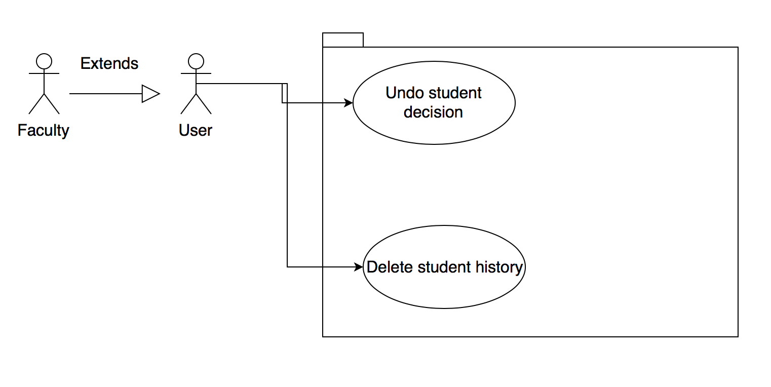

**Sequence Diagrams**

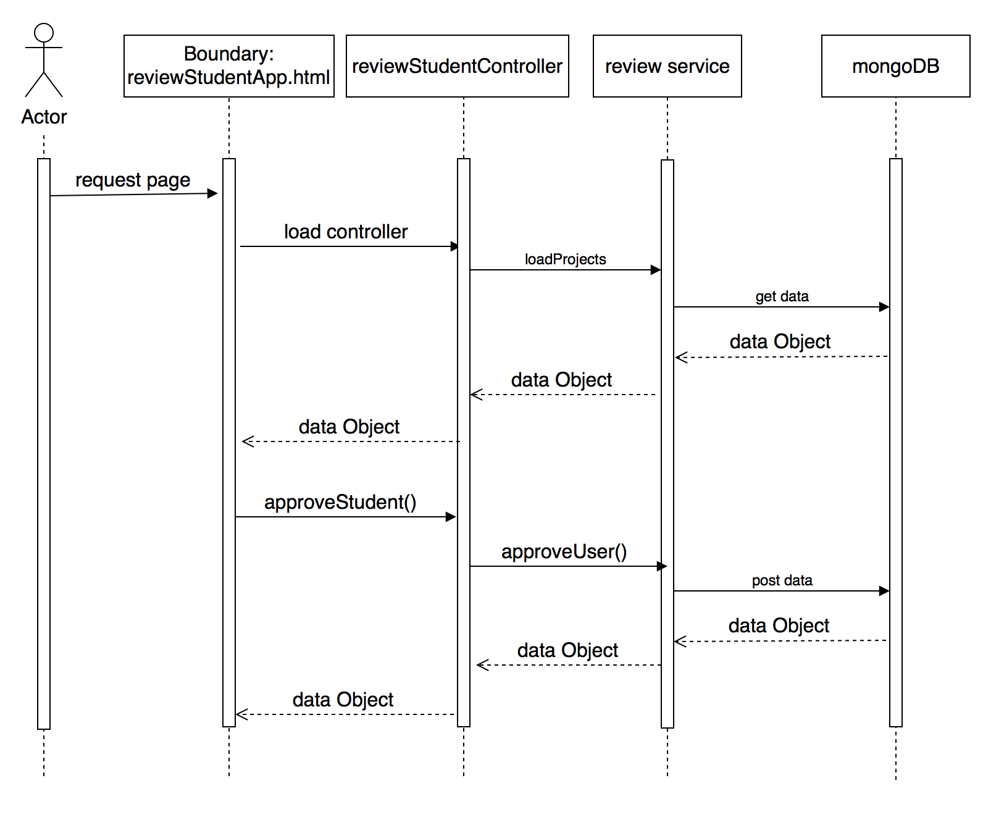

**Class Diagram**

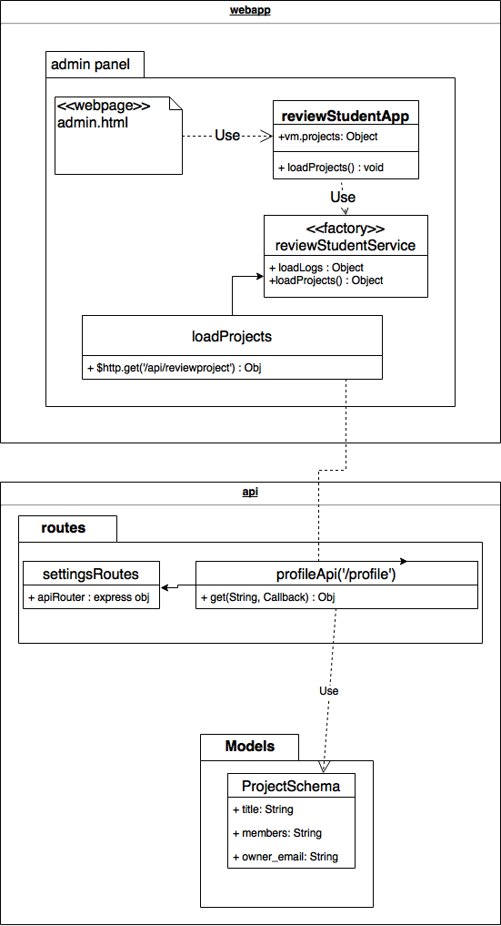

**Unit Tests**

* Test case ID: VIP-1361-U1
* Description:
* Summary of Test:

1. Tester selects review student applications
2. Tester selects types in student name
3. Tester selects approve or unapprove student

* Pre-Conditions:

1. Student has been registered
2. Admin is already signed in

* Expected Results:

1. Approved student will be removed from the pending approval table and moved to the history log

* Actual Result:

1. Approved student will be removed from the pending approval table and moved to the history log

* Status (Fail/Pass): PASS

**Visual User Guide**

