*Florida International University*

*School of Computing and Information Sciences*

Software Engineering Focus

Feature Document

User Story #1355

**Name: Adam Levy**

**Team Member(s): Adam Levy, Steve Hirabayashi, Leon Liang, Dale Keith**

**Project: VIP Webstie 7.0**

**Product Owner(s)**: Dr. Masoud Sadjadi, Dr. Franciso Ortega

**Mentor(s)**: Jose Ponce

**Instructor**: Masoud Sadjadi

**User Story Name: Connect Mobile Judge To VIP Website**

* Description: **As a** User **I would like** to access the VIP website api **so that** I view the users in the mobile judge application like I do with the SPWS api.

Acceptance Criteria

* The Mobile Judge Application makes its requests from the VIP Website API.
* The Mobile Judge application functions as it did when it made its requests from the SPWS API.

**Use Case**

* Name: Mobile Judge people tab selected
* Actor: Judge
* Preconditions:
  + Judge logged into Mobile Judge application.
  + Mobile Judge application has the VIP API key
  + VIP API is running
* Description:

1. Judge clicks the People tab in the mobile judge UI
2. The application responds by presenting the user with a table of the people that need judging

**Use Case Diagram**

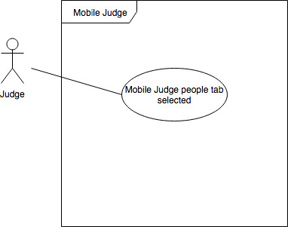

**Sequence Diagram**

**Class Diagram**

**Unit Test**

* Test case ID:
* Description/Summary of Test:
* Pre-condition:
* Expected Results:
* Actual Result:
* Status (Fail/Pass):

**Integration Test**

**Visual User Guide** <like one or two screenshots of the feature. For the hardware project, a photo of device is required>