*Florida International University*

*School of Computing and Information Sciences*

Software Engineering Focus

Feature Document

User Story #1356

**Name:** Leon Liang

**Team Member(s):** Leon Liang, Dale Keith, Andres Moser, Steve Hirabayashi, Adam Levy

**Project:** V.I.P. Website 7.0

**Product Owner(s)**: Francisco Ortega, Masoud Sadjadi

**Mentor(s)**: Jose Ponce

**Instructor**: Masoud Sadjadi

**User Story Name: Approve student registrations via admin panel**

As an admin, I want to approve student registrations from within the admin panel so that I would not have to access a separate page and improve workflow efficiency

Acceptance Criteria

* Admin will be able to approve each non-approved student will have an approve button enabled
* Admin will not be able to re-approve, already approved students

**Use Cases**

* Name: Admin approve student registrations from admin panel
* Actor: Pi/CoPi
* Preconditions:
* Admin must be logged in with administrative rights
* Admin must be at the admin panel page - users maintenance tab
* Student must be registered
* Description:

1. Pi/CoPi searches user via searchbox
2. Pi/CoPi approves student via approval button

**Use Case Diagram**

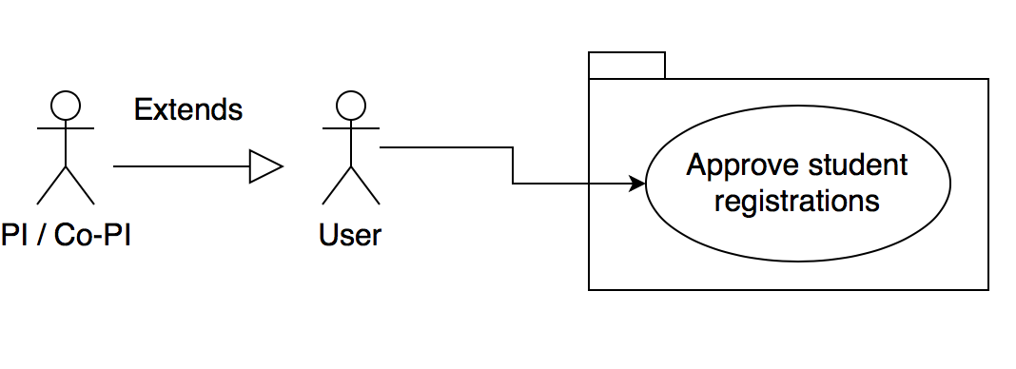

**Sequence Diagrams**

Filtering courses by semester

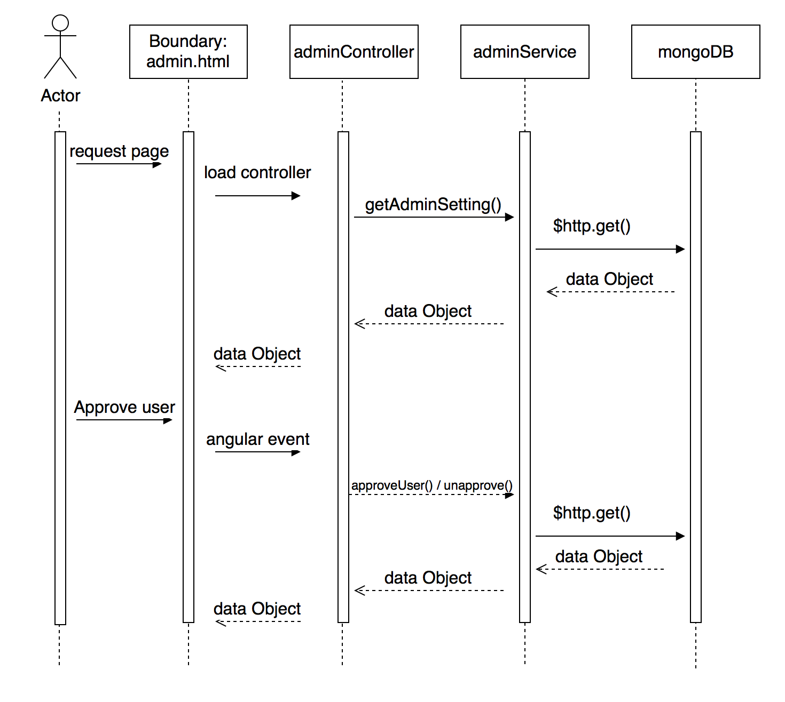

**Class Diagram**

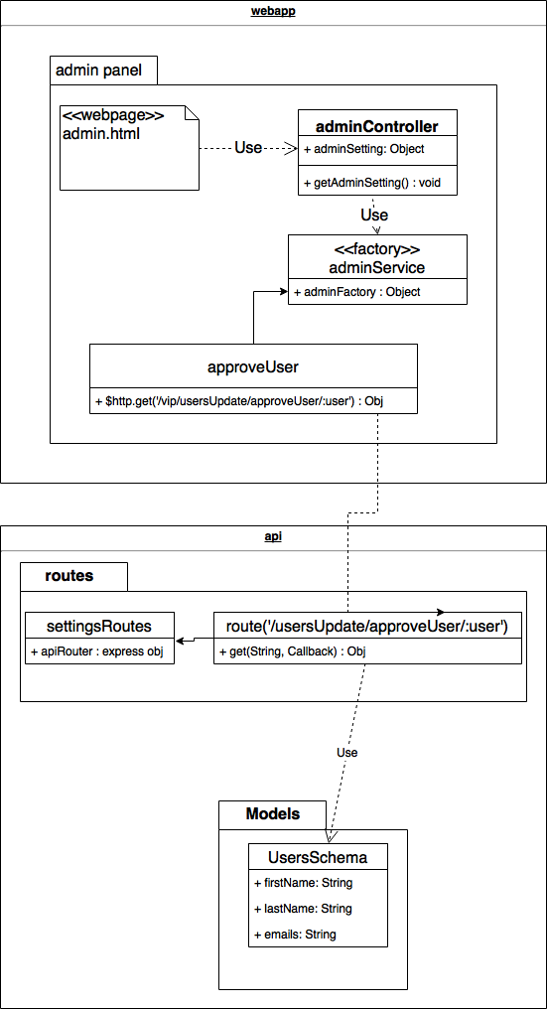

**Unit Tests**

* Test case ID: VIP-1356-U1
* Description:
* Summary of Test:

1. Tester selects tool icon on top of the page
2. Tester selects types in student name
3. Tester selects approve or unapprove student

* Pre-Conditions:

1. Student has been registered
2. Admin is already signed in
3. Admin is in the admin maintenance page

* Expected Results:

1. Selected student will have the button switched either approve or unapprove

* Actual Result:

1. Selected student will have the button switched either approve or unapprove

* Status (Fail/Pass): PASS

**Visual User Guide**

