*Florida International University*

*School of Computing and Information Sciences*

Software Engineering Focus

Feature Document

User Story #1314

**Name:** Leon Liang

**Team Member(s):** Leon Liang, Dale Keith, Andres Moser, Steve Hirabayashi, Adam Levy

**Project:** V.I.P. Website 7.0

**Product Owner(s)**: Francisco Ortega, Masoud Sadjadi

**Mentor(s)**: Jose Ponce

**Instructor**: Masoud Sadjadi

**User Story Name: Create Admin Panel Tabs**

Description:

As a PI/Co-PI, I want to be able to navigate to different admin functionality through tabs so that I would not have to manually scroll down to the bottom in order to access functionality.

Acceptance Criteria

* The tabs should directly take user to functionality corresponding to the tab in one click
* Tabs should contain all functionality from before
* Admin panel should be reduced in size and have the drop down functionalities removed

**Use Case**

* Name: Admin maintenances tabs
* Actor: PI / CO-PI
* Preconditions: User must be logged in to access functionalities
* Description:

1. User logs into VIP Website
2. Clicks on toolbar to access maintenance page
3. Upon being brought to the main page, there will be tabs for user to select at the top which set of actions they want to perform
4. Each tab should respond by replacing current tab with the one chosen

**Use Case Diagram**

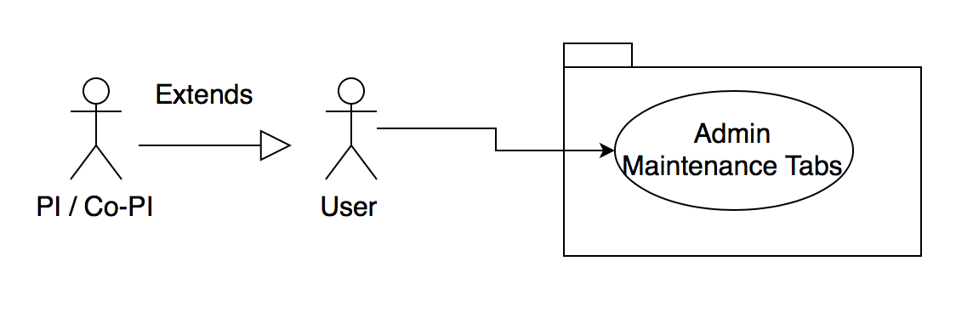

**Sequence Diagram**

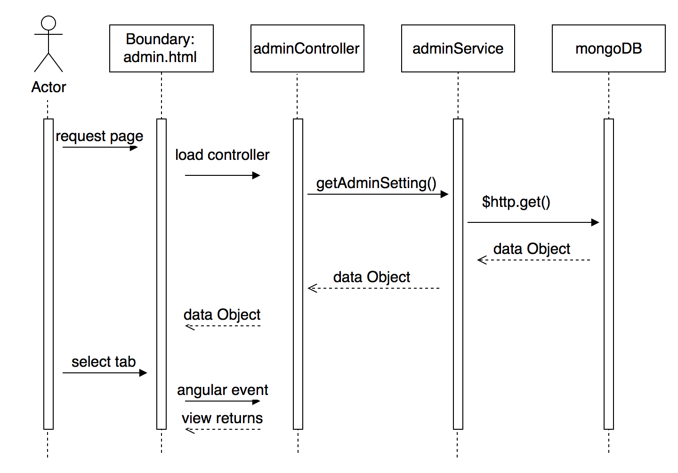

**Class Diagram**

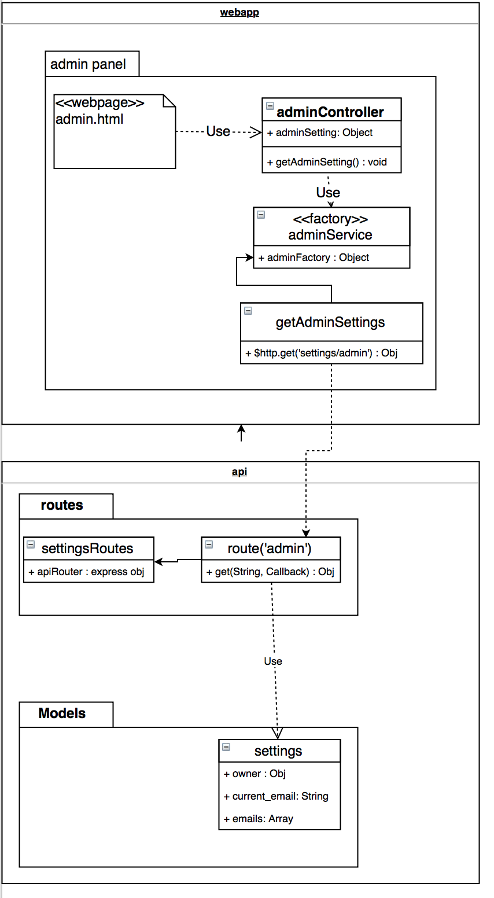

**Unit Test**

* Test case ID: VIP-1314-U1
* Description/Summary of Test:
* Click to select tab to hide current tab and display new tab
* Upon entering the main admin maintenance page, they should only see selected capabilities
* Pre-condition:
* User should be already logged in
* User is in the main admin maintenance page
* User is either an PI or Co-PI
* Expected Results:
* Maintenance page is reduced in size and selecting tabs will bring up new view capabilities
* Actual Result:
* Maintenance page is reduced in size and selecting tabs will bring up new view capabilities
* Status (Fail/Pass):
* Pass

**Integration Test**

* Test case ID: VIP-1314-G1
* Description/Summary of Test:
  + Tester enters the main page and clicks on user maintenance page
  + Tester then chooses a student to impersonate and clicks on the button ‘impersonate’ to bring them back to the home page as the target user
* Pre-condition:
  + User with Pi privileges has logged into the VIP website.
* Expected Results:
  + Tester is able to impersonate user as before and explore the website is from their login credentials
* Actual Result:
  + Tester is able to impersonate user as before and explore the website is from their login credentials
* Status (Fail/Pass):
  + PASS

**Visual User Guide**

