*Florida International University*

*School of Computing and Information Sciences*

Software Engineering Focus

Feature Document

User Story #1322

**Name:** Leon Liang

**Team Member(s):** Leon Liang, Dale Keith, Andres Moser, Steve Hirabayashi, Adam Levy

**Project:** V.I.P. Website 7.0

**Product Owner(s)**: Francisco Ortega, Masoud Sadjadi

**Mentor(s)**: Jose Ponce

**Instructor**: Masoud Sadjadi

**User Story Name:**

* Description:

**As PI/Co-PI, I want to be able to have paging in User Maintenance and Project Maintenance Table in order to increase readability and increase page loading speed.**

Acceptance Criteria

1. Upon entering each tab, the pages should already be paged with 10 entries per page
2. All filtering functionality should still work with the pagination

**Use Case**

* Name: Paginating tables
* Actor: PI / Co-PI
* Preconditions:

1. User with PI priviledges has logged into the VIP website
2. They must be in the user maintenance tab or project maintenance tab
3. There must be more than 10 entries in the database for corresponding table

* Description:

1. User logs into VIP Website
2. Clicks on toolbar to access maintenance page
3. Upon being brought to the main page, there will be tabs for user to select at the top which set of actions they want to perform
4. Each tab should respond by replacing current tab with the one chosen
5. When entering user maintenance or project maintenance, the tables should be set to max of 10 entries per table
6. User can change page by the pagination toolbar at the bottom of the page

**Use Case Diagram**

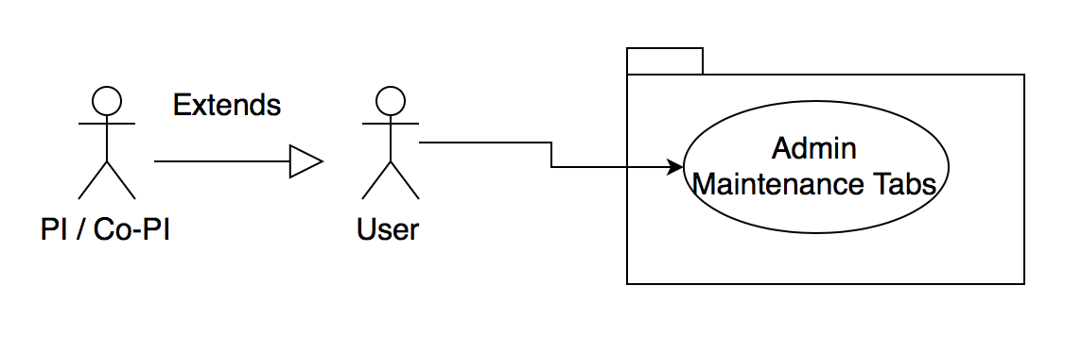

**Sequence Diagram**

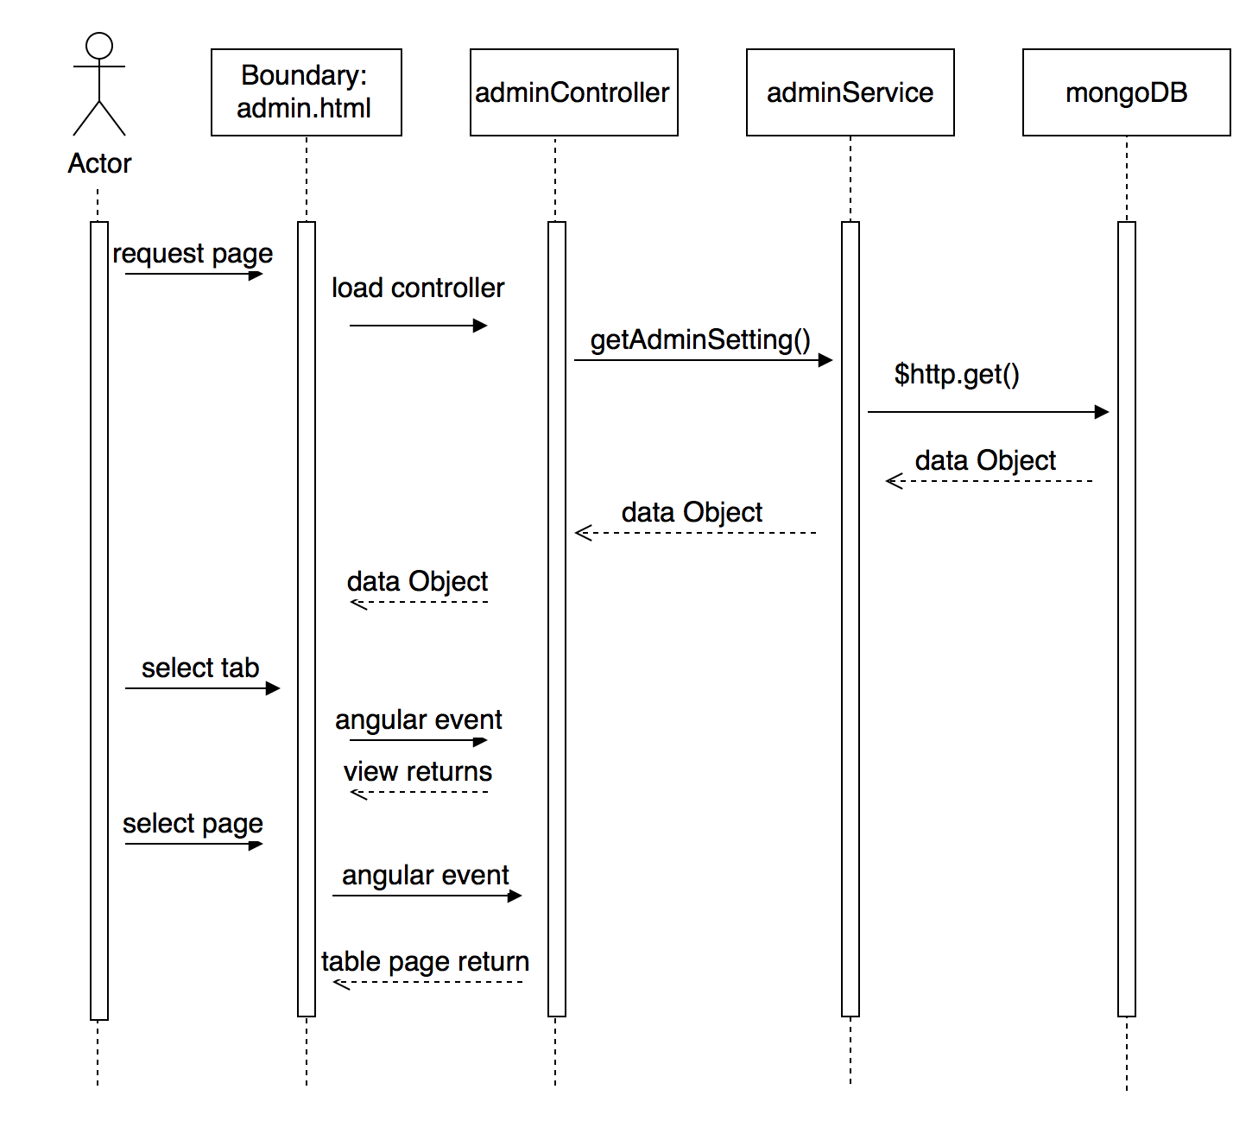

**Class Diagram**

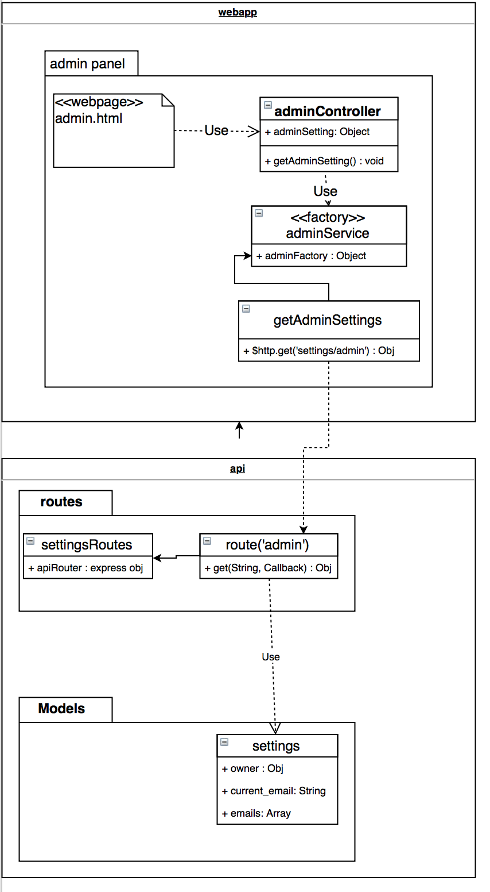

**Unit Test**

* Test case ID: VIP - 1322 - U1
* Description/Summary of Test:
* Enter user maintenance or project maintenance tab
* Choose page from the pagination tool on the bottom of table to navigate
* Pre-condition:
* User should be already logged in and have PI / Co-PI priviledge
* Expected Results:
* No more than 10 entries per page
* Table should already be paginated upon loading
* Actual Result:
* No more than 10 entries per page
* Table should already be paginated upon loading
* Status (Fail/Pass):
* Pass

**Integration Test**

Test case ID: VIP-1322-G1

* Description/Summary of Test:
  + Tester enters the user maintenance or project maintenance tab
  + Tester should be able to still filter the table based on the filter tools
* Pre-condition:
  + User with Pi privileges has logged into the VIP website.
* Expected Results:
  + Tester is able to filter all data using the filter on the top of the table
* Actual Result:
  + Tester is able to filter all data using the filter on the top of the table
* Status (Fail/Pass):
  + PASS

**Visual User Guide**

