*Florida International University*

*School of Computing and Information Sciences*

Software Engineering Focus

Feature Document

User Story #1365

**Name:** Steve Hirabayashi

**Team Member(s):** Leon Liang, Dale Keith, Andres Moser, Steve Hirabayashi, Adam Levy

**Project:** V.I.P. Website 7.0

**Product Owner(s)**: Francisco Ortega, Masoud Sadjadi

**Mentor(s)**: Jose Ponce

**Instructor**: Masoud Sadjadi

**User Story Name: Manage Project's Faculty/Mentors in Projects Panel**

* As a PI/CoPI, I would like to be able to edit a project’s faculty members and mentors, so that I can easily modify/update the information of current projects and users that are associated with that course.

Acceptance Criteria

* After selecting the option to add/remove a projects members, PI/CoPi will be able to add/remove faculty and mentors. Then after saving the changes, the Pi/CoPi will see the changes made to the project in the projects panel.

**Use Case**s

* Name: Administrator adds/removes faculty from a project
* Actor: Pi/CoPi
* Preconditions: Admin must be logged in with administrative rights, admin must be at the admin panel page - project maintenance tab.
* Description:

1. Pi/CoPi selects the ‘add/remove users’ button
2. Vip.fiu.edu responds by prompting Pi/CoPi with the add/remove users dialog
3. Pi/CoPi modifies the projects faculty list and selects ‘save changes’ button.
4. Vip.fiu.edu responds by either displaying a failure message with the specific occured error or displaying a confirmation message that the project has been updated in the system.

* Name: Administrator adds/removes mentors from a project
* Actor: Pi/CoPi
* Preconditions: Admin must be logged in with administrative rights, admin must be at the admin panel page - project maintenance tab.
* Description:

1. Pi/CoPi selects the ‘add/remove users’ button
2. Vip.fiu.edu responds by prompting Pi/CoPi with the add/remove users dialog
3. Pi/CoPi modifies the projects mentor list and selects ‘save changes’ button.
4. Vip.fiu.edu responds by either displaying a failure message with the specific occured error or displaying a confirmation message that the project has been updated in the system.

**Use Case Diagram**

[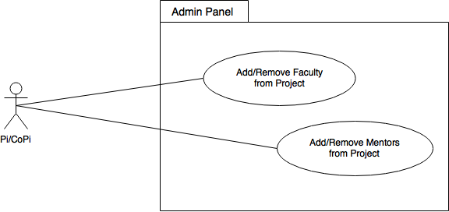](https://www.draw.io/#G1ySqAkKIsAxDyn6i2wqKnn1MyyCvD6KUF)

**Sequence Diagrams**

Add/Remove Faculty from Project  
[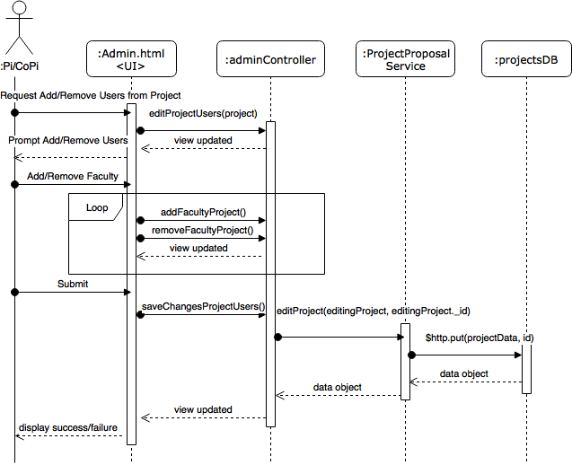](https://www.draw.io/#G1UbtBDDrsLnPOKa4V-Mofj0utKFcJLZNB)

Add/Remove Mentors from Project

[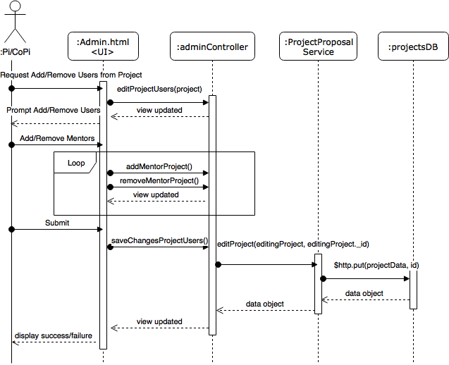](https://www.draw.io/#G1ITcumGCKpKhLAGMZMFK6Gq7X7TXVlLhC)

**Class Diagram**

[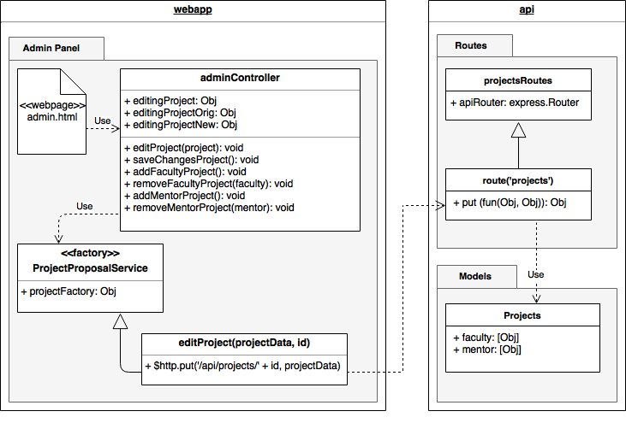](https://www.draw.io/#G1OdYIuLLIZS9eUpfMa3_cbT0AjUVB0urS)

Test case ID: VIP-1365-U1

* Description: Admin adds/removes project’s faculty members
* Summary of Test:

1. Tester selects ‘add/remove users’ button for project ‘Test Project’
2. Tester finds and selects user ‘Test User’ in add faculty drop down box
3. Tester selects ‘add faculty’ button
4. Tester selects ‘remove faculty’ button for user ‘Test User’
5. Tester finds and selects user ‘Q W’ in add faculty drop down box
6. Tester selects ‘add faculty’ button
7. Tester selects ‘save changes’ button

* Pre-Condition:

1. Admin with Pi/CoPi privileges has logged into the VIP website
2. Admin is at the admin panel page - project maintenance tab
3. Project ‘Test Project’ exists in the database
4. Users ‘Test User’, ‘Q W’ exists in the database

* Expected Results:

1. Project ‘Test Project’ will be updated in the database with user ‘Q W’ added as a faculty member
2. Projects panel table will be updated with ‘Test Project’ updated

* Actual Result:

1. Project ‘Test Project’ will be updated in the database with with user ‘Q W’ added as a faculty member
2. Projects panel table will be updated with ‘Test Project’ updated

* Status (Fail/Pass): PASS
* Test case ID: VIP-1365-U2
* Description: Admin adds/removes project’s mentors
* Summary of Test:

1. Tester selects ‘add/remove users’ button for project ‘Test Project’
2. Tester finds and selects user ‘New User’ in add mentor drop down box
3. Tester selects ‘add mentor’ button
4. Tester selects ‘remove mentor’ button for user ‘New User’
5. Tester finds and selects user ‘A B’ in add mentor drop down box
6. Tester selects ‘add mentor’ button
7. Tester selects ‘save changes’ button

* Pre-Condition:

1. Admin with Pi/CoPi privileges has logged into the VIP website
2. Admin is at the admin panel page - project maintenance tab
3. Project ‘Test Project’ exists in the database
4. Users ‘New User’, ‘A B’ exists in the database

* Expected Results:

1. Project ‘Test Project’ will be updated in the database with user ‘A B’ added as a mentor
2. Projects panel table will be updated with ‘Test Project’ updated

* Actual Result:

1. Project ‘Test Project’ will be updated in the database with user ‘A B’ added as a mentor
2. Projects panel table will be updated with ‘Test Project’ updated

* Status (Fail/Pass): PASS

**Unit Tests**

**Visual User Guide**

