*Florida International University*

*School of Computing and Information Sciences*

Software Engineering Focus

Feature Document

User Story #1346

**Name:** Steve Hirabayashi

**Team Member(s):** Leon Liang, Dale Keith, Andres Moser, Steve Hirabayashi, Adam Levy

**Project:** V.I.P. Website 7.0

**Product Owner(s)**: Francisco Ortega, Masoud Sadjadi

**Mentor(s)**: Jose Ponce

**Instructor**: Masoud Sadjadi

**User Story Name: Synchronize Users Database with Panthersoft Data**

* As a Pi/CoPi, I want to synchronize the VIP Users database using Panthersoft course enrolled data, so that I can update the database with changes to the students that are enrolled in a given course.

Acceptance Criteria

* Students that are removed from a given course are updated so that they are no long assigned that course
* Students that are added to a given course and do not exist in the database are added to the database
* Students that already exist in the database will be updated with data provided by pathersoft

**Use Case**

* Name: Admin syncs Users database using course data
* Actor: Pi/CoPi
* Preconditions:
* Admin must be logged in with administrative rights
* Admin must be at the admin panel page - course maintenance tab
* Description:

1. Pi/CoPi selects a course file (.xls)
2. Pi/CoPi selects the ‘add course file’ button
3. Pi/CoPi selects the ‘sync database’ button
4. Pi/CoPi will see the update of the users of the course in the system

**Use Case Diagram**

[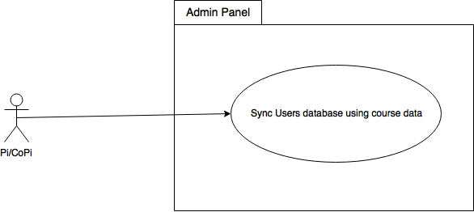](https://www.draw.io/#G10vE1lOvgPZrUlPJaTtL1ool5xidzkgo3)

**Sequence Diagram**

[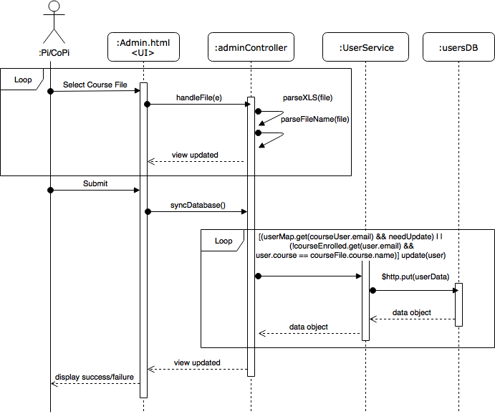](https://www.draw.io/#G1LGqA45Tw3OtN-hUNVMWO6Eou3HZYzQcD)

**Class Diagram**

[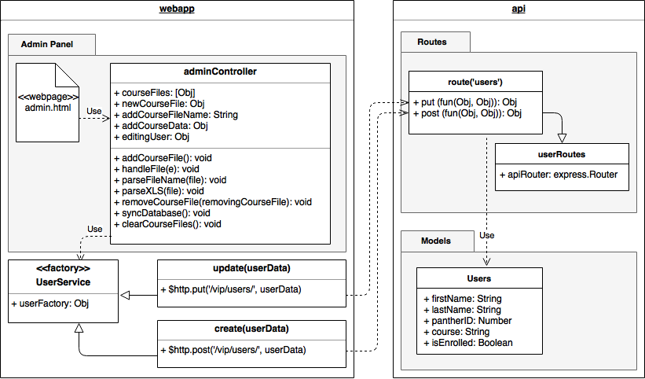](https://www.draw.io/#G184Kc86YfgjuN0onBF6FfxusfqQ3YeoyN)

**Unit Tests**

* Test case ID: VIP-1346-U1
* Description: Admin syncs Users database using course data for a course registered in the system
* Summary of Test:

1. Tester selects ‘Sync Database’ button
2. Tester selects ‘choose file’ button
3. Vip.fiu.edu responds by presenting a file dialog
4. Tester selects xls file ‘TST 1234-U01’ in file dialog
5. Vip.fiu.edu responds by updating course combo box with matching course ‘TST 1234-U01’
6. Tester selects ‘add course file’ button
7. Tester selects ‘Sync Database’ button
8. Vip.fiu.edu responds with notification of success or failure

* Test Data:
* XLS File Name: TST 1234-U01
* User: Test User

- panther ID: 0000001

- email: t@u.edu

- name: User, Test

* User: Q W

- panther ID: 0000002

- email: q@w.edu

- name: W, Q

* User: first1 last1 last2

- panther ID: 0000003

- email: f@l.edu

- name: last1 last2, first1

* Pre-Conditions:

1. Admin with Pi/CoPi privileges has logged into the VIP website
2. Admin is at the admin panel page - course maintenance tab
3. Users ‘Test User’, ‘Q W’, ‘first1 last1 last2’ are present in the Users Database
4. Course ‘TST 1234-U01’ is present in the Courses Database

* Expected Results:

1. Users ‘Test User’, ‘Q W’, ‘first1 last1 last2’ will be updated to be enrolled in course ‘TST 1234-U01’
2. Users panel will be updated with users course changes

* Actual Result:

1. Users ‘Test User’, ‘Q W’, ‘first1 last1 last2’ is updated to be enrolled in course ‘TST 1234-U01’
2. Users panel is updated with users course changes

* Status (Fail/Pass): PASS

**Integration Tests**

* Test case ID: VIP-1346-G1
* Description: Admin syncs Users database using course data for a course not registered in the system
* Summary of Test:

1. Tester selects ‘Sync Database’ button
2. Tester selects ‘choose file’ button
3. Vip.fiu.edu responds by presenting a file dialog
4. Tester selects xls file ‘NEW 1000-U01’ in file dialog
5. Vip.fiu.edu responds by asking the user to confirm the creation of course ‘NEW 1000-U01’
6. Tester selects ‘add course’ button
7. Tester selects ‘add course file’ button
8. Tester selects ‘Sync Database’ button
9. Vip.fiu.edu responds with notification of success or failure

* Test Data:
* XLS File Name: NEW 1000-U01
* User: Test User

- panther ID: 0000001

- email: t@u.edu

- name: User, Test

* Pre-Conditions:

1. Admin with Pi/CoPi privileges has logged into the VIP website
2. Admin is at the admin panel page - course maintenance tab
3. User ‘Test User’ is present in the Users Database
4. Course ‘NEW 1000-U01’ is not present in the Courses Database

* Expected Results:

1. User ‘Test User’ will be updated to be enrolled in course ‘NEW 1000-U01’
2. Users panel will be updated with users course changes
3. Courses panel will be updated with new course ‘NEW 1000-U01’ shown

* Actual Result:

1. User ‘Test User’ will be updated to be enrolled in course ‘NEW 1000-U01’
2. Users panel will be updated with users course changes
3. Courses panel will be updated with new course ‘NEW 1000-U01’ shown

* Status (Fail/Pass): PASS
* Test case ID: VIP-1346-G2
* Description: Finding a user in the course data being synced that is not currently in the Users database should create a new user in the Users database
* Summary of Test:

1. Tester selects ‘Sync Database’ button
2. Tester selects ‘choose file’ button
3. Vip.fiu.edu responds by presenting a file dialog
4. Tester selects xls file ‘TST 1234-U01’ in file dialog
5. Vip.fiu.edu responds by updating course combo box with matching course ‘TST 1234-U01’
6. Tester selects ‘add course file’ button
7. Tester selects ‘Sync Database’ button
8. Vip.fiu.edu responds with notification of success or failure
9. Test selects ‘User maintenance’ tab and searches for added user: ‘New User’

* Test Data:
* XLS File Name: TST 1234-U01
* User: New User

- panther ID: 0000004

- email: n@u.edu

- name: User, New

* Pre-conditions:

1. Admin with Pi/CoPi privileges has logged into the VIP website
2. Admin is at the admin panel page - course maintenance tab
3. User ‘New User’ is not present in the Users Database
4. Course ‘TST 1234-U01’ is present in the Courses Database

* Expected Results:

1. User ‘New User’ will be added to the database, enrolled in course ‘TST 1234-U01’
2. Users panel will be updated with new user ‘New User’

* Actual Result:

1. User ‘New User’ was added to the database, enrolled in course ‘TST 1234-U01’
2. Users panel was updated with new user ‘New User’

* Status (Fail/Pass): PASS

**Visual User Guide**

