*Florida International University*

*School of Computing and Information Sciences*

Software Engineering Focus

Feature Document

User Story ID #1301

**Name:** Dale Keith

**Team Member(s):** Leon Liang, Dale Keith, Andres Moser, Steve Hirabayashi, Adam Levy

**Project:** VIP Website 7.0

**Product Owner(s)**: Francisco Ortega, Masoud Sadjadi

**Mentor(s)**: Jose Ponce

**Instructor**: Masoud Sadjadi

**User Story Name:** Notify members if a project is deactivated

* Description: As a student/faculty/project leader, I should be notified if a project I am participating is disabled. This notification will help students who are enrolled in the project to quickly find a new one.

Acceptance Criteria

* Users are notified by email when their project is disabled, so they may choose a new one.
* Project owners/faculty members are notified when a new semester opens and are asked if they want to continue a previous project in the new semester.

**Use Case**

* Name: Administrator and participating student(s) are notified if a project is disabled/deactivated.
* Actor: Admin/Student
* Preconditions: Admin must be logged with proper privileges, be on the project maintenance tab of the admin panel, and be editing an active project. Student(s) must be enrolled in the particular project.
* Description:

1. Administrator selects Disabled under the project status dropdown.
2. Administrator saves the project by clicking Save Changes.
3. Administrator sees a message indicating that the project has been saved and the window will reload to ensure all data is updated.
4. The admin panel reloads.
5. Administrator receives an email message indicating that the desired project has been disabled and all participating students were notified.
6. Participating student(s) receive an email message indicating that their current project has been deactivated and should contact a PI for next steps.

**Use Case Diagram <**you can use draw.io**>**

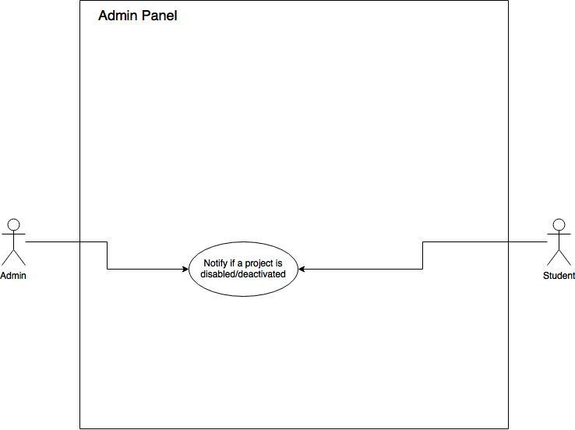

**Sequence Diagram**

Administrator and participating student(s) are notified if a project is disabled/deactivated

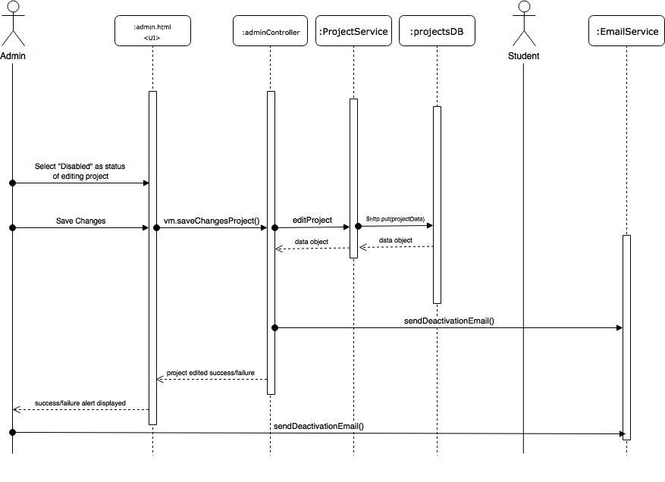

**Class Diagram**

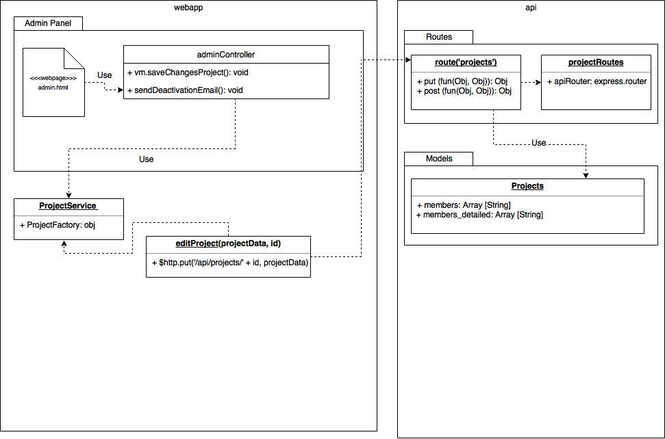

**Unit Test**

* Test case ID: VIP-1301-U1
* Description: Notify if a project is disabled/deactivated.
* Summary of Test:

1. Tester selects “Disabled” as the project’s status.
2. Tester selects Save Changes
3. Tester receives an email that the project has been deactivated and is no longer available.

* Test Data
  + Edit Project: Test Project 3
* Pre-condition:

1. Admin must be logged with proper privileges.
2. Admin must be editing an active project.
3. Student must be enrolled/participating in the selected project.

* Expected Results:

1. Admin will be notified that the project has been deactivated and all participating students will also be notified.
2. Participating student(s) will be notified that their current project is no longer available and to contact a PI for next steps.

* Actual Result:

1. Admin was notified that the project has been deactivated and all participating students were also notified.
2. Participating student(s) were each notified that their current project is no longer available and told to contact a PI for next steps.

Status (Fail/Pass): PASS

**Integration Test**

* Test case ID: VIP-1301-G1
* Description: Specified Project status will show as Disabled the next time the admin panel is loaded and student’s will no longer be able to apply/view the newly-inactive project.
* Summary of Test:

1. Tester is logged into the website as an admin.
2. VIP-1301-U1 was executed successfully.
3. Upon successful execution of VIP-1301-U1, the tester views the project list in the Project Maintenance tab of the admin panel.
4. Tester views all the available project cards.

* Pre-condition:

1. User must be logged in with proper privileges.

* Expected Results:

1. Tester will see the specified project’s status as disabled in the Project Maintenance tab of the admin panel.
2. Tester will observe that the specified project is no longer visible, as it will be disabled.

* Actual Result:

1. Tester sees the specified project’s status is shown as disabled in the Project Maintenance tab of the admin panel.
2. Tester observes that the specified project is no longer visible, as it is now disabled.

Status (Fail/Pass): PASS

**Visual User Guide** <like one or two screenshots of the feature. For the hardware project, a photo of device is required>

